Target Simulation W. Bo (Mar 12, 2009)
(1) Elliptic jet
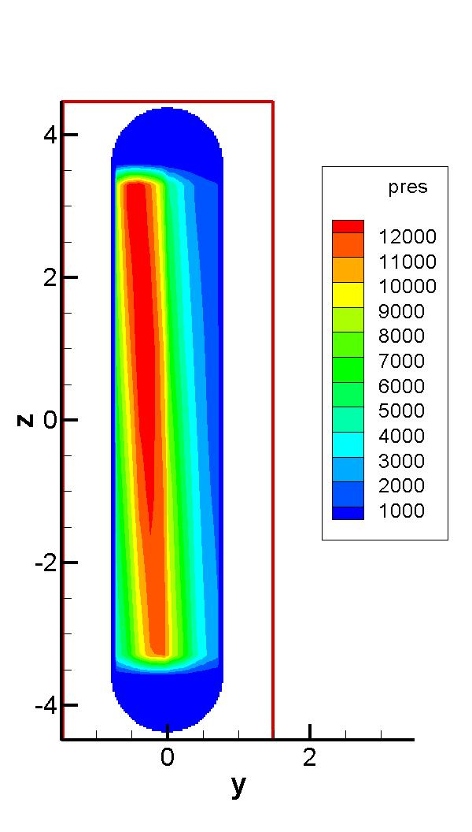
Fig1. Energy deposition in a elliptic jet

Here are the 3 different views for the elliptic jet at 120 microsecond.
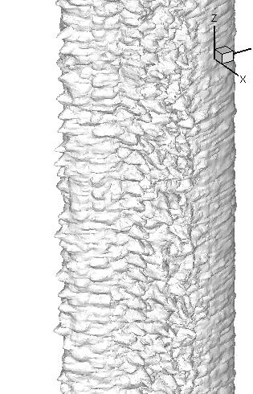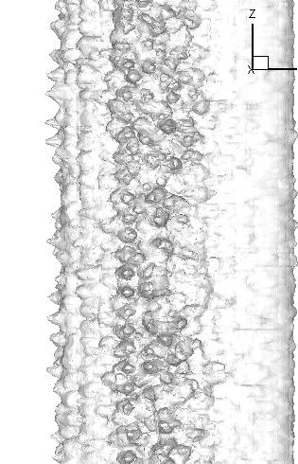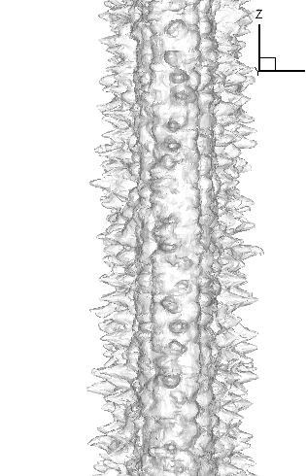

Jet surface at different z cut planes.

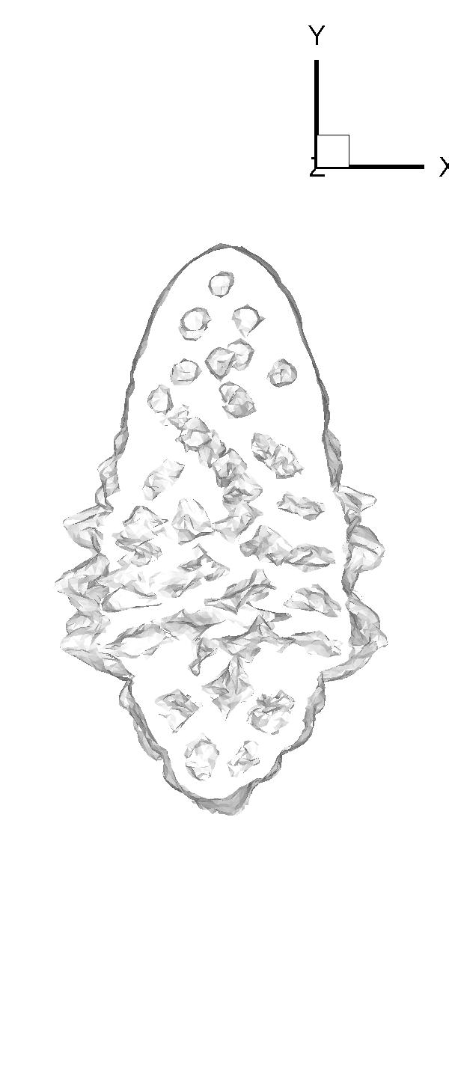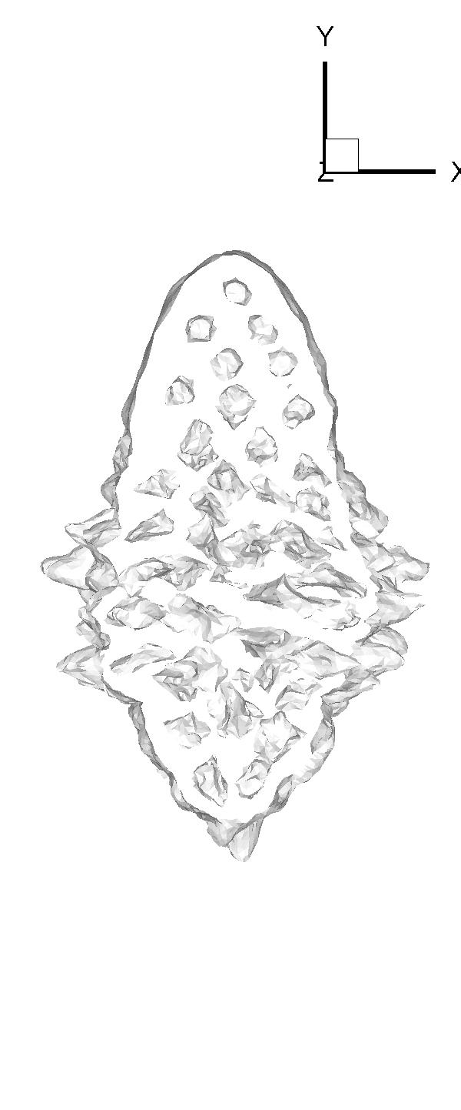
z = -1.9cm z = -2.9cm

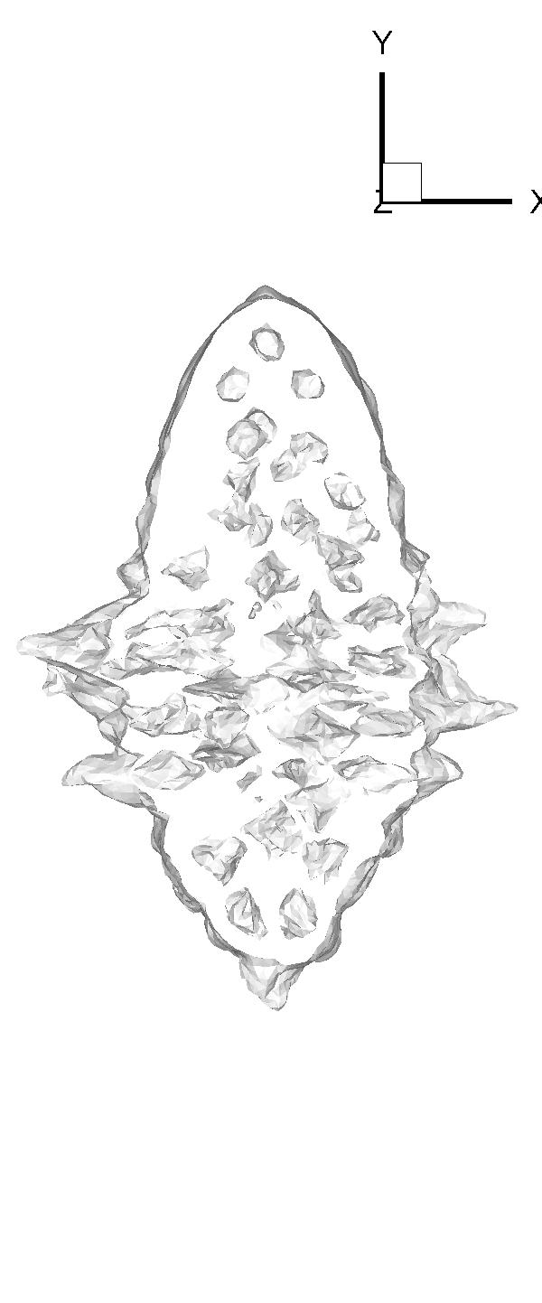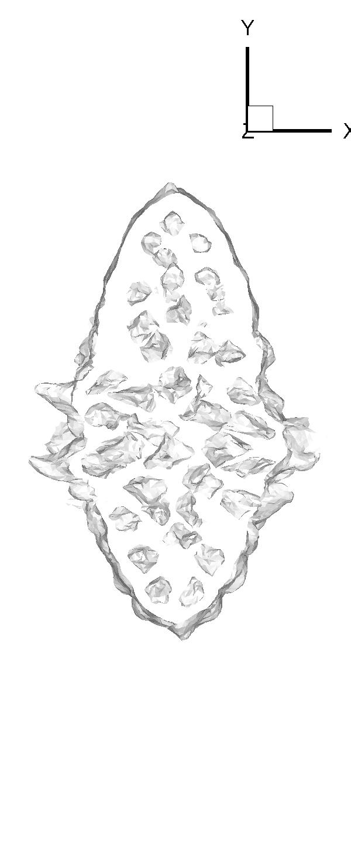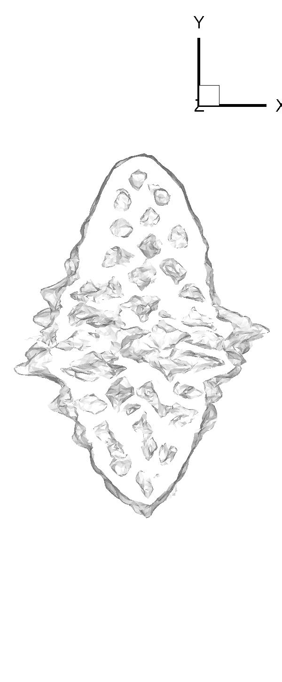
z = 0 z = 2.9cm z = 1.9cm

(2) Circular jet with reduced density

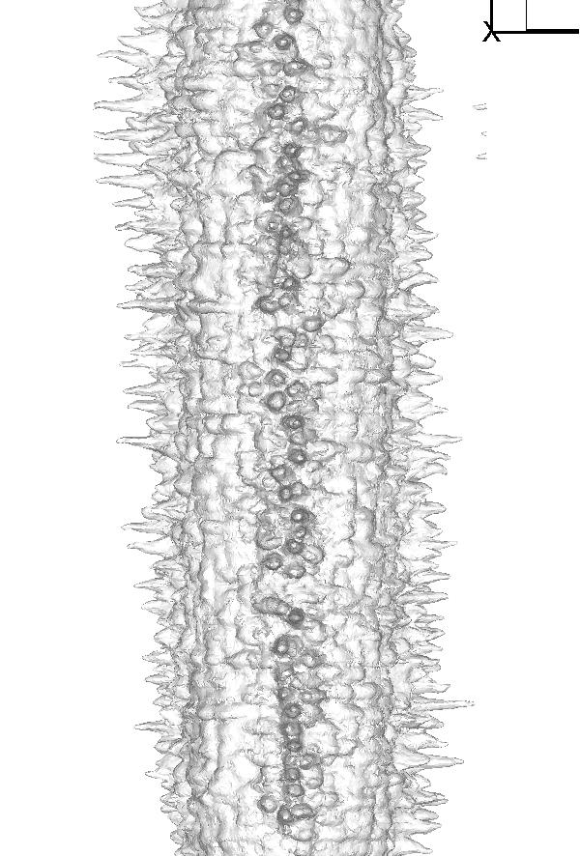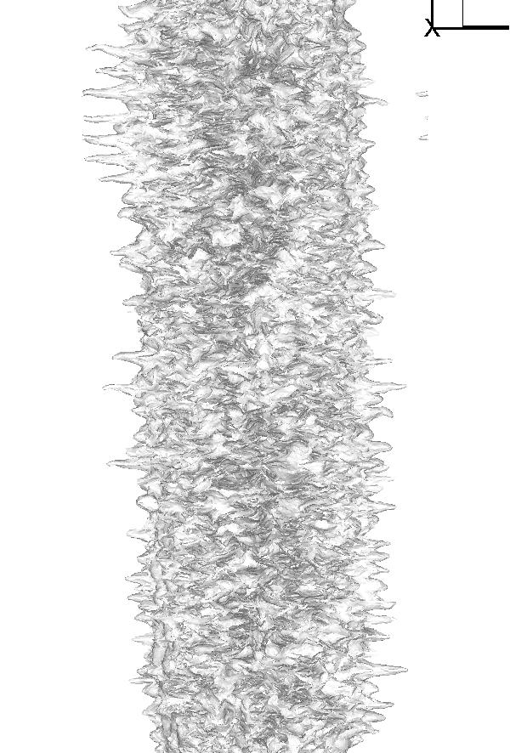

Fig 2.The jet surface and its interior at t = 120 microsecond.

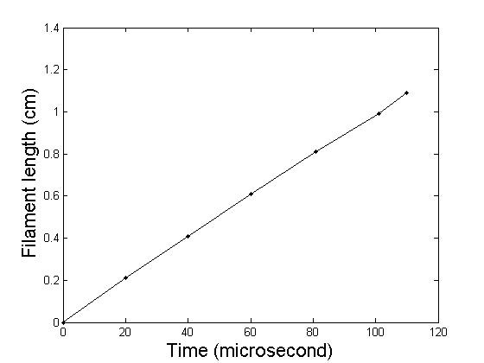
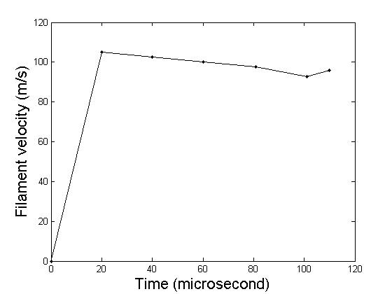
Fig3 Growth of filaments for circular jet with reduced density.

(3) Effect of magnetic field
The test problem without bubble insertion shows the stability effect of magnetic field. See the following figs

