European Organisation for Nuclear Research
European Laboratory for Particle Physics

TECHNICAL NOTE

TIS-RP/TN/2002-018

The effect of a beam loss at the PS/N_TOF interface
of the CERN PS complex

Marco Silari and Helmut Vincke

Abstract

This paper discusses the potential radiation hazard caused by beam losses in one of the transfer lines (TT2) of the CERN Proton Synchrotron, close to the point where the beam is split and can be directed towards the Super Proton Synchrotron via the TT10 tunnel, sent to the n_TOF experiment installed in the extension of TT2 (TT2A tunnel), or stopped in a massive dump. The TT2 area is separated from the downstream TT2A zone of n_TOF by a 4.8 m thick concrete wall. A full beam loss in TT2 could generate a serious radiation hazard on the TT2A side of the shielding wall. Several beam loss scenarios were investigated by Monte Carlo simulations performed with the FLUKA code. The various radiation components making up the dose equivalent rate in TT2A were assessed. It was found that the dose equivalent is dominated by either muons, mainly originating from pion decay, or neutrons produced in hadronic cascades inside the shielding wall, depending on the point where the beam is lost. A comparison between simulation results and measurements is made.

CERN, Geneva, Switzerland

5 April 2002

Introduction

The CERN Proton Synchrotron (PS) accelerates protons up to 26 GeV/c with an intensity of up to 3x10¹³ protons per pulse and has a cycle of 1.2 s. Two pulses are transferred to the Super Proton Synchrotron (SPS) each SPS super-cycle (a typical 14.4 s SPS super-cycle containing 12 PS pulses) to be further accelerated to 450 GeV/c. One to four pulses per super-cycle are sent to the n_TOF experiment. The rest of the beam is partly used for fixed target experiments in the East Experimental Hall, and partly sent to a conversion target to generate antiprotons for the Antiproton Decelerator (AD) and related experiments. This paper discusses the potential radiation hazard caused by beam losses in the TT2 transfer line close to the point where the PS beam is split. Here the beam can be directed towards the SPS via the TT10 tunnel, sent to the n_TOF experiment installed in the prolongation of TT2 (called TT2A), or stopped in a massive dump (called D3). This dump consists of an iron core 7.2 m thick, surrounded by 80 cm of concrete. Figure 1 shows a sketch of the area. The TT2 area is separated from the downstream TT2A zone of n_TOF by a concrete wall 4.8 m thick. The n_TOF area is accessible with beam present in TT2 if two independent interlock conditions are met (the magnets bending the beam into TT2A are off and two stoppers are inserted in the beam line). However, a catastrophic beam loss in TT2 could generate a serious radiation hazard on the TT2A side of the shielding wall.

This study was triggered due to an accidental condition in which a beam loss in TT2, caused by a failure of a corrector magnet installed about 100 m upstream of the shielding wall, generated a high radiation level in TT2A. At this moment TT2 was dumping two AD pulses and two n_TOF pulses onto D3, with intensities of 1x10¹³ and 5x10¹² protons per pulse, respectively. At the time of the incident the beam was lost somewhere a few tens of metres upstream of D3. A radiation monitor in TT2A, located close to the wall, generated an alarm and alerted people present in the area of the abnormal dose equivalent rate. These people left immediately but their film badges registered doses of 400 μSv, half of it due to neutrons and the other half due to low LET radiation.

This accidental condition was investigated using Monte Carlo simulations, as well as a number of other beam loss scenarios. The various radiation components making up the dose equivalent rate in TT2A were assessed as a function of the various loss positions in the TT2 beam line upstream of the shielding wall. All calculations were performed with the latest version of the FLUKA code [1,2]. A comparison between simulation results and measurements is made.

Monte Carlo simulations

Only a comparatively simple model of the geometry was implemented in the FLUKA calculations, omitting unnecessary details. However, the “key points” of this area are considered correctly. Figure 2 shows the area as coded into the FLUKA geometry, including the TT2 proton beam line. Around the beam pipe the various dipoles and quadrupoles present in the beam line were simulated in order to take into account the shielding effect of the iron of these magnets.

Some information was not available, such as the exact location of impact of the beam in the vacuum pipe, its angle of incidence at the impact point, the exact shape of the vacuum pipe, the exact number of lost particles during the incidental condition, as well as the strength of the magnetic field in the dipoles and in the corrector magnet. Reasonable assumptions were made for all these parameters. The beam parameters used in the simulations were the following:

- Particles: protons
- Momentum: 26 GeV/c
- Average beam intensity: 1.6x10¹² protons/s

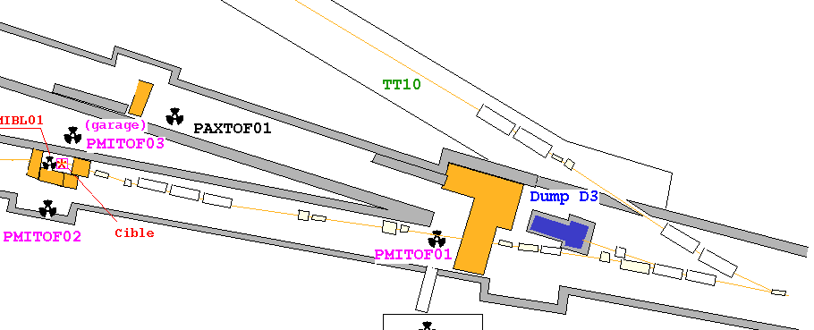

TT2A

TT2

Figure 1. Schematic view of the area around the dump D3. The dimensions of the shielding walls are not to scale. The PAX and the PMI symbols indicate the position of the installed radiation monitors.

TT10
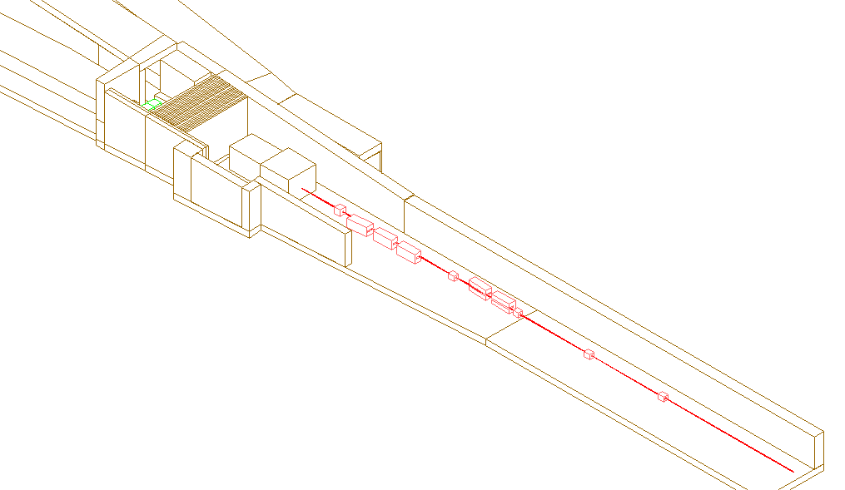
TT2A

D3

4133 cm

6500 cm
2388 cm

4053cm

5182 cm

Figure 2. Overview of the TT2 area as simulated with FLUKA. The arrows indicate hypothetical beam loss points along the vacuum pipe. The indicated distances are the distances between the various beam impact points and the front face of the dump D3. All FLUKA geometry pictures presented in this paper were produced by using the programme FLUKACAD [3].

The average beam intensity is based on the SPS cycle length of 14.4 s. Over this period one AD pulse (1.1x10¹³ p) and two TOF pulses (20.6x10¹³ p) were assumed to be lost, in order to reproduce the real experimental conditions (see below). Since no precise information on the beam size was available, the simulations were performed using a pencil beam at the various interaction points. This is a sufficiently good approximation for the purpose of the present study.

Seven hypothetical loss scenarios were considered. The first scenario simulates a beam loss occurring more than 100 m upstream of dump D3. This beam loss location enables the beam to miss the dump D3, as shown in Figure 3. Although this scenario seems unlikely, it represents the worst possible accident condition. No interaction with the pipe wall material and the air was taken into account in these calculations. Approximately 13% of the beam particles undergo a hadronic interaction with the air molecules in a path length of 100 m, but this effect can be neglected for the purpose of the present calculations. The energy loss by ionisation in 100 m of air is negligible.

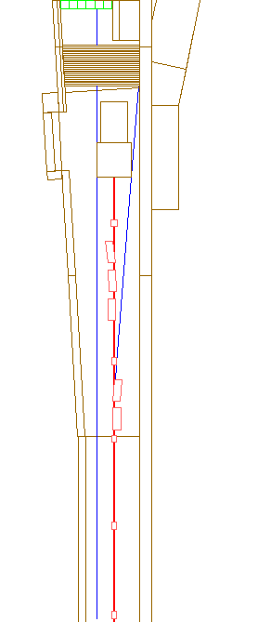
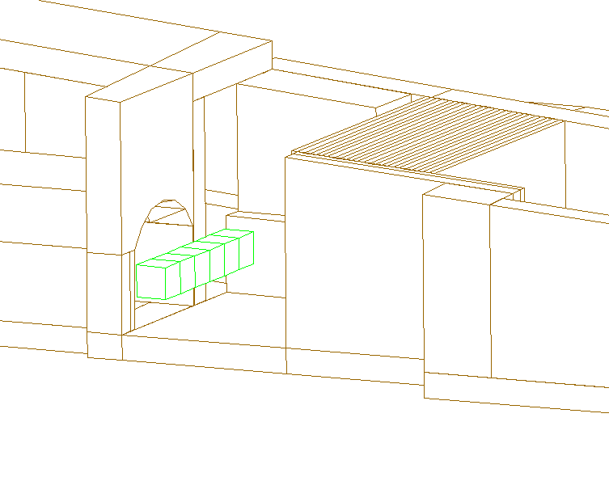

1
6

Detector
string
USRBIN detector
Beam loss directions

Figure 3. Detectors used in the Monte Carlo simulations. The picture on the left shows the two directions of the mis-steered beam hitting the wall on the left and on the right of dump D3.

In a second loss scenario a malfunction of the magnets, which normally bend the protons towards TT10, was assumed. Due to such a malfunction the beam misses the dump and directly hits the wall (see Figure 3). Furthermore, five other cases in which the beam hits the wall of the vacuum pipe at a very grazing angle were simulated. The beam loss points investigated are located upstream of D3 at the following distances from the front face of the dump: 23.88 m, 40.53 m, 41.33 m, 51.82 m and 65.00 m (Figure 2).

In order to tally particles reaching the area of interest, six detectors (labelled with indices 1 to 6 in Figure 3) each of volume of 1 m³ were positioned at the beginning of the TT2A tunnel, a few metres downstream of the shielding wall. For the scenarios in which the beam hits the wall unshielded, particle detectors, covering the whole backside of the separation wall, were used (called USRBIN in Figure 3).

Depending on the beam loss situation, either shower particles originating from interactions inside the wall or muons, produced via pion or kaon decay, form the dominant part of the radiation field behind the separation wall. These effects require different simulation procedures and thus two types of calculations were performed.

Simulation of the muon-induced radiation

In order to generate a sufficient number of muons, the decay lengths of all possible parent particles of muons were artificially shortened. To compensate for this artificial decay length, the statistical weight of the produced muons was adapted automatically in FLUKA. To obtain a reduction of the simulation time, all stable particles reaching a kinetic energy below 100 MeV were killed. In this simulation only the dose caused by muons was taken into account.

Simulation of the electromagnetic- and hadronic shower-induced radiation

The simulation procedure concerning the radiation caused by shower particles, generated inside the shielding wall, differs from the muon radiation calculation discussed above. In order to increase the number of particles traversing the wall, importance biasing was implemented. The lower transport energy threshold for electrons and positrons was set to 200 keV. Photons produced in the simulation were tracked until they reached an energy of 100 keV, whereas neutrons were followed down to thermal energies. All other charged particles were tracked until they reached energies of 100 keV.

In both simulation procedures the particle fluences were folded with energy- and particle-dependent fluence-to-dose conversion factors [4] to provide dose equivalent values.

For calculating the radiation exposure caused by a beam impact in the vacuum pipe, a combination of both simulation procedures was used. Muons, mainly produced by pions and kaons decaying outside the wall, were calculated using procedure 1, whereas dose contributions from particles other than muons were calculated via procedure 2. The simulations regarding direct impact of the beam on the wall used only procedure 2 to calculate the dose equivalent level behind the wall.

Results

Radiation caused by a direct beam impact onto the wall

Two scenarios define the accident triggered by a direct loss of the beam into the wall. On the one hand, the beam impacting on the wall on the left hand side of the dump is due to protons lost far upstream in TT2. Interactions in the pipe material and in the air, between the beam exit point from the pipe and the impact point on the wall, were neglected. Although this scenario is purely hypothetical, in terms of radiation protection it represents the worst possible accident in the area. On the other hand, a beam loss on the right hand side of the dump can be caused by a malfunction of one of the magnets bending the beam towards TT10. This is an example of a possibly more realistic scenario.

Figure 4 shows the radiation levels in TT2A behind the shielding wall separating TT2A from the area around the dump in TT2. The figure on the left shows the radiation level that would be caused by the beam impacting on the wall on the left hand side of the dump. The dose equivalent around the beam axis behind the wall would reach 250 mSv within one single super-cycle. Although this value is very localised, it would obviously be unacceptably high.

In case the protons are lost due to a malfunction of one of the magnets bending the beam into TT10, the beam hits the wall on the right hand side of the dump. This scenario is similar to the one previously described. The difference is that the highest dose equivalent rate would now be located in a more inaccessible area. Nevertheless, the radiation level in all accessible areas behind the wall would still be far too high.

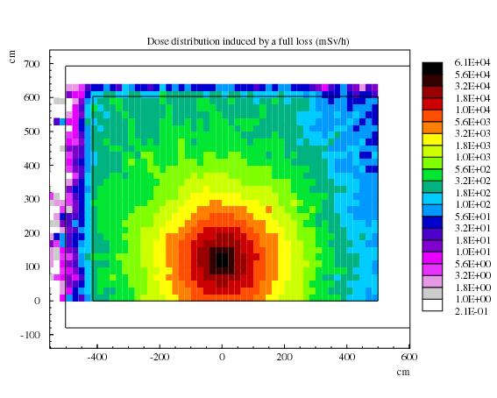
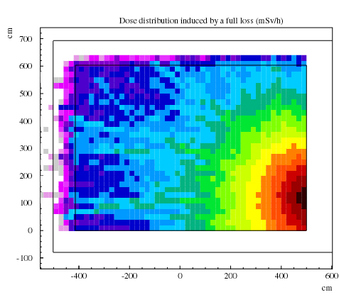

Figure 4. Radiation levels obtained behind the separation wall. The picture on the left shows the dose equivalent rate obtained if the beam hits the separation wall on the left hand side of the dump D3. The figure on the right shows the dose equivalent rate in case the beam is lost due to a malfunction of one of the TT10 bending magnets.

The dose in the detector string (see Figure 3) located about 5 m behind the wall is shown in Figure 5 and Figure 6. If the beam hits the wall on its left hand side, the dose equivalent rate could exceed 1 Sv/h (Figure 5). Here neutrons are the dominant component. Protons, pions and photons produced inside the wall represent the second largest contribution to the radiation field. In an accidental condition of a direct beam loss in the wall, the muon contribution plays only a minor role. This is because pions, which are produced inside the wall by hadronic cascades, cause further hadronic collisions. Therefore, most of them do not have time to decay to muons.

In case the beam hits the wall on the right hand side of the dump, the radiation in the detector string is much lower than in the scenario described above (see Figure 6). Since the detector string is well shielded against the main radiation source, which is located along the beam axis (Figure 3, left), the dose equivalent in this region is comparatively low. Neutrons are the main contributor to the dose equivalent; the contribution of other particles is more than a factor of 10 lower.

Figure 5. Radiation levels in the detector string (in front of TT2A) in case the beam would hit the wall on the left hand side of the dump.

Figure 6. Radiation levels in the detector string (in front of TT2A) in case the beam would hit the wall on the right hand side of the dump.

Radiation caused by a beam loss in the TT2 vacuum pipe

If the beam is lost in the beam pipe, the situation is very different from the above scenario. The beam is assumed to hit the pipe at a very grazing angle. Due to this small angle, most of the protons entering the pipe material perform a hadronic interaction. In these interactions pions and kaons are also produced, most of which leave the pipe material without making further hadronic interactions. Depending on their energy and the position from where they leave the pipe, a certain number of them decay into muons.

Figure 7 shows the radiation level in the detector string. These results correspond to the five impact positions of the beam along the beam line as shown in Figure 2. The graph representing the dose equivalent rate caused by a beam impacting 2380 cm upstream of the front face of the dump shows that muons dominate only in detectors 1 and 2. The other detectors are fully or partly shielded by the magnets and by the dump, which are located between the primary interaction point and the wall; the higher the detector number, the lower the dose contribution from muons.

The further upstream the loss point in the pipe, the smaller the “shadowing effect” of the dump and the magnets. This effect can be observed in the increasing muon dose equivalent rate in the first four detectors (especially in detector 4) with increasing distance between the loss point and the dump. Only the 5th and the 6th detector of the string are always fully shielded by the dump. The contribution to the radiation exposure of particles, other than muons, is fairly constant in all six detectors.

From the above results one can draw the following conclusion. If there is no shielding material, the radiation exposure behind the wall is dominated by muons. The dump, consisting of a thick iron core surrounded by 80 cm of concrete on all sides, the shielding wall and part of the dipole magnets provide enough shielding to stop most of the produced muons. On average 0.7 m of iron is needed to reduce the muon energy by 1 GeV. The majority of muons produced by decay do not have energies higher than a few GeV, such that they are completely stopped in the D3 dump.

If the beam loss is caused by a failure of the corrector magnet, a combination of the scenarios presented here best describes the real situation. Depending on the size of the beam and on the bending power of the corrector, a possible scenario is the following: the beam is assumed to be bent upwards. Due to the lateral extension of the beam, not all particles enter the pipe wall at the same position. If the bending power of the corrector is weak, the first interactions occur close to the dump and some of the protons interact with the dump without hitting the beam pipe. In case the corrector provides a stronger bending power, the first interactions with the pipe occur far upstream. This increases the radiation contribution of muons on the other side of the wall. Since the real beam extension is not infinitely small, the misguided beam essentially provides a line source along the beam pipe. Depending on the strength of the magnetic field, all or only a part of the proton beam interacts with the pipe. The rest hits the dump without contributing to the dose equivalent behind the wall. In most of the simulated scenarios the muons represent the main contribution to the radiation field in the first four detectors of the string. Therefore, the line source scenario will also be dominated by muons if the first interactions occur at a distance at least 40 m upstream of the dump.

Measurements

Several weeks after the incident mentioned in the introduction, the PS operating team attempted to reproduce the anomaly that caused the beam loss. Several passive and active radiation detectors were deployed across TT2A to monitor the dose equivalent rate and determine the dominant radiation components, namely: an argon-filled high pressure ionisation chamber to detect photons, muons and high-energy charged particles, a rem ion chamber for neutrons up to about 15 MeV, a plastic scintillator to detect hadrons of energy above ~20 MeV via ¹¹C production, and ⁶LiF and ⁷LiF thermoluminescent dosimeters inside polyethylene moderators to discriminate the fast neutron and photon components.

D = 23.88m
D = 40.53 m

D = 41.33 m
D = 51.82 m

D = 65.0 m

Figure 7. Dose levels seen in the detector string (in front of TT2A) in case the beam hits the beam pipe at the labelled distances (D) to the dump.

It was found that beam mis-steering by the corrector, which is positioned approximately 100 m upstream of D3, caused the beam to exit the vacuum chamber. The actual location where the beam centre exits the chamber corresponds with the second dipole bending the beam to TT10 (the component located 2388 cm upstream of D3 in Figure 2). Under these conditions the radiation monitors in TT2A indicated a dose equivalent rate of approximately 30 mSv/h, split in the ratio 2/3 due to low-LET radiation (that is, muons) and 1/3 to neutrons. If we compare this result with our simulations we can conclude as follows: the beam centre crosses the vacuum pipe at the location corresponding to the loss point simulated in the scenario shown in Figure 7, top left. Since the beam has a lateral extension, about half of the protons interacted with the wall of the vacuum chamber well upstream of this point. The interactions, which are distributed over several tens of metres upstream, contribute to the dose equivalent rate with 2/3 of muons and 1/3 of neutrons (Figure 7). The other half of the primary particles interact either with the vacuum chamber downstream of this point or with the dump. Due to the shadowing effect of the dump discussed above, the contribution to the dose equivalent rate of these interactions is negligible. With the results presented in Figure 7 and the fact that only 50% of the primary particles contribute to the radiation behind the wall we can conclude that the simulated dose equivalent rate is 30 – 40 mSv/h. This result is in very good agreement with the measurements.

Conclusions

Several hypothetical beam loss scenarios of the PS beam in TT2 were investigated by Monte Carlo simulations. Although the geometry of the area and the beam parameters were not precisely known, the results provide a sufficiently clear picture of the radiological situation following various potential accidental conditions. A full beam loss directly into the shielding wall on the left hand side of the dump, although hypothetical, would represent the worst possible accident and generate the highest dose equivalent rate in the upstream end of the TT2A tunnel. One single pulse would be sufficient to deliver a dose equivalent largely exceeding 15 mSv, which is the annual limit for occupationally exposed workers at CERN. A beam loss in the vacuum pipe at various distances upstream of the wall would also cause too high radiation levels in TT2A. The dose equivalent is dominated by either muons, mainly originating from pion decay, or neutrons produced in hadronic cascades inside the shielding wall, depending on the point where the beam is lost. The predictions of the Monte Carlo simulations are in good agreement with experimental results obtained under a well defined loss condition.

The first action that followed the incident described above was to implement a new interlock condition. With TT2A in access condition and presence of beam in TT2 (i.e., beam transferred to TT10, to the AD and/or dumped in D3), a radiation monitor was interlocked to the beam in TT2. In case of abnormal radiation level due to beam mis-steering, beam extraction from the PS was inhibited. After the present study, no access is now allowed in TT2A when beam present in TT2, until a detailed risk analysis has been performed to prove that none of the worst case scenarios here described can occur.

Acknowledgements

The authors wish to thank André Muller of the CERN Radiation Protection group for the measurements.

References

[1] A. Fassò, A. Ferrari, P.R. Sala, Electron-photon transport in FLUKA: status, Proceedings of the Monte Carlo 2000 Conference, Lisbon, 23-26 October 2000, A. Kling, F. Barao, M. Nakagawa, L. Tavora, P. Vaz eds., Springer-Verlag Berlin, pp. 159-164 (2001).

[2] A. Fassò, A. Ferrari, J. Ranft, P.R. Sala, FLUKA: Status and Prospective for Hadronic Applications, Proceedings of the Monte Carlo 2000 Conference, Lisbon, 23-26 October 2000, A. Kling, F. Barao, M. Nakagawa, L. Tavora, P. Vaz eds., Springer-Verlag Berlin, pp. 955-960 (2001).

[3] Helmut Vincke, FLUKACAD/PIPSICAD: Three-dimensional interfaces between FLUKA and AutoCAD, Proceedings of the Fifth Workshop on Shielding Aspects of Accelerators, Targets and Irradiation Facilities (SATIF 5), Paris, 18-21 July 2000, NEA/OECD, pp. 361-370, 18-21 July 2000 (2001).

[4] M. Pelliccioni, Overview of fluence-to-effective dose and fluence-to-ambient dose equivalent conversion coefficients for high energy radiation calculated using the FLUKA code. Radiat. Prot. Dosim. 88, 279-297 (2000).

