Summary of the New SC Coils
X. Ding
(Aug. 16, 2010)

- Study II SC Coils

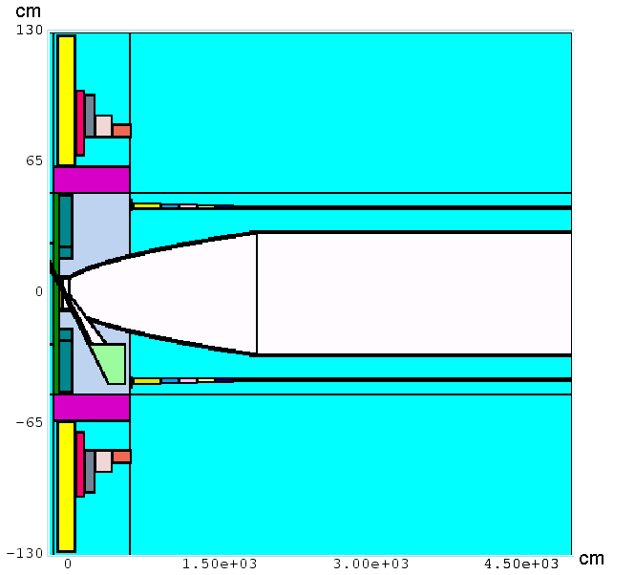

- New SC Coils and EB field

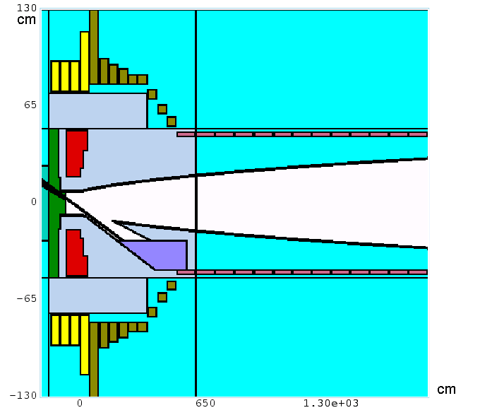

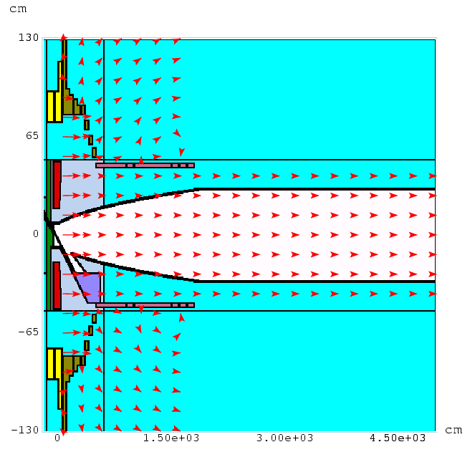

- Meson Production

At 8GeV protons and 100000 events

 | Mesons
Study II SC Coils | 28758
New SC Coils | 22627

- Energy Deposition

New SC Coils | Power dep. on  SC #1-4, kW | Power dep. on  SC #5-13, kW | Power dep. on  SC# 14-26, kW | Total on SC #1-26, kW
Standard (80%WC+20%Water) | 8.535 | 3.488 | 10.545 | 22.568
Enhanced  (80%WC+20%Water) | 1.1845 | 0.426 | 10.035 | 11.6455
Standard  (pure W) | 8.195 | 2.4525 | 10.35 | 20.9975
Enhanced  (pure W) | 0.717 | 0.17 | 10.3 | 11.187

Study II SC Coils | Power dep. on  SC #1, kW | Total power dep. on  SC #1-13, kW
Standard (80%WC+20%Water) | 24.905 | 36.13
Enhanced  (80%WC+20%Water) | 8.595 | 16.775
Standard  (pure W) | 21.055 | 31.415
Enhanced  (pure W) | 6.345 | 14.05

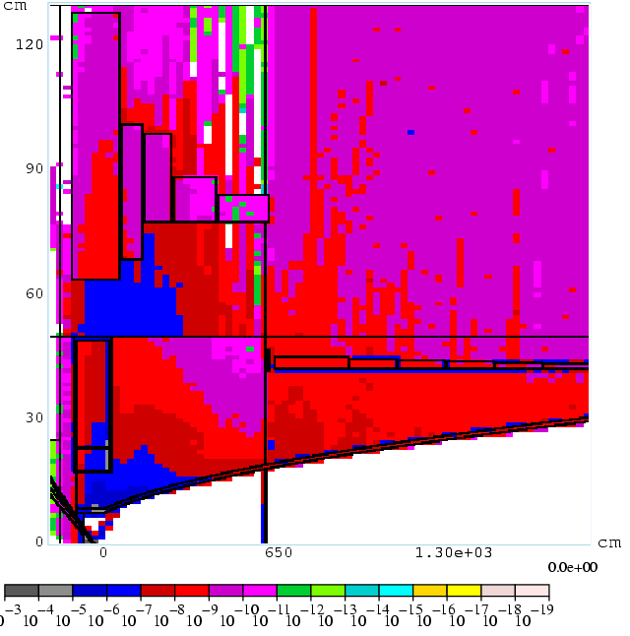

(Study II – Standard Geometry, WC shielding)

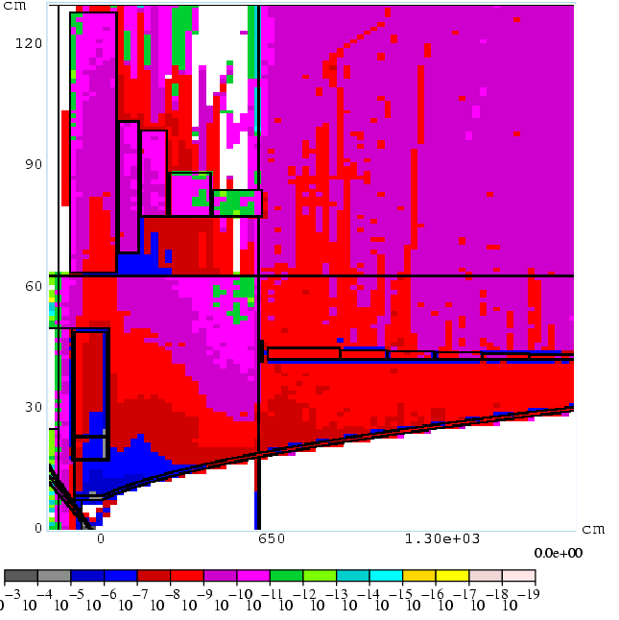

(Study II – Enhanced Geometry, WC shielding)

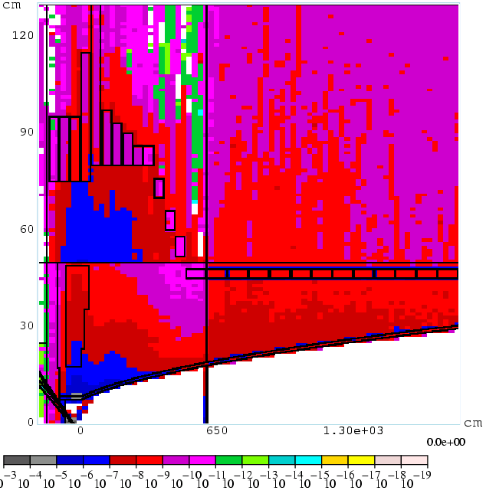
(New Coils – Standard Geometry, WC shielding)

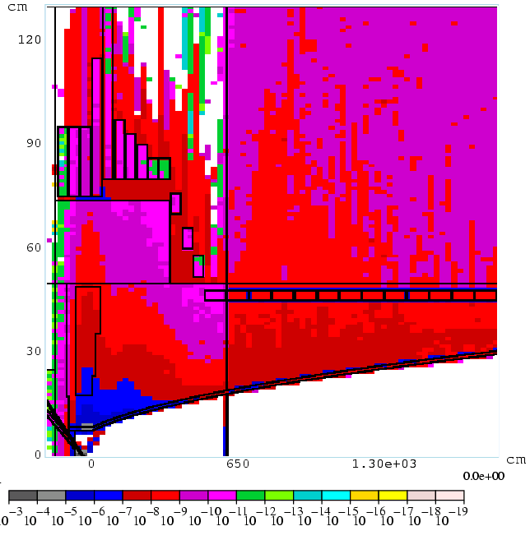
(New Coils – Enhanced Geometry, WC shielding)

