E951 15T Pulsed Magnet for Mercury Target Development
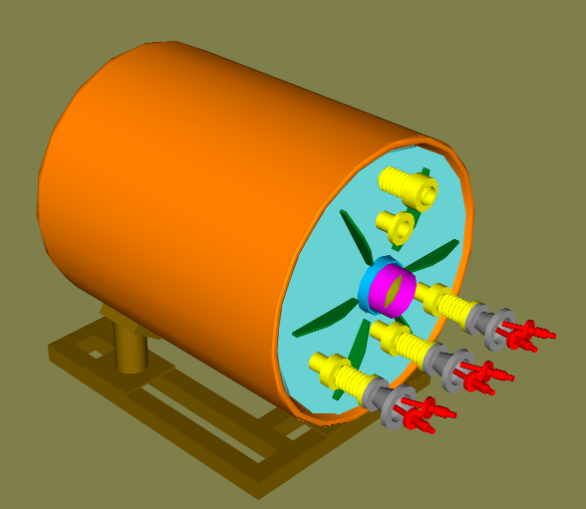
BNL Pulsed Magnet –Inertially Cooled , 30K He Gas Cooled Between Shots
Neutrino Factory and Muon Collider Collaboration

2002

Peter H. Titus
MIT Plasma Science and Fusion Center
(617) 253 1344, titus@psfc.mit.edu, http://www.psfc.mit.edu/people/titus

BNL pulsed magnet design builds off of copper magnet experience in fusion research:
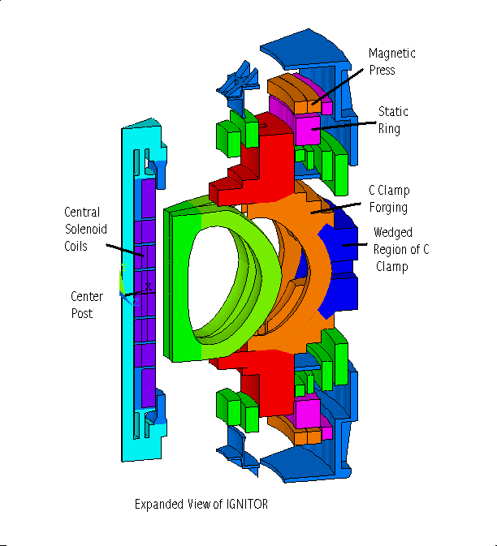
IGNITOR – Snowmass Review. - Inertially Cooled Copper , 30K He Gas Cooled Between Shots.
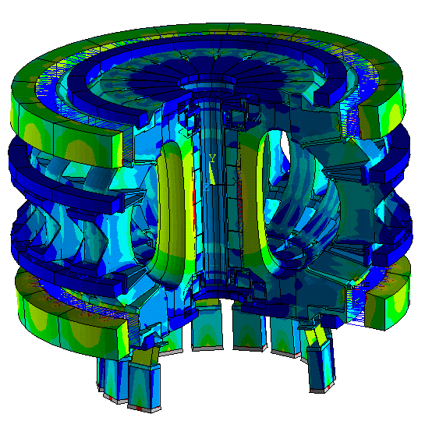
FIRE – Preconceptual Design and Snowmass Review. Inertially Cooled Beryllium Copper , LN2 Cooling Between Shots, with a Helium Purge to Limit Activation.
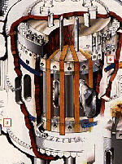
Alcator C-Mod. MIT-PSFC operating Tokamak –Inertially Cooled, LN2 cooled between shots.

The Purpose of the Experiment is to Study Mercury Targets for Neutrino Beams and a Muon Collider Source
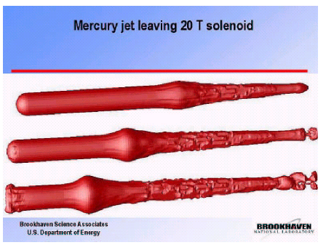
Simulations of the Mercury Jet interactions with the
magnetic field, and proton beam.

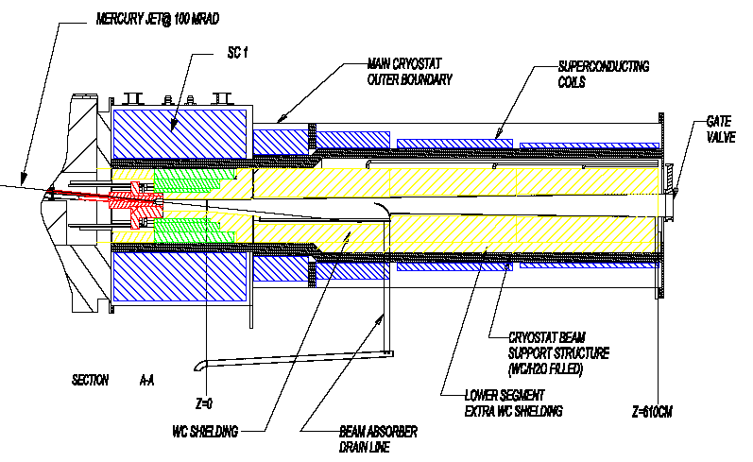
The Neutrino Factory
SC-1 could be the ITER CS Model Coil

Cost issues dictate a modest coil design.
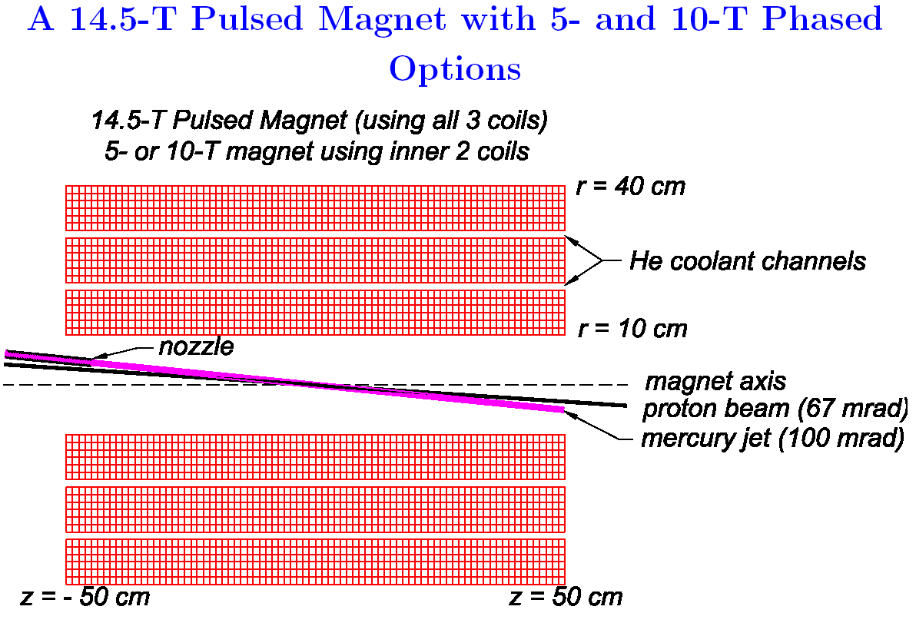
Power supply limitations dictate a compact, low inductance, high packing fraction design.

A three segment, layer wound solenoid is proposed for the pulsed magnet.

Phased manufacture is supported. The third segment may be purchased and installed in the cryostat later

The conductor is half inch square, cold worked OFHC copper.

The coil is inertially cooled with options for liquid nitrogen or gaseous Helium cooling between shots. Coolant flows through axial channels in the coil.

For the same packing fraction, a hollow conductor would have a 1.4mm diameter hole

The coil will be epoxy impregnated. Wound coils of this small radius, using cold worked conductor, retain internal elastic stresses from the winding process, and if not impregnated, require elaborate clamping mechanisms to have the coil retain it’s shape.

Bob Weggel has performed the coil/power supply simulations. He has picked operating temperatures, and basic coil build.

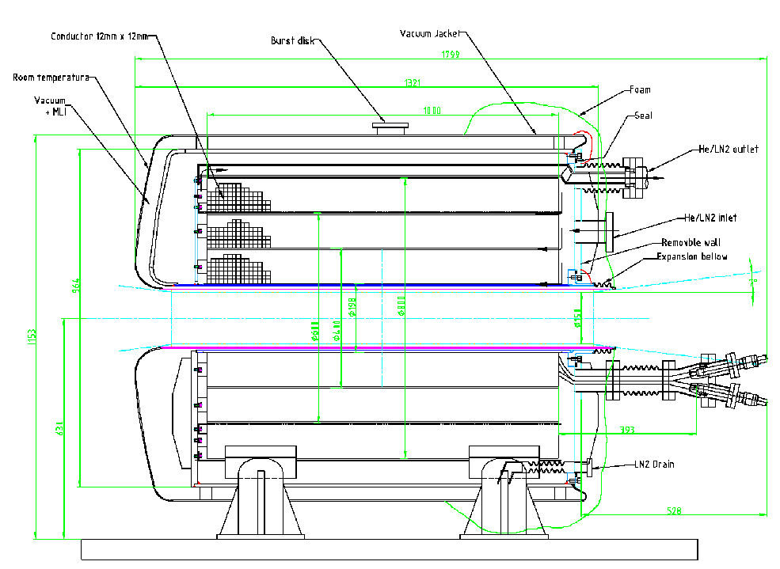


Proposed Operational Scenarios
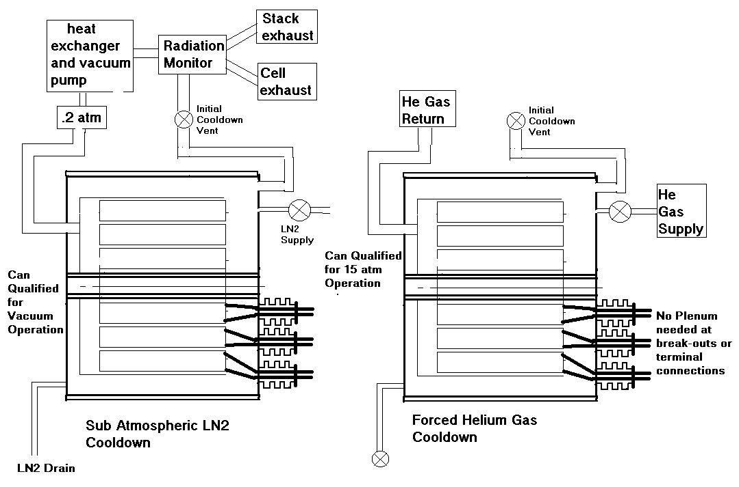
Helium-Liquid Hydrogen Heat Exchange System

The coil and cryostat are designed for two cooling modes and three fields

Case # | Peak Field | Coolant | T after pulse | T coolant | Start Bulk Temp
1 | 5T | Helium Gas | 90K | 66K | 84K
1a | 5T | LN2 | 90K | 66K | 84K
2 | 10T | Helium Gas | 96K | 66K | 74K
2a | 10T | LN2 | 96K | 66K | 74K
3 | 15T | Helium Gas | 78K | 22K | 30K
The Test Cell is near the Meco Experimental Area. The cell is already set up. It was used in a previous Mercury jet experiment that did not have a background field.
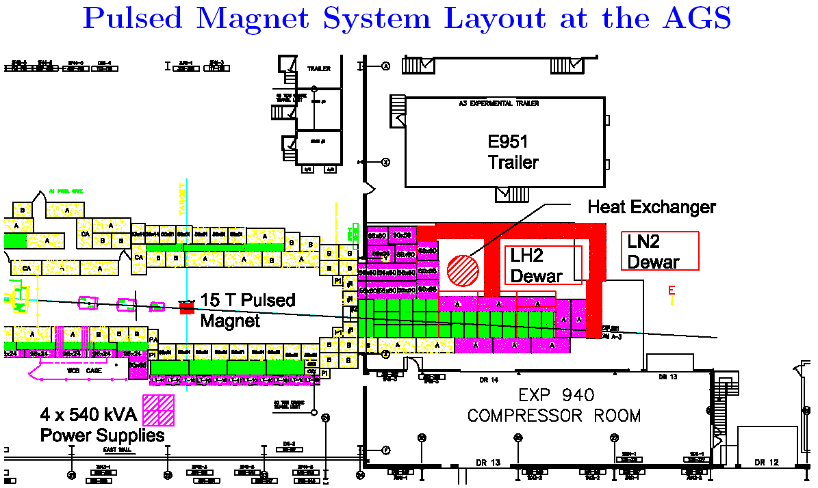
Coil Builds used in the finite Element Models:
# | r | z | dr | dz | nx | ny
1 | .15 | 0 | .098 | 1.0 | 16 | 16
3 | .25 | 0 | .098 | 1.0 | 16 | 16
5 | .35 | 0 | .098 | 1.0 | 16 | 16
Coil Description:
 | Mode 1 | Mode 2 | Mode3
Number of Segments operating: | 2 | 2 | 3
Number of turns per segment | 624 | 624 | 624
Total number of turns active | 1248 | 1248 | 1872
Layers in each coil segment | 8 | 8 | 8
Turns per layer | 78 | 78 | 78
Conductor radial thickness | .0116698 m .45944 in | .0116698 m .45944 in | .0116698 m .45944 in
Conductor Axial thickness | .012516m .49274359 in | .012516m .49274359 in | .012516m .49274359 in
Max Operating Field Bore CL | 5T | 10T | 15.0T
Max Field at Magnet
Max Terminal Current | 3600A | 7200A | 7200A
Coolant Working Fluid | 77K LN2 | 65K LN2 | 30 K Helium Gas
Terminal Voltage | 150V | 300V | 300V
Layer to Layer Volts | 18 | 36 | 24
Turn-to-Turn Volts | 0.12 | 0.24 | .16
Design Life |  |  | 1000 full power pulses
Cryostat Pressure -Initial Operating |  |  | 15 atm
Cryostat Pressure – During Cooldown |  |  | 20 atm max
Number of .54 MVA power supplies | 1 | 4 | 4
Mode of Ganging Supplies | None | 2 X 2 | 2 X 2
Charge Time | 7.2 sec | 6.3 sec | 15.3 sec
Initial Temperature | 84K | 74K | 30K
Temp Rise | 5.8K | 21.7K | 48.3K
Final temperature |  |  | 78.3
Cumulative heating at end of pulse | 2.7MJ | 9.1MJ | 15.2MJ
Structural Design Criteria

Lacking a specific design code jurisdiction, fusion project criteria are used for guidance in coil design

The referenced FIRE design document allows the primary membrane stress to be based on the lesser of 2/3 of the Yield Strength (Sy) or ½ of the Ultimate Strength (Su). The ASME Code bases the primary stress on 1/3 ultimate. The fusion project based criteria is based on a distinction between coils that are supported by cases and those that are not.

For structural elements ASME -like criteria are adopted with membrane stresses remaining below the maximum allowable stress, Sm, where Sm is the lesser of 2/3*yield or 1/3 ultimate.

Bending discontinuity, and secondary stresses are treated in a manner similar to the ASME Code.

Guidance for bolting and column buckling is taken from AISC, with average net section bolt stresses kept below 0.6*yield. Yield Strength and Tensile Strength properties are taken at the loaded temperature.

The cryostat and vacuum jackets are to be qualified and manufactured in accordance with ASMEVIII. The pressure boundary components for the pulsed magnet assembly are close enough to ASME, that these components could be stamped, However it is recommended that ASME VIII be invoked, that a shop with a stamp be utilized, but that the cryostat and vacuum jacket not be stamped.

The magnet is to be seismically qualified in accordance with the (Uniform Building Code?).

Coil Stress Analysis
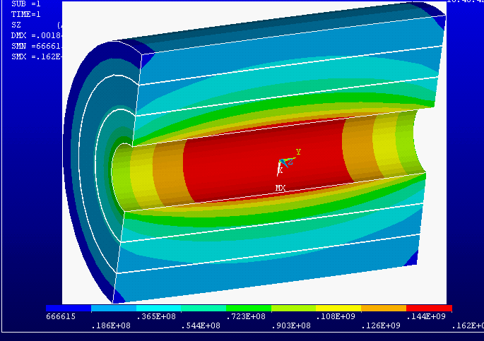
Hoop Stress, all coil segments fully energized. The Von Mises stress plot is similar with a peak of 165 MPa, Tresca is 166 MPa.
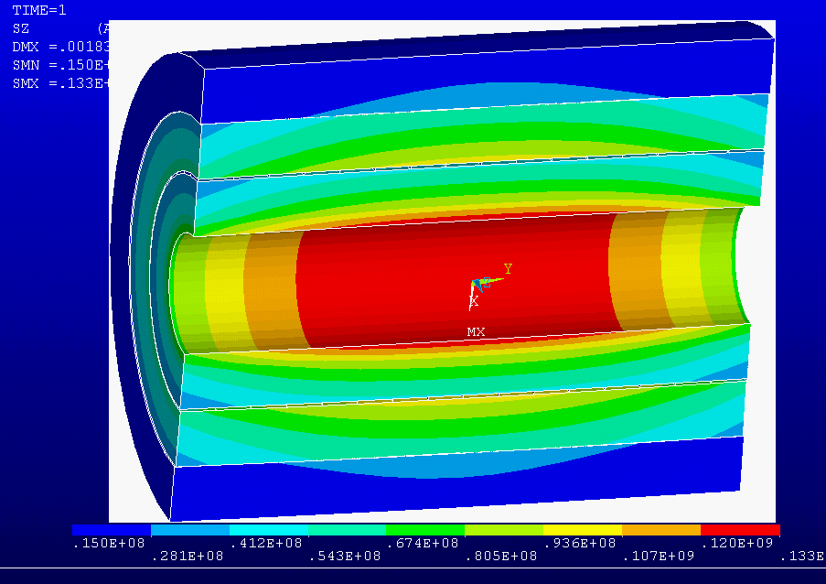
Re-run with gap elements the hoop stress went down to 133 MPa
The full performance configuration is limiting in terms of hoop stress and equivalent stress. It also has some radial stresses that will have to be mitigated with parting planes at the segment boundaries, or within the winding.

In the initial operating mode the outer coil segment is not energized. This induces some differential Lorentz forces and differential temperatures, that cause shear stresses between segments.

Conductor Allowable and Cold Work Spec

For Fusion magnets the inner skin of the solenoid is allowed to reach the yield - Treating this stress as a bending stress with a 1.5*Sm allowable with Sm based on 2/3 Yield.
Interpolated values:, Work hardened copper-, OFHC c10100 60% red
temp deg k | 77 | 90 | 100 | 125 | 150 | 200 | 250 | 275 | 292
yield | 374 | 369. | 365. | 356. | 347. | 328. | 317. | 312. | 308.
ultimate | 476. | 466. | 458. | 439. | 420. | 383. | 365. | 356. | 350.

If the highly cold-worked copper is chosen for the winding, the conductor allowable near the inside radius of the coil would be 365MPa. The max stress in the three segment coil is 166 MPa. With this stress level, it is expected that half hard copper could be used, simplifying the winding process.

Half hard copper may still be too difficult for the Inner coil winding radius.

Planned Analysis:

Elastic-Plastic analysis of the tight radius bending operation to see if this introduces sufficient cold work to satisfy the stress allowables. H/2/R is 6% at the ID turn of the inner magnet section

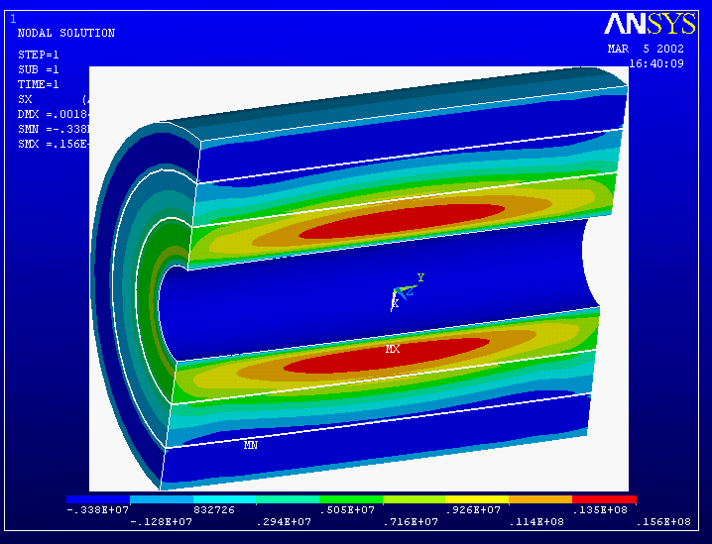
There is about an MPa of tension at the boundary between the first and second module. To avoid damage to the channel ligaments, a parting plane will be incorporated in the channel detail. This needs to occur in the ligament to retain thermal connection with the coolant in the channel.
Radial Tension Stress, All Coils Fully Energized.
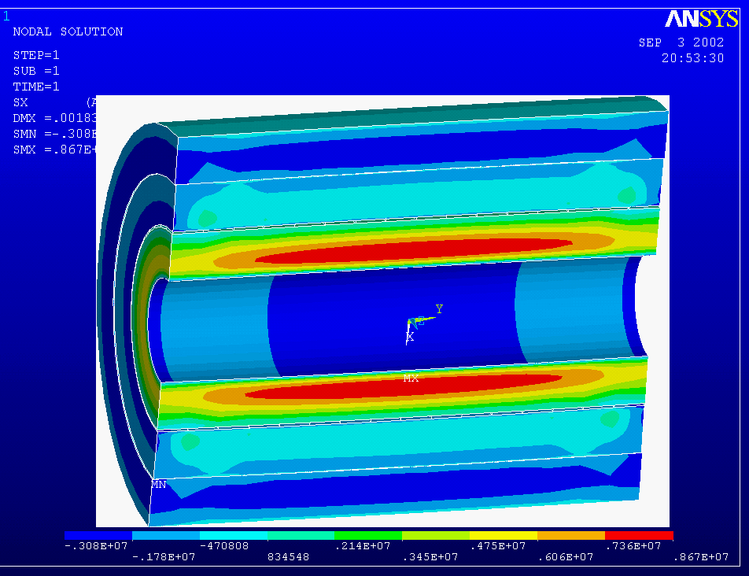
Radial Tension in the winding of the first segment is reduced by about
A half with gap elements modeling the interactions of the three coil
Segments.

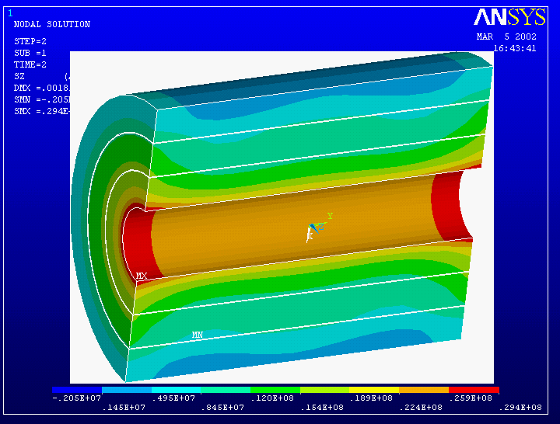

Operating Mode 2, 10T

Hoop Stress
With only the Inner Two Segments Energized.

Peak Hoop Stress is Only 29.4 MPa

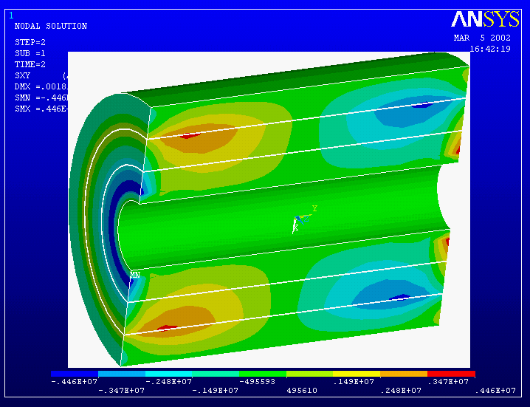
This is a peak at the interface between the second and third modules. It must be
carried across the thin ligaments between the channels, or relieved via a slip
plane.

Operating Mode 2, 10T

Smeared radial-axial shear stress with the inner two segments energized.

Channel Ligaments would be too weak to support this – Slip Planes are Used.
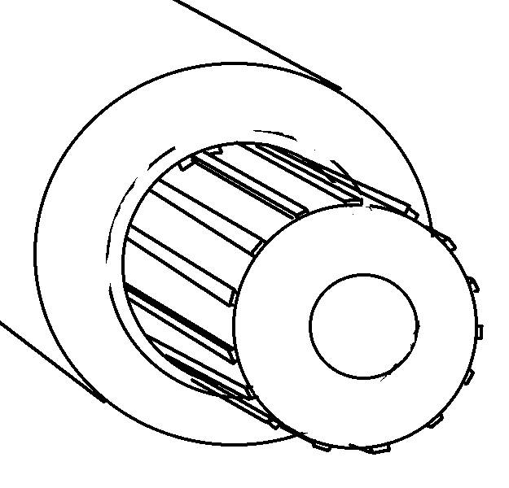
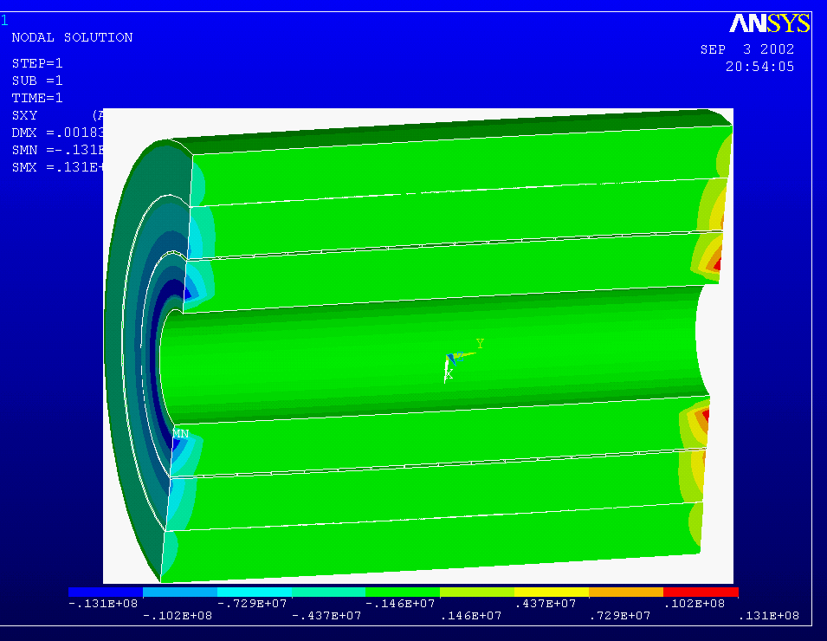
With gaps modeling the interfaces between segments, only
Inner segment shears remain.
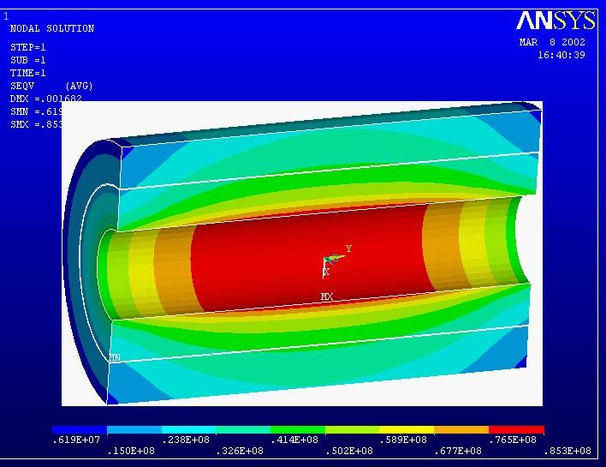

Von Mises Stress
Operating Mode 2, 10T

Outer Segment Not Yet Installed

The max stress for this case is 85.3 MPa, which is a bit more than with the outer segment in place, but less than for the fully energized three segment coil

Operational Thermal Stresses.

Although a constant current density coil, heat-up during a pulse is not uniform due to the magneto-resistive effects.
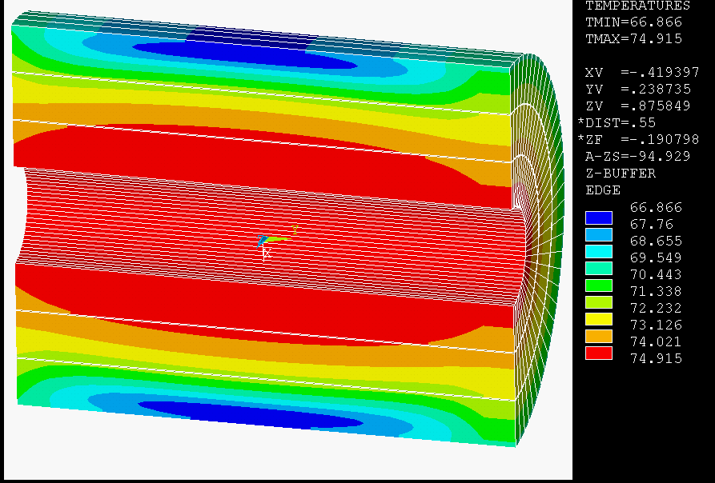
Temperatures with magneto-resistive effects, 15.0T

Temperatures were calculated for the 15 sec ramp-up, and 2 sec flat top and a 7 sec ramp down. The NIST Kohler plot and fitted equation was used for the magneto-resistance.

In my calculations, the temperatures were low compared with Bob Weggel’s. The difference was the conservatism the Bob applied to his analysis from the scatter of the Kohler plot.

To make some progress on the stress calculations I stretched the time scale to come closer to Bob’s temperature distribution.

The stresses from this analysis are small, less than 5 MPa.
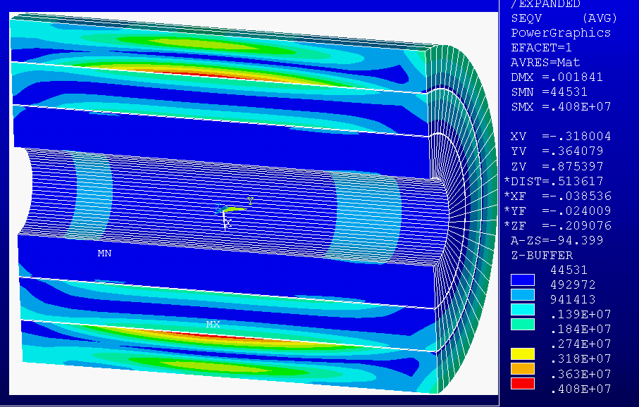
Resulting VonMise Stresses due to Temperature including the magneto-resistive effects, 15.0T.
Cooldown Stresses –Von Mises
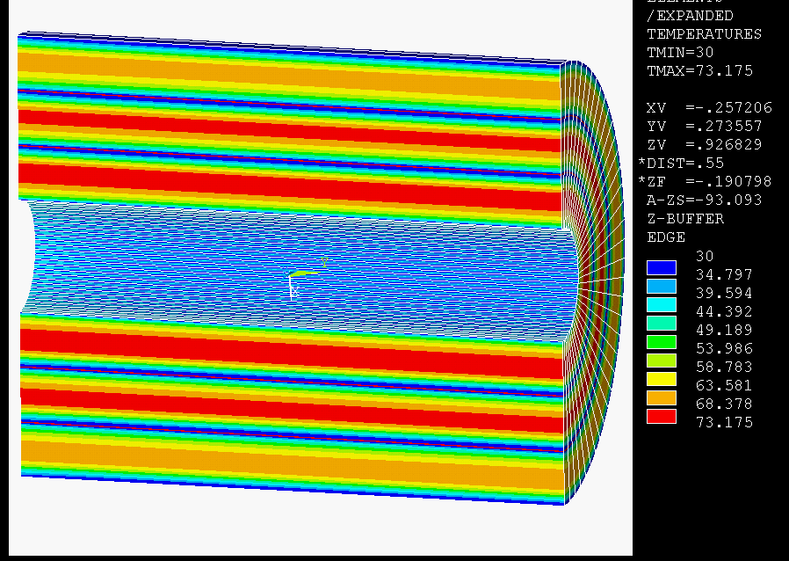
Cooldown Temperature distribution
The channels were held at 30K and the temperature distribution was obtained by averaging nodal temperatures with the final temp distribution from the heat-up calculations. This is not rigorous, and is essentially assumed, but it is representative of temperature distribution, and will serve to provide guidance for further analysis and design.

The VonMises stress is relatively modest, at 43MPa

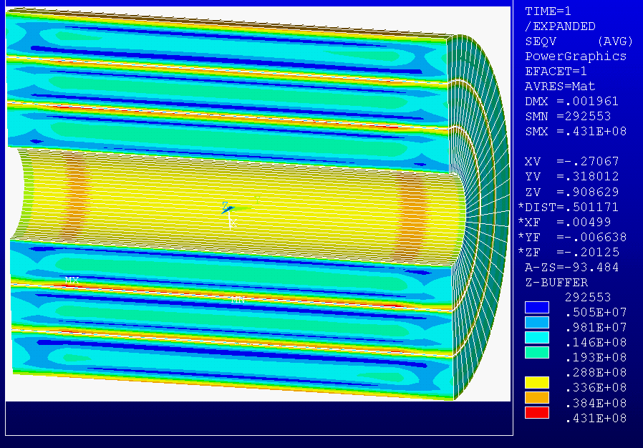
“Smeared” VonMises stress

Cooldown Stresses –Shear and Axial Tension
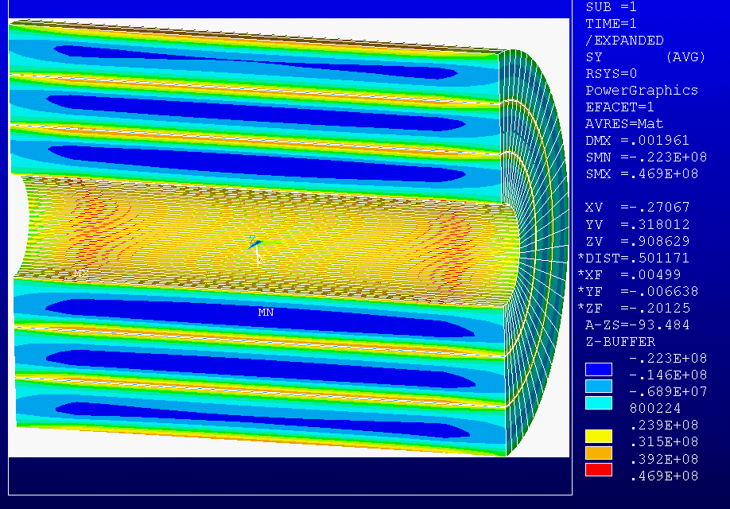
Axial tension

The axial tension near the channels is approaching 50 MPa, beyond the design capacity of epoxy bonded systems. Some provision will have to be made to either throttle the cooling gas to limit the channel temperature or design to allow the bond failure.

The shear stresses that peak at 7MPa are within the usual allowables for insulation systems, for which design allowables are in the range of 15 to 30 MPa (with no aid from compression)
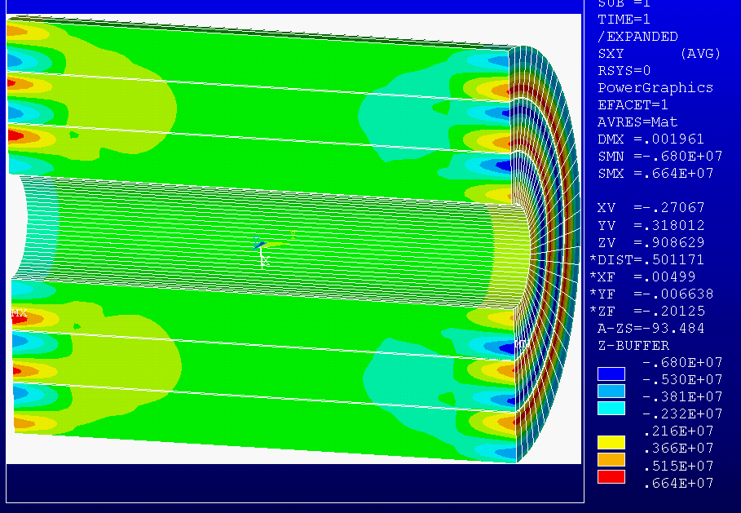
Shear stresses due to the cool down temperature distribution

The Axial Tension will be relieved with Kapton “Arcs” every eighth turn.
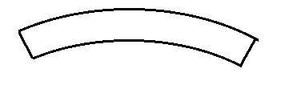
Cooldown Stress, Global Thermal Differential.

If there is stratification of He gas or if LN2 floods the bottom of the cryostat there could be a significant thermal differential between top and bottom of the coil. A 77 to 100 K variation is assumed. The resulting 15 MPa stress is Acceptable
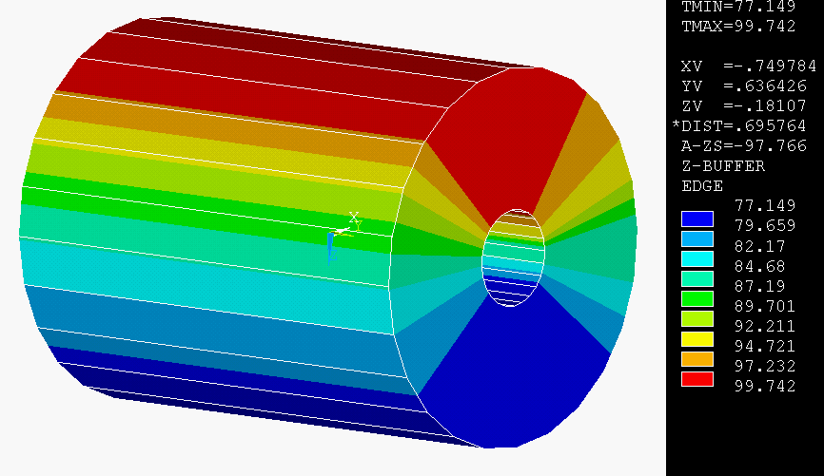
Assumed temperature variation

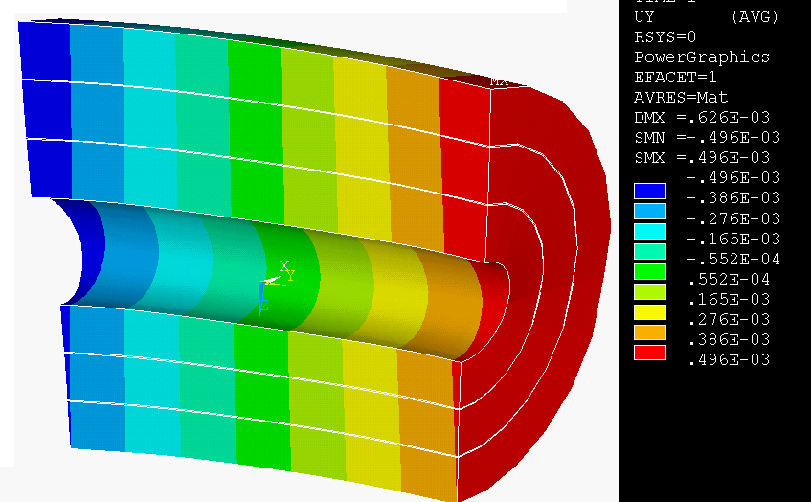
Resulting Displacements
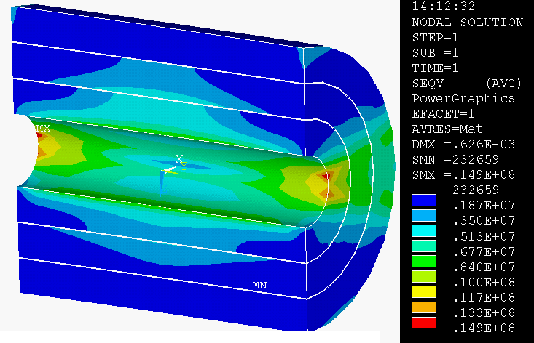
Eddy Current Temperatures – A Non-Problem
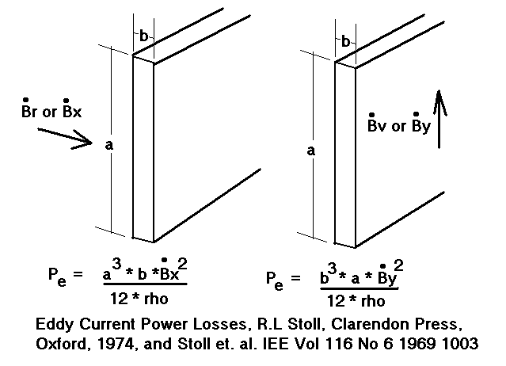
Power is in Watts/m for dimensions in meters, rho in ohm-m, and B-dot in Tesla/sec. Note that the strip orientation is actually advantageous for resisting eddy currents resulting from the vertical field.
Transient fields induce eddy currents in the conductors as well as in the cryostat plates. This has been investigated for a strip wound solenoid used for FIRE, a fusion experiment. Eddy current heating has been evaluated for the BNL pulsed magnet using the same procedure. The conductor cross section is much lower for the BNL conductor, and the eddy current heating is less than one degree. – a non-problem.

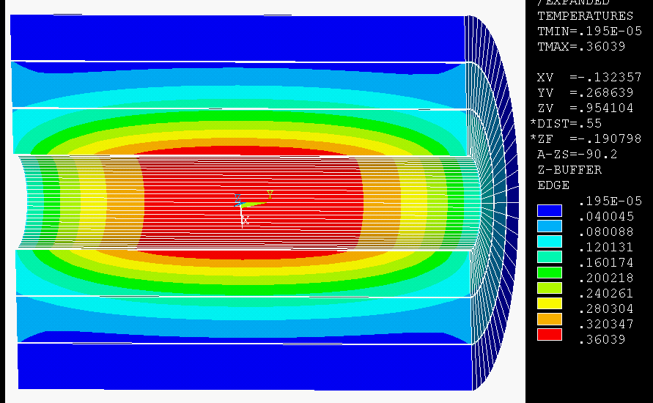
Temperatures due to conductor eddy currents in .5in square conductors subjected to a 15.0T/7sec transient (rampdown)
Steady State Heat Gain.
The specification requires that the cryostat heat gain should be <200 W at 22 K Excluding the leads.
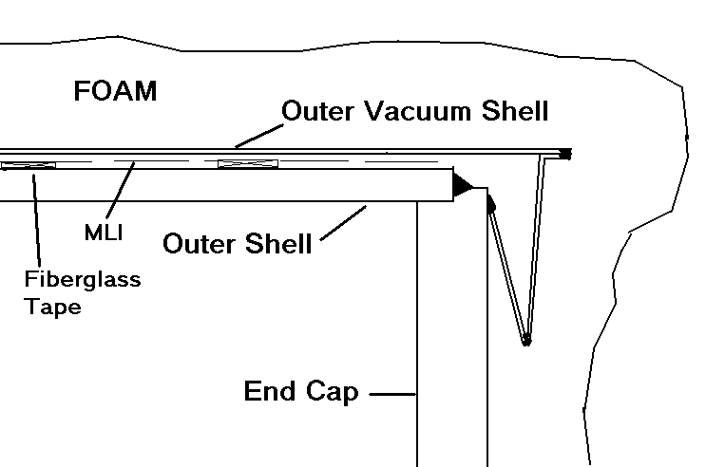
Outer Vacuum Shell to Cover Connection

A concept which has a 220 watt heat gain has been developed that employs vacuum at one head, and the outer and inner shells, and foam at the other end around fluid and electrical penetrations.

Piping penetrations are moved to the end plates,
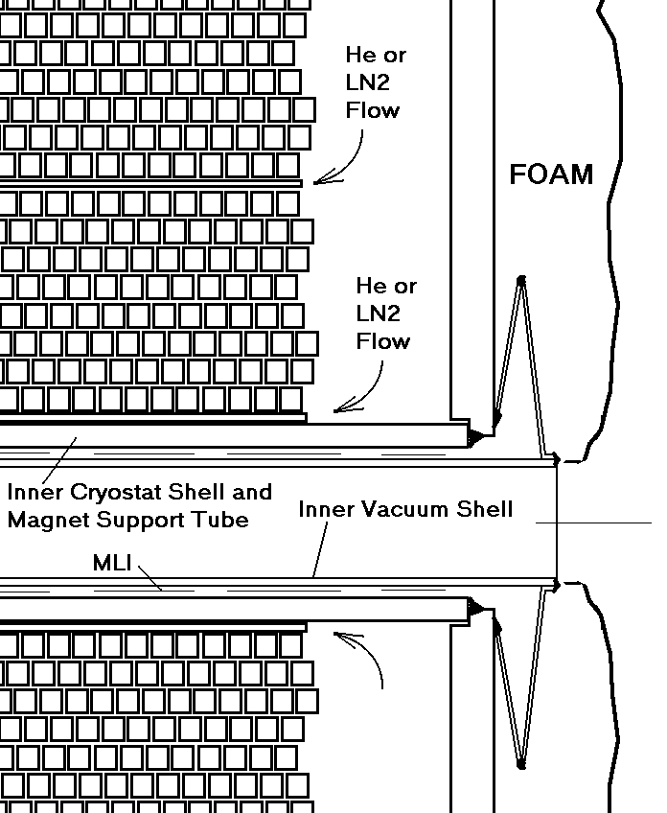
Inner Vacuum Shell to Cover Connection
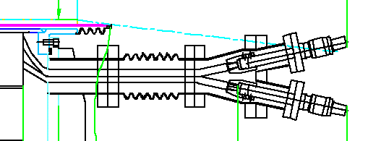
Lead with bellows
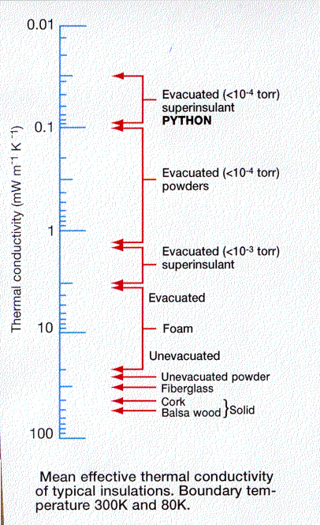

Vacuum shells are used on the ID and OD, and one head.

The magnet can be supported off the inner cryostat shell,

The system gravity supports can reach through the foam or vacuum boundary.
Heat Gain Summary
Component | Material | Thermal conductivity  W/m/degK | Area m^2 | Length m | delta T | Heat rate watts
Inner shell vacuum with mli | Vacuum/MLI | * | .75398224 | * | 292-22 | <20
Inner shell vacuum extensions | .0005m thick sst | 16.27 | 6.283e-4 | .2 | 292-22 | 13.8
Outer shell (foam option) | CTD Cryo foam insulation | .03 | 3.77 | .1 | 292-22 | 303
Outer shell foam in series with vacuum+mli | CTD foam insulation | .03 |  | .1 | 292-220 | 49**
Outer shell Vacuum Extension | sst | 16.27 | 3.14159e-3 | .2 | 292-220 | 18.4
End Cover foam (1 end) | CTD foam insulation | .03 | 1.508 | .1 | 292-22 | 62.85
End Cover | Vacuum +mli
Leads | Copper (22 to 80K) | 396.5 | 8.64e-4 | .4 | 80-22 | 49.6  (3 pairs)
Leads | Copper (80 to 292K) | 396.5 | 5.4569e-4 | .4 | 292-80 | 114.7  (2 pairs)
Lead bellows | sst | 16.27 | 4.7124e-4 | .4 | 292-22 | 5.33
Coil Support pads | g-10 | .15 | .0016 | .05 | 292-22 | 1.296
Total bold red |  |  |  |  |  | 220.
* Radiation heat gain at bore= 37.281177 watts (no MLI) Stefan Boltzman Constant = 5.668e-8 watts/m^2/degK^4 qrad=area*emis*stefboltz*(trt^4-tcold^4), emis=.12 polished sst From ref [8]: page 152. the heat flux should be divided by the number of MLI layers, conservatively it was divided by 2 – many more layers are practical in this space.
** Radiation and Foam conduction in series. The intermediate temperature (128.5K) of the vacuum shell was found by trial and error assuming a temperature and matching the heat flux for radiation and conduction.
Foam Insulation
CTD Composite Technology Development Inc.
CryoCoat™ 620T was initially developed to prevent the formation of liquid air on ground-based liquid hydrogen vent lines, and has since found numerous applications as an insulation, adhesive, sealant, protective coating, and grout for ground-based and flight applications. CryoCoat™ 620T offers excellent adhesion to many substrates with minimal surface preparation, and will cure at temperatures as low as 10°C in 8 hours. These characteristics make it especially attractive for retrofit and field installations. Known for its robustness and toughness, this syntactic foam-based insulation is resistant to UV and other environmental factors, and does not absorb moisture. It can be spray applied to large surface areas, complex surfaces, and difficult to reach areas.
CryoCoat™ UltraLight™ provides the robust mechanical properties associated with syntactic foam technology in a low-density insulation system (specific gravity from 0.08 to 0.11) with excellent thermal properties. CryoCoat™ UltraLight™ can be used as a mold-in-place insulation system on large, complex and uneven surfaces, or blown into closed molds to form near-net-shape components. CryoCoat™ UltraLight™ UL79 withstands liquid hydrogen temperatures and the elevated temperatures of re-entry from space.
The CryoCoat™ UltraLight™ consists of an adhesive layer, an insulation layer, and an outer moisture barrier/protective coating. Each component can be individually tailored to best meet the requirements of a specific application. For example, for use on a cryogenic fuel tank or rocket engine hydrogen pump, the adhesive layer will use CTD’s CryoBond™ 920 adhesive, and the outer coating will be based on CTD’s CryoBond™ XVC. The outer coating can be omitted in applications where the insulation will be exposed to a vacuum, improving the overall insulation effectiveness. The outgassing of UL-79 is low enough to maintain a stable vacuum. In applications where the insulation will be formed into a near-net-shaped part, or used on equipment requiring access for maintenance, the adhesive can be eliminated. This will allow easy removal of the insulation. CryoCoat™ UltraLight™ adheres well to itself, enabling easy insulation repair or replacement.
Cryostat/Helium Can Stress
Normal operating Pressure is 15 atm – May “evolve” depending on ballast tank
Flat head thickness is 2 cm, Dished head is .5 inch thick, Vacuum Jacket Dished head is .125 in.
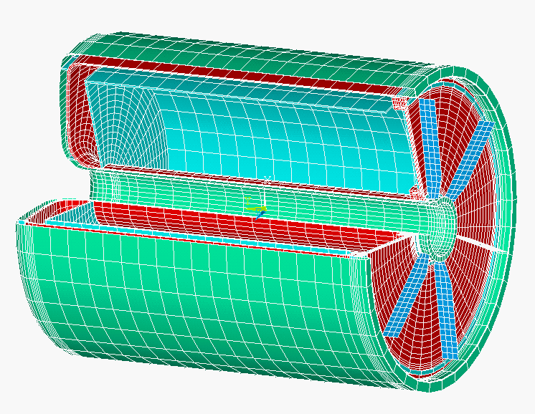Cryostat ID and OD shell thickness is 6.35mm (1/4 inch) (present analysis is based on 5mm)
Material is 316 or 304 SST
Structure Room Temperature (292 K) Maximum Allowable Stresses, Sm = lesser of 1/3 ultimate or 2/3 yield, and bending allowable=1.5*Sm
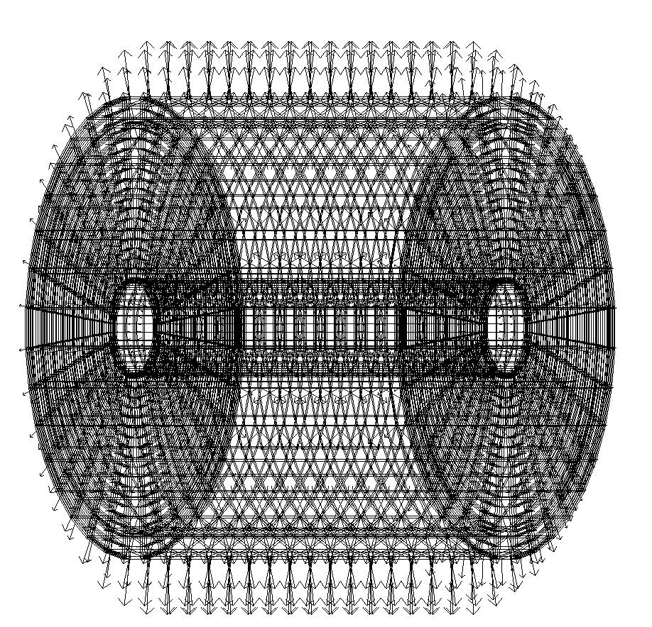
He Can pressure forces.
Material | Sm | 1.5Sm –  bending
316 LN SST | 183Mpa  (26.6 ksi) | 275Mpa,  (40ksi)
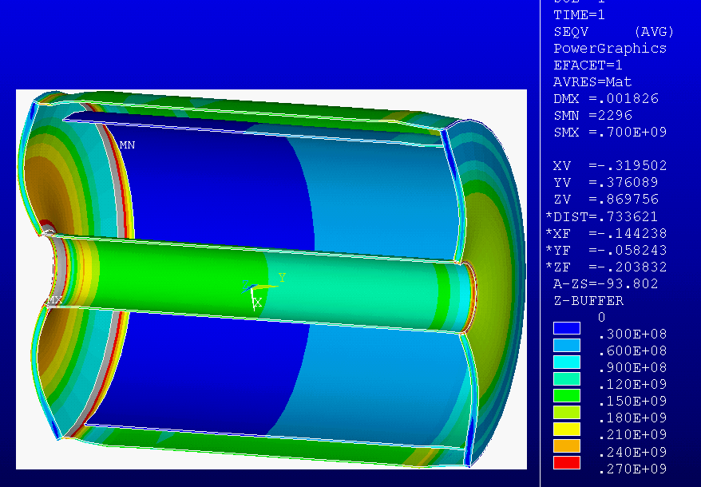
VonMises Stress without ribs.
316 LN SST weld | 160MPa  (23.2ksi) | 241MPa  (35ksi)

Local (corner) Stresses were high - 700 MPa. Stiffeners or thicker closure heads were specified to protect the seal welds
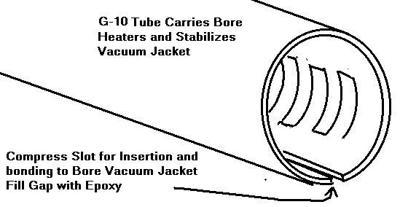
Pressure Load Vectors – Nodal Forces, Pressure times element area
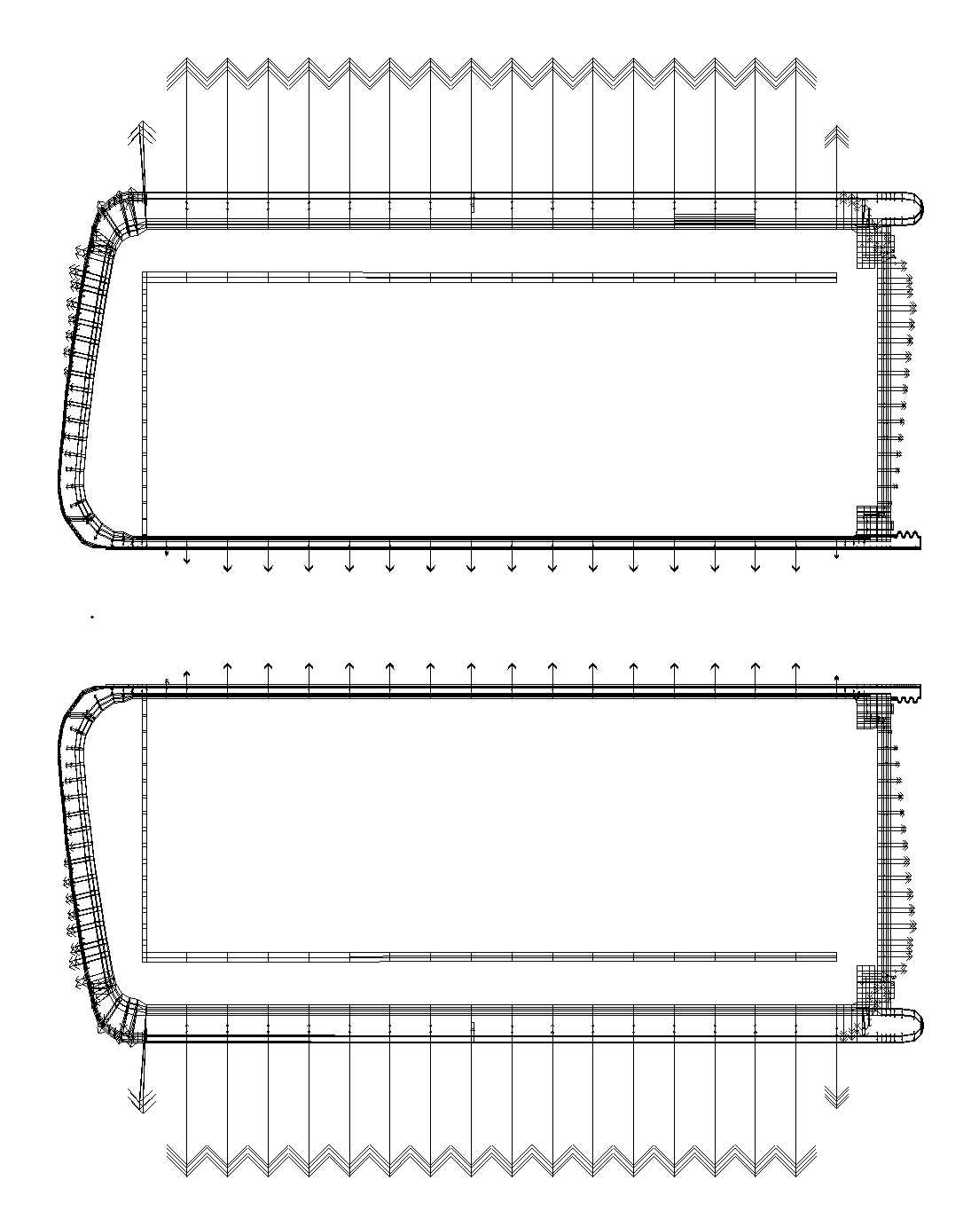
Whole model – Cryostat 16 atm loads dominate
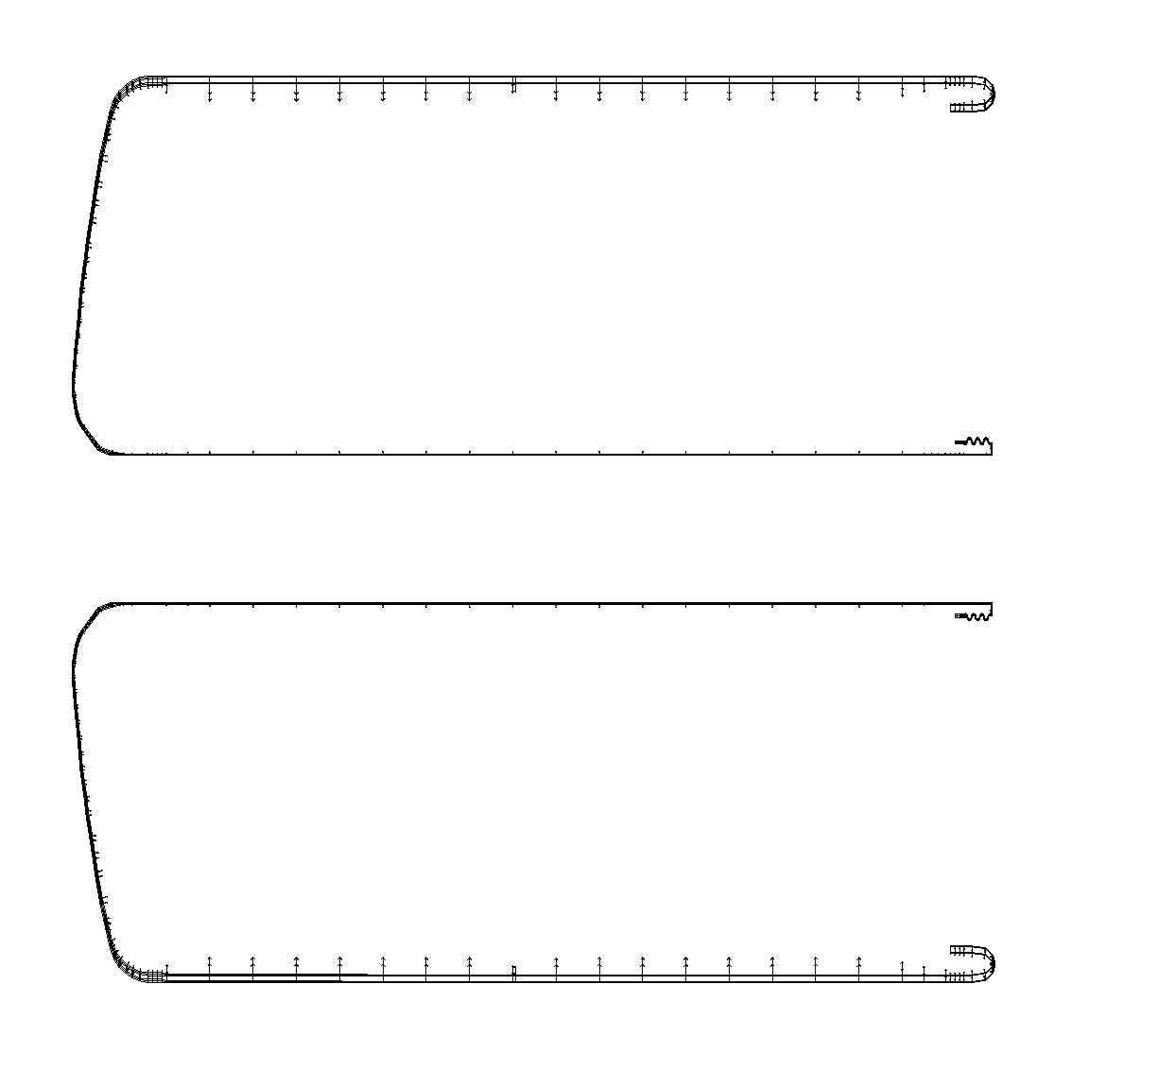
Vacuum loads on vacuum jacket
All Cryostat and Vacuum Jacket Stresses (with the exception of the bellows details) satisfy the primary membrane stress
of 183 MPa
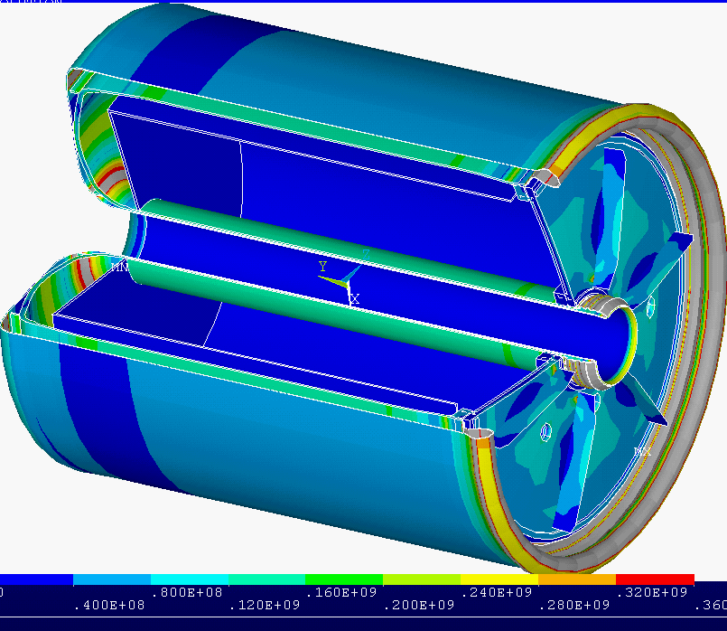
In this plot, light blue is 120 to160 MPa
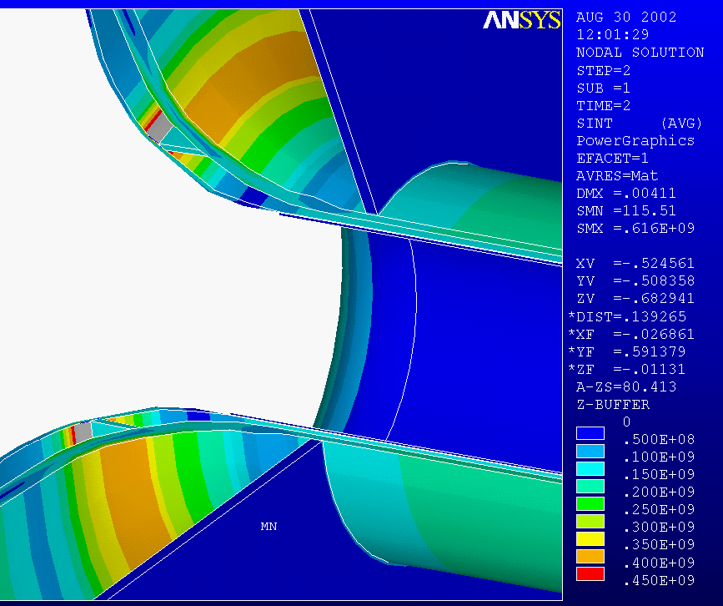
Discontinuity stress(<400 MPa) at Cryostat flare to dished head meets 3Sm
allowable at the weld of 480, Membrane stress meets 160 MPa allowable
Cryostat/Helium Can Stress – Head Closure Detail
Bolt Analysis
_ let rm=((.5^2-.1^2)/2)^.5_
_ let f=225*(rm^2-.1^2)*39.37^2
_ let ba=.375^2*pi/4
_ print f/ba/24
_ let f=225*(.5^2-rm^2)*39.37^2
_ let ba=.375^2*pi/4
_ !let ba=.1
_ print f/ba/24/4
_ end

Bolt stress =
14472.4 psi for inner 24 bolts
4275.9 psi for outer 96 bolts
Without stiffeners on the flat head, local corner weld stresses are high - 700 MPa. After the addition of six 1cm thick stiffener ribs , the peak stress went down to 448 MPa. This occurred in the ribs, and the weld and head stresses are much improved, but are still above 300 MPa. Further reductions were needed to meet the weld allowables, although the plate allowables summarized above are for room temperature, and are much below the cryogenic capability of 304 or 316. 2 cm thick ribs have been specified.

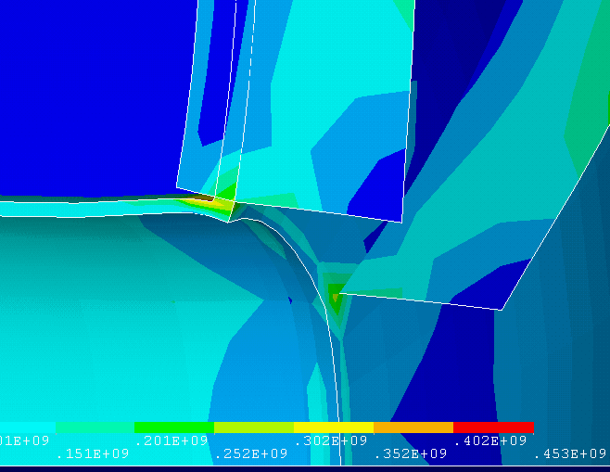
Local stress in the shell to head weld. 6cm high, by 1cm thick ribs are modeled. 2cm thick ribs have been specified.
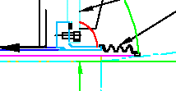
Bolted Head Closure detail

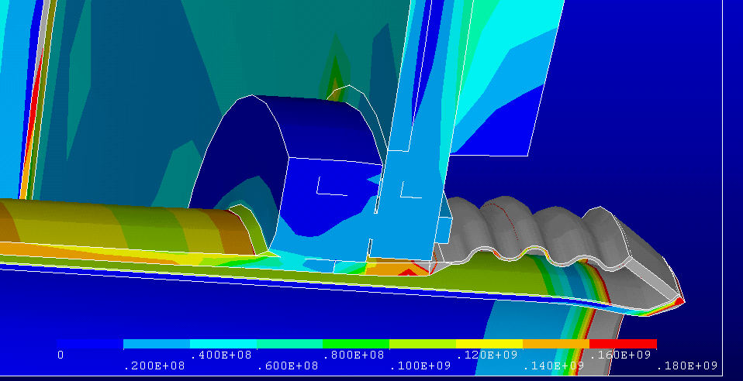

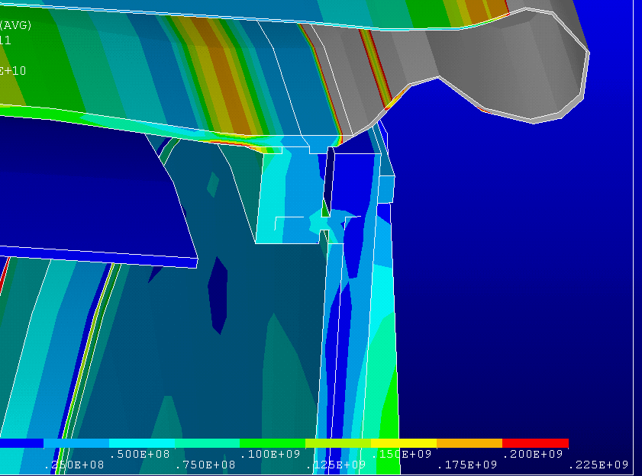
Local Flange to Shell Connection

Bending stress allowable is 241MPa (room temperature weld allowable in bending) OD flange stress is at the allowable.
ID flange has a F.S. of 1.5

Bellows details will be specified to sustain the 3 to 4 mm displacement and one atmosphere.
Vacuum Jacket Buckling needs more work:

1mm thick vacuum jacket only has a margin of 1.5 against buckling. A factor of 5 is needed.
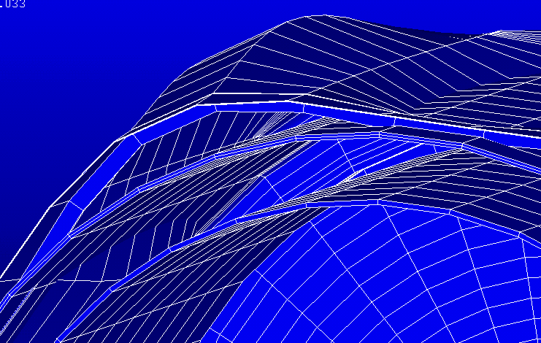
Stiffener added to inside of cryostat.
-Thicken or add stiffeners.
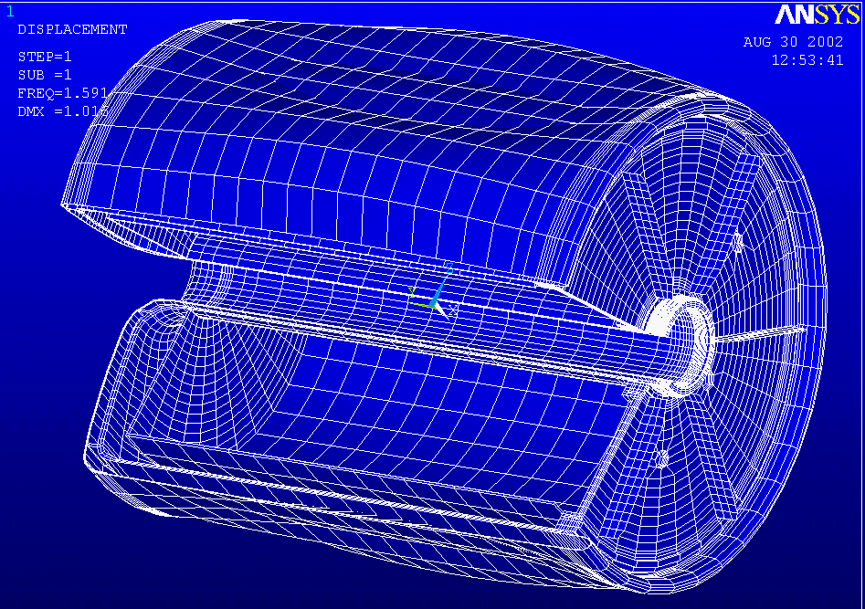
Eigenvalue Buckling Analysis, Load vector is 15 atm on cryostat and 1 atm on vacuum jacket. Analysis includes
Thermal strains and pressure loads.
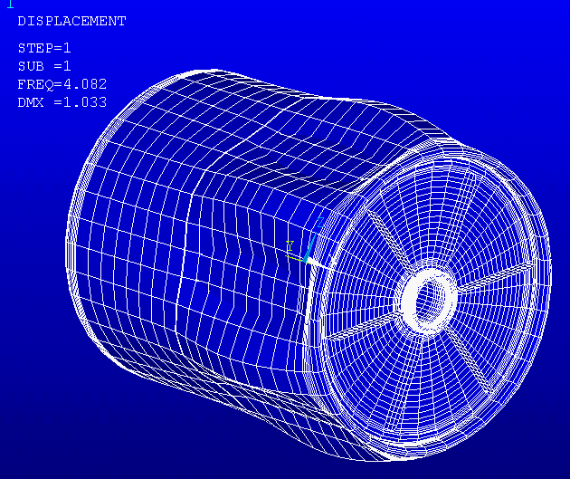
Factor against buckling is 4.08 with mid span
stiffener.
Cryostat Eddy Current Analysis– In the process of being updated with dished head

Vector Potential Solution, 7 sec Ramp-Up , (Envelopes ramp-up and ramp down)
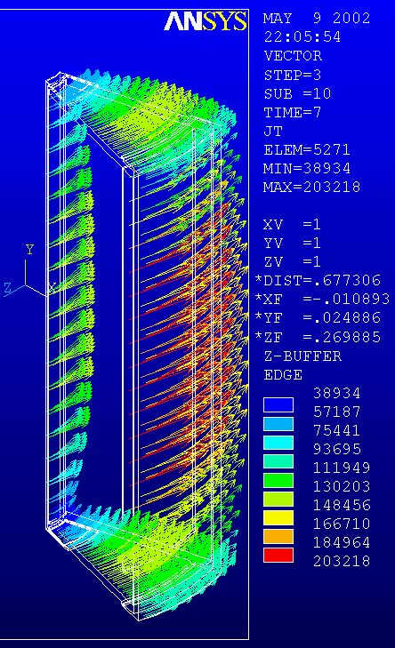
Field Loss Due to Eddy’s is
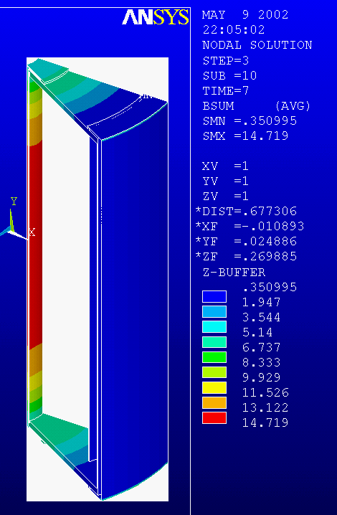
of the Order of a few
milliTesla
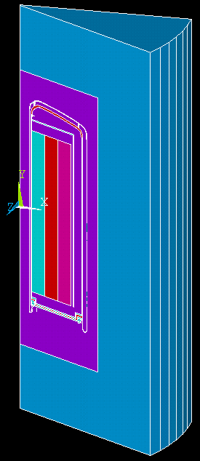
Electromagnetic Model with Air

Cryostat Eddy Current Analysis – Will be updated with Dished Head

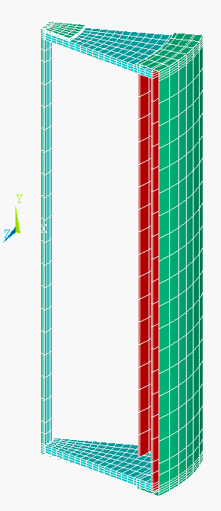
Structural Model
(Sub-Set of E-M Model), Centerline Axis is Vertical
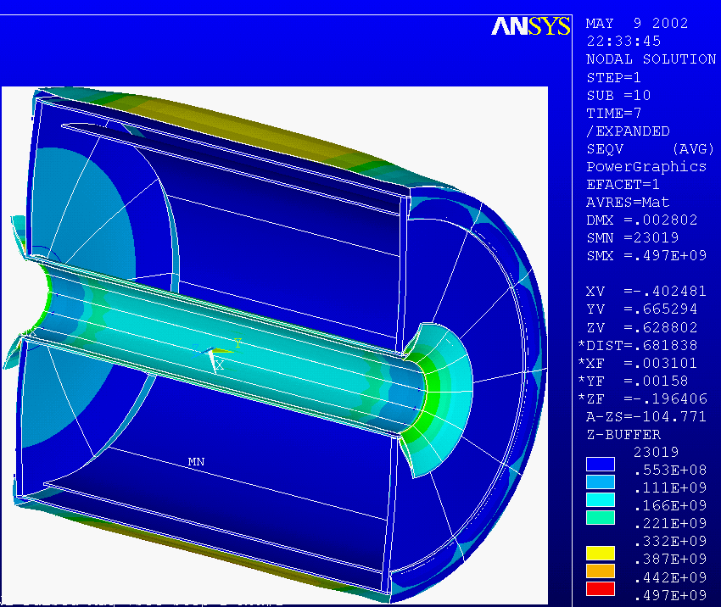
Structural Response to Eddy Currents. External Vacuum Jacket is only .5mm thick and
Will have to be made thicker. The internal Vacuum Jacket is loaded in hoop and axial
Compression, and will have to be checked for buckling. A G-10 sleeve has been added to
stabilize the inner bore and contain bore heaters.
Preliminary Results of Updated Electromagnetic Model
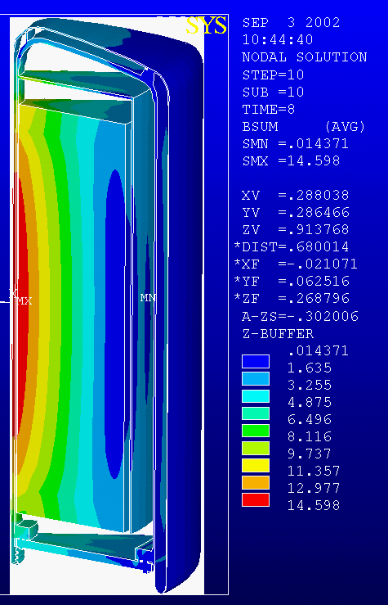
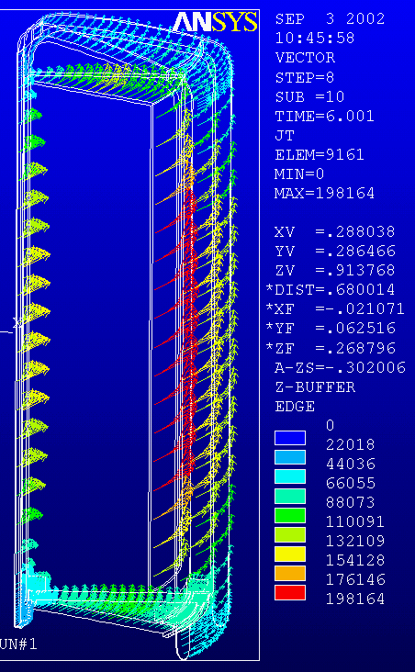
j*B*r should give an estimate of the hoop stress in any of the cryostat shells. With current densities of .2MA/m^2 and fields of 10 Tesla, and radii of .1 to .5 meters, the hoop stress should be only .2MPa
Cryostat Eddy Current Analysis – Temperature Pass

Heat-up due to the eddy current loading on the cryostat produces less than 1 degree K
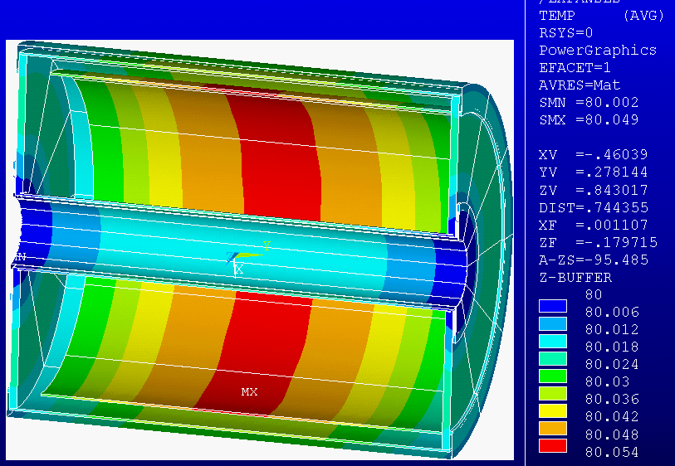
Planned:

Addition of Buckling Analysis – Use Load Vector from Stress Pass.
Break-Outs, Leads, and Penetrations
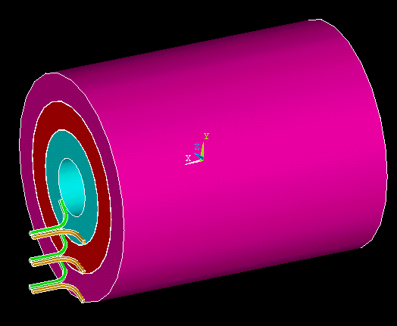
The electromagnetic model.
The fields and forces in the leads are calculated with 7200 amps in the leads, and the appropriate solenoid end field solution is results.
- The choice of modular design favors duplicating the break-out and lead design for all three segments, even though two of the segments are connected in series.
- The break-out concept structurally connects the inner layer break-out with the outer layer break-out.
- The leads are closely coupled to cancel the net loads on the lead conductors.
- Loads cancel, but there is a small torque.
- To achieve the interconnection of the leads, they cross the face of the winding.
- Bending stresses for combined thermal and Lorentz force loading of 200 MPa can be expected for the cantilevered leads. The analysis model has minimal fiberglass wrap and more extensive interconnection of the leads, and support at the winding pack end will be needed.
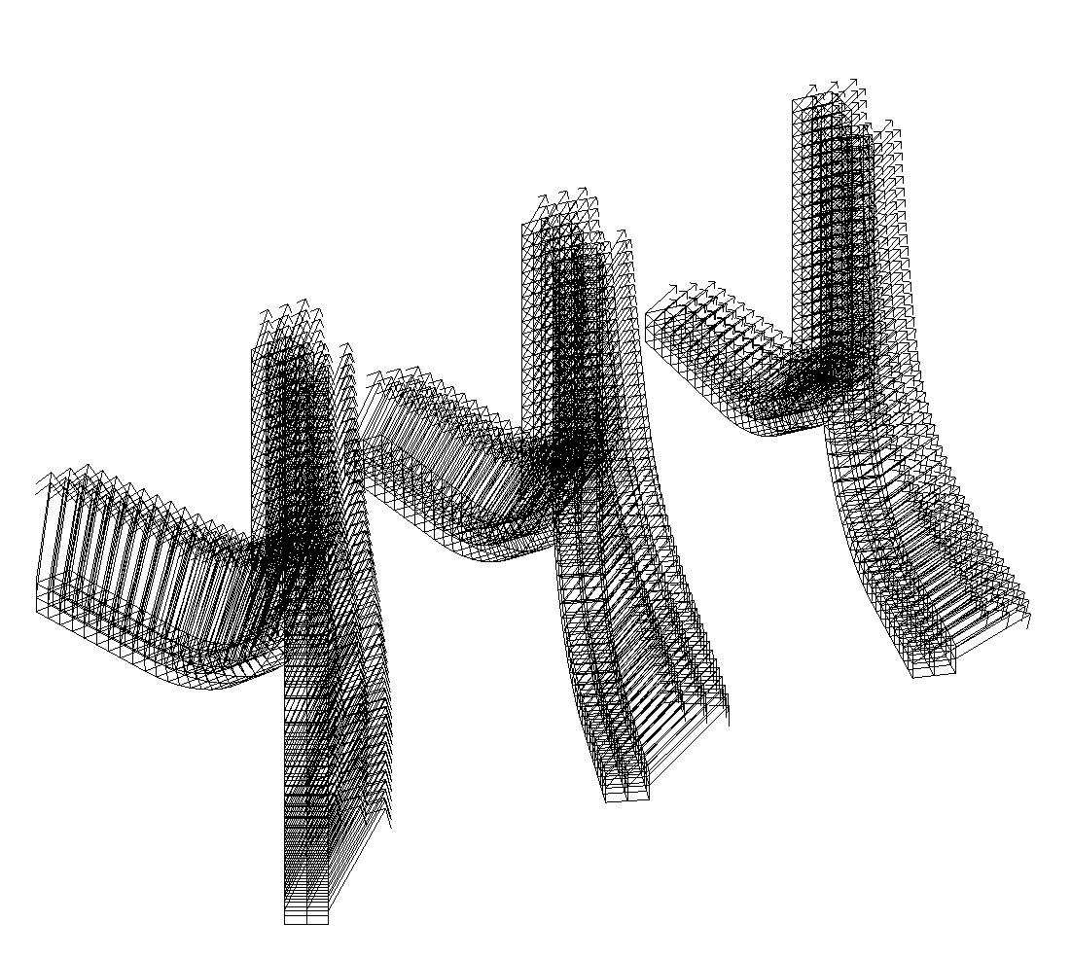
Fields at the break-outs, 15.0T Full field operation.

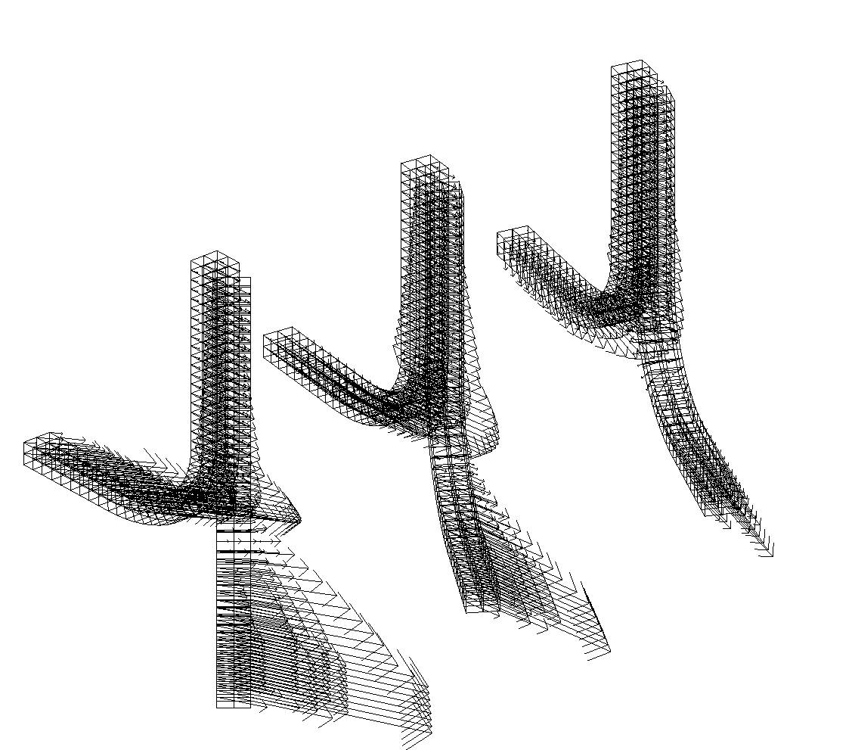
Lorentz Forces at the break-outs. 15.0T Full field operation.
Break-Outs are Interconnected to Cancel Loads, and Equilibrate Hoop Stress.

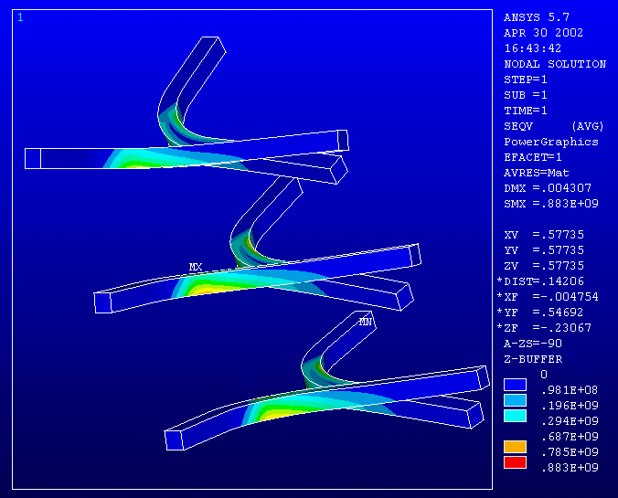
Winding ends well supported, Terminal ends Un-supported and not interconnected. Lorentz Forces Only
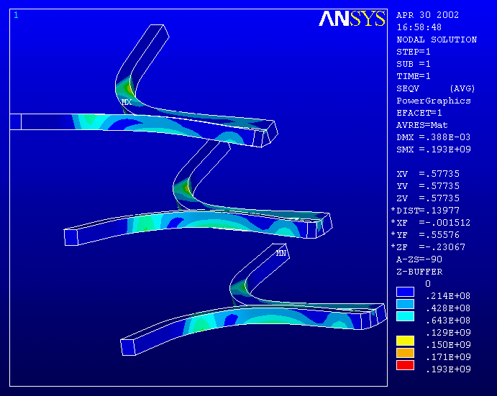
Winding ends well supported, Terminal ends interconnected at the end of the lead pair. Lorentz Forces Only

Lead Thermal Stresses
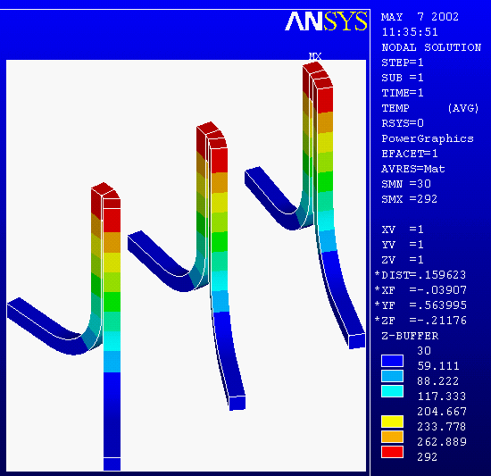
Joint Temperature
- A bellows is used because of differential thermal motions, and flexure of the end cap under pressure loading
Lead with bellows
- This also has the effect of lengthening the cold length of the lead, reducing the heat gain.
- A conduction solution is used to obtain the temperature gradient for the structural solution
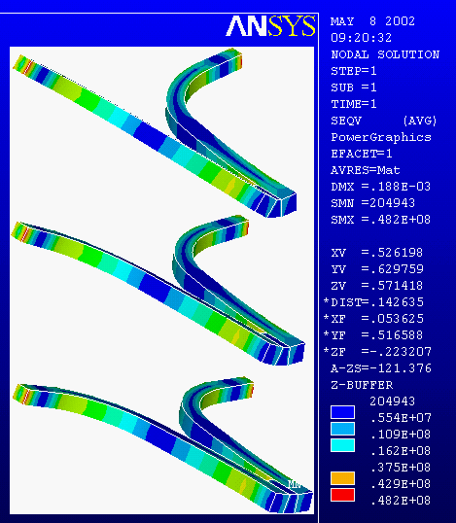
Joint thermal stress. Winding ends well supported at extreme of the radius, where the thermal constraint was applied
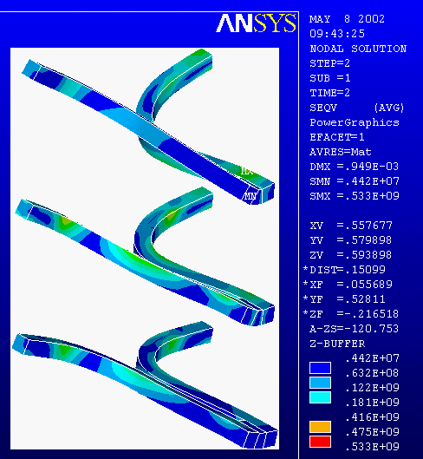
Thermal+Lorentz stress. Winding ends well supported at extreme of the radius, where the thermal constraint was applied. The peak stress occurs where the relatively short interconnection ends. This will be lengthened, and will reduce the peak stress.

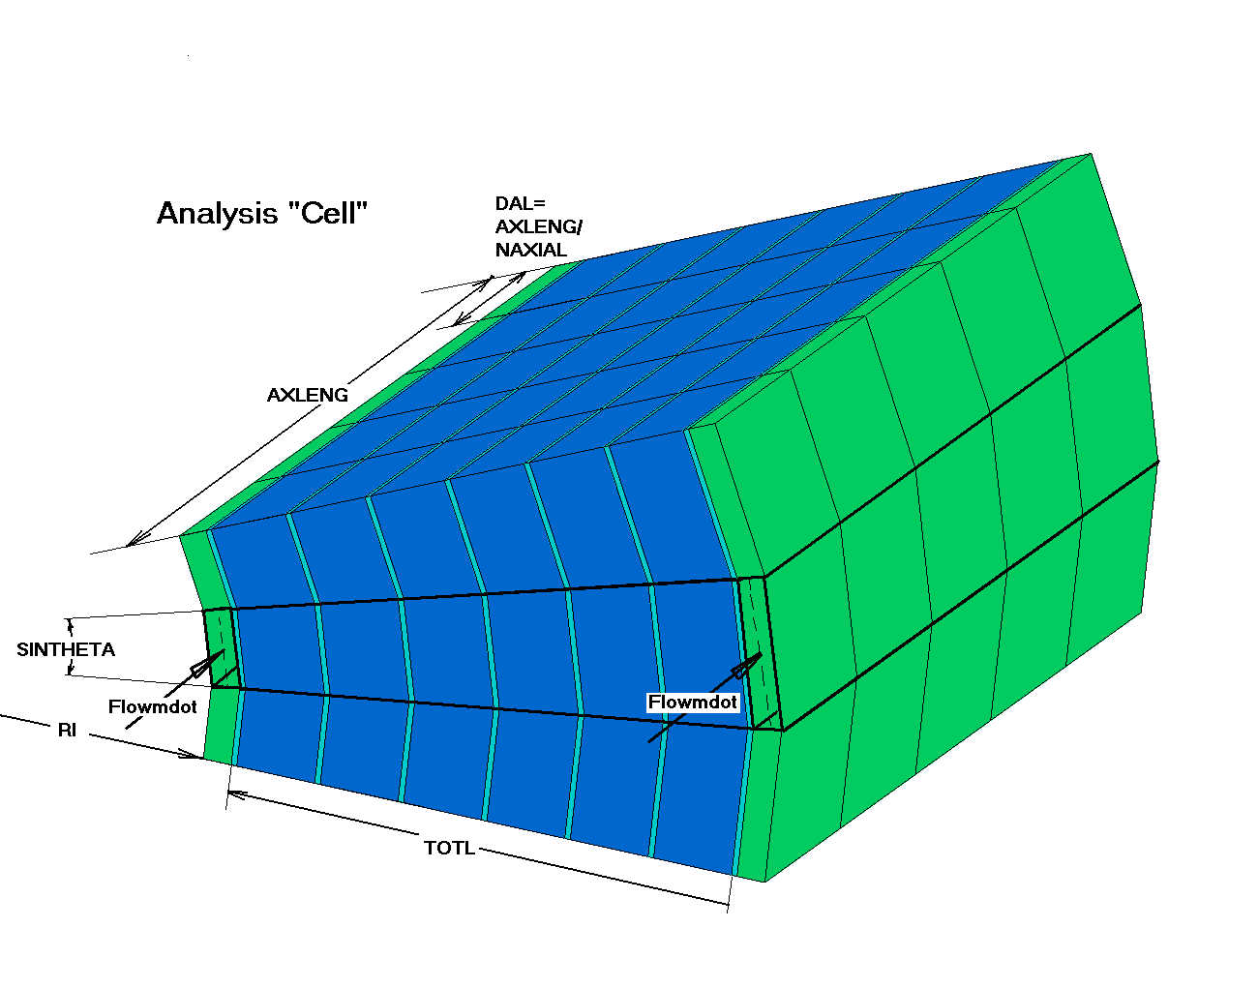

Cooldown Calculations:
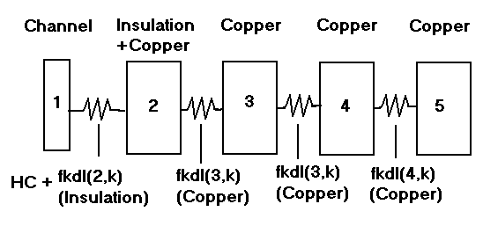
Channel Edge Thermal Model
Finite Difference Model is Used.
Channel Flow and
Transient Heat Conduction
Reducing the Kapton between Layers Allows 8 layers to be cooled from axial channels.
excerpt from: ORNL/FEDC-85-10 Dist Category UC20 c,dated October 1986

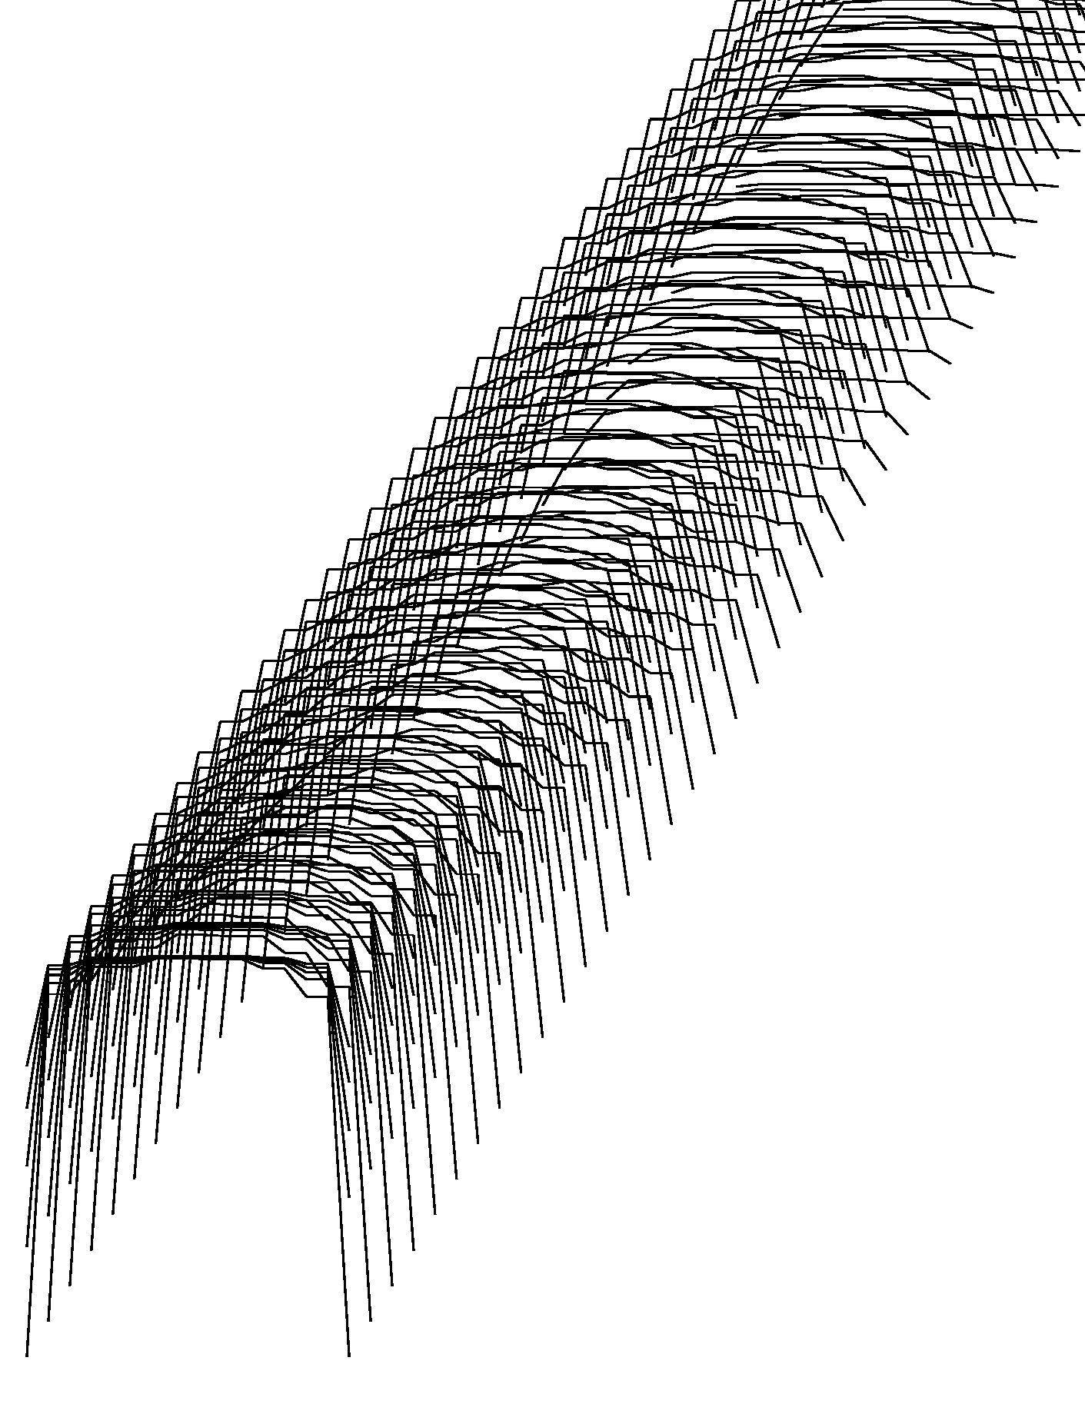
"Cell " Temperature profiles. Time is diagonally to the right. “Bunched” lines represent the axial temperature distribution.
Channel Outlet Temps
Bulk Temp
66K inlet temperature, Time Step =.0001 sec – 100 K after Pulse Temp, The bulk temp is computed at a mid -axial slice. Time to 85K is about 600 sec or 10 min. Exclusive of time to flatten temp distribution.

Present Operational Scenarios:
Case # | Peak Field | T after pulse | T coolant | Start Bulk Temp | Guestimated Time | Guestimated Time
1 | 5T | 90K | 66K | 84K | ~200 sec | 3.3 min
2 | 10T | 96K | 66K | 74K | ~800 sec | 13.3 min
3 | 15.0T | 78K | 22K | 30K | ~1500 sec | 25.0 min

30K Coolant, Cooldown from 100K

Bulk Temp Is Computed Mid Axial Build - It Bottoms out before the down stream end.

tout 1 and tout2 are Outlet Temperatures
Time in Seconds
Bulk temp
Channel Tout1
Channel Tout2

Analyses to date: Time to target bulk temp. ½ inch Copper Conductor, 100K ,
 | T after  pulse | T  coolant | Cond  Layers | Time to 85K sec | Time to 30K sec
Equiv 5 Kapton .001in wrap | 100K | 66K | 6 layers | 600
Equiv 5 Kapton .001in wrap | 100K | 66K | 8 layers | >850
Equiv 3 Kapton .001in wrap | 100K | 66K | 8 layers | 450
Equiv 5 kapton .0001in wrap | 100K | 30K | 6 Layers |  | 2000

Latest (Questionable?) Results. Initial outlet temperatures start at only a fraction of a degree below the bulk temp. The Magnet temperature at the outlet end is higher – neat the channel outlet temps
Cooldown with half the flow.
Nominal .1 kg/sec

Flow Equalization

The simulation assumes a constant pressure manifold feeding the four annular channels. Flow resistance of each channel should be comparable to produce a uniform cooldown.

Specification Content:

The Seller shall perform a flow test of the assembled magnet by blowing air in the Helium outlet connection, and with the flat cover of the cryostat removed, flow velocity of each channel shall be measured with a Pitot tube. Restrictions on the channels will be applied until uniform flow is achieved. Restrictions can be in the form of g-10 strips bonded into portions of the channel opening.

Assembly and Manufacture

Winding Procedure Specification Content:

The seller is responsible for selecting the winding process that will best achieve the required coil geometry, insulation configuration, and impregnation quality. A possible winding method is described here. The bidder shall describe his proposed winding procedure, and any change to the purchaser’s suggested procedure as a part of bid proposal. The Seller’s winding procedure shall be submitted to the purchaser for review and approval. Prior to purchase of the conductor, the Seller shall perform a test bend of a sample length of conductor, over a mandrel or bend fixture which has minimum radius required for winding the coil segment. The conductor sample shall have the same physical properties, - yield strength ultimate and % elongation, as the specified conductor. The test sample of the conductor shall be wrapped with glass tape, and the mandrel surface shall have a Kapton sheet applied. Cuts in the Kapton, or tears in the fiberglass tape shall be reported to Purchaser for resolution.

Options for “Resolution” :

- Relax cold work
- Increase corner radius
- Pre bend over shaping rollers

Assembly and Manufacture
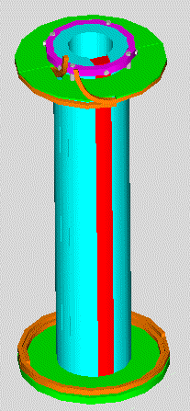
The Coil is layer wound
The Coil is made in three segments. Phased manufacture is allowed
Three separate mandrels are planned.
Mandrels maintain a precise bore geometry
Ribs are applied to outer surface of the wound and impregnated coil
Ribs are machined to match the ID of the next coil segment
Coils are slipped on to one another. – with a temperature difference if needed

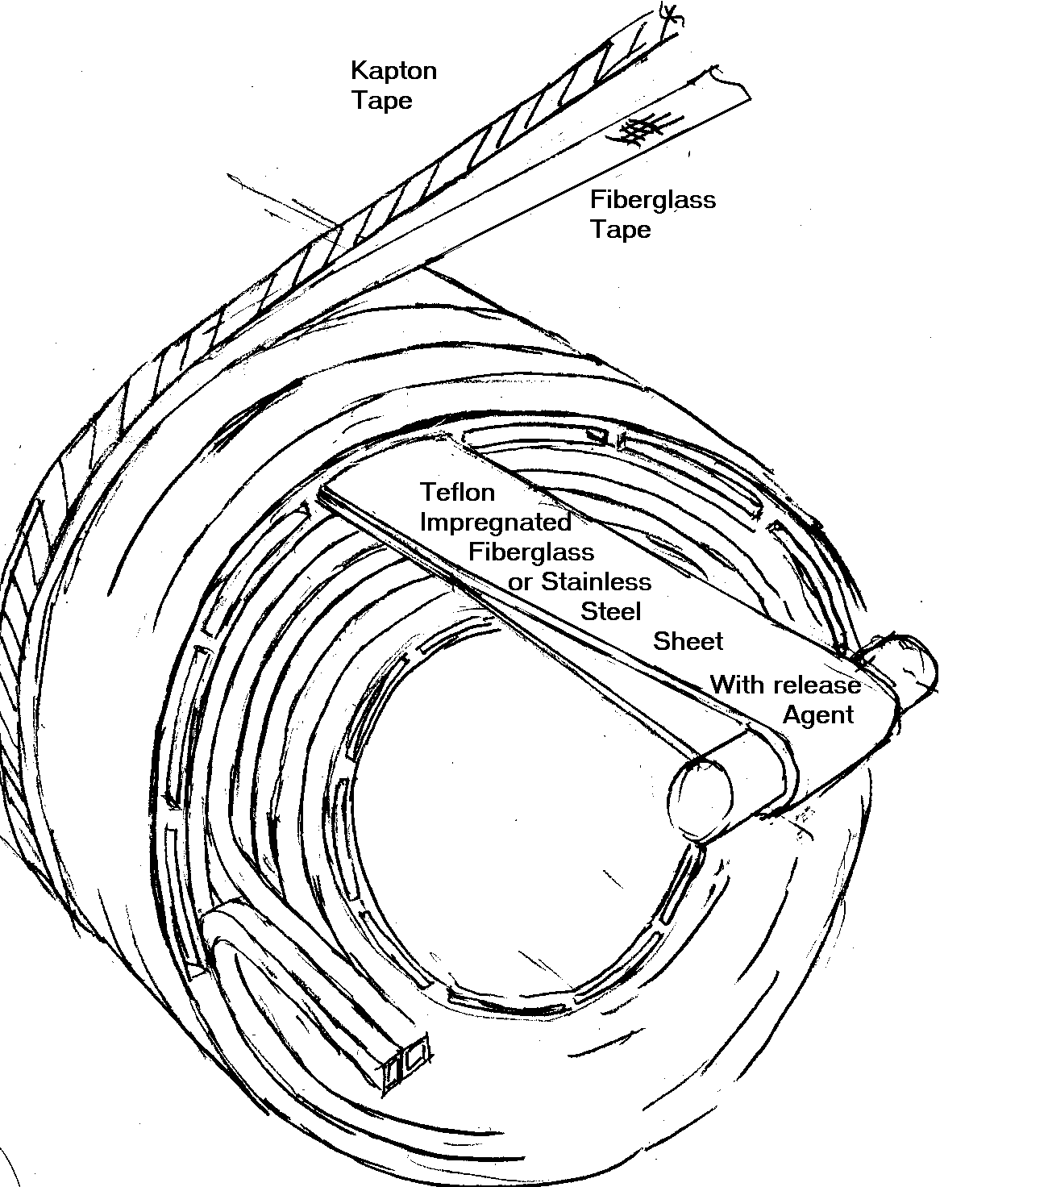
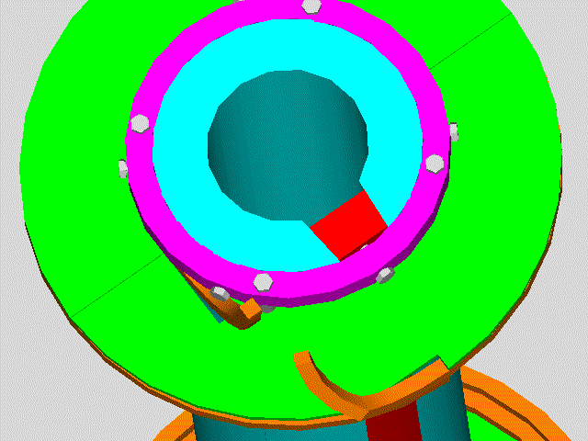
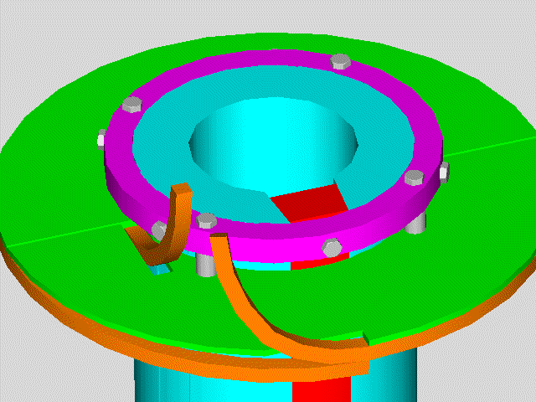
Phased fabrication of the coil segments is the motivation for the mechanical head closure.
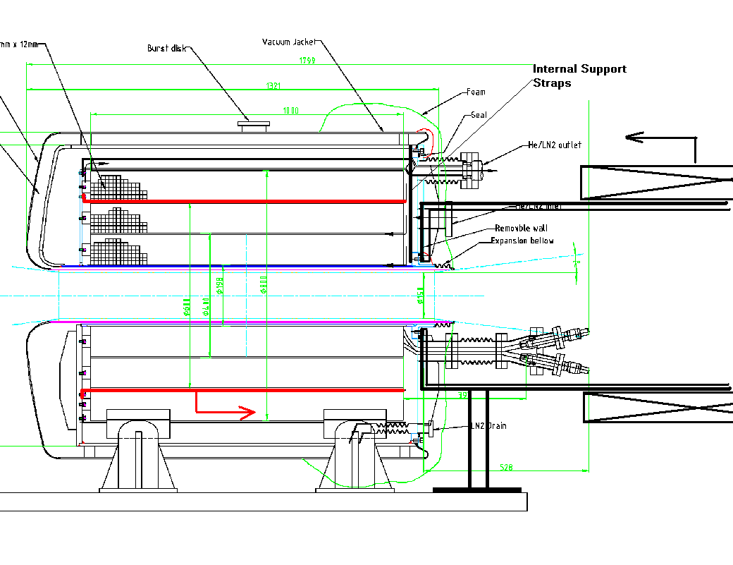
The joint flanges are loosened, bellows compressed, and ceramaseal penetration set screws are loosened.

The ceramaseal connections are removed

Head lip seal welds (if used) are cut.

The closure head is removed. Internal support straps hold the coil weight.

The assembly shell is installed, bolted to the inner head bolt circle, Temporary supports/cribbing support the shell and coil weight. The internal support straps are removed.

The coolant shroud (red) is removed swapping inner and outer temporary supports.

The third coil segment is then slipped into place.

The internal support straps are replaced. The assembly shell is removed.

The head is replaced, and bolts torqued. The lip seal welds (if used) are made. The ceramaseal connections are re-made.
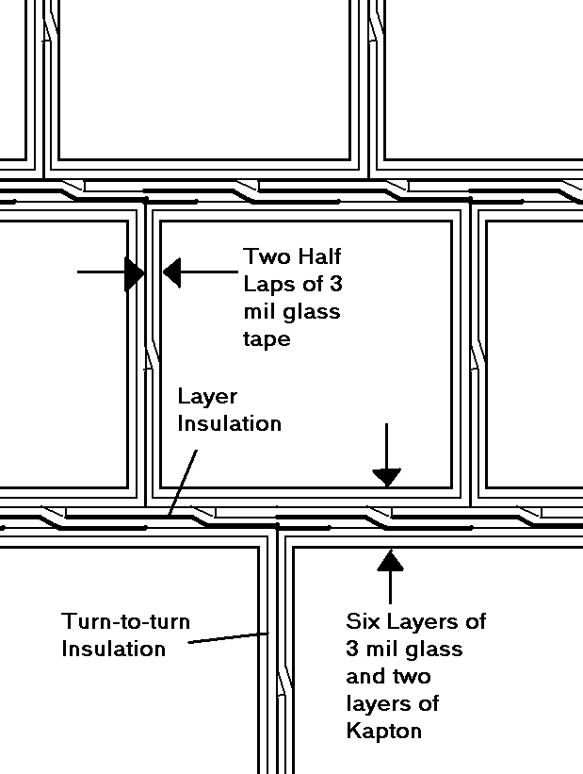Conductor Dimensions
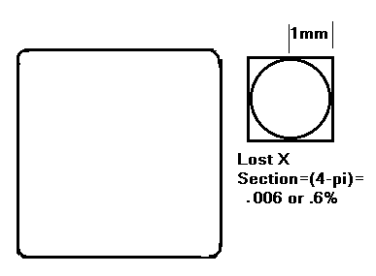
Corner Radius
conductor dimensions with 2 millimeter channel tolerance
radial dim 1.1669799e-2 m .45944 in
Axial dim 1.2515712e-2 m .49274359 in
packing fraction= .92998827

These packing fractions are based on the coil winding pack and exclude the channel. If the 2 mm channel is included, the packing fraction drops to .911.

- Kapton is the limiting element in the thermal conduction through the coil.
- Kapton was expected to be wound around the conductor. This produced the equivalent of 5 mils of Kapton between layers.
- To improve conduction, Kapton is used only between the layers. Turn to turn voltage is lower than layer to layer. The turn to turn voltage is less than the rule of thumb for He breakdown voltage (1 volt/mil at 1 atmosphere) for the insulation thickness proposed.
- The layer to layer voltage exceeds this however, and would need the Kapton if there was an imperfection in the epoxy/glass insulation. Half lapps of kapton and fiberglass, similar to the CS model coil will retain some structural integrity.
- Once a layer of conductor is wound, a layer of Kapton/glass would be wound on the completed layer of conductor. This produces the thermal conduction equivalent of 3 mils of Kapton rather than 5 if the conductor is wrapped individually. Every 8th layer channel strips are layed on.

Keystoning:

H/(2*r)= .012/.1/2=6% (elastic strain) For Plastic bending, (poisson=.5) the Keystoning contraction is 3%

This is a function of radius

Three Keystone specs are suggested. The keystone geometry for the first segment should be .012/.15/2*.5=2%

The worst case loss in packing fraction is 1%, Average loss is .5%
Keystone allowances in outer two segments are 1.2%, and .86%. Packing fraction losses in outer two segments are .15%, and .007%
Whole Magnet loss of .2%+Corner Loss of .6%=.8%
Instrumentation
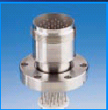
ISI Insulator Seal
Cryostat Bore Tube Geometry
Building from the Magnet ID and working towards the centerline:
Component | Thickness (m) | Radius (m)
The ID of the magnet winding |  | .15-.98/2= .101
Coolant Channel | .002 | .099
Cold Cryostat Shell | .004762(3/16in.) | .094237
Vacuum Space | .008 | .086237
Vacuum shell | .0005 | .085737
Strip heater | .001 | .084737
This leaves a clear bore diameter of .16947m
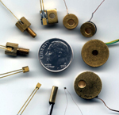
Cernox™ thin film resistance temperature sensors offer a negative temperature coefficient, monotonic response over a wide temperature range, low magnetic field induced errors and high resistance to ionizing radiation.
- Low magnetic field-induced errors
- High sensitivity at low temperatures and good sensitivity over a broad range
- Excellent resistance to ionizing radiation
- Fast characteristic thermal response times:
1.5 ms at 4.2 K; 50 ms at 77K (in bare chip form in liquid)
- High Temperature Cernox offers a wide temperature range from 0.3 K to 420 K
- Broad selection of models to meet your thermometry needs
- Manufactured by Lake Shore, insuring control
over wafer level quality and yield for the future
- Excellent stability
- Variety of packaging options
Postulation of Safety Issues:
BNL Pulsed Magnet –Inertially Cooled , 30K He Gas Cooled Between Shots
Failure of Bore Heater

Joint Failure
Excessive motion
Omission of a Force Component
Insulation Failure
Leaks
He/LN2 Cryostat Leak
Mechanical Seal Failure
Bellows Crack
Ceramaseal Break
Over Pressure
Hotter than expected Magnet
Loss of Vacuum in Jacket
Vacuum Jacket Volume Pressurization
Quick charge of LN2 with warm cryostat
Thermal Shock
Quick charge of LN2 with warm cryostat

Accident
Fire
Seismic

Failure of Bore Heater
There is no safety consequence – Only frosting of the experimental boundary

Joint Failure - The most common kind of magnet failure

Excessive Motion

Joints are cantilevered, but hoop tension and Lorentz force compensated as in a coax. Bellows allow motion. The Joints will be insulated and wrapped with epoxy Glass

= Omission of a Force Component

George Mulhulland helped with a reminder of the pressure force. This is about 1400 lbs, and is taken by tension in the joint. G-10 guides have been added to reduce the moment on the ceramaseal connections.

Insulation Failure
Conservative insulation design is employed. All insulation planes above one volt are insulated with Kapton. Regions where thermal contraction cracks are possible are insulated with Kapton to produce a reliable parting plane, and provide insulation against tracking behavior.

Specification Content:

Electrical Testing
The Seller shall assign a trained personnel and provide all necessary test equipment including digital multimeters for resistance measurement and DC hipot testers for ground insulation testing, during assembly process and at the completion of the prototype cryostat. Electrical testing of the electrical connection and component, including pulsed coil and bus connection, sensors, and diagnostic wiring, shall be performed after a component becomes inaccessible for service unless the enclosure is disassembled. The checkpoints and the type of electrical testing during assembly stage shall be defined by Seller in the fabrication plan and approved by the Purchaser’s Representative.

Insulation test
No measurable electrical connection at mega-Ohm range shall be allowed between the ground and any diagnostic component / connection, between different sensors, and between sensor and the coil circuit.

DC Hipot Testing
The initial DC hipot testing shall be performed on the pulsed magnet coils and lead connections before they are installed. All subsequently measured leakage currents shall be compared with the initial value for verification.
The coils and lead connections shall be tested at 1 kV for 1 minute with the limiting current of a DC hipot tester set to 10 micro Amp. The allowable leakage current shall be no more than 5 micro Amp.

Caution:
- Do not perform hipot testing with the coil / lead in evacuated enclosure.
- Isolate the voltage tap wires when the coil / lead is tested with hipot tester.
- Do not use hipot tester on any sensor.
Leaks
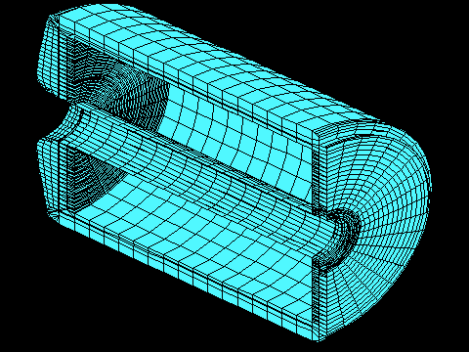
Elements modeling Helium total 2*.167 m^3 Or .335 m^3. This is 5 m^3 at 30 K and 49 m^3 of Helium at RT and 1 atm.
The dished head and annulus can be filled to reduce the He inventory. The dished head volume is .044

Probably Frostbite is the most significant danger. Even a small leak would fill the test cell with cold He.

He/LN2 Cryostat Leak
The Cryostat and vacuum jacket are designed in accordance with ASMEVIII, including proof tests, (but not stamped?)
Mechanical Seal Failure
A redundant welded seal is available as a back-up. It can be applied if there are problems in-service? Or in the shop?
Bellows Crack
These need to be specified conservatively with respect to displacement, and pressure rating. Axial displacement of the bore bellows, and lateral and radial displacements of the bellows support feet are both around 3mm.

Ceramaseal Break
The ceramaseal joint penetration is loaded in compression and restrained by it’s connection with the conductor break-out. It is intended to be either immersed in LN2 or traced with LN2 cooling tubes – This is probably an argument for tracing . Mechanical qualification is in Process ( We have one and dunk tests, and load tests are needed)

Leak Related Specification Content:

Sniffing Tests During Manufacture
The following shall be performed in the prescribed order:
- Confirm the sensitivity of sniffer is better than 5 x 10⁻⁵ std atm-cc/second helium with a calibrated helium source.
- Use an appropriate temporary cover to close the vessel / volume, and introduce helium gas into the test volume without cracking the temporary seal.
- Confirm the background helium reading is below the sensitivity of the sniffer.
- Spot leak checking shall be performed by inserting the sniffer in the envelop, which covers the outer surface of the joint area.
- At high background helium count, consider isolating the first envelop from the background with a second envelope, which is flushed with nitrogen gas.
- Remove leak checking attachments and clean up the surface. Flush out helium gas if necessary.

Over Pressure
Hotter than expected Magnet
Magnet insulation damage occurs above 100C. Our operating range is 30 to 100K
Loss of Vacuum in Jacket
Cryogenic Foam limits heat gain to less than 1000 watts. The magnet stored energy is of order 1e7 Joules
The Cryogenic Foam planned for use on the cryostat is fire retardant, and will limit heat gain and resulting pressurization during an external fire.

For Liquid N2 operation, we can vent liquid to the "shuttle tank" via pressure relief? The pressure relief valve be positioned at the bottom so we vent liquid and reduce the probability of overpressure due to relief valve pressure drop? . For He operation, since there is only a small volume of He gas - not liquid, loss of vacuum accident cannot be of much consequence in terms of relief valve performance. This is an issue with the LHe superconducting magnets not in resistive magnets. In our magnet, the loss of vacuum would produce a small heat gain with respect to the mass inventory of He. Much less time rate of expansion than pulsing the magnet.

Vacuum Jacket Volume Pressurization
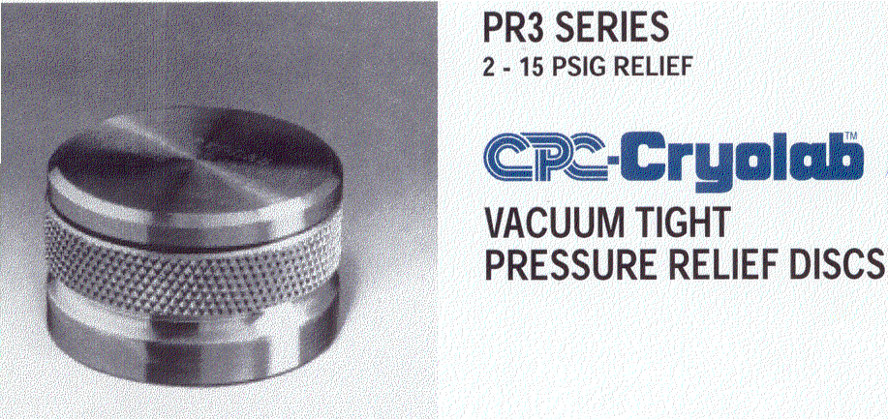

A relief disk is provided. Pressure beyond one atmosphere loads the bellows and can damage them. The “Bumpers” that take the net lateral vacuum load do not work in tension if the vacuum jacket is pressurized.

Quick charge of LN2 with warm cryostat

Thermal stress in the magnet?

Bore Heater Strip Vendor and Specifications (Willie Burke?)
Accident
Fire
Foam has good fire retardant properties
CryoCoat™ UltraLight™ provides the robust mechanical properties associated with syntactic foam technology in a low-density insulation system (specific gravity from 0.08 to 0.11) with excellent thermal properties. CryoCoat™ UltraLight™ can be used as a mold-in-place insulation system on large, complex and uneven surfaces, or blown into closed molds to form near-net-shape components. CryoCoat™ UltraLight™ UL79 withstands liquid hydrogen temperatures and the elevated temperatures of re-entry from space.

Application of the foam is intended to occur at BNL. Application procedures and use of solvents etc. will have to meet BNL safety procedures.

Seismic
The magnet is supported on three legs. One is fixed and two are sliding. The sliding block feet will have to have some tensile capacity to ensure magnet stability against side loads.
Supports are robust otherwise – not as delicate as superconducting magnets supports.

