Status: MIT/P.Titus Activities for the BNL Pulsed Magnet April 8 2005

Magnet Fabrication:

Segments 2 and 3 have dry spots. David Rakos of Everson is preparing repair procedures. Initial description of the repair is to re-insert the mandrel, seal against the rest of the coil, and re-impregnate feeding through the
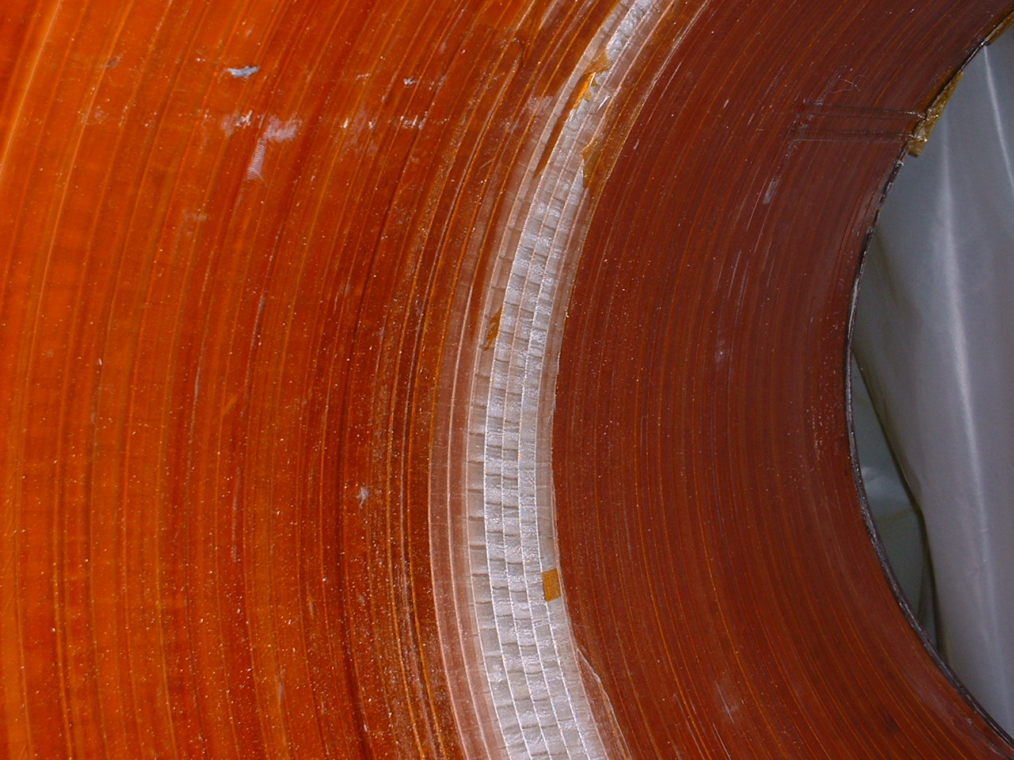
Dry Area

Vessel Fabrication:

Shells rolled, Head to shell welds made, Progress payment requested, Digital images promised, but not yet received.

Next Vendor Visit:

Planned for Tuesday April 12

Level Sensors:

Budgetary Quote from American Magnetics received and passed on to Brookhaven.

Possible competitor: http://www.trgn.com/LC3/LC3.html
Budgetary quote requested
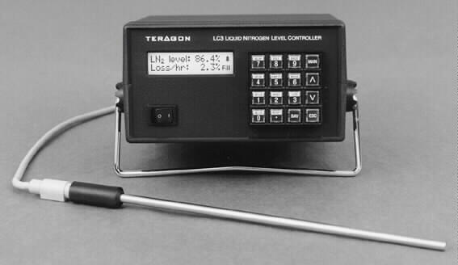
Test Plans/Preparation:
Purchase Req for Power supply components sent out – 21 week delivery may mean swapping iso amps from data acquisition sytem.
Cryo line, Vent Line Bus Bar Layout conceptual layout in diagram form –See the latest test plan at Kirk’s web page.

Test Area:

Cold Box: 3 foot by 3 foot by almost any height will fit.

-See Video
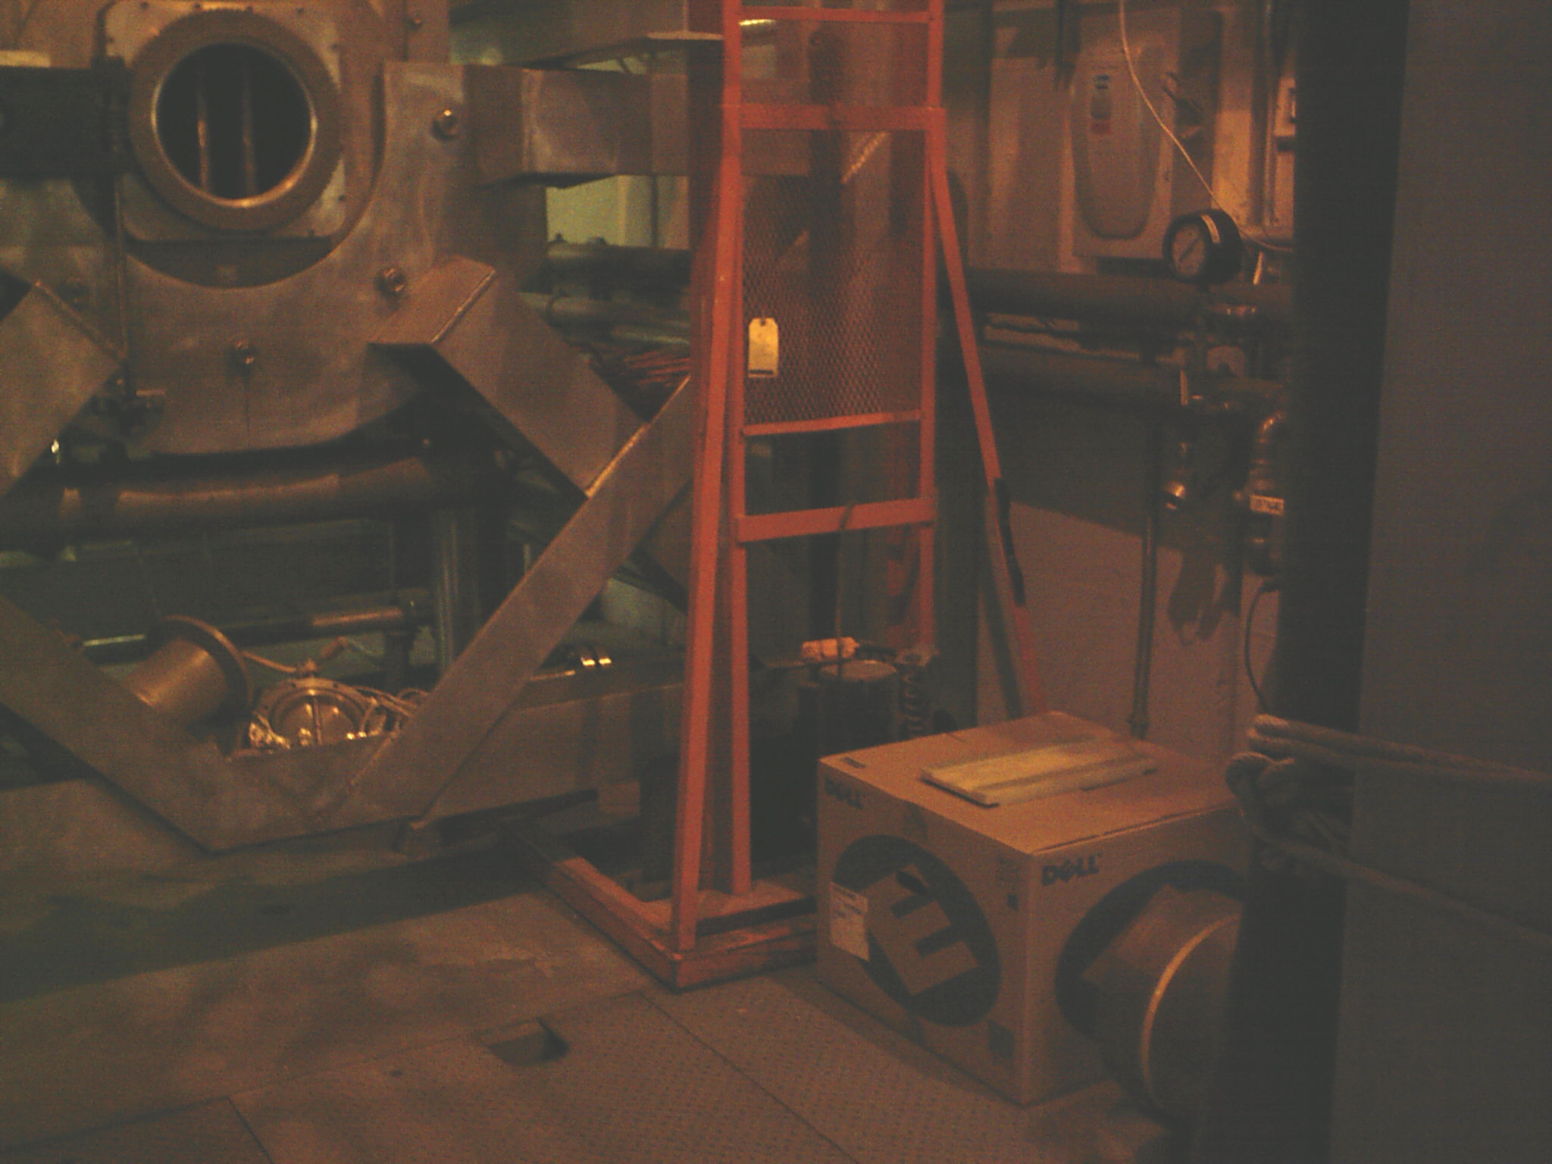
3X3 Cold Box could fit where the Dell Computer Box Is

