Solenoid Coil.doc Princeton/μμ/00-22
MUC00xx
C. Lu
Princeton University
Feb. 7, 2000

Stress Analysis of the PEP-4 Solenoid Coil

The TPC solenoid magnet coil, which was used for PEP-4 experiment at the Stanford Linear Accelerator Center, is being considered for use in the Muon Collider targetry experiment, BNL E951, where it would surround a 70 MHz rf cavity. Here we consider the option to operate the solenoid coil without a return yoke. Then, the bare coil would experience magnetic forces from steel in the walls and roof of the experimental hall. Careful stress analysis is certainly needed. In this note we present an analytical estimate and detailed FEA simulation of a simplified model of this solenoid coil.

Solenoid coil

This is rather thin composite structure which consists of following two major components: a 1.41cm-thick aluminum cylinder as the bore tube and a 1.74mm-thick copper-based Nb-Ti superconductor coil running at high current to create up to 1.5Tesla field at the center.

Model description

The solenoid coil is modeled by two concentric 3m-long cylinders. The inner cylinder is 1.4cm-thick aluminum with 1m inner radius. This supports the outer cylinder of 1.74mm thick copper-based Ni-Ti superconductor. The Young’s moduli of aluminum and Ni-Ti are 69Gpa and 110Gpa, respectively, and their Poisson ratios are both taken as 0.32.

Analytic calculation

- Magnetic flux density B
Ignoring the surrounding steel, the magnetic field B along the axis of the solenoid can be readily calculated by the analytic formula,
$B=\frac{μ_{0}}{2}\frac{I}{L}(\text{cos}α−\text{cos}β),$where I is the total current in the solenoid, L is the length of the solenoid, angles α and β are illustrated in Figure 1. The field B along the solenoid axis is plotted in the Figure 2.

To calculate the B distribution at any point in the space we can use the following basic formula,

$d\vec{B}=\frac{μ_{0}}{4π}\frac{\text{Id \{}\vec{l}×\vec{r}}{r^{2}},$

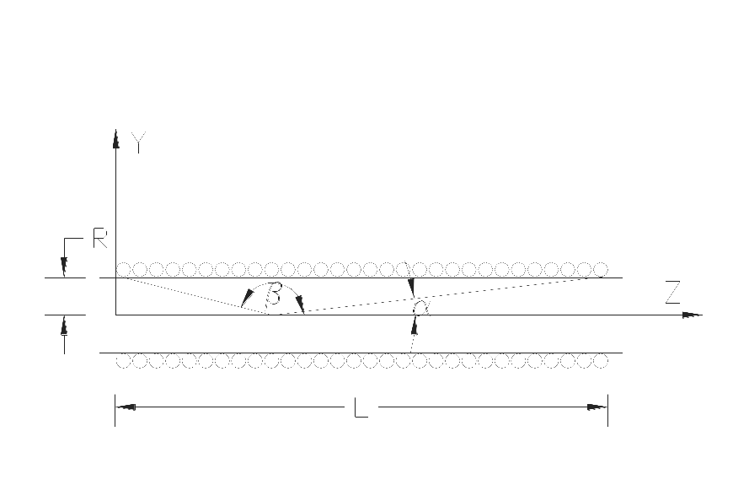
Figure 2. B field distribution along the axis of the solenoid, for a peak field of 1 T.
Figure 1. Solenoid magnet

where I is the current in a small element dl of the coil, and r is the distance between dl and the space point. Using the numerical integration we can carry out the calculation over the whole space. The B and B_{z} distribution at five radii are shown in Figure 3. For zero radius, the curve in the Figure 3 is identical to Figure 2, which verifies the accuracy of the numerical integration.

Figure 3. B and B_{z} distributions for the solenoid magnet at five radii, via numerical integration.

Using numerical integration, we also can calculate the radial field B_{r} (= B_{y} at x = 0) at the coil (r = 1m), which is shown in the Figure 4. Along this line, B_{x} is zero due to the axisymmetry.
Figure 4. The radial field B_{r} = B_{y} at the coil (r = 1m).

- Magnetic force
$f_{R}={\text{iB}}_{z},$Given the magnetic field distribution at the coil and the current density carried by the coil, the radial magnetic force f_{R} exerted per unit area on the coil is given by
where i is the current per unit axial length of the coil, as shown in Figure 5. For example, the total outward force on a 30° section of the 3m-long coil is 680,000 Newton, or 69 Tons.

The radial magnetic field will produce an axial force. For the unit axial length and a unit circumference length of the coil this force will be

$f_{z}={\text{iB}}_{y},$which is also shown in Figure 5.
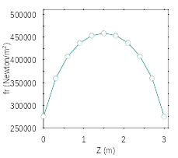
Figure 5. Distributions of (A) the radial and (B) axial force on a unit area of the coil. The dashed curve in (B) is a simplified f_{z} distribution curve.

B
A

- Stress and strain estimation
From the calculated force f_{R} above, the average radial magnetic pressure on the coil is 0.4Mpa. The resulting strain can be estimated using analytic expressions for thin-walled pressure vessels. We used Roark and Young’s formulas (Table 28 – 1B) and TK Solver on Roark & Young, to get the radial displacement and axial height change as shown in Table 1. We used an equivalent aluminum thickness 16.67mm, which corresponds to 14.1mm aluminum (E = 73Gpa) plus 1.71mm copper-based Nb-Ti superconductor (E = 110Gpa).

Name | Unit | Input | Output
Radius of the cylinder - R | mm | 1000
Height of the cylinder - H | mm | 3000
Thickness of the cylinder - t | mm | 16.67
Young’s modulus - E | MPa | 73000
Poisson’s ratio - ν |  | 0.32
Uniform radial pressure - q | MPa | 0.4
Hoop stress - σc | MPa |  | 28.3
Radial displacement - ΔR | mm |  | 0.33
Change in height - ΔH | mm |  | -0.32
Table 1. The results of TK Solver on Roark & Young for uniform radial pressure.
We notice that the radius increases 0.33mm, and the length of the cylinder decreases 0.32mm if we only take the radial magnetic force into account. We also need to consider the effect of the axial force f_{z}. In Figure 5B we can see that the axial force distribution is not uniform. To estimate the corresponding stress and strain, five subcylinders were considered, each symmetric about z = 0, and of lengths (heights) from 0.6 to 3m. The force applied to the ends of each subcylinder was the total axial force over the region z = 0.3m from the end, as listed in Table 2. These forces were used as input to Table 28 – 1A of Roark & Young’s formulas. The resulting ΔR and ΔH for the whole cylinder is then the sum of those for all five subcylinders, as shown in Table 2.

Name | Unit | Input | Output
Radius of the cylinder - R | mm | 1000
Height of the cylinder - H_{i} | mm | 3000,2400,1800,1200,600
Thickness of the cylinder - t | mm | 16.67
Young’s modulus - E | MPa | 73000
Poisson’s ratio -  |  | 0.32
Axial load - F_{i} | N/m | -28790,-22280,-11775,  -6300,-2780
Radial displacement - ΣΔR_{i} | mm |  | 0.019
Change in height - ΣΔH_{i} | mm |  | -0.14
Table 2. The results of TK Solver on Roark & Young for various axial loads.
Combining the effects of the radial and axial stress, we estimate the maximum radial increase would be about 0.35mm, and the axial decrease would be about about 0.46mm.

ANSYS finite element analysis

Finite element analysis can give us detailed stress and strain distributions for the solenoid coil. We used ANSYS element type SOLID62, which has the capability of modeling three-dimensional coupled magneto-structural field, to simulate the solenoid coil, and element types SOLID97 and SOLID96 to model the air and wall. The INTER115 elements were used between SOLID96 and SOLID97 as the interface. INFIN111 elements were used to enclose the entire outermost surface.
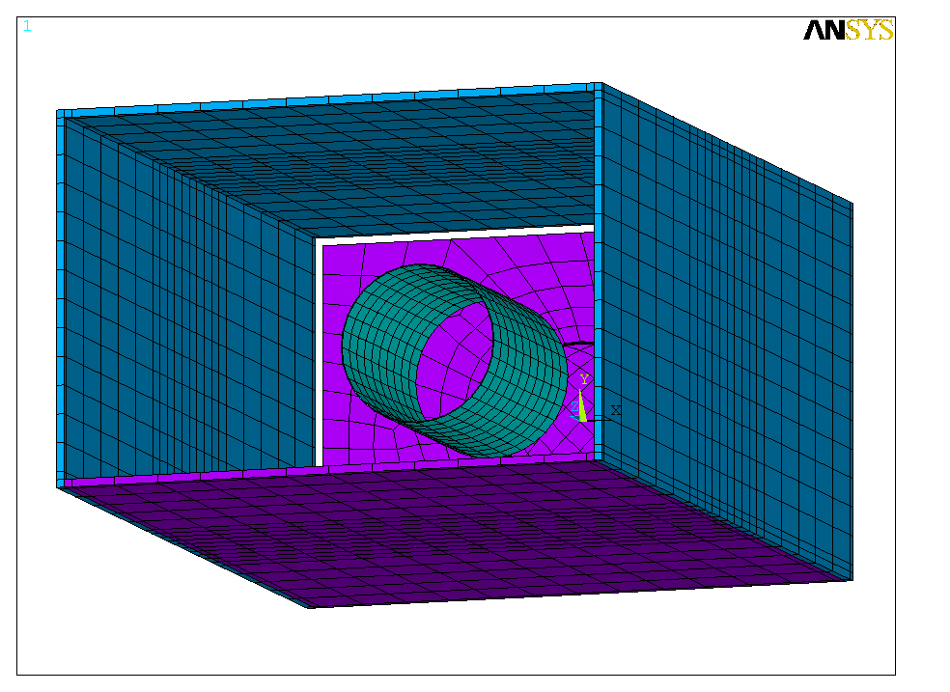
Figure 6. The geometry of FEA model

Geometry of the FEA model

The geometry of the FEA model is shown in Figure 6. The green cylinder represents the solenoid coil, which consists of two components: the inner 14.1mm thick aluminum bore tube and the outer 1.74mm thick Nb-Ti superconductor coil. The purple plates are the walls with permeability μ_{r} = 1, and the blue plates are walls with μ_{r} = 10⁶. One wall is purposely removed to reveal the position of the coil. Air elements fill up the hall and also form a layer to cover all of the outside surfaces of the walls. We set the elements of this air layer as INFIN111, and their exterior surfaces were flagged as infinite surface. The air elements are not shown in the figure.

Boundary condition

Having set the INFIN111 elements to surround the hall, we don’t need to apply any other boundary condition at the outer surface; the whole domain of the problem was extended to the infinity naturally. For the stress analysis part of the problem, we imposed the following boundary condition at two ends of the coil: at the one end we fixed all of the nodes as dX, dY and dZ = 0. The nodes at the other end of the coil are set as dX, dY = 0, and they are free to move on axial direction. The current density in the coil is set at B/(μ × S_{thick}), where S_{thick} is the thickness of the superconductor coil. With this current density flowing in the coil, the central magnetic flux of this coil would equal to B if the coil were infinitely long

Magnetic flux density B distribution

The B and B_{z} distribution at several radii are shown in Figure 7, with results very similar to those in Figures 2 and 3. The vector B distribution at the coil is plotted in Figure 8.

Magnetic force on the coil
Figure 7. B and B_{z} distribution at several radii as calculated by ANSYS.

The magnetic force vectors on the coil elements are shown in Figure 9. The force will squeeze the coil on axial direction and expand it on radial direction.
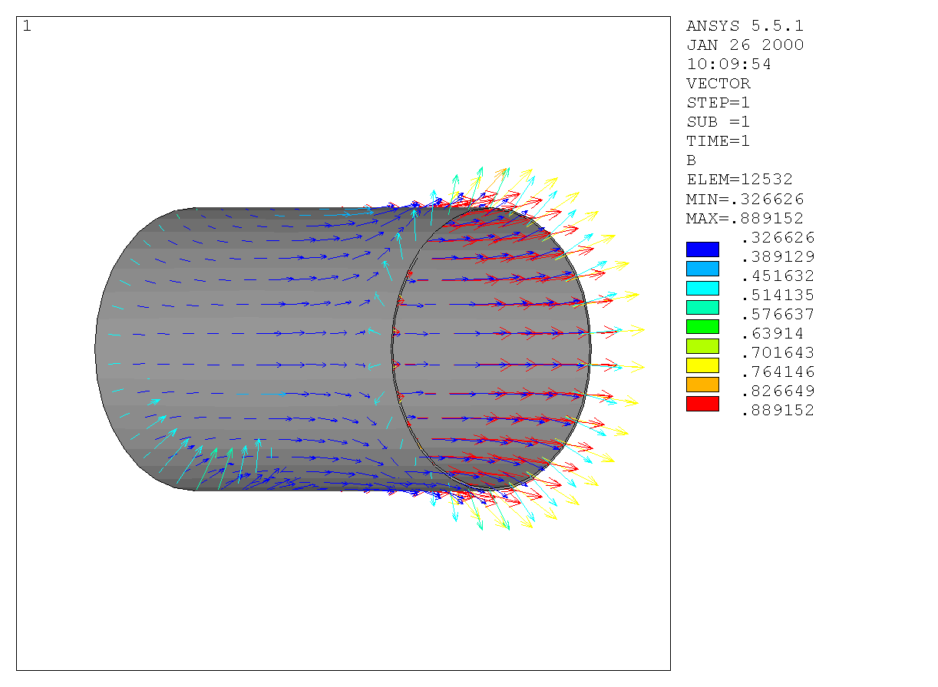
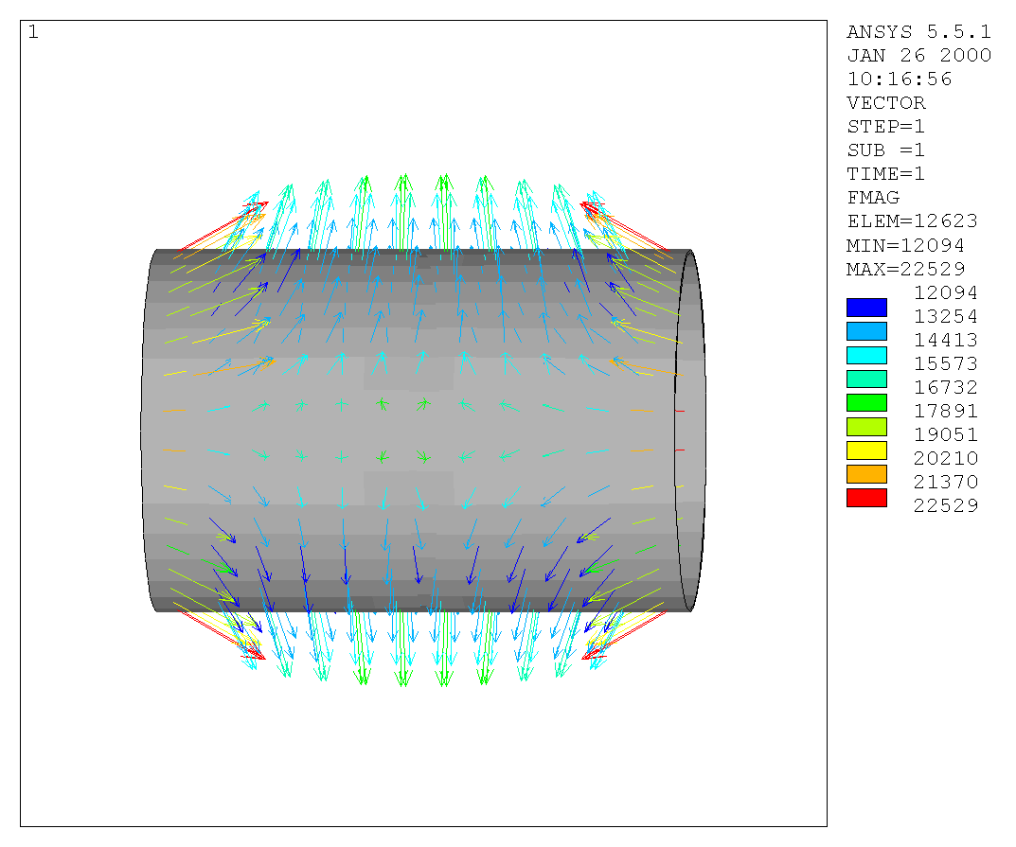
Figure 8. B vector distribution on the coil
Figure 9. Magnetic force vector distribution on the coil

Stress

The hoop stress distribution is shown in Figure 10, whose maximum is 32Mpa, and minimum is 23Mpa. This is consistent with the average value of 28.3Mpa calculated in Table 1 from Roark & Young’s formulas. The stress intensity of the coil is presented in Figure 11; with a maximum of 45Mpa. For comparison, the commercial aluminum alloy 3003 has tensile strength (ultimate strength) 110Mpa, and alloy 2014 has 185Mpa.

Deformation and Strain

The radial and axial deformation of the coil is shown in Figure 12. The average radial increase is 0.3mm, and axial decrease is 0.53mm. According to previous calculation with Roark & Young’s formulas they would be 0.35mm and 0.46mm, respectively. The strain map of the coil is shown in Figure 13. The maximum strain is 0.06%.
A

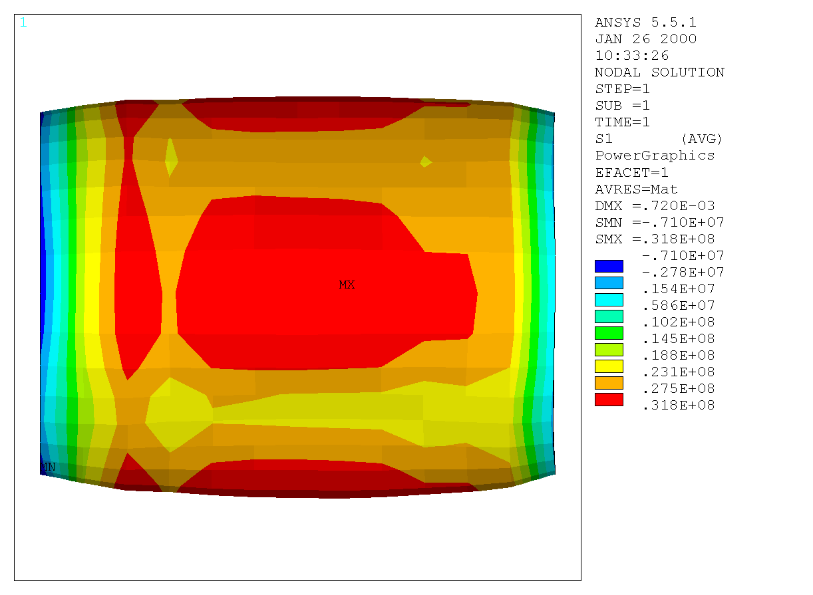
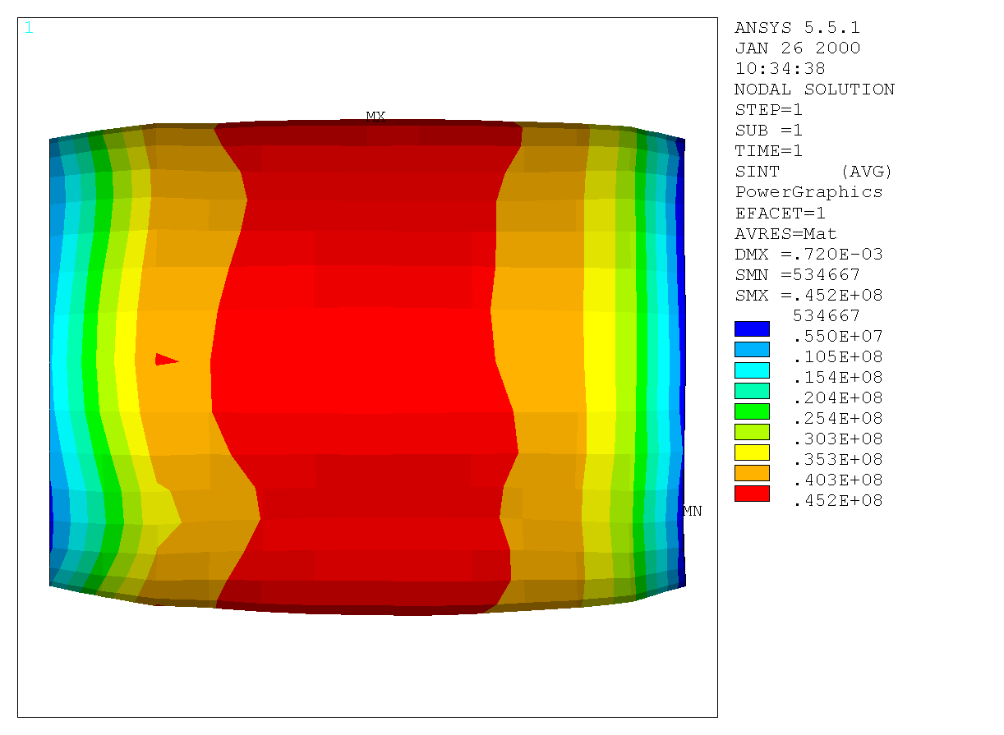
Figure 10. Hoop stress distribution
Figure 11. Stress intensity of the coil
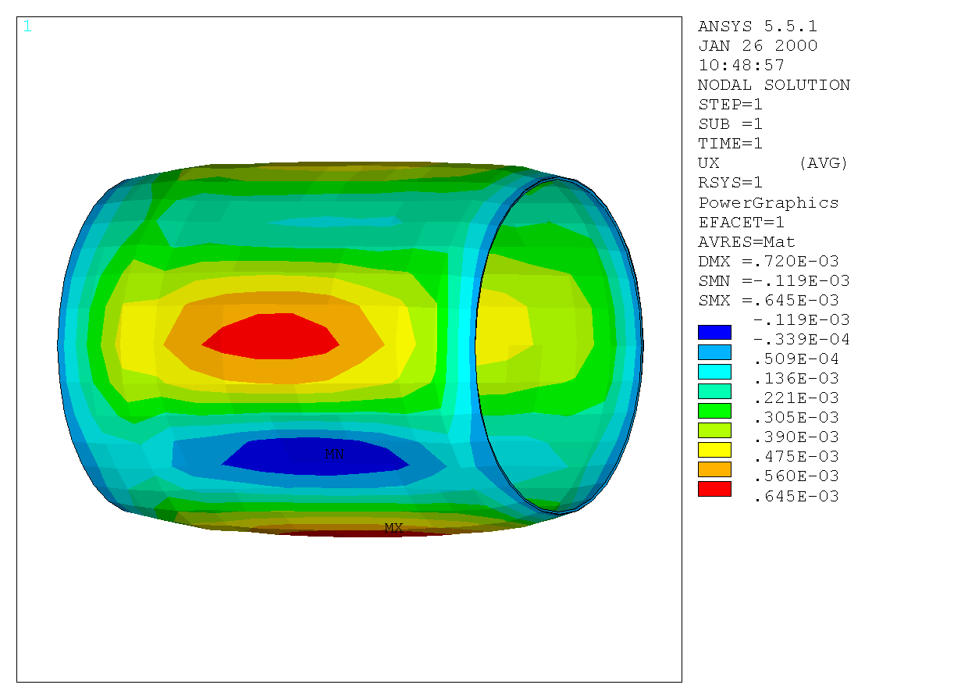
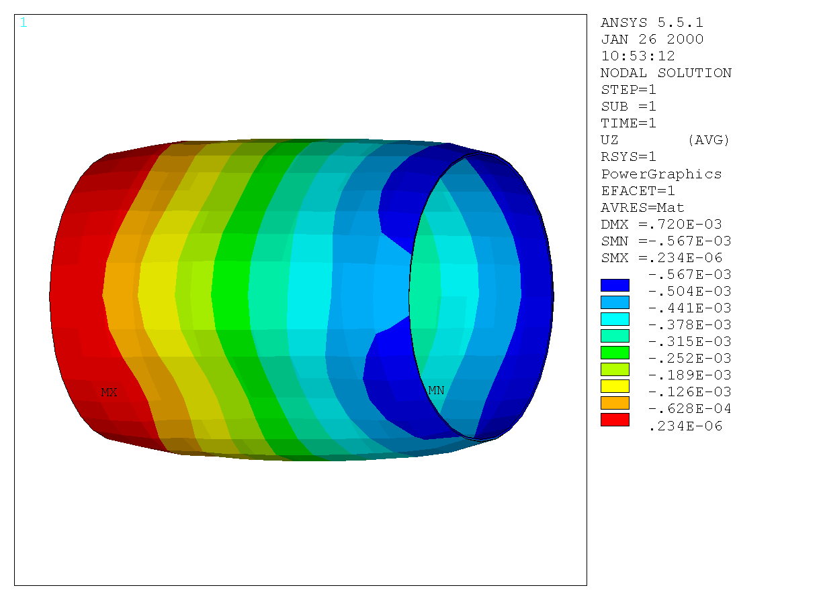
Figure 12. Deformation of the coil, (A) radial, (B) axial, the circles outlines the undeformed shape.

B

A

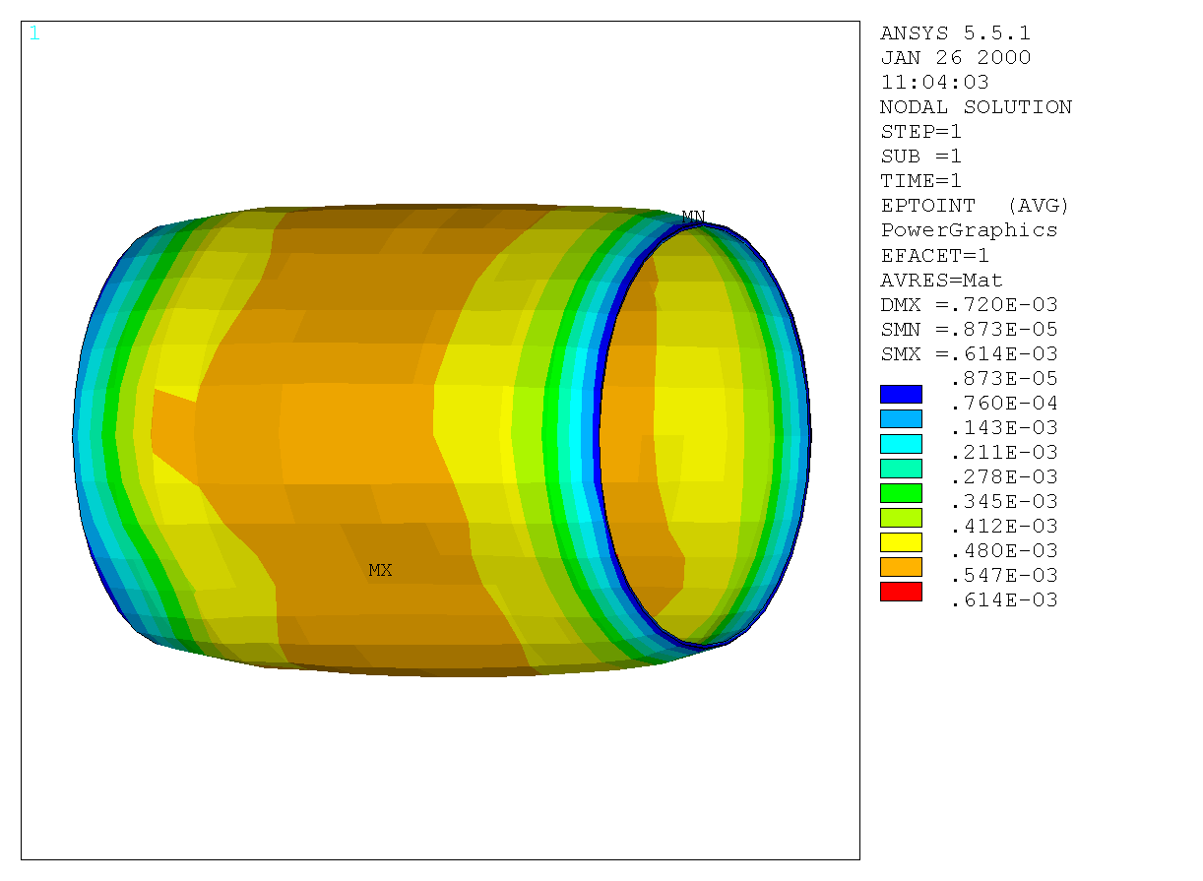
Figure 13. Strain distribution of the coil

Particularly in Figure 12A we see that the rectangular geometry of the steel walls of the experimental hall results in a pattern of radial deformation with fourfold symmetry. The spread in radial deformation is about 0.75mm, with small regions of negative radial strain. It is worrisome that this pattern might excite a buckling failure of the coil. Further study is warranted if the coil is actually to be used in such a configuration.

Lifting force

The steel ceiling and wall will exert the magnetic forces on the coil when the solenoid is energized. We set the relative permeability of the ceiling, right and left walls equal to 10⁶. The floor, the front and back walls have the same permeability as air. If the height of the hall is 4m, and the center of the solenoid coil is at 2m height, the overall lifting force on the coil is about 3.6Ton. If we placed a 5mm thick steel plate on the floor, the lifting force will be reduced to 0.7Ton.

Comparison with the calculations of original PEP-4 magnet coil engineering note

The following formulae are adopted from the original engineering note of the PEP-4 magnet coil:
$\begin{aligned}σ_{1}A_{1}+σ_{2}A_{2}=F_{t} \\ σ_{1}^{}A_{1}^{}+σ_{2}^{}A_{2}^{}=F_{t}^{} \\ δ_{1}=δ_{2} \\ δ_{1}^{}=δ_{2}^{},\end{aligned}$
where σ and δ represent the stress and strain, respectively, A is the cross-sectional area perpendicular to the direction indicated by its superscript, and F_{t} and F_{t}* are the magnetic forces on the hoop and longitudinal directions, respectively. The subscript represents the material: 1 for aluminum and 2 for Nb-Ti superconductor. The variables and parameters with superscript * represent longitudinal direction, ones without the superscript are on the hoop direction.

Since we already know the thickness of the aluminum and Nb-Ti cylinders: 14.1mm and 1.74mm, respectively, all of the areas are easy to get: A₁=A₁*=0.00174m², A₂=0.0141m². But A₂* = 0.00953m² is somewhat different from A₂, because on axial direction the cooling aluminum pipe, which is wrapped around the aluminum bore tube, is not glued together, the effective aluminum thickness of the cooling pipe (4.6mm) is not added to the thickness of the aluminum bore tube (9.53mm).

Besides those four independent equations, there are another four equations due to Hook’s law to relate the stress and strain,
2
2
2
*
2
*
2
*
2
1
1
1
*
1
*
1
*
1
E
E
E
E
σ
ν
σ
δ
σ
ν
σ
δ
−
=
−
=
*
σ
σ
*
2
*
2
*
2
2
2
2
*
1
1
*
1
1
1
1
E
E
E
E
σ
ν
σ
δ
ν
δ
−
=
−
=

where ν is the Poisson’s ratio.

Here, we only consider the hoop stress, neglecting the axial force. The hoop force per unit length along the axial direction is
$F_{t}=\frac{N⋅i⋅B⋅R}{2L}$
where N is the total turns of the coil, i is the current in each turn, B is the magnetic flux density in the central region of the magnet, R and L are the radius and length of the coil. In our case, N = 1772, i = 1463A, B = 1Tesla. Therefore F_{t} = 4.692×10⁵ N.

Solving the set of equations we get the following results: δ₁ = 4.025×10⁻⁴, δ₁* = −1.288×10⁻⁴, which correspond to ΔR = δ₁R = 0.4mm, ΔH = δ₁*L = −0.386mm. These numbers are also similar to the results from ANSYS.

Conclusion

The stress and strain analysis by Roark & Young’s formulas and ANSYS FEA calculation on the bare superconductor coil provides consistent results. The maximum stress from FEA calculation is 45Mpa, which is much less than the tensile strength for most of the commercial aluminum alloys. With FEA model we can simulate various real situations, such as tilting the coil, placing a steel plate on the floor to balance the lifting force, etc.

The azimuthal variation in the radial deformation of the coil due to its interaction with the rectangular steel walls of the experimental hall deserves further study to insure that it would not lead to a buckling failure of the coil.

J. Alessi et al., A Proposal for an R&D Program for Targetry and Capture at a Muon Collider Source (Sept. 29, 1998), http://puhep1.princeton.edu/mumu/target/targetprop.ps
A. DuBois and M. Green, Basic Parameters of the Cryostat and Coil as Fabricated in 1982, LBL Engineerint Note LBID-665 (Jan. 6, 1983).
? We used Mathcad 2000, MathSoft, Inc.
Warren C. Young, Roark’s Formulas for Stress & Strain, 6th ed. (McGraw-Hill, New York).
TK Solver 1.1, Universal Technical System, Inc.
M.A. Green, The Large Superconducting Solenoid Magnet: Stress & Strain within the Coil Package, LBL Engineering Note M5349 (June 1979).

