PRINCETON UNVERSITY PHYSICS DEPARTMENT DEVELOPMENT OF THE MERCURY ARC

WETTING EXPERIMENTS WITH WOOD’S METAL

February 5, 2003
E. de Haas

Summary: Two types of Wood’s metal were found to wet quartz plates.

The question had come up if the mercury in the arc could be replaced by liquid Wood’s metal, because mercury vapors are unhealthy, if the experimenter inhales them.
What can hold experiments back, may be the fact that the metal may wet quartz surfaces. If that happens, any splashes from the arc are liable to eventually cover the quartz windows and that will make it difficult to take pictures of or even look at the arc. The only way to find out is to imitate the actual situation in a quick mock-up.

THE MATERIAL.
Belmont Metals Inc. of Brooklyn, N.Y. publishes a list of well over one hundred types of Wood’s metal that they can offer. Most of those actually exist; the remainder can be made to order.
The majority of the alloys contain bismuth. In effect Belmont includes the bismuth content as the central two digits in their numbering system (e.g. #2552 contains 55% bismuth). The other common metals are lead, tin, indium and cadmium. The alloy melting points vary from about 40C to about 140C.
Earlier tests had shown that indium containing alloys wet glass and quartz. Also cadmium has certain health hazards. For those reasons we selected alloys that lacked indium and cadmium, namely #2531 (analysis 52.5% bismuth, 32% lead, 15.5% tin) melting point 95C and #2552 (55.5% bismuth, 44.5% lead) melting point 124C.

TEST METHOD
We put a Wood’s metal sample in a glass tube with a spout at one end and closed with a cork with a small hole at the other end. Rubber tubing permitted the glass tube to be connected to a squeeze ball. The assembly together with a plate of glass and one of quartz were placed in an oven and heated to 30 or 40C above the alloy’s melting point. The glass and quartz were leaning against the side of the oven with about a ten degree angle with the vertical. We gave the equipment enough time to get warm through and through, then opened the oven door and quickly squeezed the ball and splashed Wood’s metal on the glass and quartz surfaces. We noted that most of the metal ran off, but enough of it wetted the samples so that eventually it became difficult to look through them.

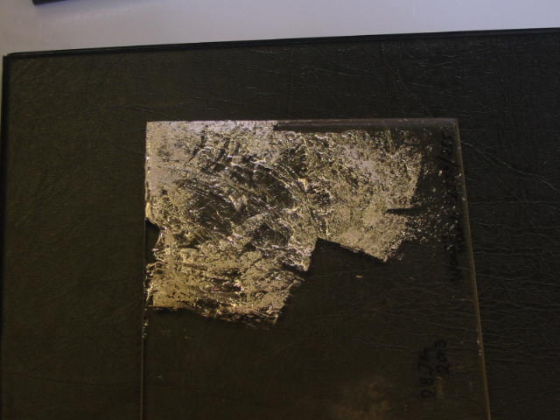
Residue of Belmont alloy 2552 on a quartz window
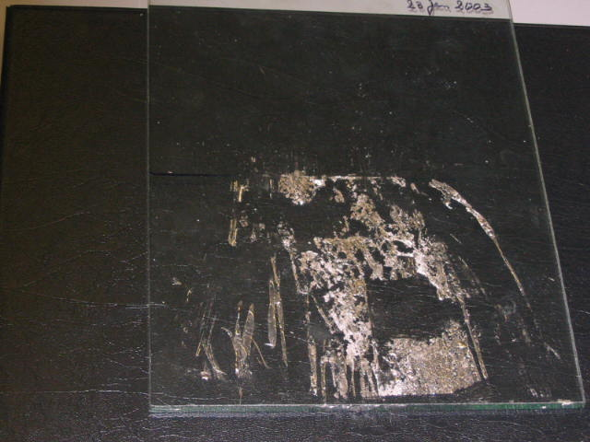
Residue of Belmont alloy 2552 on a glass window

It should be noted that the metal did not bond to the glass or quartz. It could be wiped off readily, while liquid and removed with a spatula after the samples had cooled to room temperature outside the oven.
A repeat test with the second alloy gave the same results.

CONCLUSIONS
Mercury remains the liquid of choice for the experiment.

A report dated Sept. 24/2002 with two appendixes shows that the risks are minimal in a well ventilated area. Even so, if the risk can be eliminated altogether, it is worth a brief investigation.

