Requirements for the
Passage(s) from TT2A to TT2
For the purpose of minimizing costs for connections between MERIT and auxiliaries

A. Fabich, 7 Feb 2006

Procedure: This document shall provide input to the layout of the TT2A/TT2 passages to be installed. Responsibles of the different systems should review and/or complete the information below. Information below is collected from various e-mail exchanges. It shall also serve as a template for additional input. A price inquiry is launched at the same time. The Figure below is used as a principle sketch for discussion purposes. It shows a possible scenario, but does not represent definitive layout (except the place of the solenoid/target/mercury loop, which is definitive). Auxiliaries can be rearranged together with the passages.

Deadline: Please reply (to Adrian only) until 15.Feb. 2006 with your input. The final design of the passages to be installed will be distributed again for final approval.

The floor of TT2 (auxiliaries) is above the floor of TT2A (solenoid side) by a height h in meters of h = 0.087 z + 1.69, where z in meters is given being 0 at interaction point and z runs with the beam. This function is valid for -14.8 < z < 10.

Diagnostics (T. Tsang):
- Application: Fibers for light source and image
- Preferred location of passage: z = +1.289 m
- Preferred height of penetration: n.a.
- Maximum distance between MERIT (z=0) and auxiliary rack: 6 m or 10 m
- Description of items to pass: For each viewing port (4) a fiber from the light source and a fiber to the camera is need. A total of 8 fiber bundles with a diameter each not bigger than a few millimeters are running through the passage.
- Minimum diameter of passage (circular): 5 cm (to pass connectors as well)
- Special requirements: only in contact with temperature sources 10^{O}C<T<40 ^{O}C
- Space allocation in TT2: 1 electronic rack (footprint 1m x 1m)
- Additional comments: To keep the distance between z=0 and the electronic rack at an absolute minimum is the major issue.
Mercury loop, driving circuit (V. Graves):
- Application: Hydr. circuit
- Preferred location of passage: z = +1⁺²⁻² m
- Preferred height of penetration: n.a.
- Maximum distance between MERIT (z=0) and auxiliary rack: n.a.
- Description of items to pass: hydraulic hoses & fluid couplings
- Minimum diameter of passage (circular): ~125 mm
- Space allocation in TT2: 1 pump station (1m x 1.8m), 1 electronic rack
- Special requirements: ---
- Additional comments: ---
Solenoid/cryostat (P. Titus/F. Haug):
- Application: Read-out of sensors
- Preferred location of passage: z = -1^{+0.5-0.5} m
- Preferred height of penetration: n.a.
- Maximum distance between MERIT (z=0) and auxiliary rack: n.a.
- Description of items to pass: signal wires
- Minimum diameter of passage (circular): ~100 mm
- Space allocation in TT2: 1 electronic rack
- Special requirements: ---
- Additional comments: ---
Cryogenics (F. Haug):
- Application: Supply and drain of nitrogen (N2, LN2)
- Preferred location of passage: z = -1^{+0-0.5} m
- Preferred height of penetration: n.a.
- Maximum distance between MERIT (z=0) and auxiliary rack: n.a.
- Description of items to pass: Four pipes with an outer diameter of each 100 mm are running from TT2A to TT2.
- Minimum diameter of passage (circular): ~120 mm; No parts larger than the tube diameter of 100 mm have to pass.
- Space allocation in TT2: 1 electronic rack, 1 DVB box, 1 heater
- Special requirements: ---
- Additional comments: ---
Particle detectors (I.Efthymiopoulos):
- Application: Supply and read-out cables
- Preferred location of passage: n.a.
- Preferred height of penetration: n.a.
- Maximum distance between MERIT (z=0) and auxiliary rack: n.a.
- Description of items to pass: HV and signal cables
- Minimum diameter of passage (circular): ~100 mm; No parts larger than electronic connectors.
- Special requirements: ---
Beam diagnostics (I.Efthymiopoulos):
- No needs
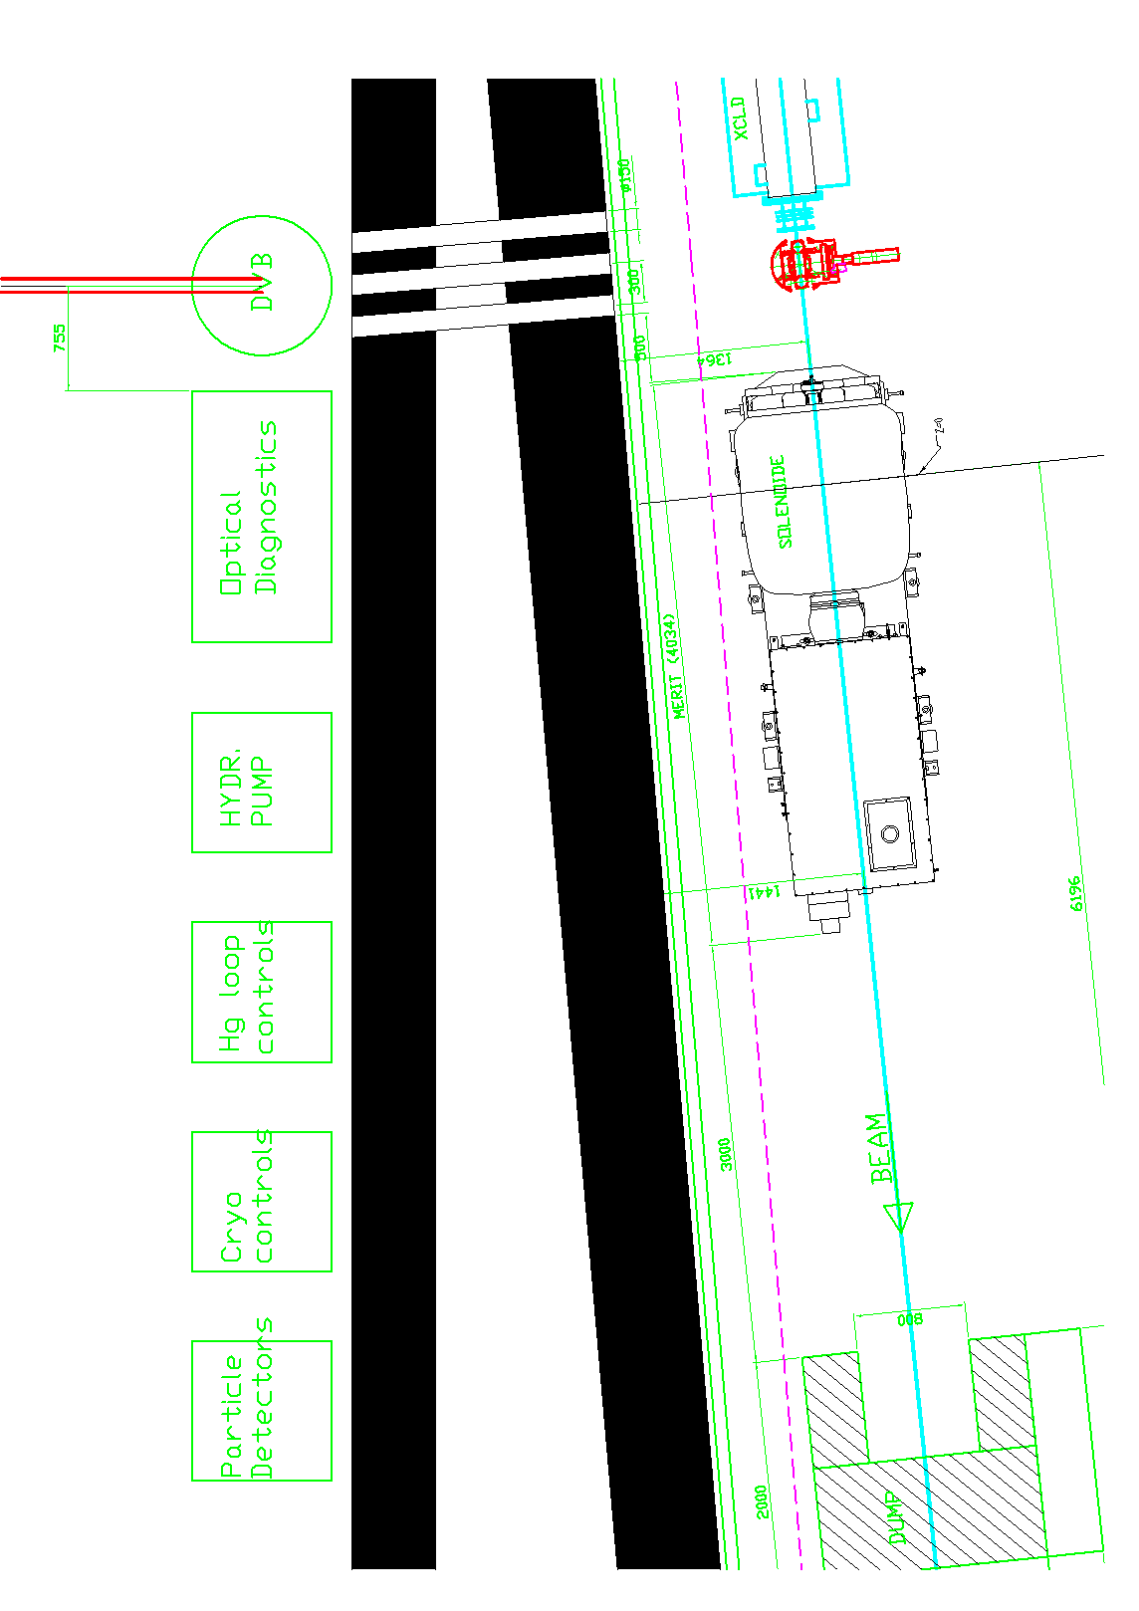

The z-axis is running in the beam-direction, e.g. a point upstream of the target center z=0 has a negative value.

