Use of He Gas Cooled by Liquid Hydrogen with a 15-T Pulsed Copper Solenoid Magnet

McDonald, K.T.

Princeton University, P.O. Box 708, Princeton, NJ 08544, USA

Iarocci, M. and Kirk, H.G.

Brookhaven National Laboratory, P.O. Box 5000, Upton, NY 11973, USA

Mulholland, G.T. (deceased)

Applied Cryogenics Technology, P.O. Box 2158, Ovilla, TX 75154, USA

Titus, P.H.

Princeton Plasma Physics Laboratory, P.O. Box 451, Princeton, NJ 08543, USA

Weggel, R.J.

Particle Beam Lasers, Inc., 18925 Dearborn Street, Northridge, CA 91324, USA

The power required to energize a copper magnet is minimized by operation at the lowest possible temperature. However, the resistance of copper drops very little at temperatures lower than 30 K, which defines a desirable temperature for economic operation of high-field/high-current magnets. Liquid hydrogen (at 1 bar) is therefore a natural candidate as the coolant for high-power copper magnets. Issues of safety make it prudent that the copper conductors (which could generate sparks during magnet failures) not be directly cooled by liquid hydrogen. Hence, a favorable scheme is that the magnet be cooled by flow of helium gas at ~ 30 K, with this gas cooled in an external heat exchanger with a liquid-helium bath. A design based on this scheme was developed (although not implemented) for the 15-T pulsed solenoid used in the so-called MERIT experiment at the CERN Laboratory (Switzerland).

INTRODUCTION

The motivation to cool any magnet cryogenically, DC or pulsed, superconducting or not, is to improve the electrical conductivity of its conductor. The application described in this paper involved a 15-T pulsed, copper solenoid magnet [1,2] requiring a peak current of 7500 A. The room-temperature resistance of the magnet was 1.25 Ω, such that a peak power of 70 MW would have been required to energize the magnet at this temperature. To be able to operate with an available power supply of only a few MW capability, we cooled the magnet.

Figure 1 (left) shows that the resistivity of high-purity copper declines greatly from room temperature down to 30 K. The incentive to operate at cryogenic temperatures is great indeed. Cooling to 80 K (with liquid nitrogen at atmospheric pressure) improves the electrical conductivity by a factor of nearly seven. Cooling to 66 K (with liquid nitrogen subcooled to nearly its freezing point of 64 K) gives a ratio of about ten. Cooling to 30 K (with liquid hydrogen as the heat sink, for example) can achieve a ratio of about 30.

There is very little motivation to cool copper conductor still further; one has entered a regime of diminishing returns. Figure 1 (right) illustrates two of the reasons for this. One is that electrical resistivity improves rather little. This is true even for copper that is exceedingly pure, unless it is so completely annealed as to be too weak for a very high field magnet. The other reason is that, if the copper is uncooled, with only its heat capacity to limit its temperature rise, it will heat up very rapidly, because its heat capacity plummets, approximately as T³, below ~30 K. The heating rate, proportional to ρ/c_{p}, is three times worse at 20 K than at 30 K.

Fig. 1. Left: Electrical resistivity ρ, heat capacity c_{p}, and ratio ρ/c_{p} between room temperature and 30 K, for copper with a residual resistivity of 0.05 μΩ cm below ~20 K. Right: Low-temperature electrical resistivity ρ, heat capacity c_{p}, and ratio ρ/c_{p} for copper with a residual resistivity of 0.05 μΩ cm below 20 K.

THE COOLING CONCEPT

Although the magnet was eventually operated at 80 K with an 8 MW power supply [3], we also designed a system [4,5] to cool the pulsed solenoid magnet (PSM) to 30 K (at which a 4 MW power supply would have sufficed) by helium gas that circulated through an external heat exchanger (HE) filled with liquid hydrogen (LH₂) from a storage Dewar, with the exhaust hydrogen gas vented to the atmosphere, as illustrated in Fig. 2. This concept is based on a magnet built in 1946 [6] that was directly cooled by liquid hydrogen, following a suggestion by Cockcroft in 1928 that magnet coils be cooled by liquid air [7]. See also [8,9].

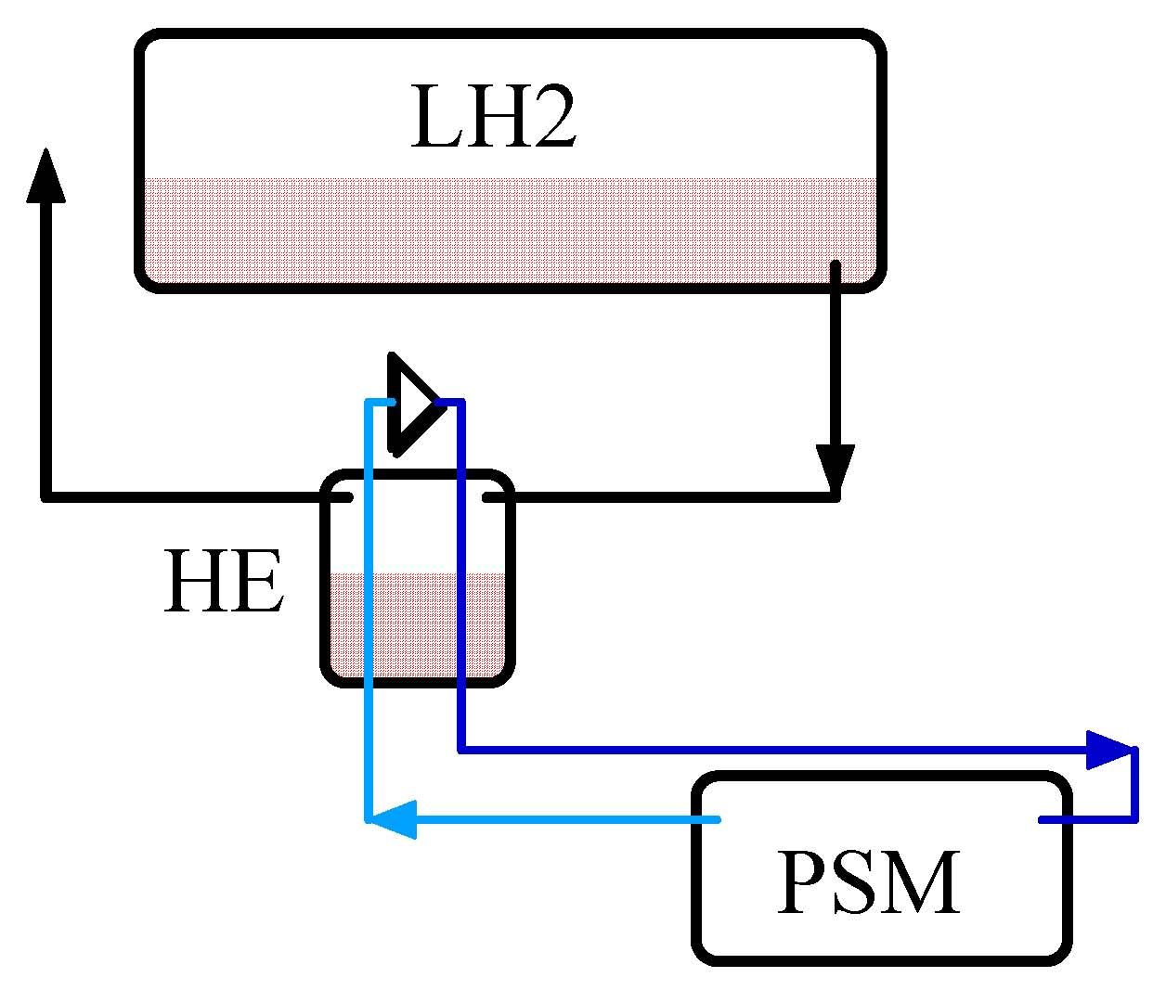
2

Fig. 2. Concept of the scheme to cool a pulsed solenoid magnet (PSM) by helium gas that is in turn cooled by liquid hydrogen (LH₂) in a heat exchanger (HE).

CHOICE OF CRYOGENS

Having chosen an operating temperature of 30 K for the magnet, possible cryogens for the circulating gas and liquid coolant were helium, hydrogen and neon. As magnets have been known to catch fire due to internal shorting, hydrogen was not considered for the circulating gas. Since helium and neon gas have the same capacity per volume at a given temperature (such that both are gases), there was no advantage to using the more expensive neon, and helium was chosen as the circulating gas. The choice of liquid hydrogen for use in the heat exchanger was made on the basis of a calculation [11], based on parameters given in Tables 1 and 2.

Table 1. Viable cryogens with a normal boiling point (NBP) below 30 K, and liquid nitrogen for reference. Subscripts L and V refer to liquid and vapor at T_{NBP}, while subscript G refers to values taken at 0˚C. The Vaporization Index (VI) = 10³⋅(300-T_{NBP}) / (ρ_{L}⋅ΔH_{V}), where ρ is density and ΔH_{V} is the heat of vaporization.

A quality factor Q for the refrigeration of the circulating gas via liquid cryogen consumption (boiling in the heat exchanger) was defined as
Q (kJ/$US) = ΔH_{V} ⋅ ρ_{L} ⋅ (1 m³/1000 liter) ⋅ (liter/$US).

That is, Q is a kiloJoule of heat-of-vaporization/$US at T_{NBP}. Relevant Q values are given in Table 2.

Table 2. Viable cryogens with NBP below 30 K and liquid nitrogen, and their quality value Q, based on refrigeration/cost at T_{NBP}. The costs are representative of the year 2002 when this study was made.

An operational cycle of the system involved a few-second-long pulse of the 15-T magnet during which about 18 MJ = 18,000 kJ of energy was generated, followed by a 30-minute cooldown during which this energy was transferred to the boiling liquid in the heat exchanger. The estimated cost for one cooling cycle (pulse) with LH₂, LHe and LNe is

LH₂ Cooling Cost = 18,000 / Q = $300 per pulse,

LHe Cooling Cost = (60/0.85) ⋅ (LH₂ Cooling Cost) = $21,000 per pulse.

LNe Cooling Cost = (60/0.60) ⋅ (LH₂ Cooling Cost) = $30,000 per pulse.

Clearly, liquid hydrogen is much more economical than either helium or neon on a per pulse basis.

A full PI diagram for this system was developed, as shown in Fig. 3.

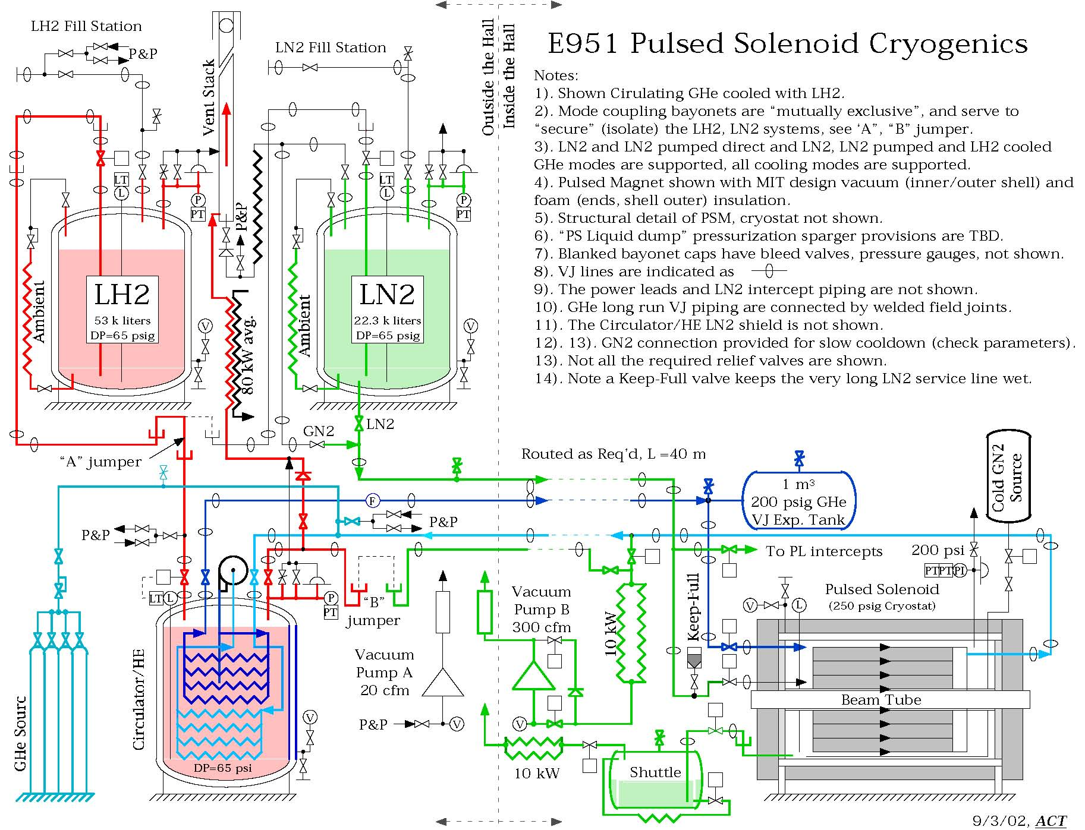
Fig. 3. Piping and Instrument diagram for the proposed cryogenic system to operate a 15-T pulsed, copper solenoid magnet at 30 K.

A surplus heat exchanger (from the never-completed Superconducting SuperCollider) of an appropriate size was identified (Fig. 4). The heat exchanger was to be equipped with s semi-hermetic centrifugal pump operating at about 1.5 bar, circulating He gas at a rate of about 100 l/s, which would have generated about 1 kW of heat (in addition to the 10 kW load of the He gas heated by the magnet). A 20,000-l Dewar was foreseen for the liquid hydrogen.
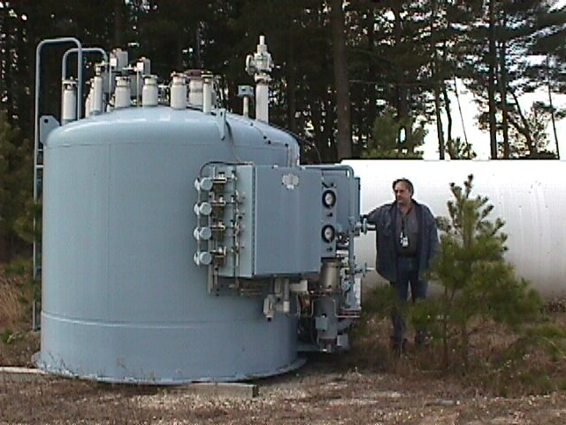

Fig. 4. The SSC-surplus heat exchanger for possible use in the proposed cryogenic system.
Discussions with the Laboratory Safety Committee as to the use of liquid hydrogen had begun, but when an 8 MW power supply became available that would permit operation of the magnet at 15 T at 80 K, cooled by liquid nitrogen [12], we implemented that option [13].

REFERENCES

- Weggel, R.J., A Three-Stage Cryogenic Pulse Magnet Program for BNL Targetry Experiment (Apr. 12, 2002), http://www.hep.princeton.edu/~mcdonald/mumu/target/weggel/E951Juan2.pdf
- Titus, P.H., E951 15-T Pulsed Magnet Design Report (March, 2007), http://www.hep.princeton.edu/~mcdonald/mumu/target/MIT/design/magnet_design_0307.pdf
- Kirk, H.G, et al., A 15-T Pulsed Solenoid for a High-Power Target Experiment, paper WEPP170, EPAC08 (Genoa, June 25, 2008), http://www.hep.princeton.edu/~mcdonald/mumu/target/EPAC08/wepp170.pdf
- Iarocci, M., Cryogenic Cooling System for the E951 Pulsed Solenoid Magnet (Feb. 9, 2002), http://www.hep.princeton.edu/~mcdonald/mumu/target/iarocci/muon_collider_tech_brd_e951.pdf
- Mulholland, G.T., E951 Cryogenics for Pulsed Solenoid Magnet (Sept. 6, 2002), http://www.hep.princeton.edu/~mcdonald/mumu/target/mulholland/E951_ESR_Pres_090602.pdf
- deHaas, W.J. and Westerdijk, J.B., Strong Magnetic Fields, Nature (1946) 158, 271-272.
- Cockcroft, J.D., The Design of Coils for the Production of Strong Magnetic Fields, Proc. Roy. Soc (London) (1928) 227, 317-343.
- Laquer, H.L. and Hammel, E.F., Cryogenic Magnets I. Feasibility Study, Rev. Sci. Instrum. (1957) 28, 875-878.
- Purcell, J.R. and Payne, E.G., High-Field Liquid H₂-Cooled, Aluminum-Wound Magnet, Rev. Sci. Instrum. (1963) 34, 893-897.
- Hirabayashi, H., et al., Feasibility of Hydrogen Cooled Superconducting Magnets, IEEE Trans. Appl. Supercond. (2006) 16, 1435-1438.
- Mulholland, G.T. et al., Technical / Economic Justification for the Use of Liquid Hydrogen to Cool the E951 15-T Pulsed Solenoid Magnet (Aug. 15, 2002), http://www.hep.princeton.edu/~mcdonald/mumu/target/mulholland/E951_Hydrogen_Justification.pdf
- Fritz, J.J. and Johnston, H.L., Design and Operation of Liquid Nitrogen-Cooled Solenoid Magnets, Rev. Sci. Instrum. (19490 21, 416-420.
- Haug, F. et al., Cooling System for the MERIT High-Power Target Experiment (June 30, 2009), http://www.hep.princeton.edu/~mcdonald/mumu/target/Pereira/MERIT_PRESENTATION.pdf

This contrasts with recent proposals to cool high-temperature superconducting magnets directly with liquid hydrogen [9].

