Gallium AS A Possible Target Material for a Muon Collider or neutrino factory
X. Ding#, D. Cline, UCLA, Los Angeles, CA 90095, USA
H. G. Kirk, J. S. Berg, H.K. Sayed, Brookhaven National Laboratory, Upton, NY 11973, USA
V. B. Graves, ORNL, Oak Ridge, TN 37831, USA
N. Souchlas, R. J. Weggel, Particle Beam lasers, Inc., Northridge, CA 91324, USA
K. T. McDonald, Princeton University, Princeton, NJ 08544, USA

Abstract
We consider the potential for gallium as an option for a muon collider or neutrino factory target. Advantages of such a target choice are its liquid state at relatively low temperature, its relative efficient meson production, and its potential for easier handling. Using the MARS code, we simulate particle production initiated by incoming protons with kinetic energies between 2 and 16 GeV. For each proton beam energy, we optimize the geometric parameters of the target: the radius of the liquid jet, the incoming proton beam angle, and the crossing angle between the jet and the proton beam. We compare the quantity of generated muons using this type of target to the case in which a free-flowing mercury jet is utilized.

Introduction
The baseline option for a possible future Muon Collider (MC) or Neutrino Factory (NF) is to use a 4-MW proton beam interacting with a free-flowing mercury jet to create copious amounts of pions that are captured in a high-field solenoid magnet system (~ 20 T). The pions are then transported into a tapered solenoid decay channel in which decay muons will be captured, cooled and stored in a storage ring, either to provide for μ⁺μ⁻ collisions or to produce intense neutrino beams. In a previous work [1] based on MARS [2] simulations, we optimized a mercury jet target utilizing the Neutrino factory Study 2 target configuration [3]. We simulated particle production initiated by incoming protons with kinetic energies between 2 and 100 GeV. For each proton beam kinetic energy, we maximized meson production by varying the geometric parameters of the target: the mercury jet radius, the incoming proton beam angle, and the crossing angle between the mercury jet and the proton beam. With an 8-GeV proton beam, we studied the variation of meson production with the entry direction of the proton beam relative to the jet. We also examined the influence on meson production by the focusing of the proton beam. The number of muons surviving through the neutrino factory front end channel was determined as a function of the proton beam kinetic energy.

#xding@bnl.gov

In order to provide more shielding for the superconducting coils surrounding the target, the target system has been reconfigured. The new capture system used for this study is referred to as IDS120h [4] (see Fig. 1). The inner radius of superconducting coils (SC) in the region surrounding the mercury jet target region has been increased from 63.5 cm to 120 cm. The axial field in the decay channel has been increased from 1.25T in Study 2 to 1.5T in IDS120h. In addition, based on the pion/muon yields for different atomic Z’s and beam energies [5], we demonstrate that Gallium can be a possible alternative to Hg. Gallium has relative efficient meson production (similar to the Cu or Ni), is a liquid at relatively low temperatures (melting point of 29.8⁰ C) and is potentially easier to handle. In this paper, we report our simulation work on meson productions and optimization studies for both Hg and Ga utilizing the field map of the new IDS120h target configuration.
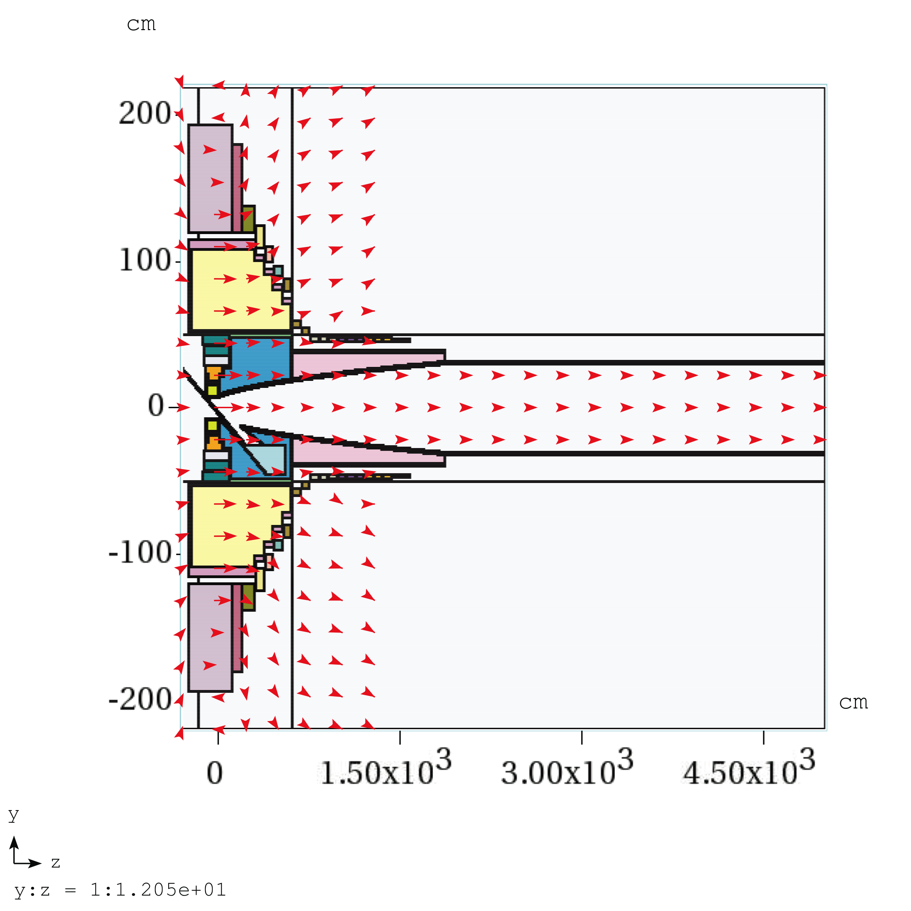
Figure 1: Schematic of IDS120h Configuration.

Optimization method
Fig. 2 is a schematic of mercury jet target geometry. Based on our previous target simulation experience, we have established new setting procedures for the Hg/Ga target geometry in the IDS120h configuration. First, the launching point for the proton beam is at z = -200 cm to avoid portions of the launched beam being inside the Hg/Ga jet. Second, we place the beam exactly below the Hg/Ga jet at the beam/jet intersection point (0, 0, -37.5 cm). In our previous study, the beam was below the Hg jet at the launching point of z = -75 cm.
For our optimization method, we launch 3 runs in each cycle: 1) Vary jet radius with initial beam angle and beam/jet crossing angle fixed; 2) Vary beam/jet crossing angle with the new target radius while keeping the beam angle fixed; 3) Vary the beam angle with the new target radius while adjusting the jet angle to always maintain a constant beam/jet crossing angle. We repeat the above cycle until convergence is achieved.
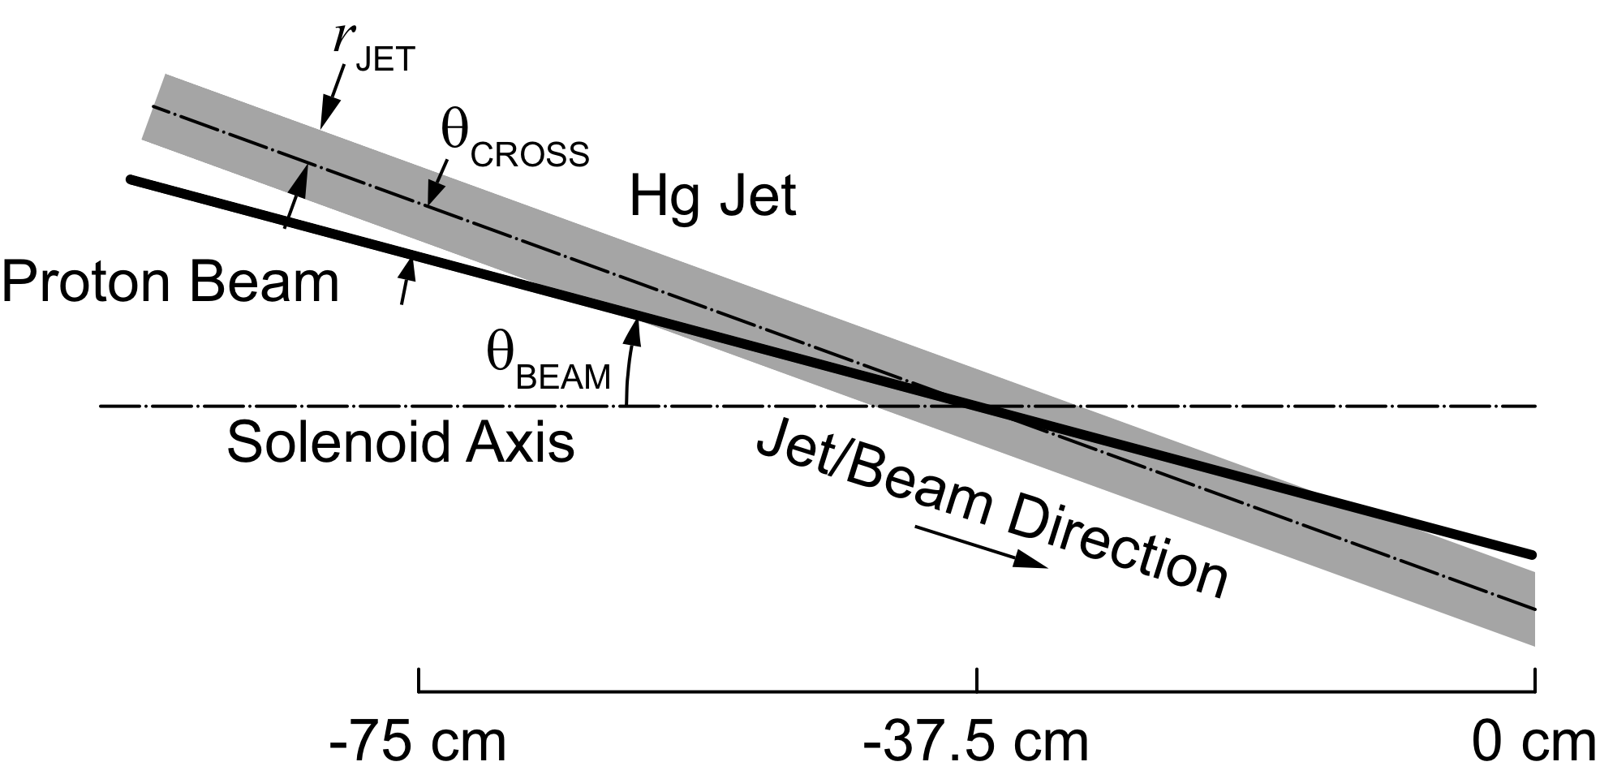
Figure 2: The mercury jet target geometry. The proton beam and mercury jet trajectories intercept at z=-37.5 cm.

Optimized Target parameters and meson productions
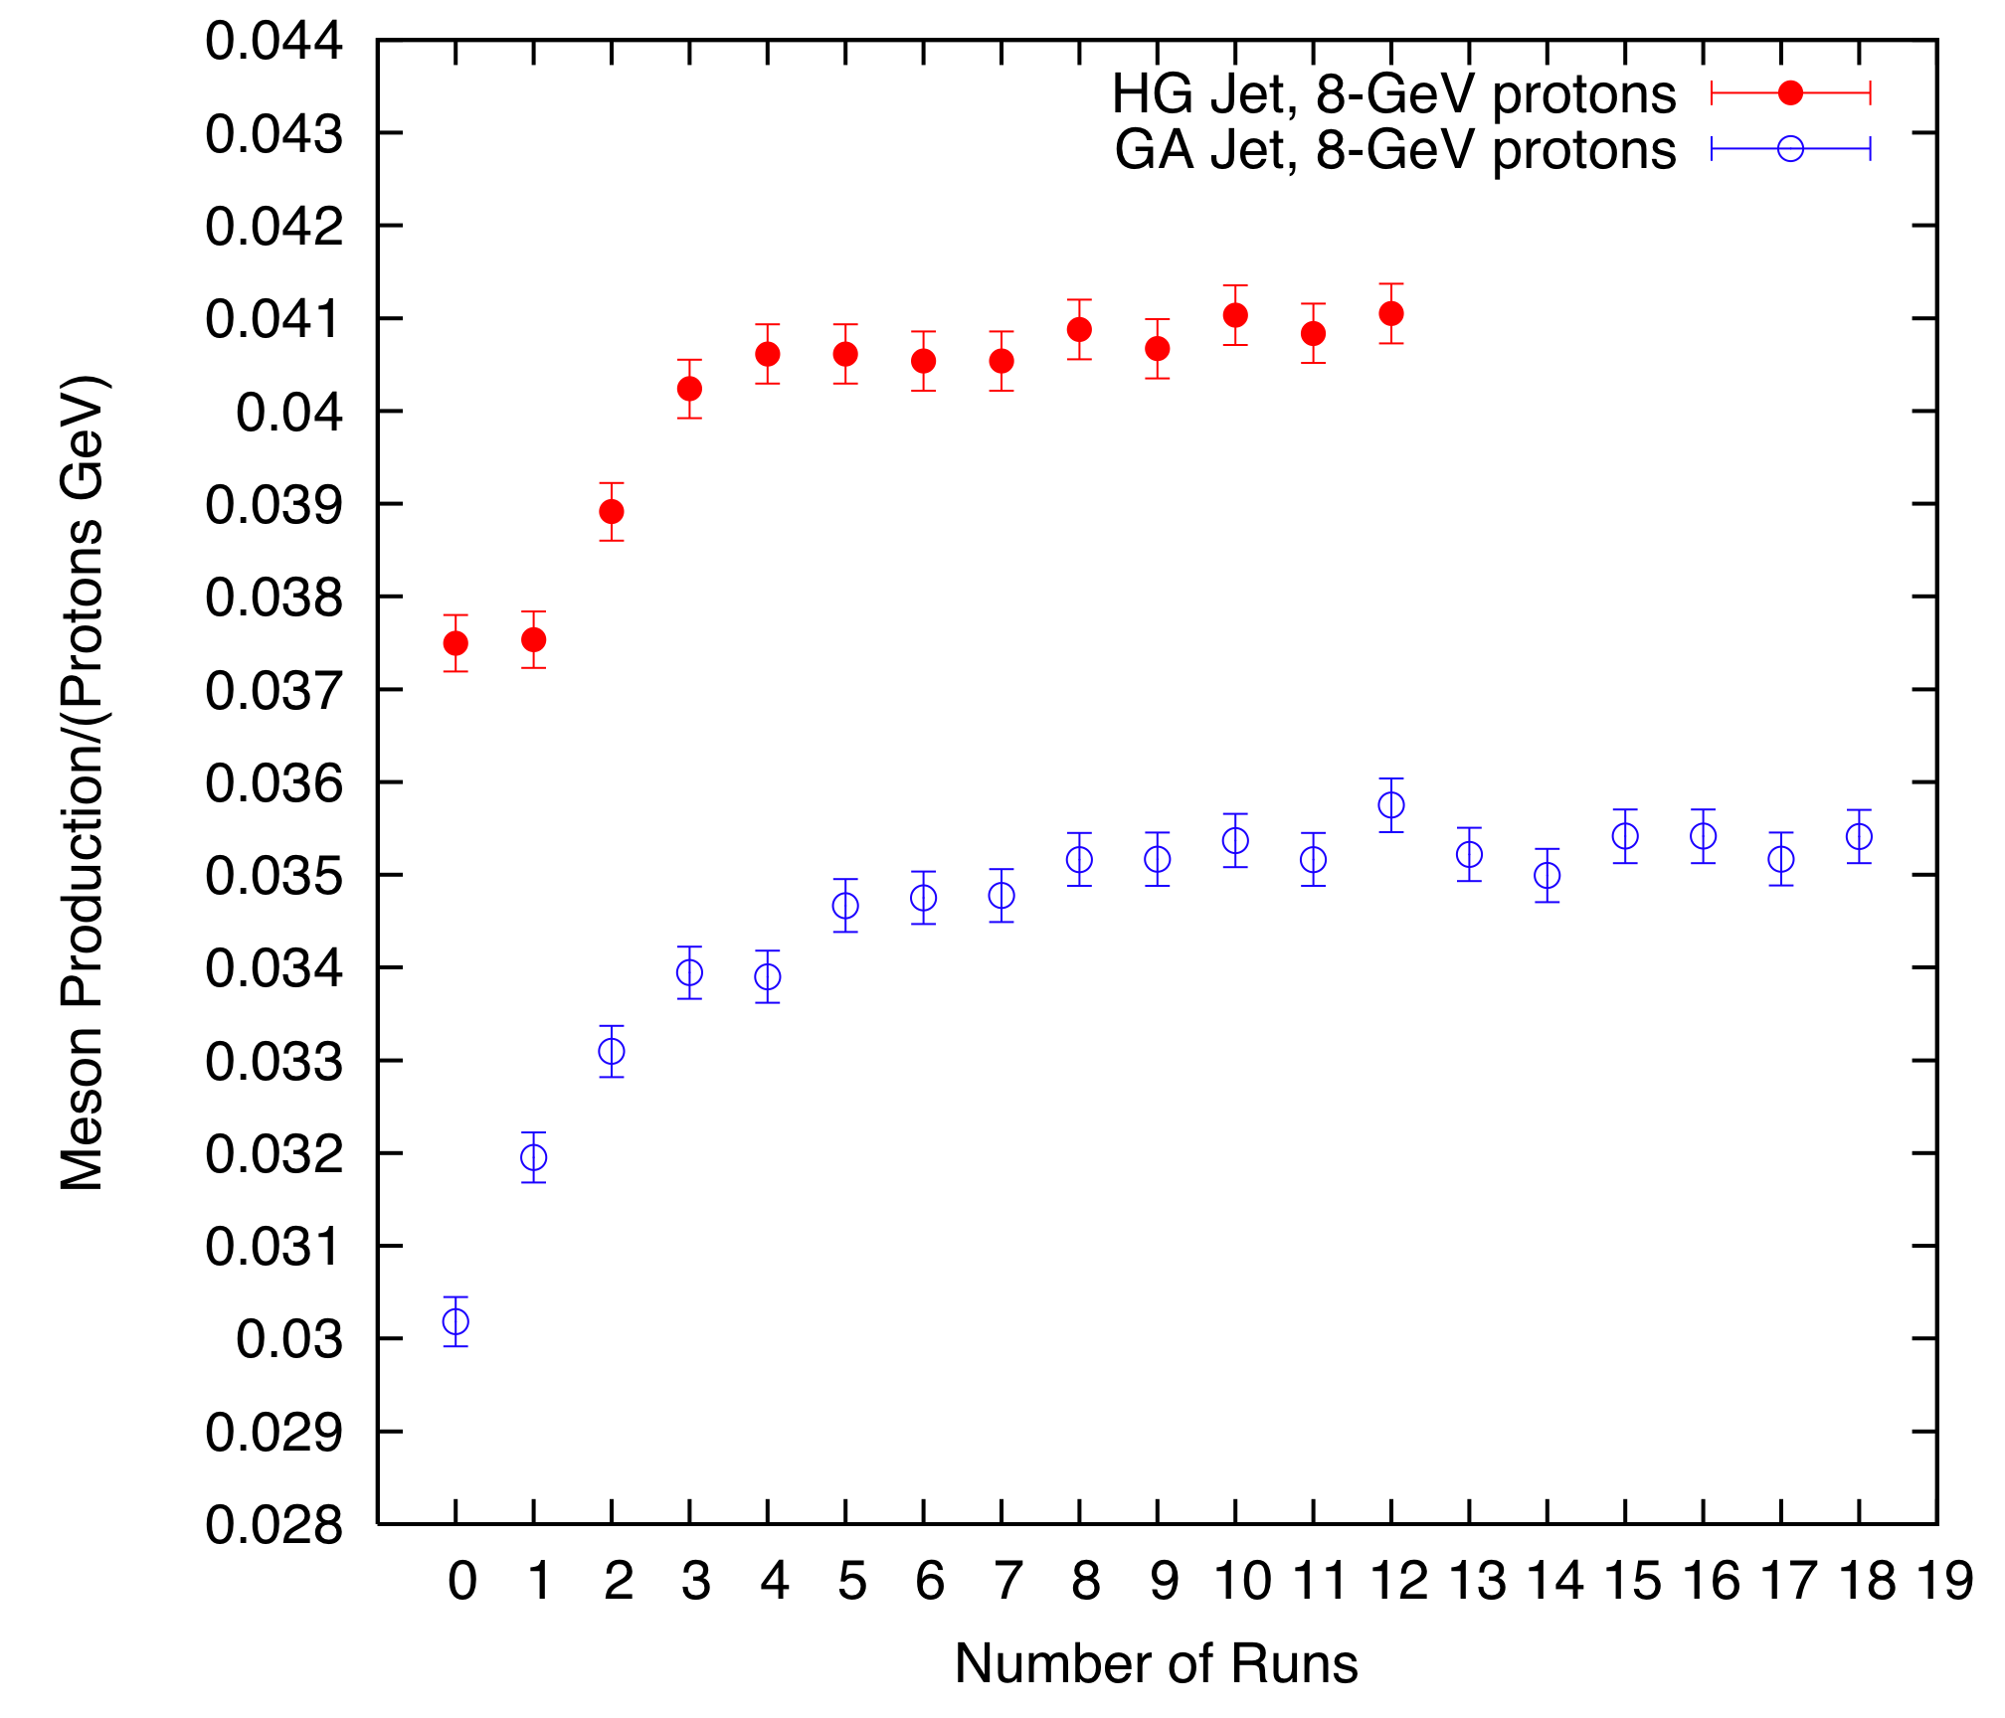
Figure 3: Meson productions as a function of number of runs at 8 GeV for Hg/Ga targets. (For these runs, the 0 represents for the initial target parameters, the 1,4,7,10,13,16 cases for optimizing the target radius, the 2,5,8,11,14,17 cases optimizing the crossing angle and 3,6,9,12,15,18 for the optimized beam angle.)
We first report simulations at a proton kinetic energy of 8 GeV. With initial target parameters from our previous study [1, 3], we have run 4 cycles for the Hg jet and 6 cycles for Ga in order to achieve convergence. After optimization, the Hg jet radius is at 4.04 mm, the beam/jet crossing angle is 20.6 mrad and beam angle is 117 mrad. For the Ga jet the final target radius is 4.4 mm, the beam/jet crossing angle is 13 mrad and beam angle is 88 mrad. Fig. 3 depicts the meson productions as a function of the number of runs in our optimization process. The meson production approaches its convergent value after several cycles. After optimization, we see that at 8GeV, the meson production for Ga is 13% less than for Hg.
We use the target parameters obtained at 8 GeV as the initial target parameters for other proton kinetic energies. We then proceed to optimize the target parameters for proton kinetic energies in the range of 2-16 GeV. Our optimized target radius, beam/jet crossing angle and beam angles are plotted in Fig. 4, Fig. 5 and Fig. 6 respectively. In Fig. 7, we plot the meson productions vs. proton KE. It shows that for Ga the production peaks near KE = 5 GeV and is comparable to Hg at that KE.

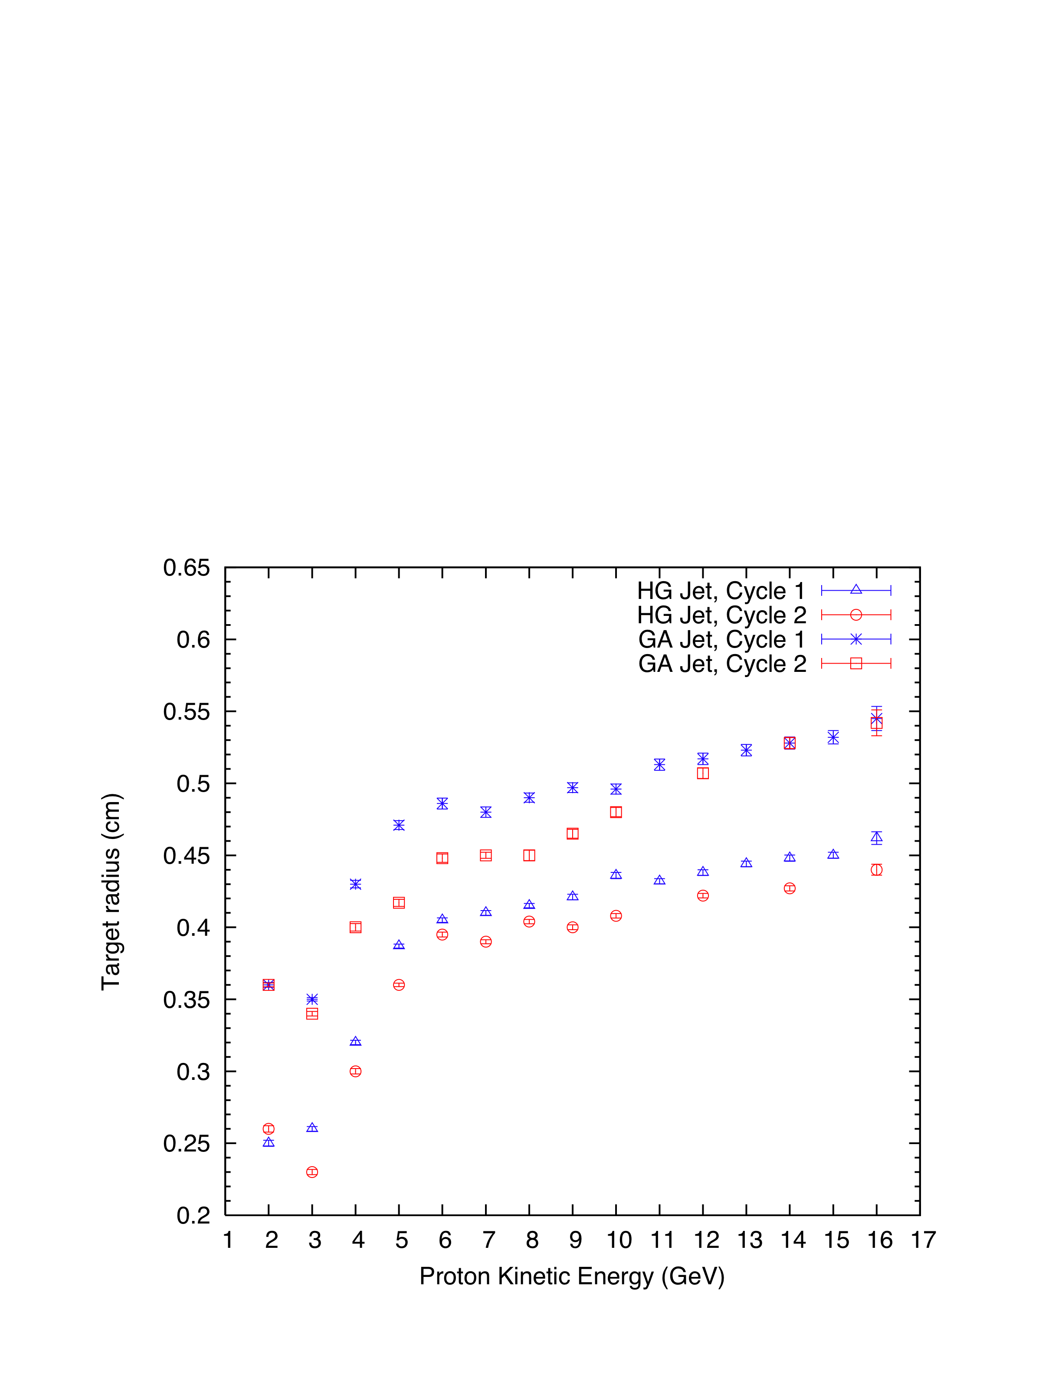
Figure 4: Optimized target radius as a function of proton kinetic energy.
We have also compared meson production in Fig. 8 between IDS120h, Study 2 and a previous study by N. V. Mokhov [6]. Compared with the Study 2 target system, we observe a 13% increase in meson production with the new IDS120h configuration and our new optimization procedure
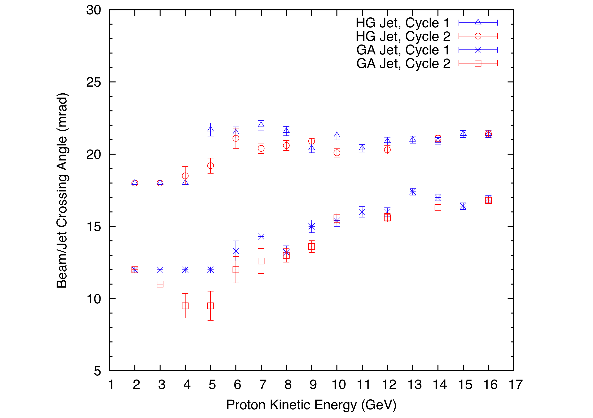
Figure 5: Optimized beam/jet crossing angle as a function of proton kinetic energy.
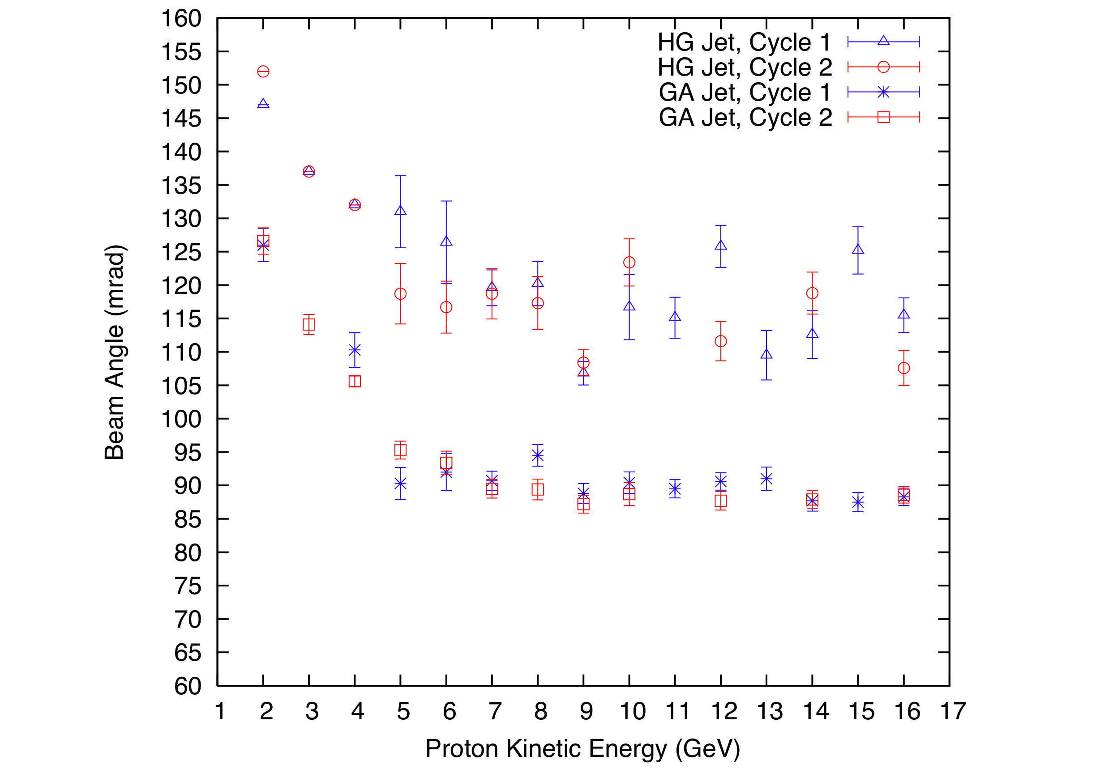
Figure 6: Optimized beam angle as a function of proton kinetic energy.
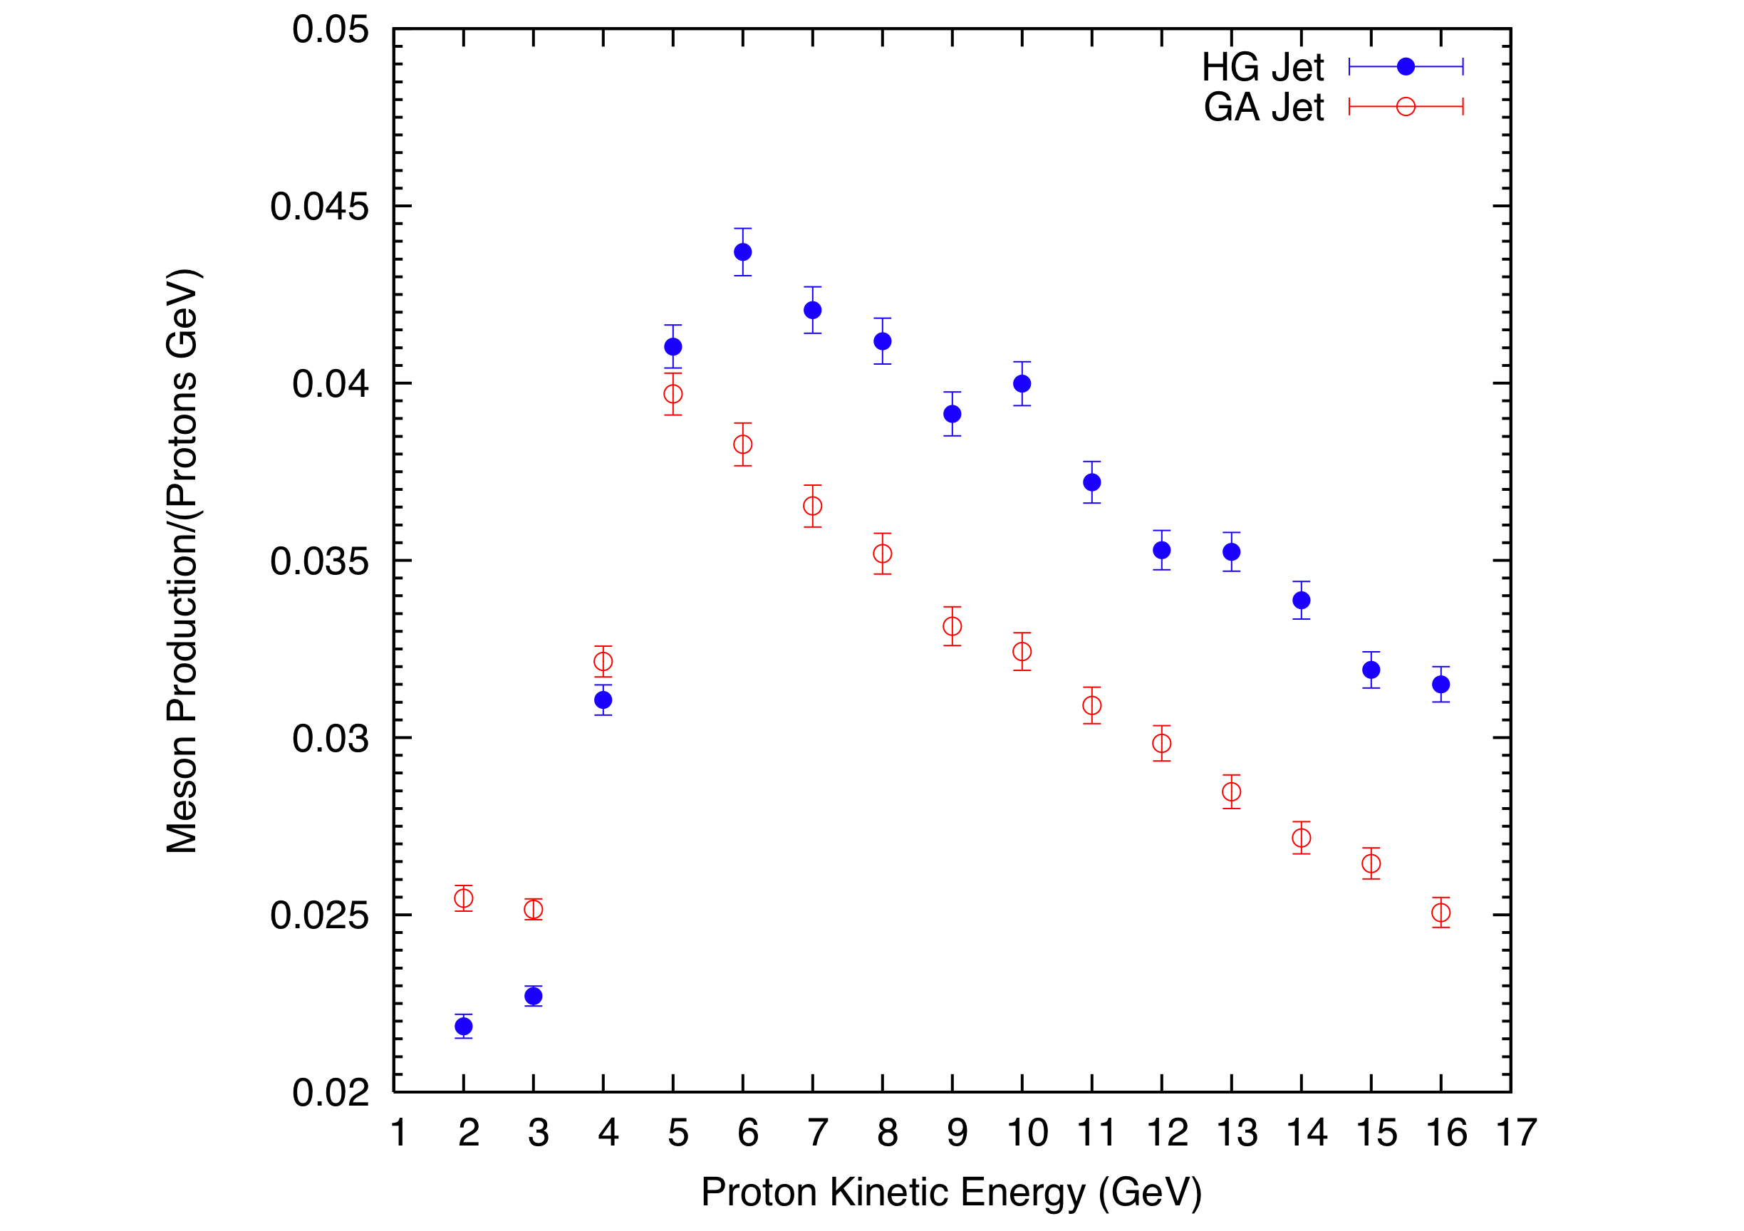
Figure 7: Meson productions as a function of proton kinetic energy.
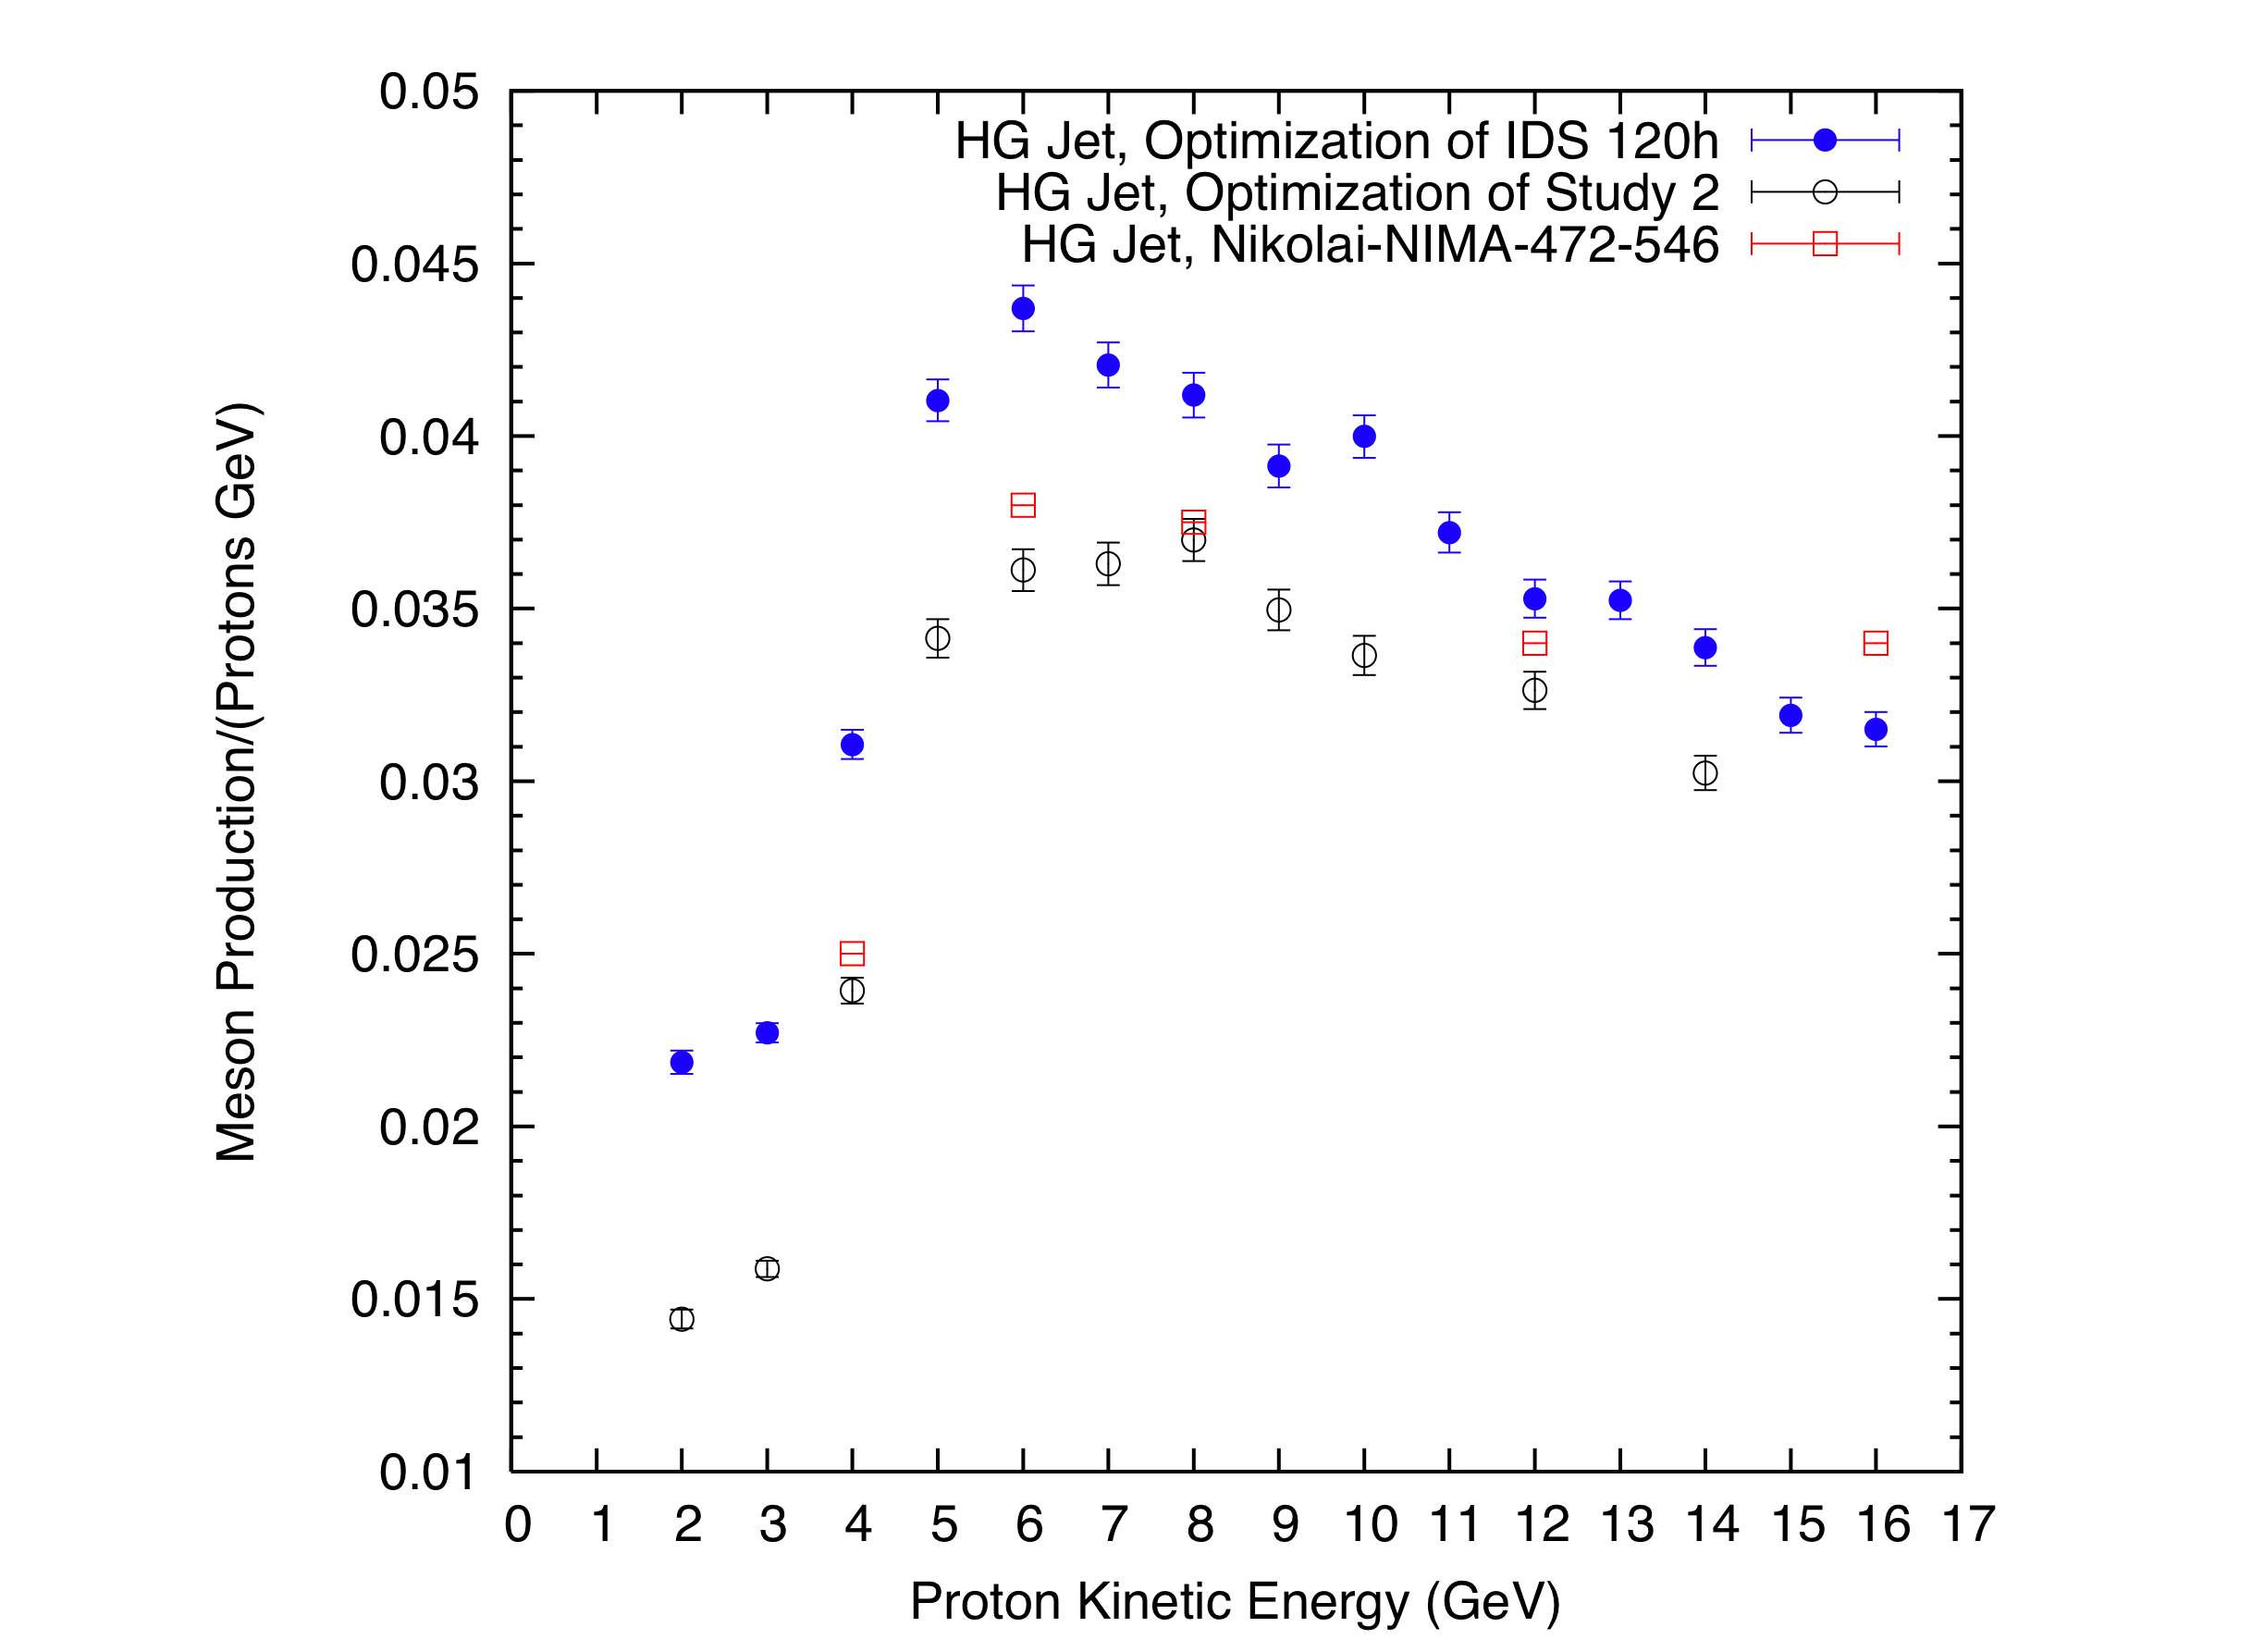
Figure 8. Comparison of meson production between Study2, IDS120h and a previous study by N.V. Mokhov as a function of proton kinetic energy.

Conclusions
We have simulated the IDS120h target configuration using Gallium and Mercury as target material. With optimization for incident protons at 8 GeV, the Hg jet has a target radius of 4.04 mm, a beam/jet crossing angle of 20.6 mrad and a beam angle of 117 mrad. For Ga, the jet target radius is 4.4 mm, the beam/jet crossing angle is 13 mrad and the beam angle is 88 mrad. In addition, we find that, for Ga, the production peaks near KE = 5 GeV and is comparable to Hg for that kinetic energy.

acknowledgment
This work was supported by the U.S. Department of Energy in part under contracts DE-AC02-98CH10886 (BNL) and DE-FG02-92ER40695 (UCLA).

References
[1] X. Ding, et al., “Optimization of a mercury jet target for a neutrino factory or a muon collider”, Phys. Rev. Spec. Top. Accel. Beams 14 (2011) 111002; X. Ding et al., "Optimized Parameters for a Mercury Jet Target," in Proceedings of PAC09, Vancouver, Canada, May 2009, paper WE6PFP102; X. Ding et al., "Meson Production Simulations for a Mercury Jet Target," in Proceedings of NuFact09, Chicago (2009), AIP Conference Proceedings 1222 (2010), p.323.
[2] N.V. Mokhov, “The Mars Code System User's Guide,” Fermilab-FN-628 (1995); O.E. Krivosheev, N.V. Mokhov, “MARS Code Status,” Proc. Monte Carlo 2000 Conf., p. 943, Lisbon, October 23-26, 2000; Fermilab-Conf-00/181 (2000); N.V. Mokhov, “Status of Code,” Fermilab-Conf-03/053 (2003); N.V. Mokhov, K.K. Gudima, C.C. James et al., “Recent Enhancements to the MARS15 Code,” Fermilab-Conf-04/053 (2004); http://www-ap.‌fnal.‌gov/‌MARS/.
[3] S. Osaki, R. Palmer, M. Zisman and J. Gallardo, eds., Neutrino Factory Feasibility Study 2, BNL-52623 (2001), Ch.3.
[4] H. Kirk, “Target System Update”, IDS-NF Plenary Meeting, Arlington, VA, 2011. www.hep.princeton.edu/mumu/target/hkirk/hkirk_101811.pdf
[5] J. Back, “First look at π, μ yields vs atomic Z”, http://physics.princeton.edu/mumu/target/Back/back_092011.pdf; X. Ding, “Meson production for different Z at 6 and 8 GeV with MARS”, http://physics.princeton.edu/mumu/target/Ding/ding_092011.pdf.
[6] N.V. Mokhov, Nucl. Instrum. Methods Phys. Res., Sect. A 472, 546 (2001).

