# InFLUENCE OF Proton beam emittances on particle production off a muon collider target\*

X. Ding†, D. Cline, *UCLA, Los Angeles, CA 90095, USA*

J.S. Berg, H.G Kirk, H.K. Sayed, *Brookhaven National Laboratory, Upton, NY 11973, USA*

V.B. Graves, *Oak Ridge National Laboratory, Oak Ridge, TN 37830, USA*

N. Souchlas, R.J. Weggel, *Particle Beam lasers, Inc., Northridge, CA 91324, USA*

K.T. McDonald, *Princeton University, Princeton, NJ 08544, USA*

Abstract

A free-mercury-jet or a free-gallium-jet is considered for the pion-production target at a Muon Collider or Neutrino Factory. We previously optimized the geometric parameters of the beam and target to maximize particle production by incoming protons with kinetic energies (KE) between 2 and 16 GeV, using the MARS15 code, assuming a parallel proton beam with Gaussian transverse profile. In this paper, we extend our optimization to focused proton beams with various transverse emittances. For the special cases of proton beams with geometric emittances of 2.5, 5 or 10 μm-rad and a kinetic energy of 8 GeV, we optimized the geometric parameters of the target: the radius of the proton beam, the radius of the liquid jet, the crossing angle between the jet and the proton beam, and the incoming proton beam angle. We also studied the influence of a shift of the beam focal point relative to the intersection point of the beam and the jet.

## INTRODUCTION

The baseline option for a possible future Muon Collider (MC) or Neutrino Factory (NF) [1] is to use a 4-MW proton beam interacting with a free-flowing mercury jet to create copious amounts of pions that are captured in a high-field solenoid magnet system (~ 20 T). The pions are then transported into a 1.5-T solenoid decay channel in which decay muons will be captured, cooled and stored in a storage ring, either to provide for μ+μ- collisions or to produce intense neutrino beams.

ID2536_F1.tiff

Figure 1: Lower half of the IDS120h target system.

In previous work [2,3] based on MARS [4] simulations, we optimized a free-mercury-jet or a free-gallium-jet target utilizing the IDS120h target configuration. As sketched in Fig. 1, the inner radius of superconducting coils (SC) in the region surrounding the mercury-jet target region is 120 cm (up from 60 cm in [3]) to permit sufficient internal tungsten shielding for a 10-year operational lifetime of the SC coils against radiation damage. The axial magnetic field tapers adiabatically from 20 T around the target to 1.5 T at the end of the target system.

Figure 2 shows a schematic of the mercury-jet target geometry. The center of the beam/jet interaction region is at (0, 0, -37.5) cm. The launch point for the proton beam in the MARS simulations is at *z* = -200 cm, well upstream of the interaction region. For a simple Gaussian incident proton beams with an infinitely large Courant-Snyder β parameter (zero-emittance, parallel beam), we have optimized the geometric parameters of the target (the mercury-jet radius, the incoming proton beam angle, and the crossing angle between the mercury jet and the proton beam) to maximize particle production initiated by incoming protons with kinetic energies (KE) between 2 and 16 GeV. The pions and muons of interest for a Muon Collider/Neutrino Factory are taken to be those with kinetic energy 40 < KE < 180 MeV at the transverse plane *z* = 50 m [5].

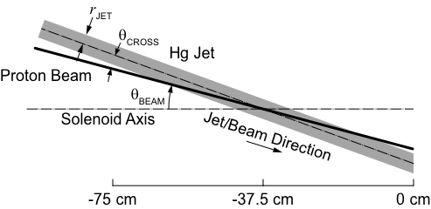

Figure 2: The mercury-jet-target geometry (with *z* = 0 being the downstream end of the beam/jet interaction region). The proton beam and mercury jet lie in the vertical plane and their trajectories intersect at *z*0 = -37.5 cm.

The optimized target radius (beam radius is fixed to be 30% of target radius), beam/jet crossing angle and beam angles are plotted as functions of KE in Figs. 3, 4, 5, respectively. In Fig. 6, we plot meson production *vs*. proton KE, which shows that the production from Ga peaks near KE = 5 GeV and is comparable to that from Hg at this energy.

\_\_\_\_\_\_\_\_\_\_\_\_\_\_\_\_\_\_\_\_

\*Work supported in part by US DOE Contract NO. DE-AC02- 98CHI10886.

†xding@bnl.gov

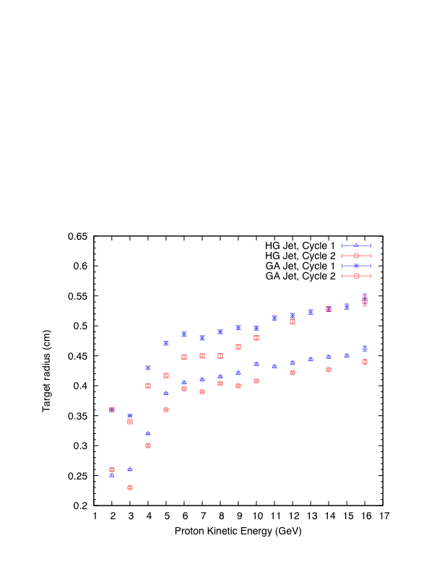

Figure 3: Optimized target radius as a function of proton kinetic energy, for a zero-emittance beam.

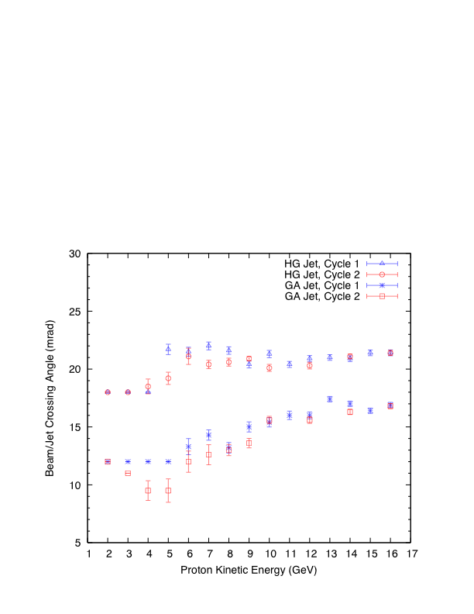

Figure 4: Optimized beam/jet crossing angle as a function of proton kinetic energy, for a zero-emittance beam.

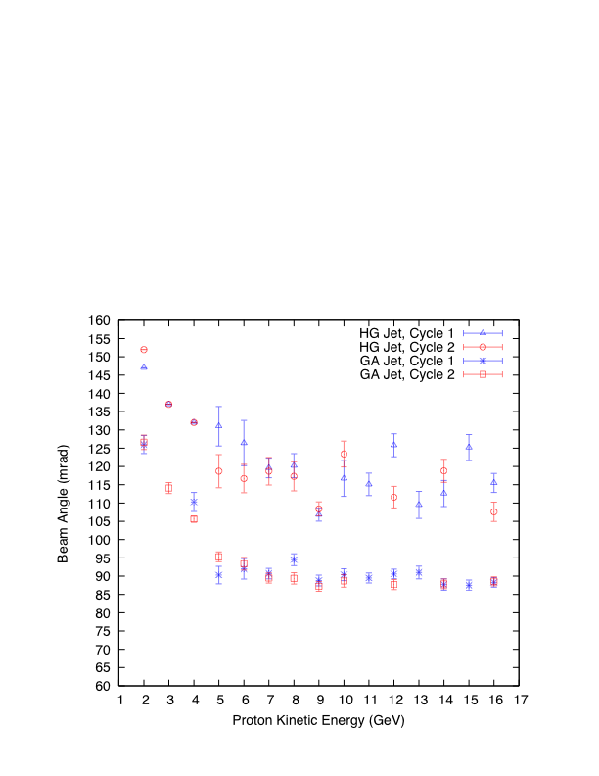

Figure 5: Optimized beam angle as a function of proton kinetic energy, for a zero-emittance beam.

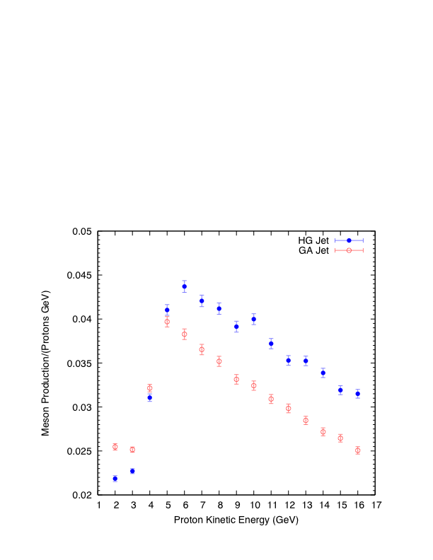

Figure 6: Optimized meson production as a function of proton kinetic energy, for a zero-emittance beam.

## INfluence of proton beam emittance on particle production

Our simulations based on a parallel, Gaussian incident proton beam (zero emittance) at 8 GeV show that the optimal Hg jet has target radius of 4.04 mm, beam/jet crossing angle of 20.6 mrad and beam angle of 117 mrad; while the Ga jet has the optimal target radius of 4.4 mm, beam/jet crossing angle of 13 mrad and beam angle of 88 mrad. See Figs. 3-5. The optimized meson production is shown as a function of beam kinetic energy in Fig. 6.

We consider now a focused 8-GeV proton beam and study the influence of proton beam (geometric) transverse emittance ε = σ\*2/β\* on particle production. We assume the focal point is at *z*0 = -37.5 cm where the beam has Twiss parameters α\*= 0, β\* and rms radius σ\*. A beam launched at *z* = -200 cm has Twiss parameters given approximately as α = *L*/β\*, β = β\*+ *L*2/β\*, and σ = σ\*√(1+*L*2/β\*2), where *L* = *z*0 – *z* = 162.5 cm (the exact Twiss parameters are given by the Courant-Synder invariant and the matrix transformation under the solenoid magnetic field in the target region).

For our optimization method, we performed 4 runs in each cycle. In run 1 we varied beam radius σ\*, while also varying the β\* to maintain constant the beam emittance; in run 2 we varied target radius; in run 3 we varied beam/jet crossing angle; and in run 4 we rotated the beam and jet together to keep the crossing angle same. We repeated the above cycle and found the optimized parameters listed in Table 1. In Fig. 7 we plot meson production *vs*. beam emittance; the production falls with increasing emittance. The meson production for a Gaussian proton beam of fixed radius σ = 0.12 cm and 8 GeV kinetic energy is shown in blue (a parallel beam corresponds to zero emittance), and the optimized production is shown in red.

Table 1: Optimized target parameters for proton beams with emittances of 2.5, 5, 7.5 and 10 μm-rad and a kinetic energy of 8 GeV.

|  |  |  |  |  |  |
| --- | --- | --- | --- | --- | --- |
| **Emittance (μm-rad)** | | **2.5** | **5** | **7.5** | **10** |
| Target radius  (cm) | Hg jet | 0.47 | 0.55 | 0.60 | 0.65 |
| Ga jet | 0.51 | 0.60 | 0.66 | 0.71 |
| Beam radius  (cm) | Hg jet | 0.14 | 0.15 | 0.20 | 0.23 |
| Ga jet | 0.13 | 0.17 | 0.20 | 0.23 |
| Crossing angle  (mrad) | Hg jet | 23 | 26.5 | 29.3 | 32 |
| Ga jet | 15.3 | 18.4 | 21.7 | 23 |
| Beam angle  (mrad) | Hg jet | 118 | 127 | 131 | 135 |
| Ga jet | 92 | 97 | 97 | 100 |
| Jet angle  (mrad) | Hg jet | 141 | 154 | 160 | 167 |
| Ga jet | 107.3 | 11 | 119 | 123 |

## emit_meson_HG_GA.eps

Figure 7: Meson production as a function of proton beam emittance.

## shift of the beam focal point

The rate of particle production varies along the target, whose center crosses the beam at *z*0 = -37.5 cm, which was taken to be the beam focal point in the previous studies. It could be that particle production is maximal for a focal point shifted away from the crossing point. To study this, we changed the Twiss parameter α at *z*0 to a nonzero value α0, which corresponds to a new focal point at *z* = *z*0 + α0β\*. Figure 8 plots the meson production as a function of parameter α0 for the case of emittance ε = 5 μm-rad and β\* = 50 cm. The production is highest for α0 = -0.1 (shift of the focal point upstream by 5 cm) according to a quadratic fit, but the increase in particle production is negligible compared to the focal point at *z*0.

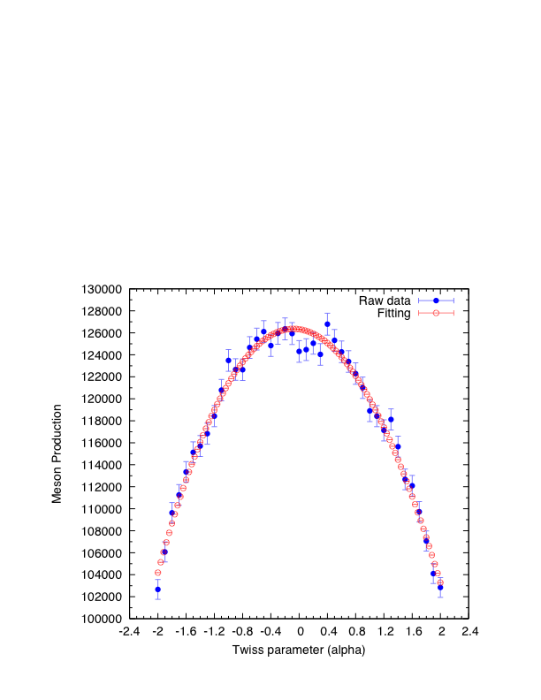

Figure 8: Meson production for a shift of beam focal point relative to the intersection point of the beam and the jet.

**Conclusions**

Meson production for a Muon Collider or Neutrino Factory decreases with increasing proton beam emittance, but careful optimization keeps this decrease to 7% for a Hg-jet target and 4% for a Ga-jet target for a proton beam of 8 GeV kinetic energy and transverse emittance ε = 5 μm-rad, compared to the case of zero emittance beams. The optimized meson production a Ga-jet target is then about 88% of that for a Hg-jet target. In addition, we find the meson production to be well optimized taking the proton beam focal point at the intersection point of the center lines of the beam and jet.

## References

[1] M.M. Alsharo’a *et al*., *Status of Neutrino Factory and Muon Collider Research and Development and Future Plans*, Phys. Rev. ST Accel. Beams **6**, 081001 (2003).

[2] X. Ding *et al., Gallium as a Possible Target Material for a Muon Collider or a Neutrino Factory,* IPAC12, MOPPC044.

[3] N. Souchlas *et al*., *[Beam-Power Deposition in a 4-MW Target Station for a Muon Collider or a Neutrino Factory](http://www.hep.princeton.edu/~mcdonald/mumu/target/ipac11/tups054.pdf),* IPAC11, TUPS054.

[4] The MARS Code System: <http://www-ap.fnal.gov/MARS/>

[5] X. Ding *et al.,* *Optimization of a Mercury Jet Target for a Neutrino Factory or a Muon Collider*, Phys. Rev. ST Accel. Beams **14,** 111002 (2011).