CARBON TARGET OPTIMIZATION FOR A MUON COLLIER/NEUTRINO FACTORY WITH A 6.75 GeV PROTON DRIVER*
X. Ding,† UCLA, Los Angeles, CA 90095, USA
H.G. Kirk, Brookhaven National Laboratory, Upton, NY 11973, USA
K.T. McDonald, Princeton U., Princeton, NJ 08544, USA

Abstract
The first phase of a Muon Collider/Neutrino Factory program may use a 6.75-GeV proton driver with beam power of only 1 MW. At this lower power it is favorable to use a graphite target (replaced quarterly) with beam and target tilted slightly to the axis of the 15-20 T pion-capture solenoid around the target. The low-energy proton beam is significantly deflected by the magnetic field, requiring careful optimization, reported here, of the beam/target configuration.

INTRODUCTION
The first phase of a Muon Collider/Neutrino Factory program recommended by the Muon Accelerator Staging Study (MASS) will use a 6.75-GeV proton driver with beam power of 1 MW [1]. In addition, a graphite target in an updated magnetic-capture system, referred to as 20to2T5m, as sketched in Fig. 1, has been used for the present study. Figure 2 shows that the axial magnetic field for configuration 20to2T5T tapers adiabatically over 5 m from 20 T around the target to 2 T in the rest of Front End [2]. The inner radius of superconducting coils (SC) in the region surrounding the graphite target is 120 cm to permit sufficient internal tungsten shielding for a 10-year operational lifetime of the SC coils against radiation damage [3].
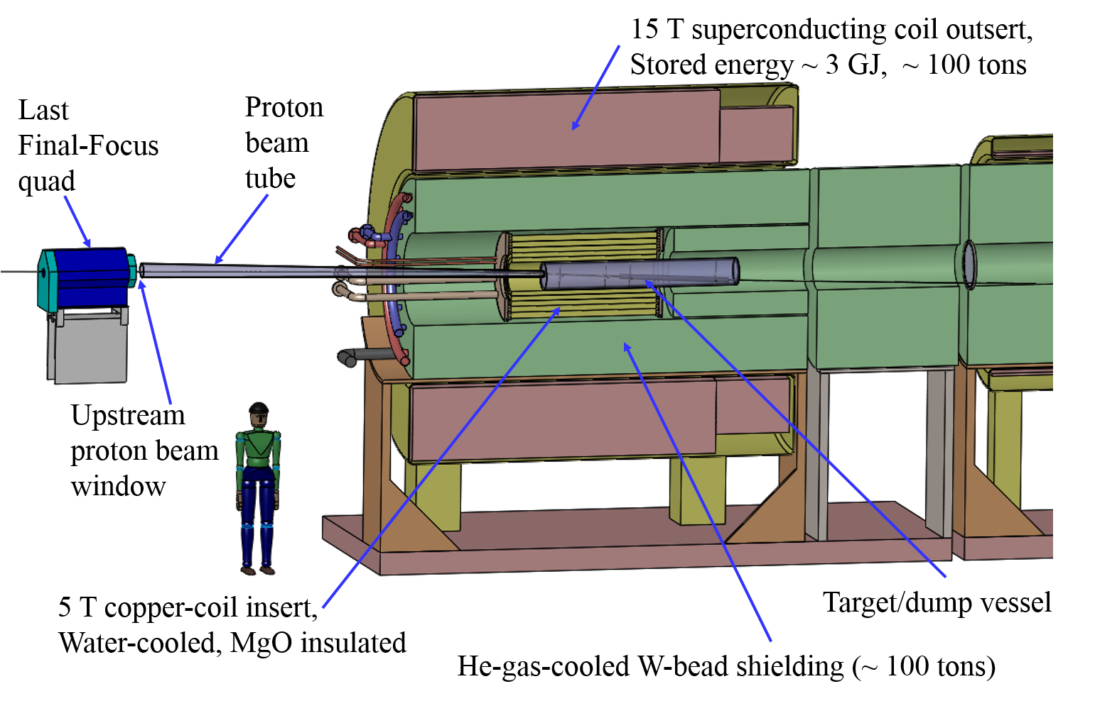
Figure 1: Layout of the 20to2T5m Target System configuration.
The particle production at the target, shown also in Fig. 3, depends on the length and radius of the target, and on and the angle of the beam and target relative to the magnetic axis (which angle lies in the vertical plane). The trajectory of the proton beam in the magnetic field is helical, and this trajectory is collinear with target axis on at the center of the target (z = 0). This beam has a waist and at z = 0, geometric rms emittance of 5 μm, and β* of 80 cm. The graphite density is assumed to be 1.8 g/cm³.
In this paper, we report on the optimization of particle production (pion and muon yields) by a carbon target inside a solenoid magnet of 20to2T5m configuration. In addition, we study the beam dump to intercept the unscattered proton beam.
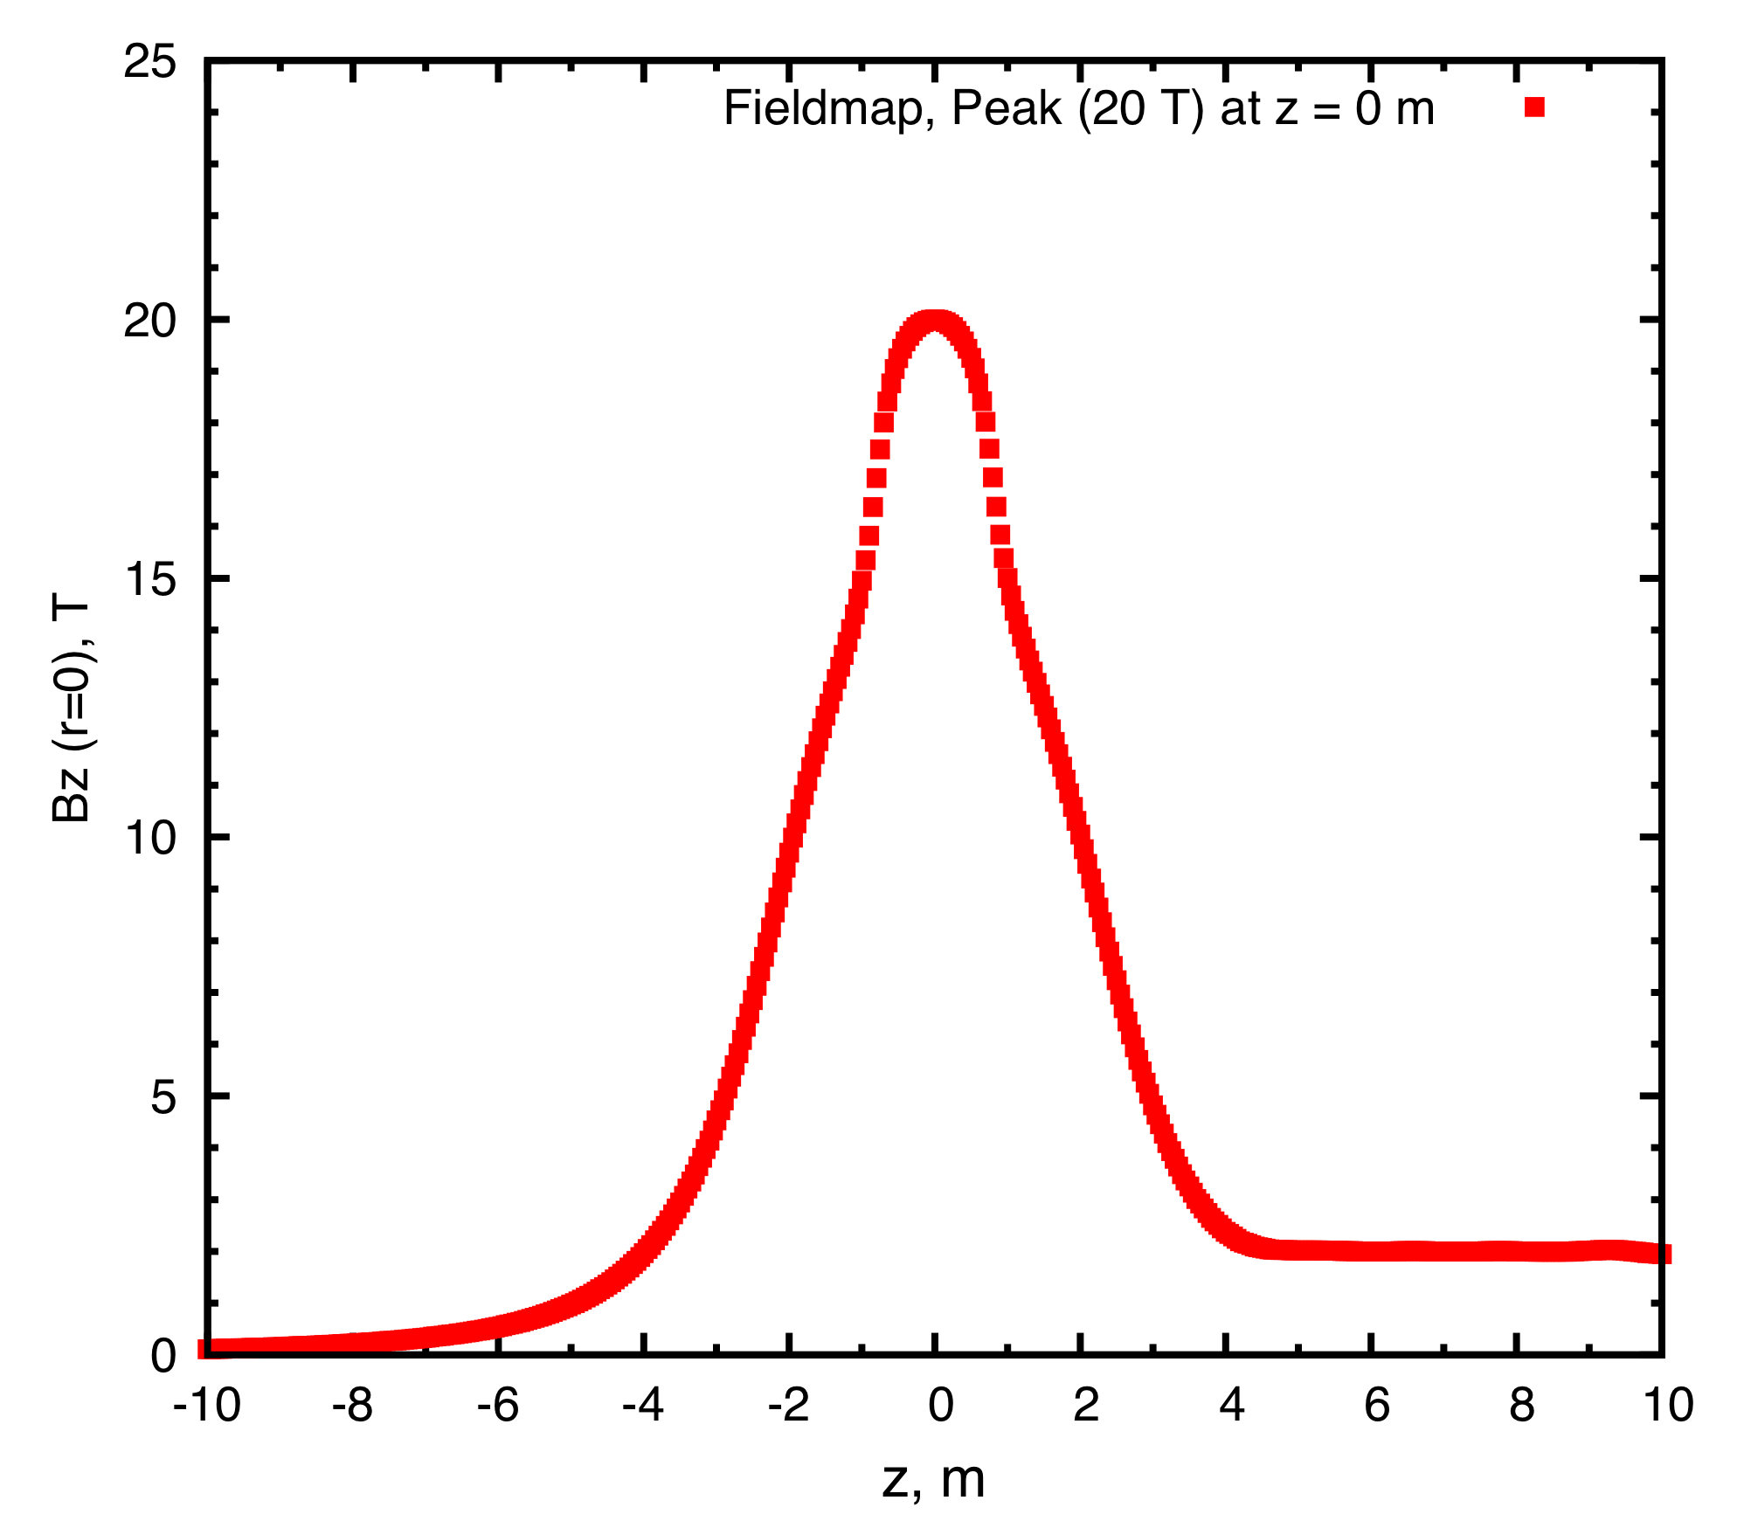
Figure 2: Longitudinal magnetic field along the solenoid axis of the 20to2T5m Front-End channel. The center of the target is at z = 0.
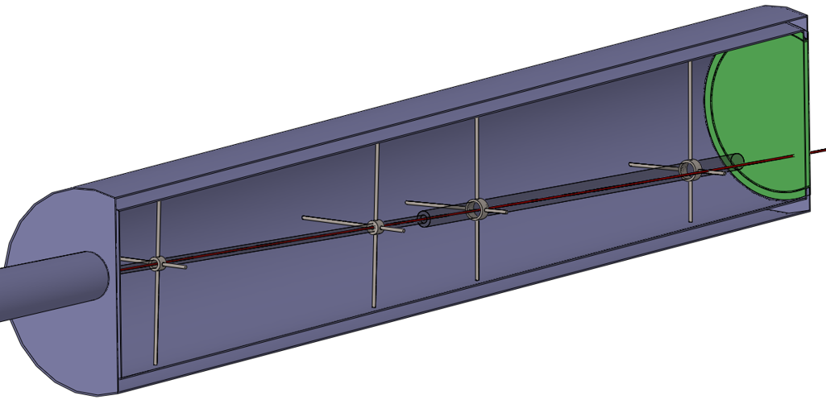
Figure 3: The carbon-target and dump rod inside the double-walled stainless-steel containment vessel, with downstream Be window. The proton beam and carbon target cross at z = 0 cm. The proton beam is launched at z = −100 cm in the simulation.
We used the MARS15(2014) code [4] (denoted MARS15 below) and its default setting for event generator (ICEM 4 = 1). The proton beam wass launched at z = −100 cm. The pions and muons of interest for a Muon Collider/Neutrino Factory are those with kinetic energies between 40 and 180 MeV, and we report rates of these at the transverse plane z = 50 m (downstream the beam/target intersection point) near the beginning of the Buncher of the Front-End [2].

*Work supported in part by US DOE Contract NO. DE-AC02-98CH110886.
†xding@bnl.gov

OPTIMIZED TARGET PARAMETERS

Using MARS15, we optimized the target parameters for a 6.75-GeV proton beam impinging on a carbon target in the 20to2T5m configuration. The target and beam were tilted by the same angle with respect to the solenoid axis, while the beam radius (rms spot size) at z = 0 cm was fixed to be ¼ of the target radius. Several runs were performed during each optimization cycle. In run 1 we varied the target length while keeping initial target radius, target angle fixed; in run 2 we varied the target radius using the new target length while keeping the target angle fixed; and in run 3 we varied the target angle with the new target radius. We repeated the above until convergence was achieved.
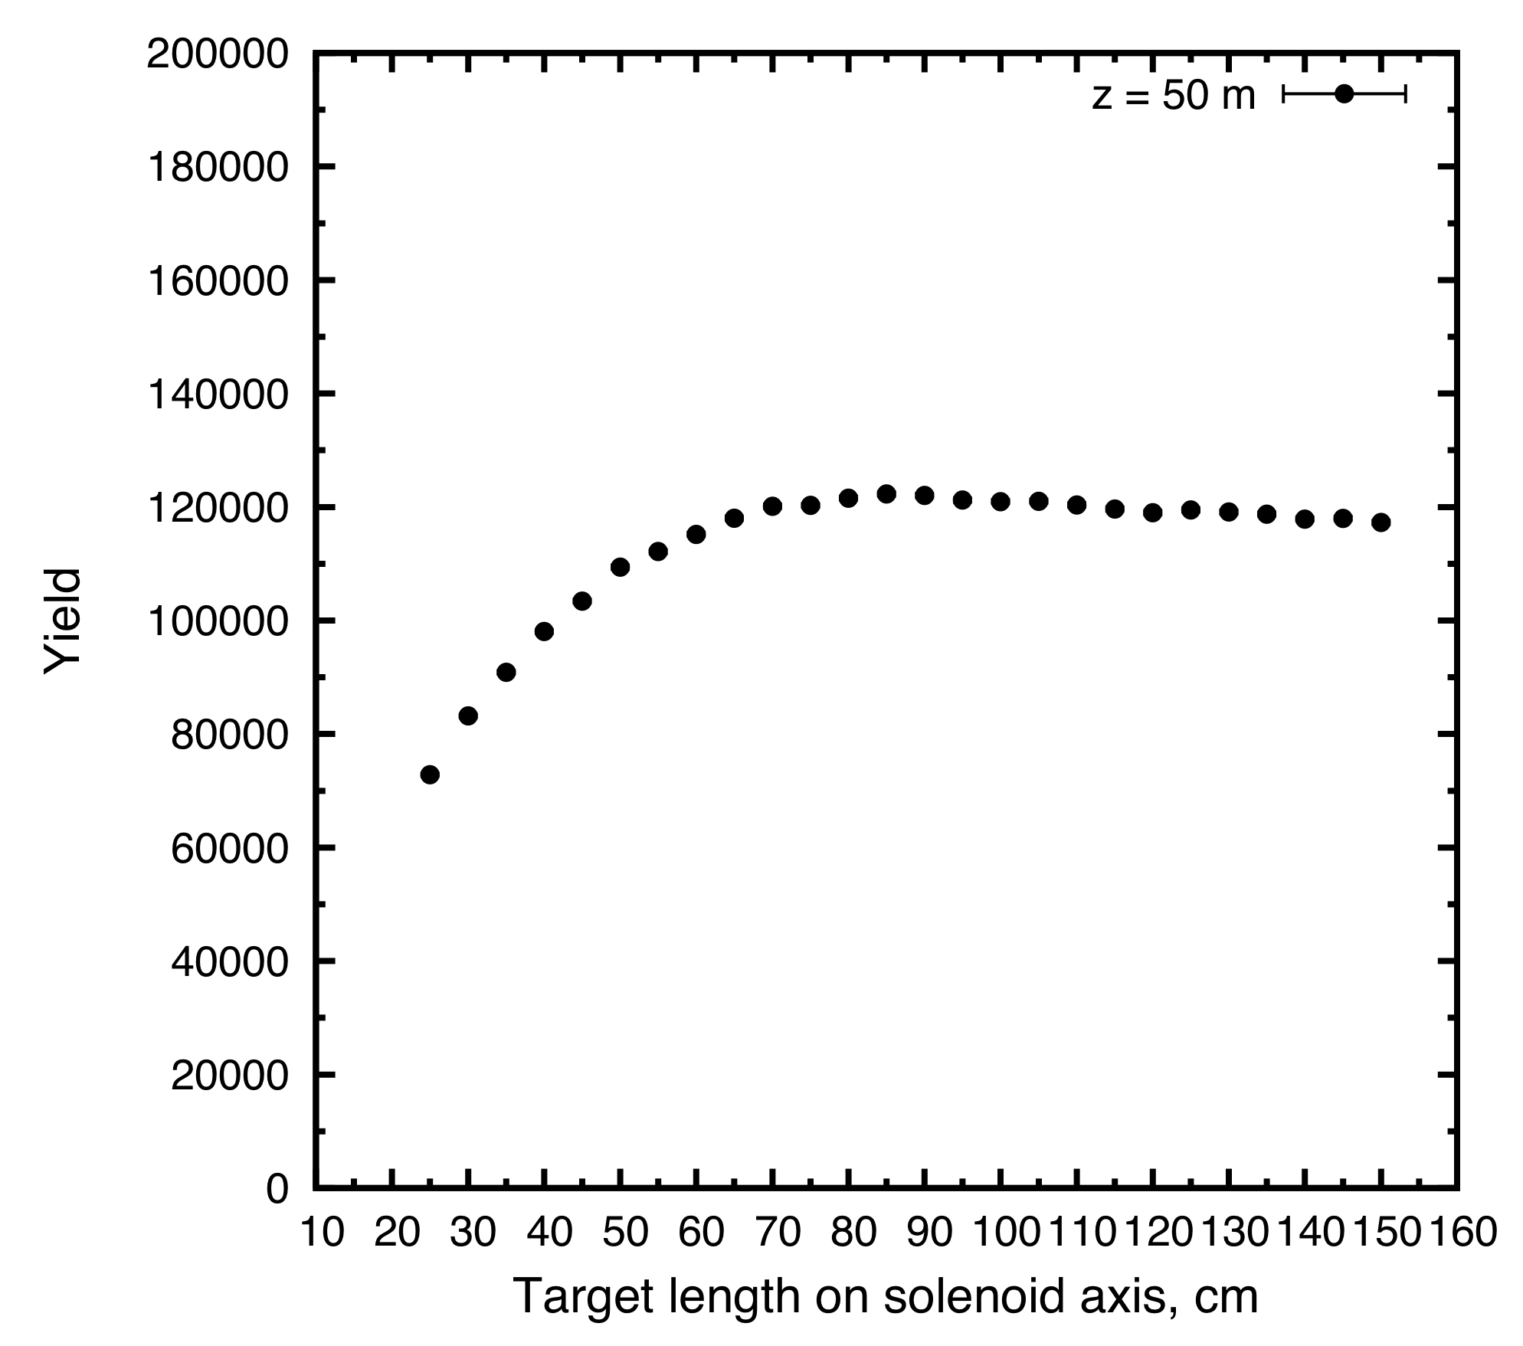
Figure 4: Muon yield at z = 50 m as a function of target length.
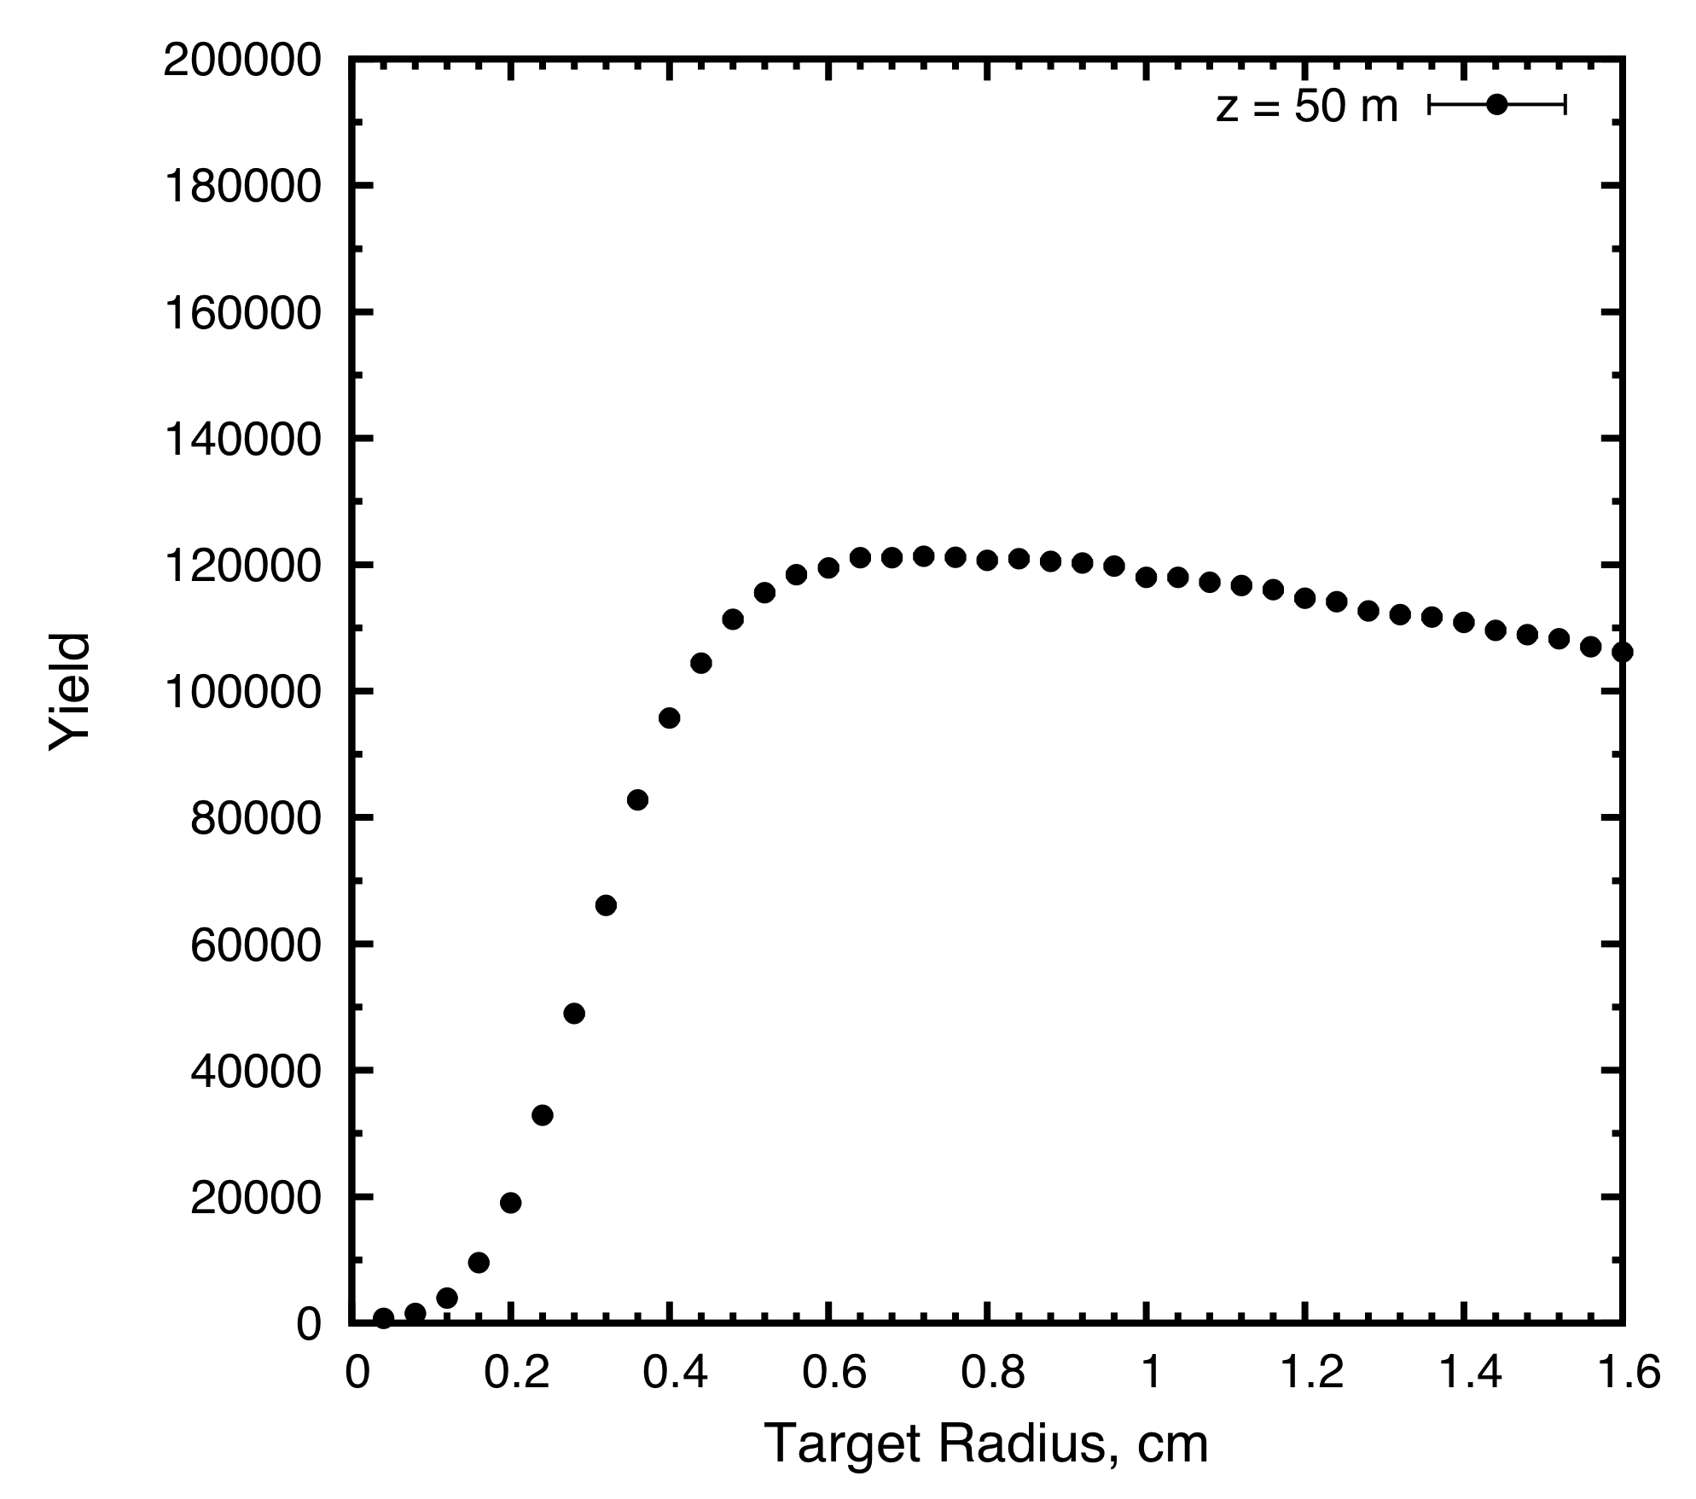
Figure 5: Muon yield at z = 50 m as a function of target radius.
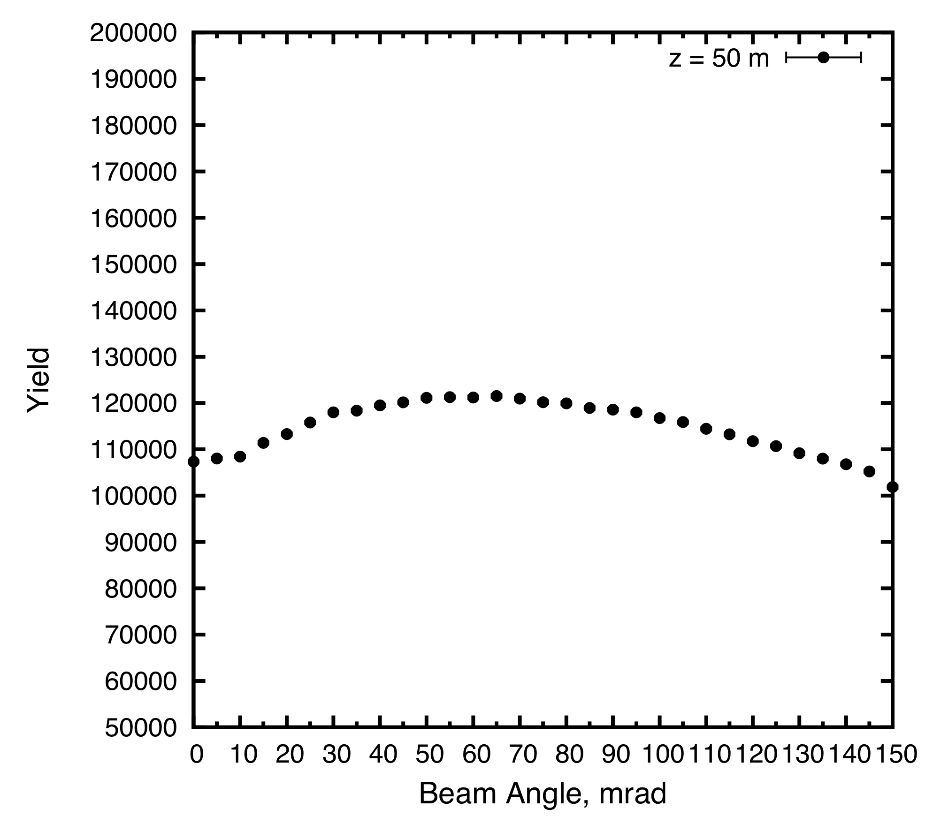
Figure 6: Muon yield at z = 50 m as a function of beam angle.
Figure 4 depicts the yield of muons with 40 < KE < 180 MeV at z = 50 m as a function of target length, which indicates that the target length corresponding to the peak of production is about 80 cm.
Figure 5 shows the variation of muon yield with target radius. The production is maximized when the target has a radius of 0.64 cm for a beam radius equal to 1/4 of this. However, there is little decrease in the yield if the target radius is increased to 0.8 cm, which is favorable for radiation cooling of the target.
Figure 6 shows the yield as a function of beam angle, with a peak around 65 mrad, when the beam radius is 0.2 cm and the target has length and radius of 80 cm and 0.8 cm, respectively.
Figures 7 and 8 show the optimized target length is 80 cm and target radius is 0.64 cm when the beam angle is fixed at 0 mrad to SC axis. There is about 13% advantage to tilting the beam/target.

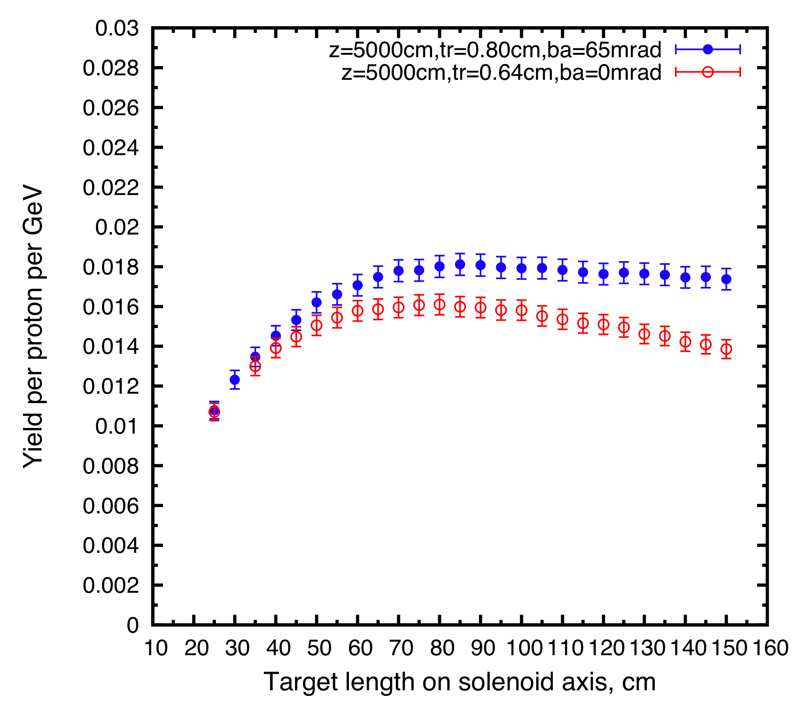
Figure 7: Muon yield at z = 50 m as a function of target length for beams with angles of 0 and 65 mrad.
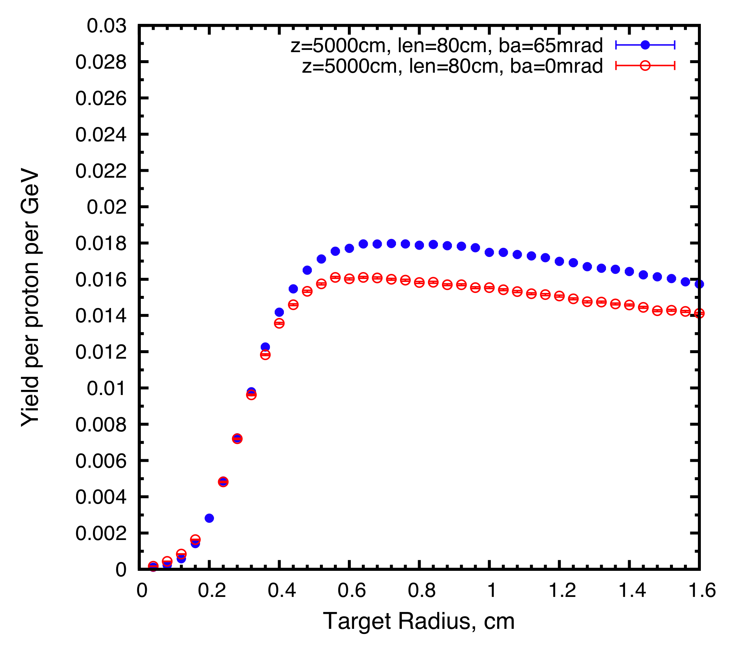
Figure 8: Muon yield at z = 50 m as a function of target radius for beams with angles of 0 and 65 mrad.

STUDY OF THE PROTON BEAM DUMP
The above optimization of the carbon target in the 20to2T50m configuration for a 6.75-GeV proton beam was used as a starting point for studying the proton beam dump. The graphite rod of the target, with radius of R_{target} at 0.8 cm, extends from z = −40 cm to z = 40 cm and has a tilt angle of 65 mrad to the x-z plane. The beam dump is also made of graphite, and begins just after the target at z = 40 cm.
We studied the effect on high-energy protons, and on the yield of muons, of beam dumps with different lengths (0, 40, 80 and 120 cm) and radii (1, 2, 3 × R_{target}) on the unscattered beam. To intercept the unscattered beam, we considered a dump consisting of two 60-cm-long rods; the first extended over 40 < z < 100 cm with tilt angle 56.27 mrad to the x-z plane and 31.1 mrad to the y-z plane, and the second rod extended over 100 < z < 160 cm with tilt angle 44.17 mrad to the x-z plane and 44.9 mrad to the y-z plane [5]. Table 1 shows the yields from a 1-MW proton beam at z = 5 m regarding the total kinetic energy (KE) of protons within a beam pipe of 23-cm radius (3rd column), the total KE of non-protons (4th column), the (diverging) unscattered proton beam with KE > 6 GeV (5th column) and the muon yield at z = 50 m. The results show that a beam dump of graphite with length of 120 cm and radius of 2.4 cm can intercept most of the (diverging) unscattered proton beam while causing only 8% decrease in the yield.

CONCLUSIONS
With optimization of the geometric parameters for a carbon target with a 6.75-GeV incident proton beam, the yield of muons at z = 50 m with 40 < KE < 180 MeV is around 0.018 per proton per GeV when the target length is set at 80 cm, target radius at 0.8 cm, beam radius at 0.2 cm and beam angle at 65 mrad for the 20to2T5m configuration. If the beam/target angle were taken to be 0 mrad, there would be about 13% less muon yield. We also studied use of a graphite beam dump for the case of a tilted beam and target, and found that a beam dump of 120-cm length and 2.4-cm radius can intercept most of the (diverging) unscattered proton beam.

Table 1: Yields for a 1-MW Beam (Tilt Angle of 65 mrad and Radius of 0.2 cm) on a Carbon Target and Beam Dump
L_{dump}  (cm) | R_{dump}/R_{target} | Total KE  (protons,r<23cm)  [Watts] | Total KE  (non-proton)  [Watts] | Protons  KE>6  (×10¹¹) | Yield at  z=50 m  (×10¹¹)
0 | 0 | 88359 | 105454 | 301 | 1241
40 | 1 | 85504 | 105007 | 270 | 1268
80 | 1 | 88318 | 102577 | 318 | 1256
120 | 1 | 85932 | 100030 | 299 | 1230
40 | 2 | 77262 | 101664 | 207 | 1246
80 | 2 | 75493 | 97715 | 206 | 1196
120 | 2 | 78364 | 96967 | 204 | 1171
40 | 3 | 72615 | 101494 | 176 | 1085
80 | 3 | 64610 | 97569 | 112 | 1142
120 | 3 | 66430 | 94936 | 130 | 1135

ACKNOWLEGEMENT
We thank other colleagues from the Target Studies Group of the Muon Accelerator Program for their help on this work.

REFERENCES
[1] M.A. Palmer et al., Muon Accelerators for the Next Generation of High Energy Physics Experiments, Proc. IPAC13, TUPFI057.
[2] J.S. Berg et al., Cost-effective design for a neutrino factory, Phys. Rev. ST Accel. Beams 9, 011001 (2006).
[3] K.T. McDonald et al., Energy Deposition in the Target System for Muon Collider/Neutrino Factory, Proc. IPAC14, THPRI088.
[4] N.V. Mokhov, The MARS Code System User's Guide, Fermilab-FN-628 (1995); N.V. Mokhov and S.I. Striganov, MARS15 Overview, AIP Conf. Proc. 896, 50 (2007), http://www-ap.fnal.gov/MARS
[5] X. Ding, Carbon Target Optimization for a Muon Collider/ Neutrino Factory with a 6.75-GeV Proton Driver, http://physics.princeton.edu/mumu/target/Ding/ding_140529.pdf

