CARBON AND MERCURY TARGET SYSTEMS

FOR MUON COLLIDERS AND NEUTRINO FACTORIES

*
X. Ding, UCLA, Los Angeles, CA 90095, USA
J.S. Berg, H.G. Kirk, D. Stratakis, Brookhaven National Laboratory, Upton, NY 11973, USA
K.T. McDonald,† Princeton University, Princeton, NJ 08544, USA

Abstract
A high-power target is required to convert a powerful MW-class proton beam into an intense muon source or neutrino source in support of physics at the intensity frontier. The first phase of a Muon Collider or Neutrino Factory program may use a 6.75-GeV proton driver with beam power of only 1 MW. At this lower power it is favorable to use a graphite target with beam and target tilted slightly to the axis of a 20-T pion-capture solenoid around the target. Using the MARS15(2014) code, we optimized the geometric parameters of the beam and target to maximize particle production at low energies by an incoming proton beam with kinetic energy of 6.75 GeV impinging on this carbon target. We also studied beam-dump configurations to suppress the rate of undesirable high-energy secondary particles in the beam. For a possible upgrade to a proton beam of multi-MW power, we considered a free-flowing mercury jet.

INTRODUCTION
Neutrino physics and muon physics at the intensity frontier require the greatest possible beam intensities of neutrinos and muons [1]. The target scenario for the present study is to use a 6.75-GeV proton driver with beam power of 1 MW [2] interacting with a graphite target in the so-called 20to2T5m target system configuration, as shown in Fig. 1.
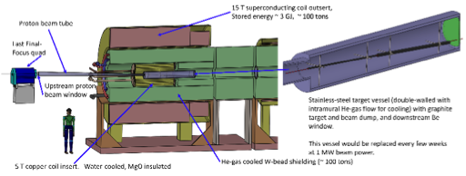
Figure 1: Layout of the 20to2T5m Target System configuration.
Figure 2 shows that the axial magnetic field for configuration 20to2T5m tapers adiabatically over 5 m from 20 T around the target to 2 T in the rest of Front End [3]. The field profile for an alternative configuration, 20to4T5m, in which the field is 4 T in the Front End is also shown. If a mercury target were used in a possible 4-MW upgrade, it would be preferable to use a 15-T field, whose profiles are also shown in Fig. 2. The inner radius of superconducting coils (SC) in the region surrounding the graphite target is 120 cm to permit sufficient internal tungsten shielding for a 10-year operational lifetime of the SC coils against radiation damage [4].
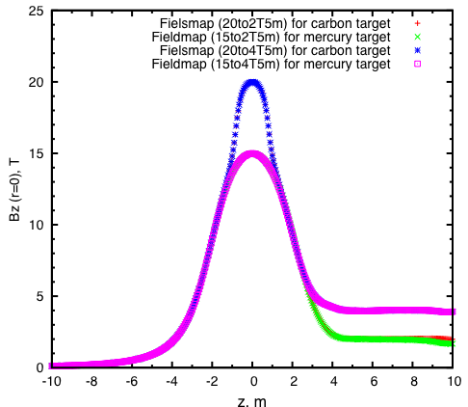

Figure 2: Axial magnetic field of the 20to2T5m and 20to4T5m configurations for a C target, and of the 15to2T5m and 15to4T5m configurations for an Hg target.. The center of the target is at z = 0.

The graphite-target, and graphite-beam-dump, rods are inside a double-walled stainless-steel containment vessel, with downstream Be windows, shown at the right of Fig. 1. These rods are radiation cooled, and the containment vessel is cooled by He-gas flow between its double walls. The outer cylinder extends over -46 < z < 170 cm, with outer radius r = 15 cm. The inner cylinder extends over -45 < z < 169 cm, with inner radius r = 14 cm. The downstream faces of the vessels are Be windows, ≈ 1 mm thick.

*Work supported in part by US DOE Contract NO. DE-AC02-98CH110886.
†kirkmcd@princeton.edu

The Front End for 5 < z < 50 m consists of nine 5-m-long superconducting magnet modules, each with internal tungsten shielding around the 23-cm-radius beam pipe. The latter has thin Be windows, ≈ 0.05 mm thick, at each end of a magnet module, and is filled with He gas at 1 atmosphere.

CARBON TARGET OPTIMIZATION
The MARS15(2014) code [5], with its default setting for event generation (IQGSM = 1), was used for target optimization. The proton beam was launched at z = −100 cm so as to have a specified rms transverse emittance, beam angle and waist at the center of the target (z = 0), after propagating in the magnetic field. For this, an antiproton beam was generated at z = 0 with the specified parameters, propagated back to z = - 100 cm without a target, and then the charge and momentum was reversed, and the target restored, for subsequent propagation in the positive z direction.
The pions and muons from the target of interest to a Muon Collider/Neutrino Factory are those with kinetic energies between 40 and 180 MeV. The optimization used here is based on maximizing the yield of these particles at the plane z = 50 m, which is near the beginning of the Buncher of the Front-End [3].
We also considered a more aggressive scenario in which muons of kinetic energies between 40 and 300 MeV are transported in the Front End.
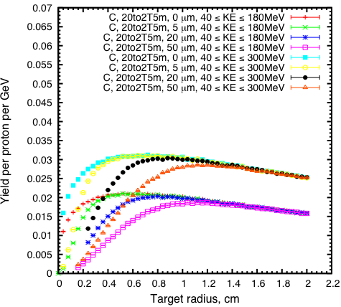
(a)

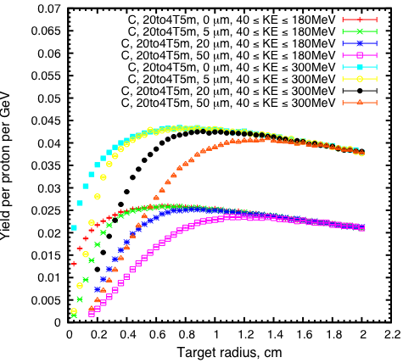
(b)

Figure 3: Muon yield at z = 50 m as a function of target radius for different rms geometric emittance. (a) 2-T field in the Front End; (b) 4-T field in the Front End.

The graphite density was assumed to be 1.8 g/cm³. In a previous optimization [6] for incoming protons with kinetic energy of 6.75 GeV and rms geometric emittance from 5 mm-mrad, we found the optimized geometric parameters of the beam and target to be: target length = 80 cm, target radius = 0.8 cm, beam radius = 0.2 cm and beam/target angle = 65 mrad to the magnetic axis.
In the present study, we ran MARS15(2014) with a ROOT-based geometry description. The optimization was extended to focused proton beams with transverse emittances between 5 and 50 mm-mrad, showing that the particle production decreases only slowly with increasing emittance (see Fig. 3). The optimal beam and target angles are essentially independent of the beam emittance. If the Front End could operate at 4 T, a substantial increase in the muon yield over 2-T operation would ensue, as also shown in Fig. 3.
We also designed a graphite proton-beam dump to intercept the (diverging) unscattered and slightly scattered proton beam. The beam dump consisted of two segments, each of length of 55 cm. The first rod, of radius 3 cm, extended over 55 < z < 105 cm. The second rod, of radius 4 cm, extended over 105 < z < 160 cm. We found that this beam dump would intercept about 2/3 of the unscattered proton beam with kinetic energy above 6 GeV while causing only 8% decrease in the yield [7].
Figure 4 illustrates the x-y distributions of proton at various positions along the beam in the target/dump system, showing that the dump radius should be larger than that of the target to intercept the substantial flux of slightly scattered protons.

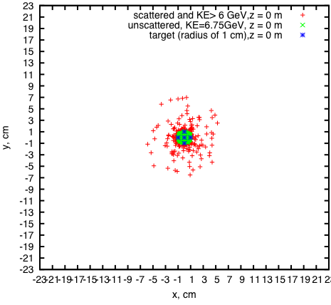
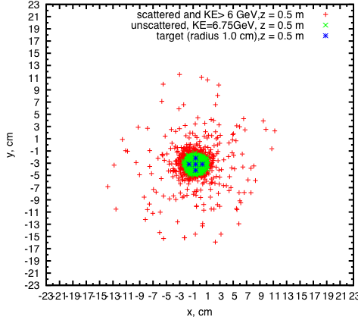
(a)
(b)

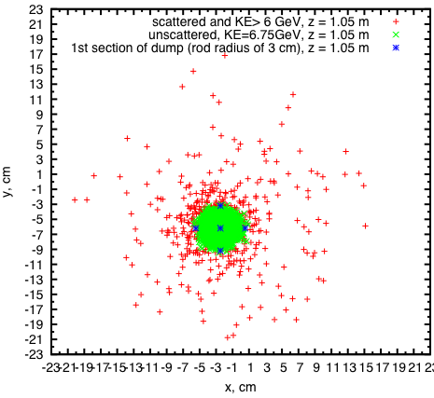
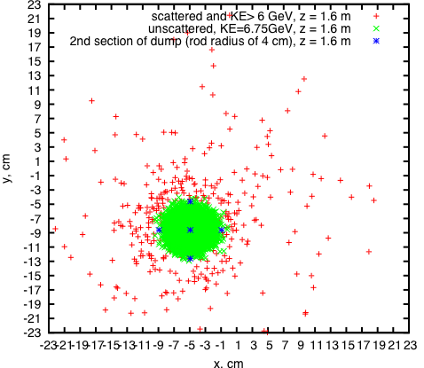
(c)
(d)

Figure 4: Transverse profiles of protons at (a) the center, and (b) the end of the 80-cnm-lon, 1-cm-radius graphite target; (c) at the end of the first dump rod (of 3-cm radius); (d) at the end of the second dump rod (of 4-cm radius.

MERCURY TARGET OPTIMIZATION
For a possible upgrade to a proton beam of multi-MW power, at which the operational life of a graphite target might be undesirably short, we considered a free-flowing mercury jet in the so-called 15to2T5m configuration, which would evolve from the 20to2T5m configuration by extracting the C-target/dump vessel and the 5-T copper coil insert (which is not physically compatible with the mercury-target infrastructure), and inserting a mercury target vessel in their place (z < 4.5 m, r < 23 cm).

We optimized the target parameters for a 6.75-GeV proton beam impinging on a mercury jet with length of 100 cm in the 15to2T5m configuration. The target and beam were tilted at different angles with respect to the magnetic axis, while the rms beam radius at z = 0 cm was fixed to be 30% of the target radius.

Figure 5 shows the variation of muon yield with target radius for both mercury targets at beam emittance of and 20 mm-mrad. The production was maximized when the target had a radius of 0.5 cm (mercury) and 0.8 cm (carbon). The yield from a mercury target (in 15-T peak field) was about 10% higher than that from a carbon target (in 20-T peak field). If the mercury target could be operated in a 20-T peak field, the yield would be about 30% higher than from a carbon target, at 6.75-GeV beam energy [8].
The simulations showed that the yield increased with the proton- beam angle, saturating for angles larger than about 65 mrad. This is favorable, in that it would be desirable to use the same incident proton beam in a mercury-target option as in the initial carbon-target configuration.
Optimization was also performed for the 20to4T5m configuration, with 4-T field in the Front End. As for use of a graphite target, a higher magnetic field in the Front End would lead to considerably larger yield of useful muons.

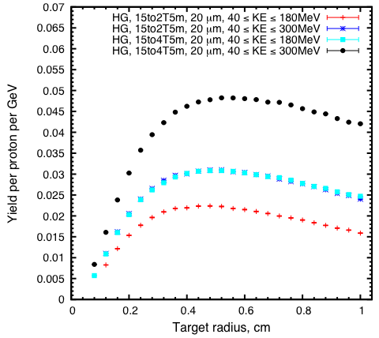
Figure 5: Muon yield at z = 50 m as a function of Hg target radius.

Unlike with the solid graphite target, the beam must cross a liquid target at an angle, which was optimized at
24 mrad. The mercury-jet angle would be larger than the proton-beam angle, i.e., about 89 mrad to the magnetic axis, which larger angle would facilitate collection of the mercury jet in a pool that also serves as the proton-beam dump for the mercury-target configuration.

CONCLUSIONS
With a 6.75-GeV incident proton beam, we optimized both a carbon target in the 20to2T5m (20-T peak field) and a mercury target in the 15to2T5m4PDL configuration (15-T peak field). For rms transverse, geometric beam emittances between 5 and 50 mm-mrad, the optimized parameters for a carbon target are: target length 80 cm, target radius 0.8 cm, beam radius 0.2 cm, beam angle 65 mrad and target angle 65 mrad; while for a mercury-jet target they are: target radius 0.5 cm, beam radius 0.15 cm, beam angle 65 mrad and beam/Hg jet crossing angle 24 mrad. The mercury target is predicted to give about 10% more yield than the carbon target.
In addition, the study showed that the yield would decrease only very slowly with increasing transverse emittance of the proton beam, such that good performance is compatible with the use of larger emittance proton beams.
The study for the graphite target included consideration of a graphite proton-beam dump, modelled in ROOT-based geometry.

ACKNOWLEGEMENT
We thank other colleagues from the Target Studies Group of the Muon Accelerator Program for their help on this work.

REFERENCES
[1] M. Alsharo’a et al., Recent progress in neutrino factory
and muon collider research within the Muon Collabora-
tion, Phys. Rev. ST Accel. Beams 6, 081001 (2003).
[2] R.D. Ryne et al., Design Concepts for Muon-Based
Accelerators, Proc. IPAC15, WEPWA057.
[3] J.S. Berg et al., Cost-effective design for a neutrino facto-
ry, Phys. Rev. ST Accel. Beams 9, 011001 (2006).
[4] K.T. McDonald et al., Energy Deposition in the Target
System for Muon Collider/Neutrino Factory, Proc.
IPAC14, THPRI088.
[5] N.V. Mokhov, The MARS Code System User's Guide,
Fermilab-FN-628 (1995); N.Mokhov and S.I. Striganov,
MARS15 Overview, AIP Conf. Proc. 896, 50 (2007),
http://www-ap.fnal.gov/MARS
[6] X. Ding et al., Particle Production of a Graphite Target
System for the Intensity Frontier, IPAC15, WEPJE010.

[7] X. Ding et al., Carbon and Mercury Target Optimization
with a 6.75 GeV Proton Driver for the Intensity Frontier,
physics.princeton.edu/mumu/target/Ding/ding_160105.pdf

[8] X. Ding, Carbon Target Optimization for a Muon
Collider/Neutrino Factory with a 6.75 GeV Proton Driver,
2014 MAP Spring Meeting,
physics.princeton.edu/mumu/target/Ding/ding_140529.pdf

