Princeton/MuMu/99-24
May 20, 1999
ANSYS Coupled-Field Analysis in the Simulation
of Liquid Metal Moving in the Magnetic Field

Changguo Lu (lu@puphed.princeton.edu)
Princeton University, Princeton, NJ 08544

Abstract

We discuss a possible solution of using ANSYS coupled-field analysis to simulate the behavior of a liquid metal object moving into a solenoid magnetic field.

To build a high luminosity muon collider, we are faced with many technical challenges. One of these is the construction of a target to be bombarded by a 4 MW proton beam, and residing in a 20 T magnetic field, to create and capture enough muons for further processing. According to various considerations, a tilted heavy liquid metal jet is our baseline design for the target, which is shown in figure 1. The first engineering question we have to answer is: can a heavy liquid metal jet enter a strong solenoid magnet without breaking up into droplets? This problem may can be treated by the ANSYS coupled-field analysis: coupling FLOTRAN, Emag and Structural Analysis into a single problem. So far we haven’t completely solved this problem yet. But as a first step, we have made those three physics disciplines interact with each other, been able to pass the results from one physics discipline to the other as the loads or real constants of the elements, and got some preliminary instructive results.
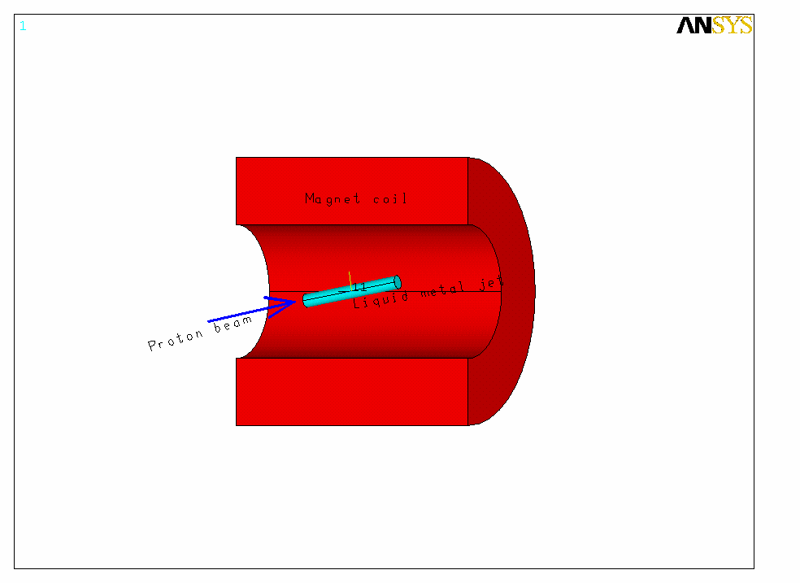
Figure 1. Sketch of the tilted liquid metal jet target for muon collider

Description of the model

Since ANSYS FLOTRAN does not allow the fluid having free surface, the liquid metal has to be contained in a solid pipe. We start our simulation from FLOTRAN analysis, which will provide the velocity for all nodes of the fluid elements. To get the velocities for each element we just simply average the velocities of every node on the element. Then we pass this velocity to Emag element as its real constant. In Emag analysis the Eddy currents and magnetic forces are calculated. Knowing the force on each element, we carry on the simulation further into structural analysis. Assign the mechanical properties of these fluid elements and pipe elements with Young’s modulus and Poisson ratio of rubber, we can observe how the rubber-like metal cylinder being distorted under the magnetic forces. The type of coupled-field analysis we adopted in this problem is sequential method. A cut-off view of this model is shown in figure 2, and brief flowchart of

our analysis is shown in figure 3. To reduce the model size, we use the symmetry condition of this problem to create a 90model for the analysis.

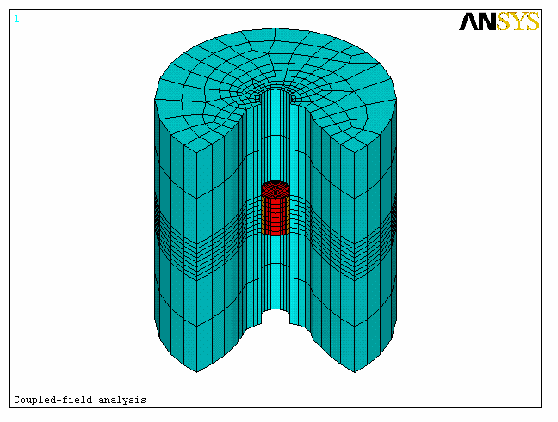
Figure 2. A cut-off view of the geometry of a 360 model. The central red elements are for metal fluid; the brown elements are for rubber pipe; the blue elements are for air. Not shown are the solenoid source element and the infinite elements, which are covering the air elements. In our analysis we used a 90model for reducing the model size.

ET,1,SOLID97,1,1!MAGNETIC SOLID,WILL BE FLUID ELE.
ET,2,INTER115!COUPLE 96 AND 97
ET,3,PLANE13!HELP TO MAKE 3D MODEL,WILL BE !DELETED
ET,4,SOLID97,1,1!ELEMEMNTS FOR RUBBER PIPE
ET,5,SOURCE36!SOLENOID MAGNET
ET,6,INFIN47,0!INFINITE MAGNETIC ELEM.
ET,7,SOLID96!MAGNETIC SOLID FOR AIR
Make a FEA model for Emag analysis.
Define COMPONENTS: INNERTUBE, OUTERTUBE,
TOP, BOTTOM
Create a physics environment called EMAG. Ph1
ET,1,FLUID142!ONLY ET,1 WILL BE USED IN FLOTRAN
ET,2,0 ET,4,0 ET,5,0 ET,6,0 ET,7,0 !ALL OTHERS ARE NULL
Set up
CFD solution control
CFD property information
CFD boundary condition

Create a physics environment called FLUID.ph2
ET,1,SOLID45!STRUCTURAL ELEMENT
ET,4,HYPER58!HYPERELASTIC SOLID FOR !INCOMPRESSIBLE RUBBER-LIKE !MATERIAL. SET NLGEOM,ON
ET,2,0 ET,5,0 ET,6,0 ET,7,0 !ALL OTHERS ARE NULL ELEMENTS
Set up
Material properties: rubber-like
Moony-Rivlin constants

Create a physics environment called STRUC.ph3
Figure 3. A flowchart of the coupled-field analysis.

K=K+1
N

Start iteration: K = 0
Get node numbers for FLUID elements: *USE, GETENH

K > 1 ?
Solve FLOTRAN
Save as FLOTRST.DB
Save result file as FLOTRST.RFL
Read FORC from Emag results and apply them to FLUID elements as load.
Get velocity data for fluid elements, *USE,GETVH
Read in physics environment EMAG.ph1
Modify real constant (velocity) for ET,1 elements, *USE,MODREALH
Solve EMAG
Save database as EMAGRST.DB
Save result file as EMAGRST.RST

Read in physics environment STRUC.ph3
Apply 0 pressure to the component OUTERTUBE
Read FORC from EMAGRST.RST, set them as load for ET,1
Set constraints for the model
No tangential displacement;
Constrain few central nodes on top surface of ET,1
Set the coordinate of ET,1 and ET,4 back to its original
Read in physics environment FLUID.ph2
Solve STRUC
Update the coordinate of ET,1 and ET,2
Save the database as STRUCT.DB
Save result file as STRUC.RST
K=Kmax?
END
N

Y

Y

N

Results of the simulation

- FLOTRAN analysis

Since our final goal is to simulate a free fluid jet, of which the surface is free of friction, in this calculation we don’t apply the conventional boundary condition, v = 0, on the wall of the pipe. The only boundary condition we used is V = V = 10 m/s at the inlet surface, and zero pressure on the outlet surface. After first 100 iterations of FLOTRAN calculation the velocity distribution is shown in figure 4. It is not surprised that the velocity is very close to 10 m/s everywhere among the fluid elements.
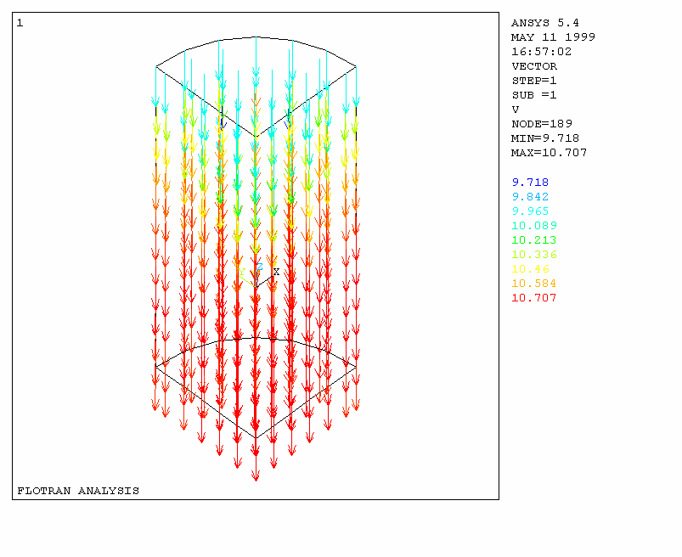
Figure 4. The velocity distribution among the fluid elements after 100 iterations of FLOTRAN analysis in the first loop.

- Emag analysis

Because we are expecting that the velocities will vary among the different fluid elements, we have to be able to setup the velocity for each fluid element individually. To accomplish this task we have created a macro library file called GETENV.LIB, which includes three macros: GETENH, GETVH, and MODREALH. The macro GETENH is used to get the node numbers for the fluid elements with the command *GET,,ELEM,,NODE, and store them into a two-dimension array ELENOD. The macro GETVH then retrieves the velocity components V, V and V of each node of the fluid elements with the command *GET,,NODE,,VX, etc. and store them into another two-dimension array VELOCT. The third macro MODREALH is used to calculate the velocity of each element by averaging the velocities of its eight nodes, then set a new real constant, and modify the real constant of this element to the new one with the command EMODIF,,REAL. We have noticed that if an element has its own real constant, this element becomes a region. The total number of regions in ANSYS is limited to 1000. We have to restrict our model within this limit. The distributions of B field, Eddy current and magnetic force are shown in figures 5, 6 and 7.

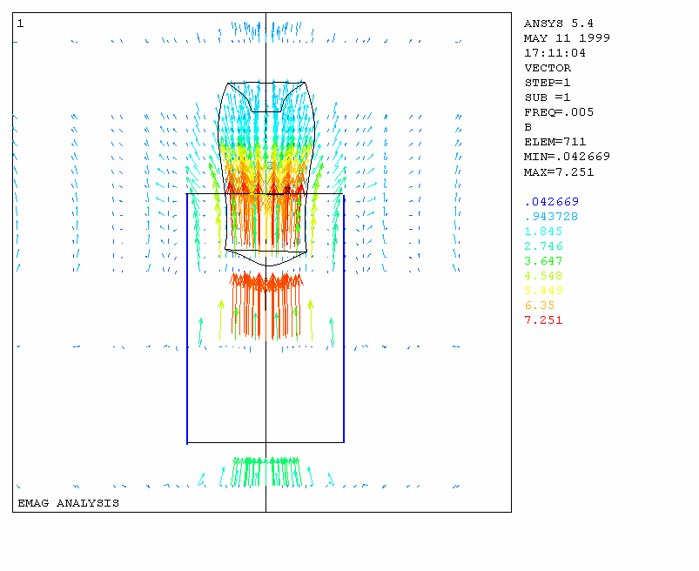
Figure 5. B field distribution of a solenoid magnet with a deformed moving metal cylinder. The blue box indicates the geometrical position of the solenoid coil.

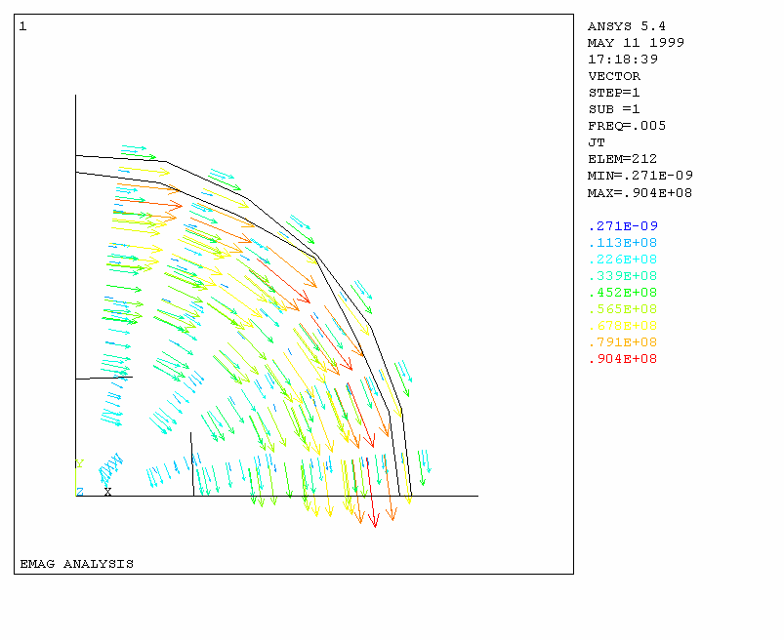
Figure 6. Eddy current in the moving metal fluid

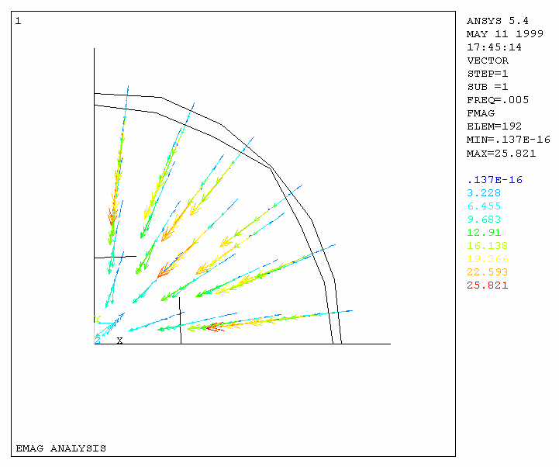

Figure 7. Magnetic force encountered on moving metal elements.

- Structural analysis

In our model there is a pipe surrounding the metal cylinder. Both pipe and metal elements have rubber’s properties at present stage. The pipe encounters no pressure from outside surface (component OUTERTUBE). The metal and pipe elements with four defined components on them are shown in figure 9. The magnetic force on each of the metal element will introduce a displacement. The structural analysis part of our simulation utilizes an ANSYS command LDREAD,FORC,,,,,EMAGRST,RST to fetch the magnetic forces from the EMAG result file EMAGRST.RST and apply them to the structural model as the loads. If we set the metal elements with structural fluid properties, such as small Young’s modulus: 1% of rubber’s and very small Poisson’s ratio: 0.0001, the calculation wouldn’t be converged. Some of the fluid elements are tore off under the magnetic force. It indicates that this is not the right approach to the solution. In order to be able to get some sense of the behavior for the moving metal fluid in a non-uniform magnetic field, we change the mechanical properties of the metal elements as the rubber. The deformed metal cylinder is shown in figure 8.

When we do the structural analysis the model has to have some restrictions to make it stable. For this analysis we apply the complete restriction (UX, UY and UZ = 0) on the central few nodes of the cylinder’s top surface (component TOP), also restrict the axis of the cylinder from any radial displacement due to the symmetrical consideration. After 12 loops of FLOTRAN-EMAG-STRUCTURE analysis the results from each analysis are converged. The figures 5 to 8 are showing the results from Emag and structural analysis after the 12-th loop. The velocity distribution in FLOTRAN after 12-th loop is shown in figure 10.

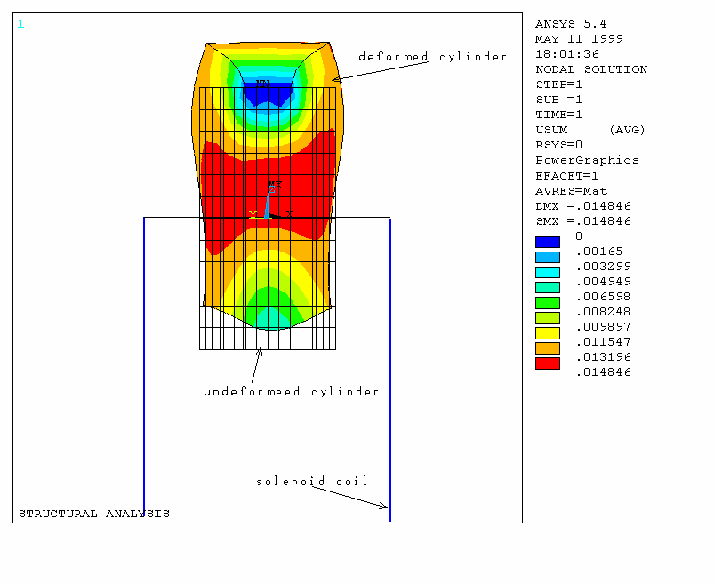
Figure 8. The deformed rubber-like metal cylinder when it is entering a solenoid magnet

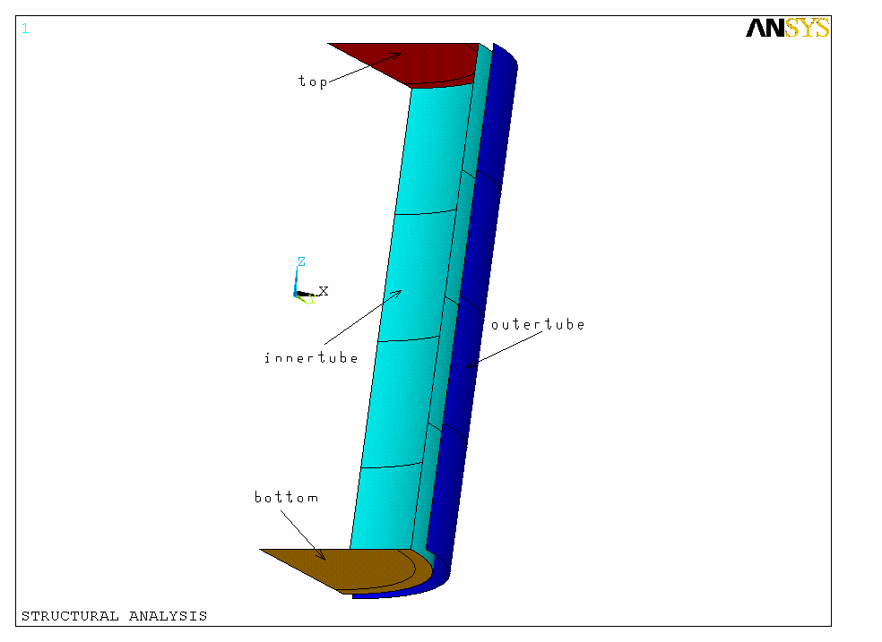
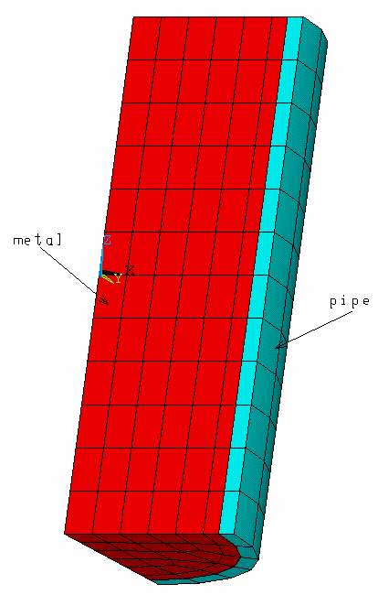
Figure 9. The metal and pipe elements with four defined components on them

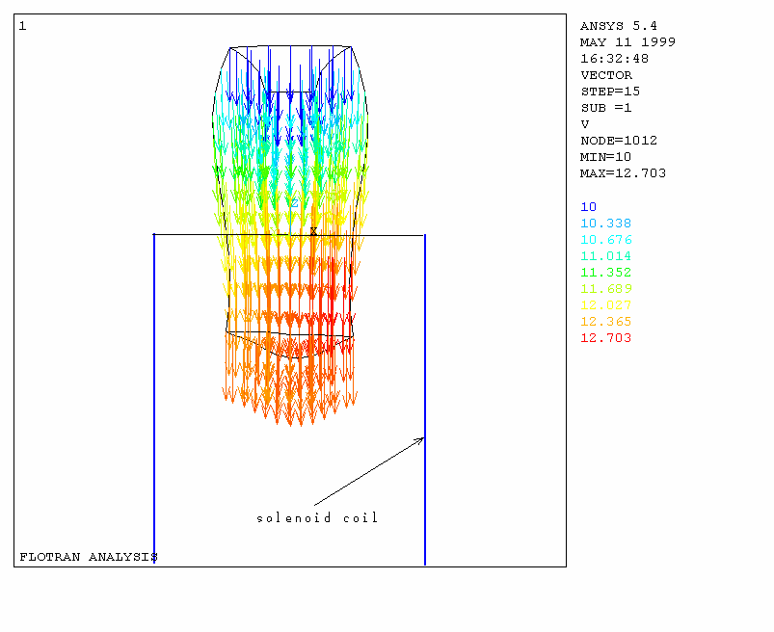
Figure 10. The velocity distribution in FLOTRAN after 12-th loop of FLOTRAN-EMAG-STRUCTURE analysis

Where to go from here

- Is this possible to use structural fluid elements to simulate the metal elements in structural analysis when each of the elements obtains electromagnetic force due to Eddy current?
- Tilt the solenoid magnet to simulate the metal jet entering the magnetic field with small polar angle with the axis.
- Add thermal analysis into the simulation to complete the target study.

