Technical / Economic Justification
for the use of Liquid Hydrogen to
Cool the E951 15-T Pulsed Solenoid Magnet

G.T. Mulholland, ACT
M. Iarocci and H.G. Kirk, BNL
K.T. McDonald, Princeton U.
(August 15, 2002)

Background

Brookhaven National Laboratory Experiment E951 requires a field of up to 15 teslas within a warm-bore 15-cm diameter and 1-m length. A cryogenically cooled, pulsed solenoid magnet (PSM) most efficiently provides that field over the required volume.
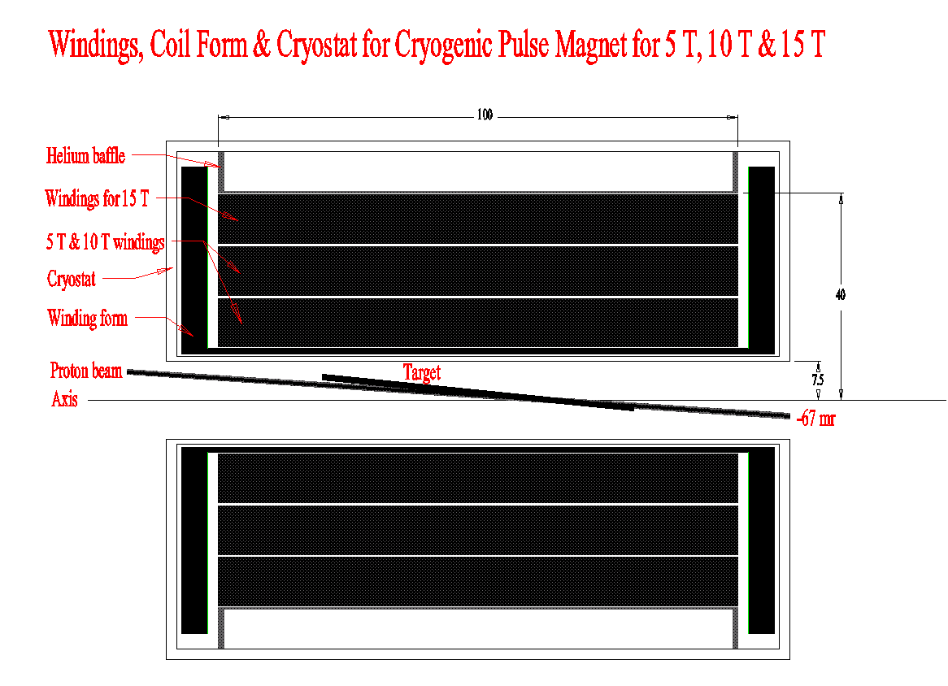
Realization of this magnet, as sketched above, and the power supply system to drive it requires that the magnet be cooled to reduce the copper conductor’s resistance and thus the power consumed and the refrigeration required per pulse. System optimization of the 15 T pulsing concludes that the magnet should be cooled to about 30 K before the pulse, and from 71 K to 30 K thereafter in 30-60 minutes prior to the next pulse. This note addresses the methods to extract the 13.5 MJ dissipated in the magnet each field pulse, and justifies the choice of liquid hydrogen as opposed to a refrigeration system or other cryogens that meet the temperature requirement.

Task Definition

At the fastest proposed repetition rate (30-minute), the 15-T-pulse dynamic energy deposition results in a 27 kW peak and 7.5 kW average cooling system power load. The sum of the steady state background loads in the magnet itself is currently estimated as no more than 700 W. Heat is extracted from the magnet at temperature by circulated cooled gaseous helium (GHe). The GHe cooling system circulator flow work and conductive heat loads may add as much as a 1 kW to the background steady state average conductive and radiation loses. In sum, the 9.2 kW average operating load must sustain peaks to 28.7 kW, dropping down to the standby load of about 1.7 kW.

Use of a Refrigerator

A helium refrigerator to provide 20 kW at 80 K has recently been purchased for $1.2 million. Scaling linearly by the power and temperature, a budgetary cost estimate for a refrigerator to provide 10 kW of cooling at 20 K is (10/20)*(80/20)*$1.2 million = $2.4 million, exclusive of installation, housing, power consumption, etc.

Cooling via Cryogen Consumption

Alternatively, cooling at the required 30 K temperature can be obtained by, cryogen consumption (use of the liquid’s heat of vaporization and release of the vapor to the atmosphere). For this, the normal boiling point temperature of the cryogen must be less than 30 K, i.e., hydrogen, helium or neon. Some relevant properties of these cryogens are summarized in Table 1 (along with nitrogen for comparison, although it cannot be used for 30 K operation because of its normal boiling temperature.)

Table 1. Viable cryogens with a normal boiling point (NBP) below 30 K, and liquid nitrogen for reference. Subscripts L and V refer to liquid and vapor at T_{NBP}, while subscript G refers to values taken at 0˚C. The Vaporization Index (VI) = 10³ * (300-T_{NBP}) / (ρ_{L}*ΔH_{V}).

A process diagram for cooling of the pulsed solenoid magnet via consumption of liquid hydrogen is shown below. The magnet itself is actually cooled by helium gas that is cooled in a heat exchanger filled with the boiling liquid hydrogen. The heat exchanger is to be located outside the experimental hall.

A quality factor, Q, for the refrigeration via cryogen consumption is defined as
Q (kJ/$US) = (ΔH_{v})*(ρ_{L})*(1/(1000 liter/m³))*(liter/$US),

that is, a kilo-joule of heat-of-vaporization/$US at T_{NBP}. Q values are given in Table 2.

Table 2. Viable cryogens with NBP below 30 K and liquid nitrogen, and their quality value, Q, based on refrigeration/cost at T_{NBP}. The costs are representative.

The estimated cost to operate a 10 kW average load, at the 30 min repetition rate, with consumed LH₂ per pulse is:

LH₂ Cooling Cost = (10/60)*3600 *1/2 = $300 per pulse

The corresponding LHe cost per pulse is:

LHe Cooling Cost = (60/0.85)*(H₂ Cooling Cost)
= 71*($300)
= $21,000 per pulse.

The corresponding cost per pulse for LNe is:

LNe Cooling Cost = (60/0.60)*(H₂ Cooling Cost)
= 100*($300)
= $30,000 per pulse.

Clearly, liquid hydrogen is much more economical than either helium or neon on a per pulse basis.

E951 estimates it may require between 30 and 100 pulses at full field. For this range of pulses, the total cost of liquid hydrogen is $9--30k, for neon the total cost is $1--3M, and for helium the total cost is $0.6--2.1M, using the simplified boiling liquid approach.

Unless there is a subsequent Refrigerator/Liquefier use that could afford the circa $2M capital cost, the experiment is most economically performed with liquid hydrogen consumption.

Safety Issues

The indicated choice, liquid hydrogen, is flammable and must be handled with care. Some additional cost for making a proper liquid hydrogen installation is not presented above, but the estimated direct cost is < $20k to modify those hydrogen area items (mostly electrical) and install a hydrogen gas monitor system. To that level of additional cost, none of the above conclusions change.

The BNL CSC and the C-AD ESRC will review the system design to assure that all safety issues for the E951 pulsed solenoid magnet have been identified and that the proposed implementation satisfies all of the relevant safety rules. Once the conceptual design safety reviews are complete, operating procedures are detailed and safety reviewed and BNL personnel trained in the use of the equipment, the hard-piped, vacuum-jacketed, automatic-hydrogen-leak-monitored/interlocked, system can be safely operated in the BNL E951 experimental area.

***

K.T. McDonald, The R&D Program for a 4-MW Target Station for a Neutrino Factory and Muon Collider Source (Feb. 9, 2002), particularly pp. 15-17, http://www.hep.princeton.edu/~mcdonald/mumu/target/targettrans32_013102.pdf
H.G. Kirk, Overview of E951 Pulsed Solenoid Proposal (Feb. 9, 2002) http://pubweb.bnl.gov/users/kirk/www/e951/iit_feb_02/pulsed_solenoid.pdf
R.J. Weggel, A Three Stage Cryogenic Pulse Magnet Program for the BNL Targetry Experiment (Feb. 9, 2002), http://www.hep.princeton.edu/~mcdonald/mumu/target/weggel/chicago_020902.pdf
P. Titus, BNL Pulsed Magnet: Magnet System Cooldown and Structural Analysis (Feb. 9, 2002), http://www.hep.princeton.edu/~mcdonald/mumu/target/pulsepres.pdf
I. Marneris, E951 Power Supply to Pulse a 14.5-T Solenoid Magnet (Feb. 9, 2002), http://www.hep.princeton.edu/~mcdonald/mumu/target/marneris/e951_power_supply_km2.pdf
See ref. 3.
Exclusive of all steady-state background losses: circulator, cryostat, transport, storage dewar, etc.
This is the cost of the CERN ATLAS 80 K refrigerator.
And a circa 1-year minimum fabrication delay.
Assumes there is no rate-dependent load non-linearity.

