Muon Collider / Neutrino Factory Targetry R&D 2009-2012
V.B. Graves, H.G. Kirk, K.T. McDonald
(August 5, 2008)

Introduction
In recent years, research and development on high-power targets for muons colliders and neutrino factories has been centered around the MERIT experiment which took data at CERN during the Fall of 2007. While that experiment was successful as a proof of principle of the use of a free mercury jet inside a high-field solenoid magnet as a target for a multi-megawatt proton beam, that experiment was not a prototype for a production target system. Hence, we propose a program of continued R&D that builds on the MERIT experiment, and on systems engineering studies performed in 2000-2001 as part of Neutrino Factory Studies 1 and 2, to enhance our understanding of issues related to implementation of a production target system at either/both of a muon collider and/or neutrino factory.
The proposed effort is in three areas:
- Simulations
- Hardware R&D
- Systems Engineering Studies
A version of our R&D plans appears at http://puhep1.princeton.edu/~mcdonald/mumu/target/rndtrans.ppt and a summary of proposed efforts on simulations and systems engineering appears in the recent document “Accelerator Design and Simulation Study” by C. Ankenbrandt et al. (30 July 2008).

Simulations

Refine models of beam-liquid-magnetic field interaction
The interaction of a proton beam with a free liquid jet inside a magnetic field involves complex physical processes including magnetohydrodynamics of materials that can break up internally (cavitate). Simulation of this physics was beyond the state of the art in the year 2000 when efforts began in this area as part of the NFMCC R&D program. Much progress has been made, but there is need and opportunity for additional improvements to codes such as FRONTIER that are presently used for these simulations.
Level of effort: 0.5 FTE grad student × 3 years; 0.2 FTE scientist × 3 years

Benchmarking MERIT beam/jet/magnet results
Results from the recent MERIT experiment provide opportunities for validation of the thermomagnetohydrodynamic simulations that will guide our thinking about future liquid target applications. The scope of the MERIT results is that this validation should continue for another year (2009).
Level of effort: 0.5 FTE grad student × 1 year; 0.2 FTE scientist × 1 year

Refining simulations of nozzle performance
The nozzle that shapes the free liquid jet is a key component of target system, and it appears that an optimal design of the nozzle has not yet been achieved. A combination of simulation and hardware studies should be made to improve our understanding of nozzle performance, both in zero magnetic field and in high fields.
Level of effort: 0.5 FTE scientist × 1 year

Consideration of Hg Jet/Dump splash issues
Another key component of a target system for a muon collider / neutrino factory is the proton beam dump, which will be close to the target and inside the solenoidal magnet system that captures/confines secondary pions. The baseline concept is that a pool of liquid from the target jet serves as the beam dump. Simulations should be performed to aid in design of the pool/dump to mitigate the effects of disruption of the pool by the proton beam, and by the incoming liquid jet.
Level of effort: 0.4 FTE scientist/engineer × 1 year

Simulation program resources
2.0 FTE Grad Student ($50k/yr) | $100k
1.7 FTE Scientist/Engineer ($220k/yr) | $374k
Travel | $25k
Total | $499k

Systems Engineering (RDR Support)
A major goal of the proposed R&D is to produce a Reference Design Report (RDR) for a Neutrino Factory by 2012, which will also serve as a Zero Design Report (ZDR) for a Muon Collider. As the target station is believed to be the same for both facilities, and since the baseline target scheme of a free-stream Hg jet has not changed, the ORNL/TM-2001/124 technical report (footnote 2) can serve as the basis for an update of this target station concept.

Hg Loop
A preliminary schematic flow diagram and conceptual mechanical models were developed in the ORNL/TM document of 2001, but some areas of the system had considerably less detail included. Because of the significant amount of activated Hg vapors that will be created, the nozzle and catch basin/beam dump within the main cryostat must be considered as a system rather than separate components. Remote replacement and/or maintenance of the loop components will be considered in more detail.
Level of effort: 0.4 FTE engineer × 2 years
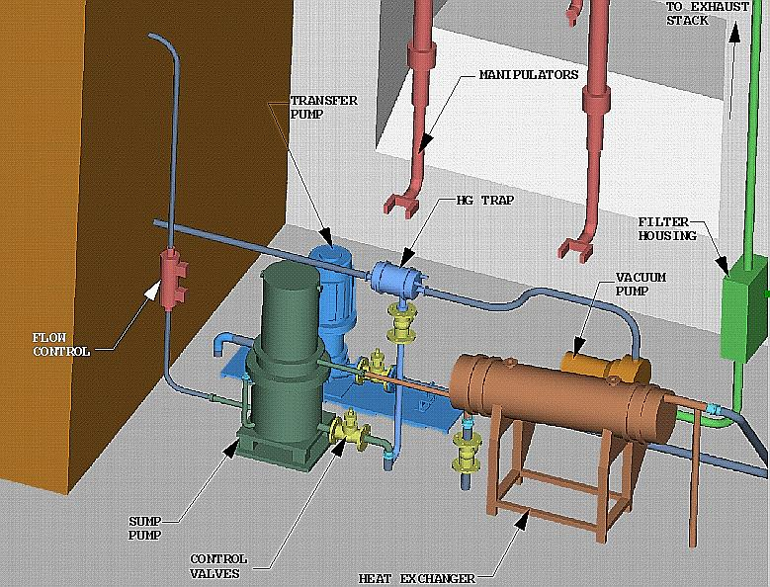
Hg flow loop components
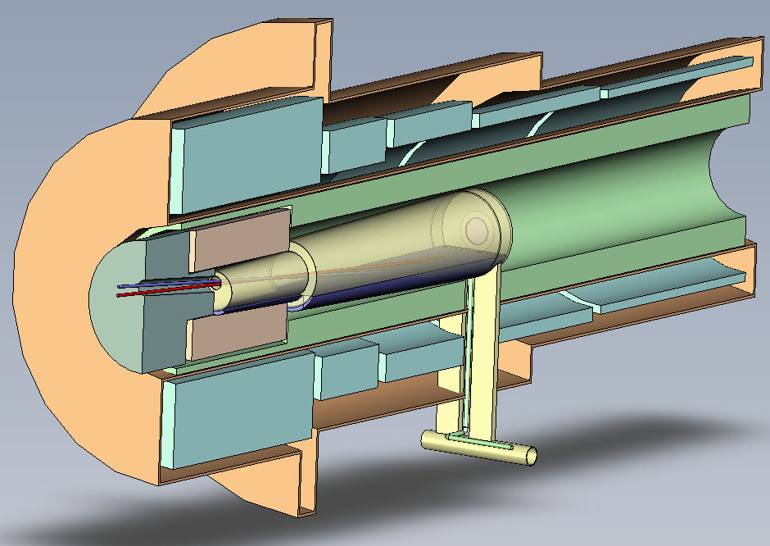
Target solenoid concept, including the collection pool/beam dump

Target component remote handling
General concepts for the remote handling and maintenance of the main cryostat were developed in the earlier study, but the design of the components was not at a detail sufficient to see many of the difficulties associated with such tasks, such as the required utilities connections for electrical power and water cooling and required penetrations through the cryostat. A new effort will develop more detailed mechanical models that incorporate remotely-operable connectors along with greater consideration for the remote maintenance or replacement of major components.
Level of effort: 0.4 FTE engineer × 2 years

Upstream / downstream beam windows
The location and design of all beam windows within the Target Facility will be reviewed and updated as the component design becomes more refined. The SNS proton beam window inflatable seal design and its remote replacement ability will be incorporated into the Neutrino Factory window design if possible. Location and replacement of the upstream window will also be more fully developed.
Level of effort: 0.5 FTE engineer × 1year
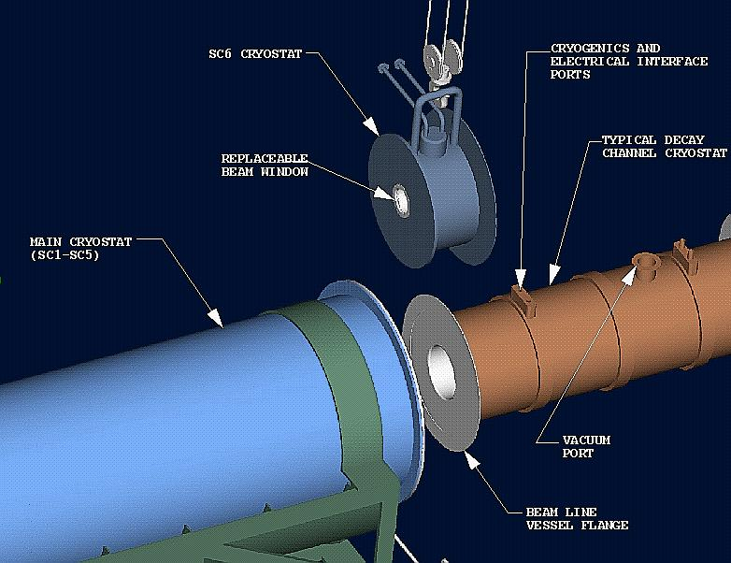
Proton beam window concept

Water-cooled tungsten carbide shielding
The Study-2 target station concept proposed the use of water-cooled, tungsten-carbide balls housed in a cylindrical structure as the means for shielding the superconducting coils SC1-SC5. The conceptual design will be refined to resolve issues associated with fabrication, remote assembly/disassembly within the main cryostat, required utility connectors, etc. Results from hardware testing will be incorporated into the component design.
Level of effort: 0.5 FTE engineer × 1 year
Tungsten-carbide-filled shield module

CAD/administrative support
Engineering and physicist design input will drive creation of facility and component 3D CAD models. The final assembly will include beamline components, remote handling systems, maintenance areas, and utility systems for the target facility.
Level of effort: 0.2 FTE engineer × 2 years; 1 FTE CAD operator × 2 years

Option for High Temperature Superconducting Solenoid
The baseline design for the 20-Tesla solenoid around the target is for a hybrid magnet with a 6-T copper core surrounded by a 14-T superconducting coil operated at 4K. Development of high-temperature superconductors has advanced to the point that it may be feasible to use a single 20-T superconducting coil (perhaps still operated at 4K). Investigation of this option would be coordinated with related studies of 50-T solenoids for the final cooling stages of a muon collider.
Level of effort: 0.3 FTE engineer × 2 years

Systems engineering resources
3.0 FTE Engineer ($350k/yr)  0.6 FTE Engineer ($220k/yr) | $1050k  $132k
2.0 FTE CAD operator ($250k/yr) | $500k
Travel | $30k
Total | $1712k

Hardware R&D
The development of the second generation target station will require investigation into several technical challenges as identified in the original document as well as further refine the knowledge and experience gained with operation of the MERIT test loop.

Study 2 prototypic test loop
Incorporate the existing syringe pump into a new loop that is more prototypic of the system described in Study II. The loop would provide the capability to further study Hg nozzle configurations as well as methods of successfully capturing the jet in a collection pool with minimal splashing. Flow within the collection basin is also a concern, as active mixing of the pool fluid may be required to eliminate any regions of locally increased temperature. These tests would be in a no-field condition; integration with the MERIT solenoid would not be a consideration for this test loop.
These studies could be performed at ORNL, or optionally at CERN. The budget below is based on studies at ORNL.
Infrastructure upgrade (TTF) | $25k
0.5 FTE Engineer × 1yr ($350k/yr) | $175k
0.2 FTE Technician × 1yr ($250k/yr) | $50k
Hardware | $80k
Subtotal | $330k

Nozzle injection: straight nozzle vs. 180° upstream bend
This series of tests would use the MERIT syringe pump and solenoid in an integrated test environment to compare jet quality via horizontally- and vertically-oriented camera systems. This was not possible in the MERIT experiment due to the presence of a proton beam, which required radiation-resistant, fiber-optic-based camera systems. These tests would be performed without a proton beam, and initially without a magnetic field as well.
Significant infrastructure costs will be incurred to provide the required electrical power to operate the MERIT solenoid at ORNL, and these costs are included in the estimate below.
Installation costs | $200k
0.3 FTE Engineer × 2yr ($350k/yr) | $210k
0.4 FTE Technician × 1yr ($250k/yr) | $100k
Hardware | $80k
Subtotal | $590k

TC shielding tests
The use of water-cooled, tungsten-carbide spheres as radiation shielding will require scaled testing to determine optimum ball diameter and distribution as well as to assess properties such as pressure drop and heat transfer coefficient. Thermal-hydraulic simulations may be required to restrict the range of sphere sizes and packing density. The results of these tests would be incorporated into the RDR conceptual design.
0.5 FTE engineer × 1yr ($350k/yr) | $175k
0.3 FTE technician × 1yr ($250k/yr) | $75k
Hardware (cost of TC balls uncertain) | $80k
Subtotal | $330k

Integration of the nozzle into an iron plug at the upstream end of the magnet
The baseline design of the target system calls for an iron plug at the upstream end of the target solenoid to flatten the magnetic field profile which will reduce the distortion of the jet as it enters the magnetic field. The nozzle is to be incorporated into this plug. This concept can be studied with the MERIT solenoid, as augmented by iron plugs.
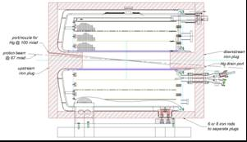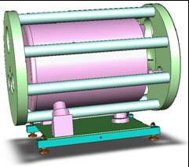
Configuration of the MERIT solenoid with iron plugs
0.3 FTE engineer × 1yr ($350k/yr) | $105k
Hardware | $100k
Testing | $20k
Subtotal | $225k

Studies of mercury handling in collaboration with ESS/Eurisol
An opportunity exists to collaborate with the ESS/Eurisol project on issues of mercury handling, including possible hardware studies at the Institute of Physics of the University of Latvia. A well-defined proposal for this effort does not exist, so we indicate only a representative level of funding that might be appropriate.
0.1 FTE scientist × 3yr ($220k/yr) | $66k
0.1 FTE technician × 3yr ($170k/yr) | $50k
Travel | $20k
Subtotal | $136k

Total Hardware R&D Program
Study 2 prototypic test loop | $330k
Nozzle injection | $590k
TC shielding tests | $330k
Iron plug integration | $225k
ESS/Eurisol collaboration | $136k
Total | $1611k

Chap. 4, Target System and Support Facility, Neutrino Factory Study 1 (April 1, 2000), http://www.fnal.gov/projects/muon_collider/nu/study/report/machine_report/04_source_target+_rev11.PDF
P.T. Spampinato et al., Support Facility for a Mercury-Jet Target Neutrino Factory, ORNL/TM-2001/124 (Sept. 2001), http://puhep1.princeton.edu/~mcdonald/mumu/target/tm-2001-124.pdf

