Operation of a Free Hg Jet Delivery System

in a High-Power Target Experiment *
V. Graves#, A. Carroll, P. Spampinato, ORNL, Oak Ridge, TN 37831, U.S.A.
H. Kirk, BNL, Upton, NY 11973, U.S.A.
A. Fabich, I. Efthymiopoulos, J. Lettry, CERN, Geneva, Switzerland
K. McDonald, Princeton University, Princeton, NJ 08544, U.S.A.

Abstract
Operation of a mercury jet delivery system is presented. The delivery system was part of the MERcury Intense Target (MERIT) Experiment, a proof-of-principle experiment conducted at CERN in 2007 which demonstrated the feasibility of using an unconstrained jet of mercury as a target in a Neutrino Factory or Muon Collider. The mercury system was designed to produce a 1-cm-diameter, 20-m/s jet inside a high-field (15 Tesla) solenoid magnet. A high-speed optical diagnostic system allowed observation of the interaction of the jet with both 14- and 24-GeV proton beams. Performance of the mercury system during the in-beam experiment will be presented.

INTRODUCTION
The MERcury Intense Target (MERIT) Experiment was a proof-of-principle effort to determine the feasibility of using a free jet of liquid mercury (Hg) as a target in a Neutrino Factory or Muon Collider facility [1]. The interaction of the jet and a proton beam would take place within a high-strength magnetic field. This field would capture the produced pions while constraining the shape and density of the jet after the impact of the beam. The MERIT Experiment was conducted at CERN in October-November 2007 under the designation nToF11.
The design requirements for the equipment were that the mercury jet have a diameter of 1 cm and a maximum velocity of 20 m/s; the magnetic field was produced by a cryogenically-cooled, pulsed solenoid [2] with a maximum field strength of 15 T. Because the nature of the experiment was single-pulse-on-demand with a subsequent cool-down period for the solenoid, a jet duration lasting more than a few seconds was not required. Because of the health hazards associated with mercury, especially irradiated vapors, the target system was designed to provide primary and secondary containment of the mercury. Safety requirements at CERN dictated that the primary containment not be opened while at CERN, which led to a configuration in which the mercury system incorporated a 180-degree bend in the nozzle piping.
Beam momentum was either 14 GeV/c or 24 GeV/c, with up to 30 x 10¹² protons per pulse and an integrated protons-on-target experimental limit of 3 x 10¹⁵. High-speed optical diagnostics [3] were used to observe the jet-beam interactions, and particle detectors [4] were deployed down-beam of the target to quantify the produced pions.

equipment description
A vertical cross-section view of the experimental equipment is shown in Fig. 1, with the solenoid magnet on the left and the mercury delivery system shown on the right; the “snout” of the mercury system, where the jet was produced, is shown inserted into the solenoid bore. The mercury system provided double-containment of the hazardous liquid metal and was designed so that it could be decoupled from the solenoid without disassembly of either system.
In Fig. 1, the proton beam is shown as a horizontal line; direction of the beam and the Hg jet is from left-to-right. The magnetic axis was positioned at a slight angle (67 mrad) to the beam, with the tilt provided by a common baseplate supporting all the equipment. The four viewports shown within the solenoid bore represent viewing locations for observation of the Hg jet within its primary containment. Viewport #2 was positioned at the center of the high field within the solenoid and was also where the center of the proton beam interacted with the center of the Hg jet.
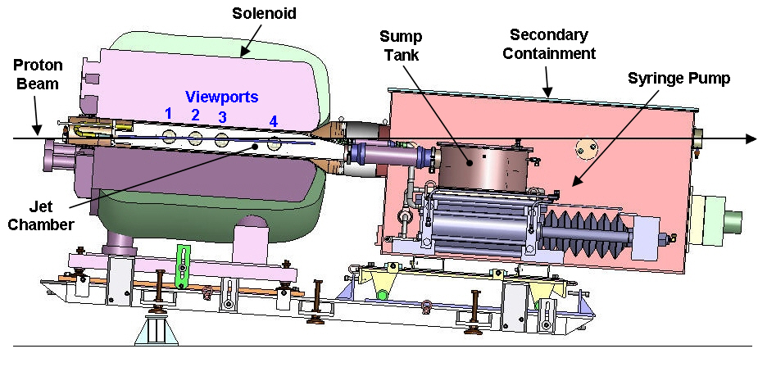
Figure 1: Vertical cross-section of MERIT equipment.
The mercury jet was produced using a custom-designed, hydraulically actuated syringe pump [5]. The syringe was comprised of three stainless-steel hydraulic cylinders, a single ten-inch-diameter mercury cylinder between two six-inch-diameter drive cylinders, mechanically linked together through a solid beam. Actuation of the drive cylinders caused motion of the mercury cylinder piston. Mercury was drawn into the syringe from a sump tank and was then expelled to the nozzle as required; piston velocity (and thus jet velocity) was controlled by a hydraulic proportional control valve.

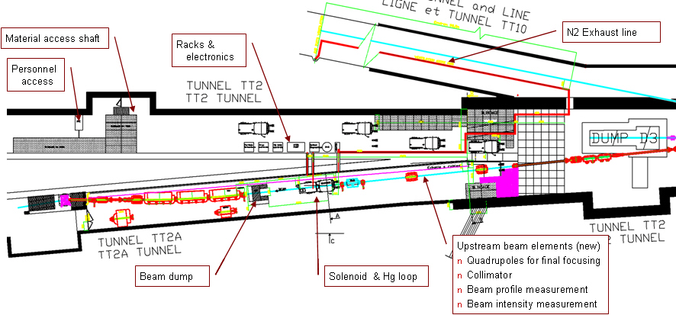
Figure 2. MERIT experimental layout in CERN TT2/TT2A tunnels.

The choice of this type of pumping system was primarily driven by consideration of temperature: inefficiencies in a standard centrifugal pump would have added significant heat to the mercury and would have required the addition of a heat exchanger to minimize the release of mercury vapors. The syringe pump added minimal heat to the mercury because there were negligible frictional losses in the mercury cylinder.
All beam windows were fabricated from Grade 5 titanium (Ti6Al4V) after analyses concluded this material could best withstand the thermal shock stresses induced by the beam. One of these beam windows was integrated into a flange welded to the nozzle tubing, so the entire length of nozzle tubing was fabricated from titanium; a mechanical union provided a transition from titanium to stainless steel.
Sensors on-board the mercury system provided feedback on sump-tank level; piston position; discharge pressure; various metal, fluid, and air temperatures; two mercury-vapor levels; and air pressures within two safety beam windows. Because of the radiation environment, sensor electronics were separated from the sensor heads where practical; the exception to this was the mercury-discharge-pressure transducer. The high-speed viewing cameras were also removed from the target area, with radiation-tolerant fiberoptic cables employed to provide optical illumination and image transport.
The experiment was performed within the CERN TT2/TT2A tunnels, a layout of which is shown in Fig. 2. The in-beam equipment was located in TT2A, while the electronics, cryogenics, and other control system equipment was located in the adjacent TT2 access tunnel. Personnel were located in a control room in a separate building; all system control and monitoring was via Ethernet.

OPERATIONS
The MERIT experiment was conducted during a three-week period October-November 2007. The experimental program was designed to study the impact of single proton pulses on the mercury jet while under the influence of a strong magnetic field. Each pulse was a separate experiment in the overall program. Proton beam energy was configured at either 14 GeV or 24 GeV, with various bunch intensities, structures, and numbers of bunches. The magnetic field strength was varied between 0T and 15T. A total of 267 target jets were produced; jet velocity was typically 15 m/s, but in two cases a 20-m/s-velocity jet was generated. A total of approximately 2.2 x 10¹⁵ protons were delivered to the mercury target.
Operation of the mercury system during the MERIT experimental run was completely successful, with no mechanical failures. There were no fluid (mercury or hydraulic) leaks in the system and no observed elevated mercury-vapor-level readings. The syringe pump was unaffected by the radiation, and with the exception of the mercury-pressure transducer, none of the mercury system sensors were adversely affected. After 6 x 10¹⁴ protons were delivered to the target, the readings from this pressure transducer began to show signs of radiation damage, which was anticipated since the off-the-shelf transducer had on-board electronics and was not designed to withstand radiation exposure. Performance of this transducer was intermittent for the remainder of the experiment. However, because the mercury flow to the nozzle was well characterized through earlier testing, the loss of this sensor was not critical to the operation of the syringe pump.
Once the mercury was ejected from the hydraulic cylinder, it traveled to the nozzle via 1-inch-diameter pipe and 1-inch-diameter tubing; the flow path converged to a 1-cm-diameter nozzle after traversing a 180-degree bend. The mercury delivery system had been designed with a working pressure of 100 bar (1500 psi) for the mercury-wetted components. This requirement was based on a steady-state flow analysis which indicated a static pressure inside the mercury cylinder could reach 35 bar for a 20-m/s-velocity jet, with most of the pressure drop in the system occurring in the converging section and in the sudden expansion as the jet left the nozzle. In addition to the pressure caused by the flow conditions, magnetohydrodynamic simulations indicated that a significant flow resistance could occur in the mercury as a result of electrical eddy currents induced in the flowing conductor by the magnetic field. This flow resistance would be manifested as an increased pressure drop in the system and was estimated to be on the order of tens of bar. To mitigate this effect, the titanium nozzle tubing was anodized to provide a nonconducting layer on the tubing walls, thus preventing any currents from traveling from the mercury to the tubing. Flow resistance due to this magnetohydrodynamic effect was not observed in the measurements provided by the mercury-pressure transducer. For a 20-m/s-velocity jet in both 0 T and 15 T fields, the steady-state static pressure was approximately 33 bar.
The primary diagnostic for the experiment was high-speed photography that showed the jet-beam interaction [3]. From these images it was apparent the quality of the jet in a no-field condition was not as good as was hoped. Figure 3 shows images typical of those observed during the experiment with no proton beam interaction. It can be seen that the jet profile was not cylindrical but had severely jagged edges. The constraining effects of the magnetic field on the jet are observed in the other images shown in Fig. 3, but these too show the lack of consistently good jet quality.

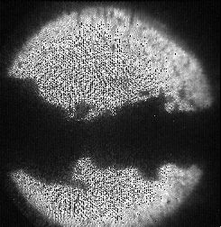 | 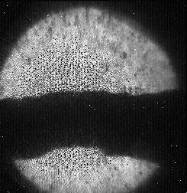
15 m/s, 0 T | 15 m/s, 5 T
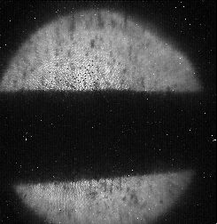 | 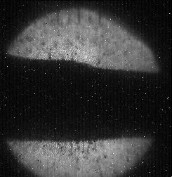
15 m/s, 10 T | 15 m/s, 15 T
Figure 3. Influence of magnetic field on jet profile.

There are several possibilities that could have caused this poor jet quality. Firstly, the 180-degree bend in the tubing just upstream of the nozzle was not a preferred flow path. Secondly, the shape of the nozzle tip was based on information obtained from a limited amount of published data, and no development testing was performed with mercury due to schedule constraints. Finally, fabrication of the welded tubing near the nozzle could have resulted in flow perturbations that contributed to inconsistent mercury jets.
Once the mercury equipment is returned to ORNL from CERN, an analysis of the nozzle piping will be performed to ascertain whether fabrication issues may have been the cause. In addition, while there was no evidence of any physical damage of the primary vessel by the mercury droplets, further inspection of the primary containment will be performed at ORNL.

CONCLUSIONS
Post-experimental analyses of the MERIT data showed that an unconstrained jet of mercury is a feasible target for future accelerator facilities [6]. All the subsystems required for this experiment functioned as intended throughout the duration of the experiment. Mechanically, the syringe pump proved to be a good design for this type of intermittent operation, but its inability to consistently produce a good-quality jet was noted.

Acknowledgements
This work was supported in part by the U.S. Department of Energy under contract number DE-AC05-00OR22725.

References
[1] J.R.J. Bennett et al., “Studies of a Target System for a 4-MW, 24-GeV Proton Beam,” A Proposal to the ISOLDE and Neutron Time-of-Flight Experiments Committee, CERN-INTC-P-186 (April 26, 2004).
[2] H.G. Kirk et al., "A 15-T Pulsed Solenoid for a High-Power Target Experiment," EPAC'08 (Genoa, June 2008), WEPP170.
[3] H.G. Kirk et al., "Optical Diagnostic Results for the MERIT High-Power Target Experiment," PAC'09 (Vancouver, May 2009), WE6RFP010.
[4] I. Efthymiopoulos et al., Time Structure of Particle Production in the MERIT High-Power Target Experiment," PAC'09 (Vancouver, May 2009), TU6PFP085.
[5] V.B. Graves et al., "Systems Testing of a Free Hg Jet System for use in a High-Power Target Experiment," PAC'07 (Albuquerque, June 2007), THPMS068.
[6] K.T. McDonald et al., "The MERIT High-Power Target Experiment at the CERN PS," PAC'09 (Vancouver, May 2009), TU4GRI03.

