CONCEPTUAL DESIGN OF MOLTEN LEAD-BISMUTH TARGET COMPLEX
OF INTEGRAL TYPE FOR ADS

A. Dedoul, B. Gromov, E. Yefimov, E. Zemskov, K. Ivanov, M. Leonchuk. Yu. Orlov, D.Pankratov, Z.Sivack, V. Troyanov, N. Khaveyev, V. Chitaykin, V. Chekunov
(IPPE, Russia)
N. Klimov, M. Koulikov, V. Stepanov
(EDO «GIDROPRESS», Russia)
T. Kitano,M.Ono
(Mitsui Eng, & Shipb. Co., Ltd, Japan)

Abstract

This report outlines the main design approaches and some calculation results on justification of conceptual design of lead-bismuth target complex developed in 2000 within the framework of the ISTC Project 1762, task B. The complex was designed for operation in demonstration ADS with 200 kW proton beam (E_{p}=600 MeV, I_{p}=0.33 mA)

Introduction

Vast experience has been gained in Russia in the development, fabrication and operation during many years of nuclear power plants and experimental facilities with liquid metal (lead-bismuth eutectic) coolant. This experience was used for designing and fabrication of the target complex TC-1 for LANSCE accelerator (LANL, USA) [1].
This project has been developed using experience gained in TC-1 design. However, many solutions made in this project are different from those applied in TC-1. This is because of the difference in the input data and requirements to these projects. In this project, integral (pool) arrangement of the complex components has been accepted. This arrangement seems preferable in comparison with the loop arrangement from the safety viewpoint since all components of the primary lead-bismuth circuit are installed in the single vessel. Horizontal transportation scheme was accepted for the complex transportation from operation compartment to repair cell. For this purpose, the complex is mounted on movable platform. Design approaches used in the project envisage an opportunity of replacing and repairing of the major components by remotely controlled devices, including replacement of the most important assembly – the target window with the set of irradiated samples. Choice of thermal and engineering parameters of the primary coolant provides necessary conditions for the samples testing and corrosion strength of structural materials of the target circuit in lead-bismuth eutectic.

FLOW diagram OF THE TARGET COMPLEX

Flow diagram of the complex is presented in Fig. 1. The target complex (TC) includes: lead-bismuth coolant circuit, cooling water circuit, cover gas circuit, and sensors.
The coolant circuit is intended to provide coolant flow in the target removing heat generated in the target to the heat exchanger. The circuit includes: vessel; target; MHD pump (MHDP); heat exchanger (HX); main and auxiliary pipelines and drain tank (DT).
On the stage of TC preparation for work, the coolant is moved by the cover gas pressure from DT into the vessel to the upper level according to level indicator, target active part remaining free of coolant.
Filling of the target active part and forced coolant circulation is provided by MHDP. Coolant circulation can be provided with either connected or disconnected proton beam.
The coolant is supplied by MHDP to the target, where it is heated by the proton beam. Then it flows downwards on the HX shell side being cooled by water flowing in tubes. Leaving HX the coolant flows upwards through the radiation shielding to cool it, and then enters the MHDP inlet from the volume having free surface in the vessel. A portion of the coolant flow (~10%) is permanently pumped by MHDP through the coolant technology system, which includes mass exchanger and oxygen activity sensors.
Draining/filling pipeline serves for pressing coolant out from DT into TC and back. It is supplied with two stop valves with remote drives, one of them serving as backup valve.

Figure 1. TC flow diagram

TC gas system is designed to keep an inert atmosphere over coolant free surface, fill TC with the coolant, make and keep gas space separating coolant circuit from cooling water circuit in HX and, if necessary, to perform coolant technology procedures.
HX cooling system serves for heat removal from the coolant to transfer it into external cooling system, which is located beyond the TC bounds. The system includes HX with bayonet tubes and two pipelines to connect HX to the external cooling system.
The following sensors are used for measuring TC thermal and hydraulic parameters:
- thermocouples;
- spark-plug level indicators;
- MHD flow-meter.
Oxygen thermodynamic activity in the coolant is controlled using oxygen activity sensors.
Window integrity is checked using coolant leak detector.
The rest TC parameters (cover gas pressure in TC, DT and HX gas blanket, cooling water parameters, etc.) are controlled in the TC external systems.

2. TARGET COMPLEX ARRANGEMENT

General view of TC arrangement is presented in Fig. 2. All TC components, namely - MHDP, HX, supply and discharge pipelines, internal radiation shielding, coolant technology equipment and instrumentation are located in the single vessel. Below the vessel, there is DT connected to TC by the pipeline with a valve. There is radiation shielding in the vessel to protect TC components against target neutron radiation. The target is arranged horizontally on the supports and connected to TC by the pipelines.
To mitigate a radiation impact on the components and media, TC is located in the shielding plug installed on the movable platform. This approach allows moving the target complex (TC) between operation compartment and technological (repair) cell. TC dimensions and radiation shielding inside the vessel make it possible to locate TC either in any place within the shielding plug or outside it, as well as in the target room. One of possible versions of TC arrangement is presented in Fig. 2.
Integral TC design facilitates its inspection to be performed in the access cell (after replacement of the window or the samples or repair work is completed) in the absence of the proton beam.

Figure 2. TC arrangement

3. LIST OF THE MAIN COMPONENTS
Table 1.
Components and parameters | Values
Vessel  Volume, m³  Amount of coolant, m³  Coolant  Gas | 0.42  0.13  lead-bismuth  helium
MHD pump  Rated capacity, m³/h  Pressure head, MPa  Current frequency, Hz  Power supply voltage (linear), V  Power consumption, kW | 5.5  0.1  60  380  3.0
Heat exchanger with gas space  Thermal power, kW  Cooling water temperature, °С:  - inlet  - outlet  Cooling water pressure, MPa  Cooling water flow-rate, m³/h | 150  200 (150)  217 (167)  3.5 (1.6)  7.2
Target  Proton beam thermal power, kW  Coolant temperature, °С:  - inlet  - outlet  Target dimensions, mm:  - length  - diameter  Coolant flow-rate through the target, m³/h | 200  350  450  600  150  3.6
Samples  Number  Length, mm  Diameter, mm | up to 37  100  6
Drain tank  Volume, m³ | 0.15
Structural materials  Components and pipelines  Target window  Internal radiation shielding | Austenitic steel  Ferritic-martensitic steel  Steel and boron carbide

4. DESIGN SPECIFICATION FOR THE MAIN components

4.1. Target
The target is designed for neutrons generation owing to the proton beam interaction with lead-bismuth coolant.
Principle design of one of the target version is given in Fig. 3.
Fig. 3. Target design with convex window

The target contains window 1, through which the proton beam from the accelerator guide tube enters lead-bismuth. In the project, the target design versions were developed both with convex window line (see Fig. 3) and with concave window line, similar to that in TC-1 project. The target designs also differ in the ways of the target connection with TC vessel. The target thickness is 1.35 mm.
The window 1 is fastened in the replaceable technological assembly 3. Perforated grid 4 is attached to the technological assembly 3 for profiling coolant velocity field in the target. In the cylindrical section of the grid, there is a partition 5 with built-in hexagonal nozzle 6, in which up to 37 irradiated samples 7 (6 mm in diameter, 100 mm long) are fixed.
The coolant route in the target is as follows: the coolant from the inlet nozzle 12 flows to the annular inlet chamber between casing 8 and separator 11. Then it flows along the chamber to the window 1, passes over it and flows through the grid 4 and the samples 7 to enter the internal cavity of the separator 11 and then the outlet nozzle 13.

4.2. Heat exchanger
HX is designed for heat removal from the coolant to cooling water.
HX is a vertical recuperative heat exchanging apparatus with bayonet tubes.
Each bayonet tube is inserted into a jacket. The gap between tube and jacket is filled with gas forming a protective inter-layer between the coolant circuit and cooling water.

4.3. Magnetohydrodynamic pump
MHDP consists of casing, working channel, where the coolant is pumped, core and inductor located outside the channel. Leak-tight inner cavity of the MHDP casing is filled with compound. Inductor magnetic circuit consists of length-wise core-lamination stacks with grooves, in which three-phase winding is placed. The working channel is formed by two coaxial thin-walled cowlings resting lengthwise on the core and inductor magnetic circuits.

5. computation results

5.1. Target physical parameters
Target physical parameters have been calculated using well-known Monte Carlo codes LAHET (LCS) and MCNP-4b.
The following target physical parameters have been evaluated:
- spectra of neutrons generated in hadron-nuclear cascade;
- total number of neutrons and leaking neutrons spectra;
- power density in the target volume;
- radiation damage of structural materials (dpa).
Two models of protons distribution in the beam (beam form) were used in calculations:
- According to Gaussian function, σ = 1.5 cm;
- Uniform beam structure of radius R = 1.8 cm.

5.1.1. Number and spectra of leaking neutrons
Total number of neutrons leaking through three surfaces bounding the target (per proton) is shown in the Table 2. Both beam forms lead to the same neutron leaking.

Table 2.
Target surface | Number of neutrons
 | Gaussian function, σ = 1.5 cm | Uniform beam structure, R = 1.8 cm
Frontal | 4.36 |  | 4.44
Lateral | 6.76 |  | 6.73
End | 0.0079 |  | 0.0072
Total | 11.13 |  | 11.17

Leakage neutron spectrum is given in Fig. 4.
Fig. 4. Spectra of neutrons leaking through different target surfaces

5.1.2. Power rating distribution in the target
Total energy deposition in the target being similar for both beam forms is equal to 147 kW.
Graphically power distribution in the target (of a flare form) for the beam with Gaussian distribution is given in the Figs. 5.

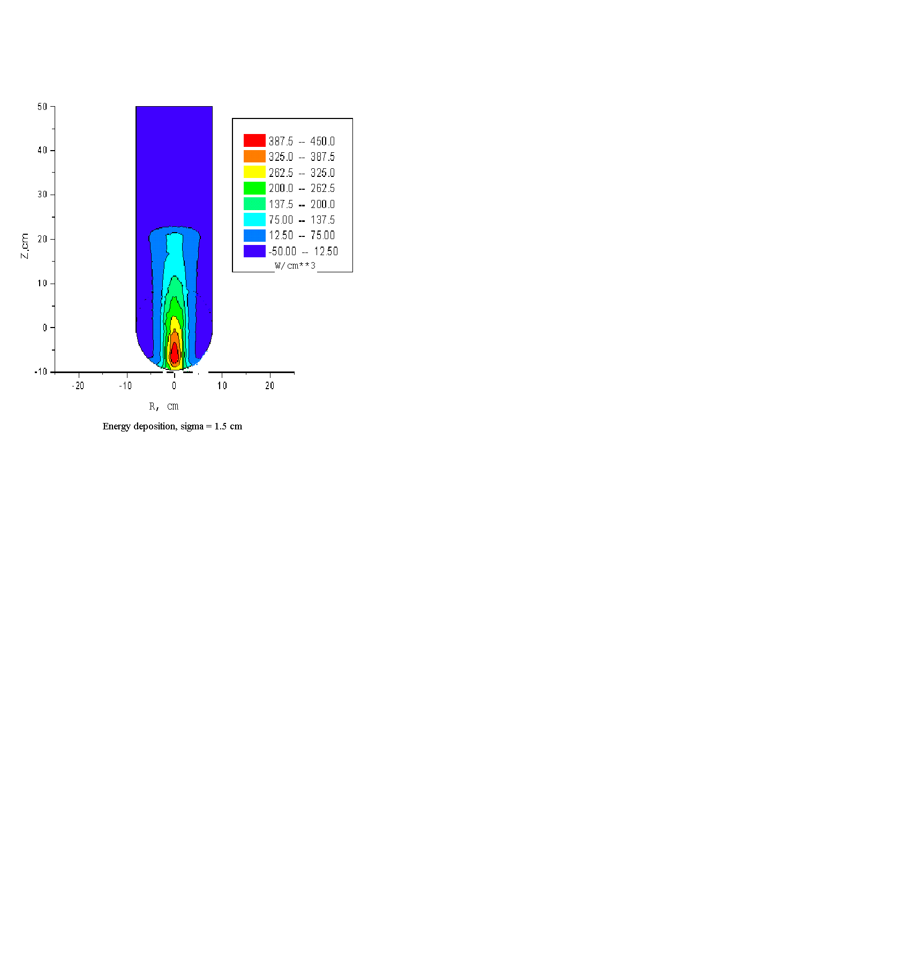
Fig. 5. Power distribution in the target, Gaussian proton beam.

5.1.3. Radiation damage and accumulation of gaseous spallation products
Estimation of steel radiation damage (dpa) has been performed on the basis of continuous target operation during 5000 hours. Under this condition proton fluence is equal to 3.74×10²² protons.
Radiation damage distribution along the target axis with the convex window is presented in Fig. 6а. This direction is characterized by the most severe radiation damage. One can see that radiation damage for uniform and Gaussian form proton beam does not exceed respectively 12.15 dpa and 8.32 dpa. Radial radiation damage distribution is shown in Fig. 6b.
- b)

Fig. 6. a) radiation damage distribution along the target axis, Z = 0 corresponds to the target window; b) radial radiation damage distribution.

For the same proton fluence, maximum accumulated amount of gaseous spallation products (helium and hydrogen) in the steel of the window and the diffuser grid was estimated for both proton beam forms. The results are presented in the Table 3.

Table 3.
Maximum accumulated content of gaseous spallation products in the target elements

Gaseous spallation products | Gaussian beam form, σ = 1.5 cm. | Uniform beam form,  R = 1.8 cm
Window
Hydrogen, ppm | 3.71×10³ | 5.30×10³
Helium, ppm | 4.48×10² | 6.40×10²
Diffuser grid
Hydrogen, ppm | 4.28×10³ | 6.25×10³
Helium, ppm | 5.97×10² | 8.72×10²

5.2. Thermal and hydraulics parameters of the target
Coolant temperature and velocity fields in the target have been evaluated using 2D DUPT code developed at the SSC RF- IPPE to analyze reactor thermal hydraulics in R-Z geometry. The code is based on the finite-difference solution of the Navier-Stocks and thermal energy equations. Model of anisotropic porous body is used for numerical simulation of grids and similar structures. The code was tested by modeling hydraulics and heat transfer in the elements of lead-bismuth cooled reactors, namely: core, plenums and heat exchangers and comparison of calculation results with experimental data obtained by the air blowing of full scale mock-ups of TC-1 target.
Numerical analysis of temperature and velocity fields in the target elements was performed for nominal operating conditions of the target complex. Both designs of the window (convex and concave) were considered. Each design was evaluated with energy deposition field under either “flat” proton flux, or proton flux with Gaussian distribution.
To increase coolant velocity near the target axis, where the test samples are located and power deposition is maximum, the diffuser grid of 5 mm thickness with two concentric zones of different diameter perforations was used. There is a hole in the central area of the diffuser grid. Besides, for reaching given velocity near the samples, uniform and non-uniform arrangement of the samples in the target cross-section was considered in calculation.
Maximum temperature values are presented in table 4 and 5 for both window shapes and the beam distributions. Plots of temperature fields in the convex and concave window targets for Gaussian distribution of the beam are shown in Fig. 7.
Table 4.
Maximum coolant and window temperatures for the Gaussian proton beam

Maximum temperature, C | Concave window, uniform displacer | Concave window,  non-uniform displacer | Convex window,  non-uniform displacer
Window on vacuum side | 447 | 439 | 488
Window on the coolant side | 428 | 420 | 470
Coolant at the target outlet | 470 | 460 | 489
Coolant in the displacer | 470 | 508 | 470
Coolant in the samples bundle | 437 | 421 | 441

Table 5.
Maximum coolant and window temperatures for the uniform proton beam

Maximum temperature, C | Concave window, uniform displacer | Concave window,  non-uniform displacer | Convex window,  non-uniform displacer
Window on vacuum side | 481 | 471 | 536
Window on the coolant side | 453 | 444 | 511
Coolant at the target outlet | 514 | 500 | 536
Coolant in the displacer | 414 | 424 | 405
Coolant in the samples bundle | 470 | 456 | 465

a) convex window b) concave window

Fig. 7. Temperature field in the target with non-uniform bundle of samples (energy deposition field for Gaussian distribution of the beam)

5.3. Radiation hazard of lead-bismuth coolant

Lead-bismuth coolant, cover gas, air in the target room and cooling water in the TC systems are the media offering radiation hazard both during TC operation and after TC operation completion.
Volatile and gaseous radionuclides entering cover gas from the coolant surface in the buffer tank, are accumulated there in the form of vapor, gaseous and aerosol phases resulting in radioactive contamination of relatively cold surfaces of TC gas system due to vapor condensation and radioactive aerosols deposition.
Radioactive noble gases and radionuclides of polonium, mercury, cesium, iodine, bromine and rubidium are the most hazardous.
It is known, that in the irradiated lead-bismuth eutectic, polonium exists mainly in the form of the PbPo intermetallide. This phenomenon explains 10³ times lower polonium emission to gas media from lead-bismuth coolant as compared to elementary polonium emission.
Being chemically high-reactive, radioactive halogens (iodine and bromine) apparently form compounds with the main coolant components, namely: PbI(Br), BiI(Br), PbI₂(Br₂), BiI₂(Br₂), BiI₃(Br₃), etc. BiI₃ and BiBr₃ are the most volatile among them. However, due to low iodine and bromine concentration in the coolant (~10⁻⁸÷10⁻⁹ ppm), generation of their three-atom compounds with lead or bismuth is improbable. But to be on the safe side, it was assumed, that the rate of radioactive halogens emission is proportional to saturated vapor pressure of three-atom compounds (BiI₃ and BiBr₃) at corresponding temperature.
In order to estimate alkali metals (Rb and Cs) emission, it was assumed that these exist in atomic form.
Calculation results for radiation characteristics are given in table 6.
Table 6.
Radiation characteristics of the target complex
 | Coolant | Gas system (including solid deposits) | Target room | In the environment
Radioactivity, Bq:
Total | 5.0E+15
PbPo | 6.1E+13 | 1.0E+08 | 1.6E-03 | 6.7E-01
Hg | 1.4E+14 | 2.8E+14 | 1.2E+05 | 9.8E+06
Rb+Cs | 1.1E+13 | 6.6E+12 | 4.2E+01 | 1.0E+05
Cd | 1.2E+13 | 2.7E+11 | 2.0E-01 | 1.3E+03
BiBr₃+BiI₃ | 1.2E+13 | 2.1E+12 | 5.3E+02 | 6.3E+04
Kr+Xe+T | 6.1E+12 | 1.2E+13 | 1.0E+08 | 2.0E+12
Gases and volatile substances in total | 2.4E+14 | 3.1E+14 | 1.0E+08 | 2.0E+12

Total water radiotoxicity index after irradiation completion is equal to 6.9⋅10⁹ m³, where ~70% falls at the polonium isotopes. One year later, it decreases to 1.5⋅10⁹ m³.
Among the volatile radionuclides, the most dangerous are those of mercury; polonium contribution being significantly lower.

Conclusion

In accordance with the Statement of Work of MES Co., Ltd. (Japan), conceptual design of target complex of integral type was developed for operation in proton beam with 200 kW power (E_{p}=600 MeV, I_{p}=330 μA). This project has been developed taking into account Russian experience gained during many years in the development and operation of test facilities with lead-bismuth coolant, including the experience gained in the development and fabrication of the target complex for 1 MW proton beam of LANSCE accelerator in Los Alamos National Laboratory, USA.

REFERENCES

1. B. Gromov, E. Yefimov, M. Leonchuk. et al.
Development of Molten Lead-Bismuth Target Complex TC-1 for the LANSCE Accelerator,
this meeting.

