Experimental Study of Characteristics of Molten Lead-Bismuth Target without Window.

A.V. Beznosov, A.G. Meluzov, D.V. Davydov, S.S. Pinaev,
State Engineering University,
Nijni Novgorod, Russia

Yu.I. Orlov, A.D. Yefanov, E.I. Yefimov
State Scientific Center of Russian Federation - Institute of Physics and Power Engineering
Named after Academician A.I. Leypunsky,
Obninsk, Russia

V.I. Rachkov

Minatom, Department an Atomic Power

Abstract
The experimental investigations of molten metal target model having 60mm diameter of the inner cavity using lead-bismuth at temperature 260-400˚C in flow rate interval 5.0-80.0 t/h confirmed the possibility of windowless target realization for ADS. The target model design provided the stable and reproducible formation of coolant free surface.

One of the important problems of accelerator driven system development with molten lead-bismuth targets is a proton beam insertion from evacuated ion guide into the target.
At present the version with arrangement on the ion guide a special membrane (window) is widely considered. This window separates coolant from evacuated cavity and it is in contact with molten metal.
But heat removal from the window and its radiation safety ensuring are complicated tasks, since the window is placed in high radiation and heat fields. And if in the target of comparatively low power (~1Mw) window reliability for some time can be provided then for more powerful target window design becomes rather problematic.
Work for windowless target justification were begun in the frames of ISTC Project 017. Analysis of possible target designs was made, experimental investigations were performed for flow part diameter of the models of 17,0mm using water and lead-bismuth as well as experimental investigations of two models with the inner diameter of the work cavity of 70mm and length up to 2000mm ^{[1,2]} using water. Analysis of work results confirmed the principle possibility of creation of windowless target.
The goal of this experimental work was characteristics investigation of improved model with diameter of the work cavity of 60mm and the length of 300mm and lead-bismuth flow rates in the interval 5.0-80.0t/h at temperature 260-400ºC.
The following topics were subjected to investigations:
- the conditions of coolant non-flowing into the tube-simulator of an ion guide;
- ejection characteristics of the target flow part;
- formation condition, geometry (profile) and dynamic stability of the coolant free surface in the target work cavity.
Tests were performed on the isotermal facility ФТ-1 of State Engineering University, Nijni Novgorod. Simplified diagram of the facility is presented in fig.1. The model design is given in fig.2. Very important factors are the target arrangement in regard to coolant free surface in the expansion tank and hydraulic characteristics of the path from the target model to the pump and the expansion tank. Difference between zero level in the target and alloy free surface in the expansion tank was about 2000mm.
Investigations of the conditions of coolant non-flowing in ion guide simulator during circulation start of coolant through the target cavity, circulation through the target cavity with flow rates 5,0-80t/h and circulation stop were made for both gas cavity of the guide simulator connected and disconnected with gas system of the facility. Gas pressure (argon, argon-hydrogen mixture, cover gas with water vapor) was in the interval 0.05-0.6bar. In all experiments coolant reproducible flowing in

to gas
system

Fig. 1. Basic diagram of ФТ - 1 test facility.
1 - experimental model of liquid metal target without membrane;
2 - circulation pump for liquid metal coolant;
3 - buffer capacity;
4 - level indicators.

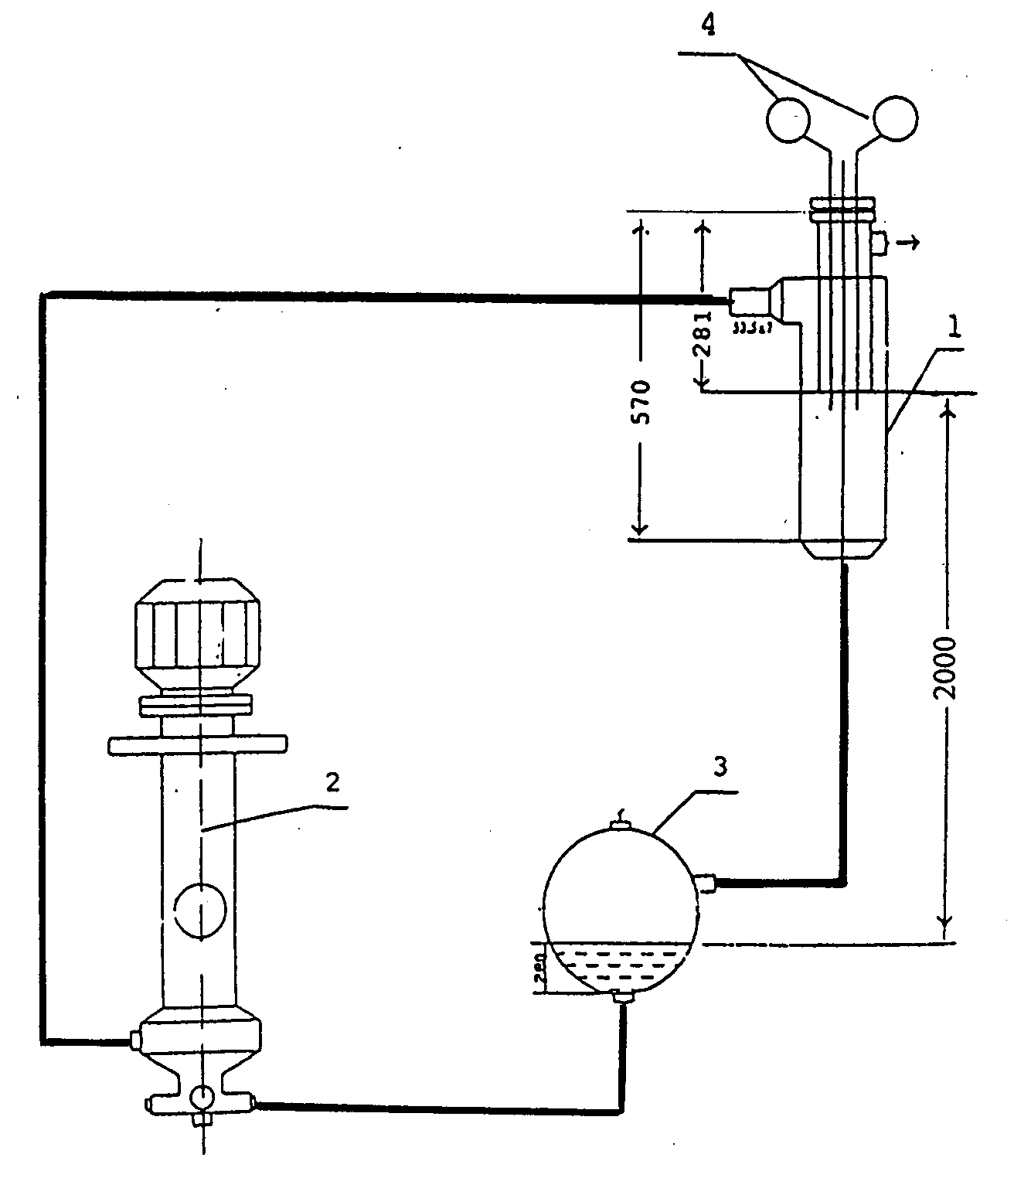

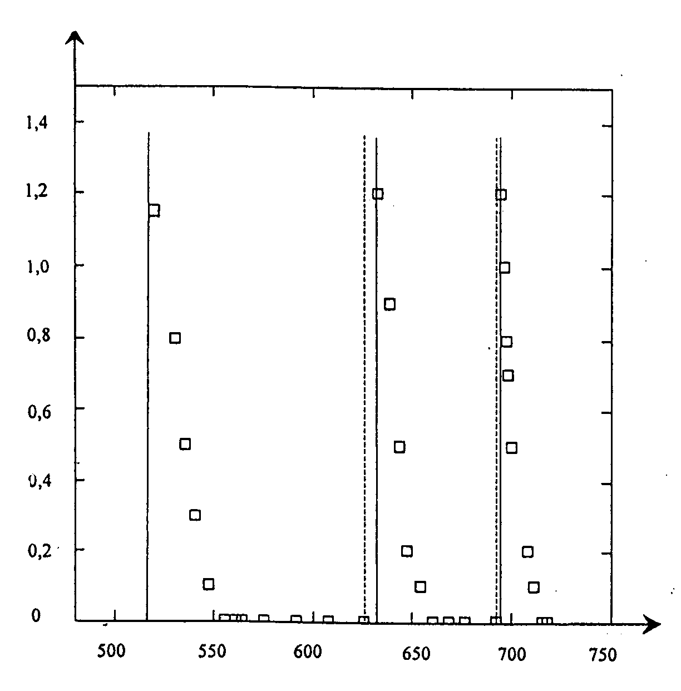
τ, min
P, bar

Fig. 2. Time dependence of gas pressure changing in the target cavity,
caused by gas ejection by alloy flow.
- - - - - target cavity is connected up to gas system;
target cavity is disconnected from gas system.

the guide simulator cavity monitored with electrocontact level indicators was not observed. In operation modes with high flow rates (more than 30-50 t/h) periodical short-time locking of indicators was observed. This locking probably can be explained by local disturbances of coolant free surface as well as by coolant drops (sprays) locking gas gaps.
Investigations of ejection characteristics of the target flow part with argon and argon-hydrogen mixture in the loop gas system demonstrated that gas ejection with coolant flow was observed in the whole interval of alloy flow rates 5.0-80.0t/h. Flow rate of ejected gas depended on gas pressure in gas system and coolant flow rate through the target. Approximately, an average value was 10-30 nl/h.
The example of typical time-depending pressure changes in the target cavity caused gas ejection after closing (opening) the valve in the pipeline connecting the gas cavity of the guide simulator with the gas system of the facility is presented in fig.3.
Investigation of coolant free surface conditions in the target cavity demonstrated that availability of this surface is observed in flow rate interval 5.0-80.0 t/h with both gas pressure higher than atmospheric one and vacuum in the target cavity. Geometry of the free surface is determined, basically, by centrifugal forces, gravitation, viscosity and forces of surface tension. To realise centrifugal forces (flow swirling), 4 ribs by height 3.0 mm, length 11.0mm and thickness 2.0mm were installed in the circular gap by length 74,0 mm between the inner surface of the external tube by diameter 60 mm and the external surface of the inner tube by diameter 53mm under the angle 15º in regard to the vertical plane passing through the model axis.
Projections of the free surface profile points of lead-bismuth coolant to the plane are presented in fig.4. The coordinates of these points were measured using rotation and axis movement of pins №1 (left to axis) and №2 (right to axis) of electrocontact level indicators. Profile points of “inner” surface were obtained under such positions of the indicators when periodical closing of electric circuit takes place because of the free surface oscillation. The points of “external” surface were obtained under such positions of the indicators under which signal interruption does not take place, i.e. it’s continuous. These points are some below lower boundary of oscillating free surface of alloy.
The points positions left and right to the target axis show that the profile is asymmetric in regard to the target axis to some extent. This picture can be explained by the fact that coolant feeds the target through the nipple installed under the angle 15˚ in regard to the projection of the vertical plane passing through axises of two indicators pins and the target axis.
Analysis of the free surface profile of alloy confirms the authors conclusions made earlier that stable surface in the target cavity can be realized using flow swirling. The free surface forms in investigations of the target models using water and lead-bismuth had some difference. When using water, the free surface is a conical “cord” with a small conical angle. When using lead-bismuth, the free surface of coolant after the circular gap first repeats the surface geometry to which the centrifugal forces "press" the flow. Then a small conical part follows with subsequent sharp change of the profile, which approaches to parabolic form. This can be explained by the fact that eutectic surface tension and its density approximately 10 times higher than water ones.

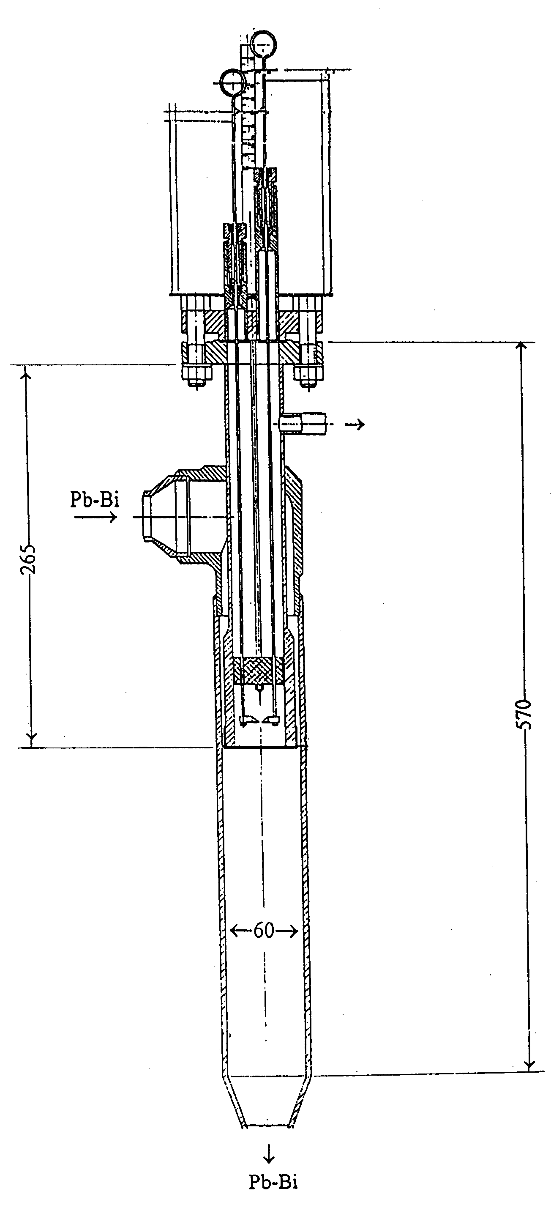

Fig. 3. Construction diagram of experimental model of liquid metal target.

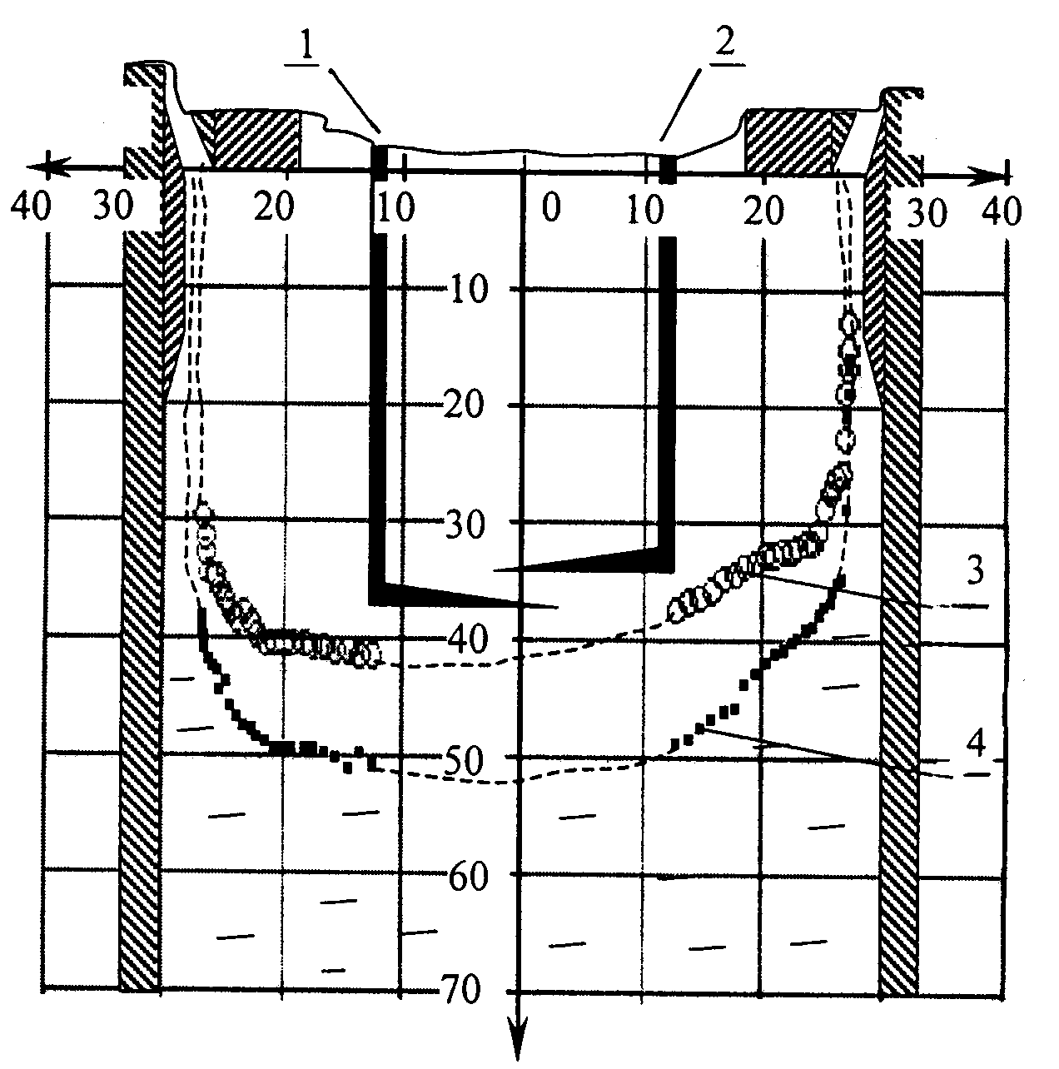
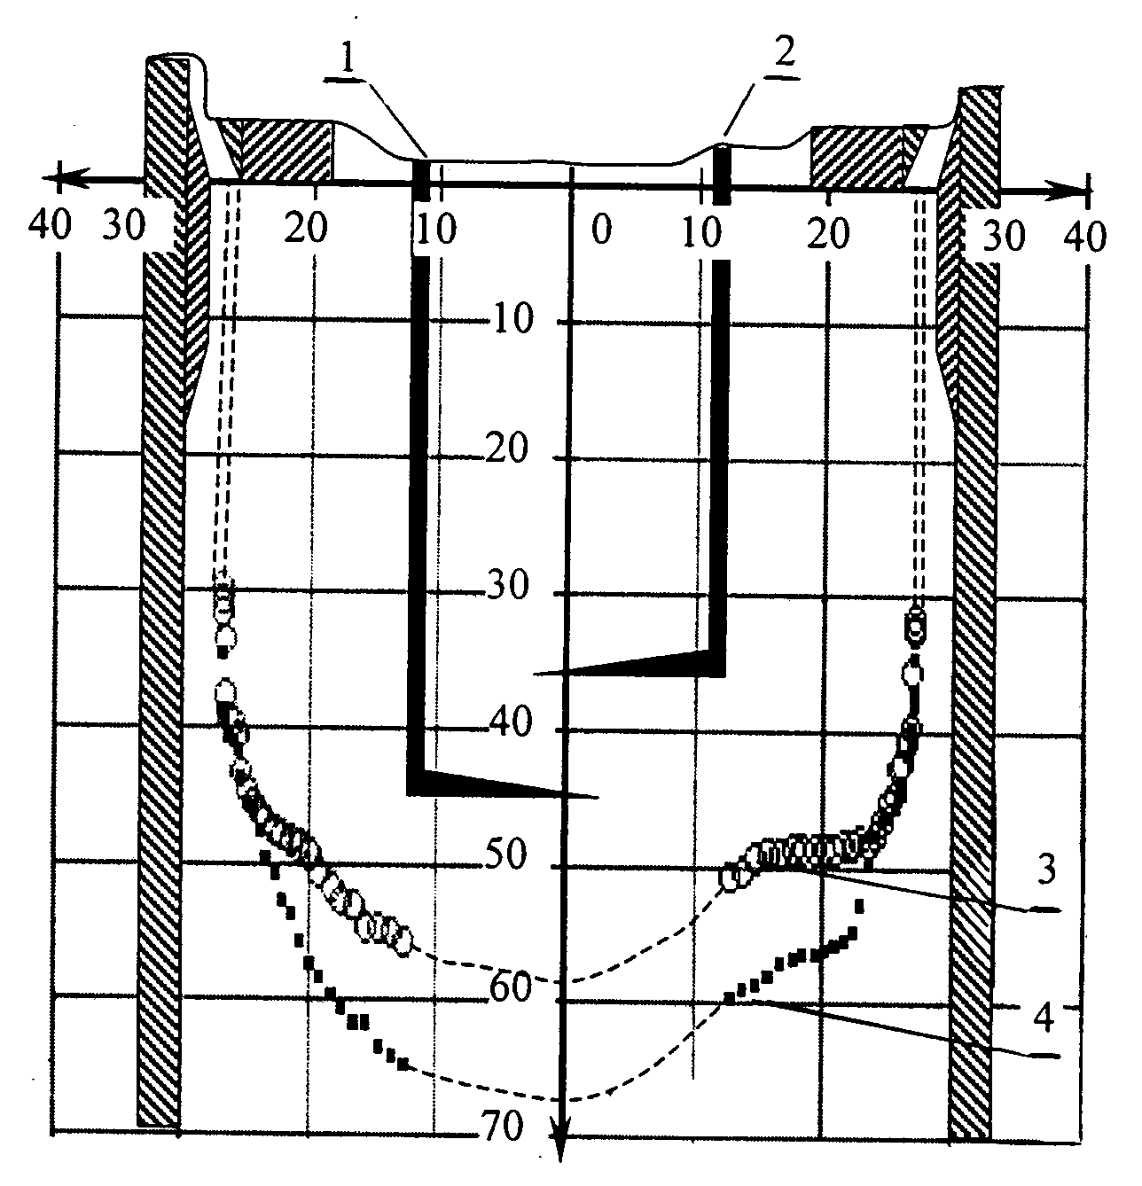

Fig. 4. Plane projection of the points of free surface profile of lead-bismuth coolant.
1 - left level indicator of contact kind;
2 - right level indicator of contact kind;
3 - upper margin of unsteady free surface of liquid metal coolant;
coolant contact with indicator is of discrete kind;
4 - bottom margin of unsteady free surface of liquid metal coolant.

Reference

2. YU.I. ORLOV, M.I. SOTOV, G.P. POLETAEV
"Experimental Investigations of Hydrodynamics of Liquid Lead-Bismuth Target without Window",
presented at 2nd Int. Conf. ADT Technologies and Applications, June 3-7, 1996, Kalmar, Sweden.

2. Y.I.ORLOV, M.I. SOTOV, G.P. POLETAEV, A.V. BEZNOSOV
"Experimental Investigation of a Liquid Lead-Bismuth Target Hydrodynamics without an Ion Guide Diaphragm",
1997 Winter Meeting

. Albuquerque,
N.M, American Nuclear Society. Transactions, vol. 77, p.456.

