EXPERIMENTAL STUDIES OF TARGETS AND COLLIMATORS FOR HIGH INTENSITY BEAMS*
N. Simos#, H. Kirk, H. Ludewig, L-P Trung, J. O Conor,
BNL, Upton, NY 11973, USA
K. McDonald, Princeton University, Princeton, NJ 08544, USA
N. Mokhov, FNAL, Batavia, IL 60510, USA

Abstract 
The ever-increasing demand for high power accelerators requires high-performance materials that can safely intercept the proton beam either as accelerator targets or collimators. To satisfy the requirements of these multi-MW level machines the envelope of the current knowledge regarding material behavior and endurance for both short and long exposure needs to be extended. For collimating structures intercepting the halo of an intense beam under normal or the entire beam during off-normal conditions, performance issues are essential and directly tied to materials and their ability to maintain key properties and absorb beam-induced shock. The limitations of most materials in playing such pivotal roles have led to an extensive search and experimentation with new alloys and composites appear to possess the right combination of properties satisfying target and /or collimation requirements. This paper presents experimental results on a host of materials explored in recent years for use in the high-power target concepts and the collimators of accelerators currently under consideration or construction.

introduction
High-performance targets intercepting multi MW proton beams or collimators with high cleaning efficiency depend almost entirely on the ability of the materials intercepting either the whole or a portion of the proton beam to withstand both the induced shock. In addition, they must resist irradiation damage which manifests itself as changes in their key physical and mechanical properties.
The demand imposed on the targets of high power accelerators or the component of the beam cleaning system, combined with the physical limitations of most common materials in playing such pivotal roles have led to an extensive search and experimentation with new alloys and composites. These new high-performance materials are being explored through a multi-phased experimental study at Brookhaven National Laboratory (BNL). The overall study that brings together the interest in accelerator targets and/or collimators of various facilities around the world, seeks to simulate conditions of both short and long exposure to proton beams and assess the survivability potential of materials against high intensity pulses. It should be noted that collimators, while shaving the halo of the beam under normal operating conditions, could be exposed to a full beam under an accident scenario and thus assuming the role of a target. During short exposure the effects of the thermo-mechanical shock on the solid material both its thermal and mechanical limits are challenged. Figure 1 represents predictions of stresses in a stainless steel target intercepting tightly focused 100 ns long, 16x10¹² proton intensity pulses. Results show that such interaction leads to stress levels in the material far exceeding its strength limits. Such concerns led to a BNL experiment that used high intensity proton pulses from AGS at 24 GeV and exposed various solid targets. Of particular interest during this beam-induced shock study was the validation that special carbon composites are superior to typical graphite in absorbing high intensity pulses. Findings of the study have direct applicability not only towards conceptual high-power target concepts that rely on low Z materials for the production of secondary particles, but also in collimator applications like the one designed for the LHC. Specifically, Figure 2 depicts the schematic of a collimator jaw intercepting a portion of the beam that was used to estimate the conditions created within the material following proton interception. Figure 3 shows estimates of temperature conditions following interception. It is apparent from the shown trends that only few materials can safely operate at the induced conditions.
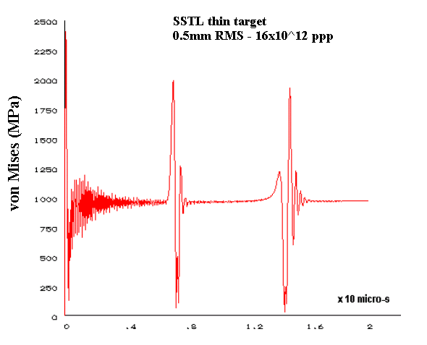
Figure 1: Stress predictions in a stainless steel target intercepting a 16 TP, 100ns proton pulse
While beam-induced shock tests the target or collimator material against its limits, it is the long exposure to the proton beam that has the potential to reduce its capacity to perform the intended functions and even fail prematurely. Prolonged exposure to the beam is linked with irradiation damage which manifests itself in the form of drastic at times changes in the physical and mechanical properties. Key properties that are affected are thermal conductivity, thermal expansion, ductility, fatigue endurance and strength. To assess how resilient to radiation damage several promising new alloys and composites are, as they are being considered for use in several high power target concepts and collimators, a series of material irradiation exposures to high proton fluences using the BNL Linac were conducted and new phases of the studies are planned. The irradiating beam at the Isotope Production Facility consists of either 200 or 117 MeV protons at ~90 μA current on the irradiated specimens. Preliminary results of this comprehensive study are presented in a later section.
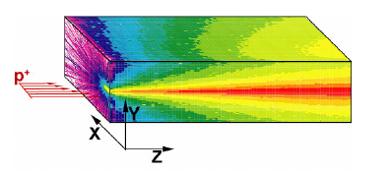
Figure 2: Collimator jaw material schematic
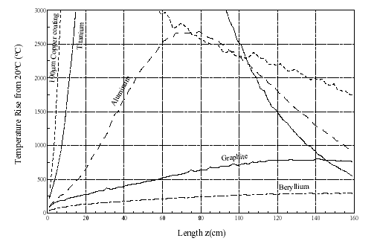
Figure 3: Estimates of temperature in the LHC collimators based on different material choices [Ref. 5]

EXPERIMENTAL STUDIES

The response of solid materials destined for targets or beam halo intercepts to short, intense bunches as well as their long-term exposure effects to ionizing radiation have been addressed (and continue to be addressed) through a series of experimental efforts using primarily the BNL facilities. In the following sections these studies are described along with some key findings that resulted from the experiments.

Shock Studies
These studies were performed on a variety of thin and thick targets in an attempt to (a) ensure that the materials chosen to hermetically isolate a Hg target will withstand the intense stresses generated by the short (~100ns), 0.5mm σ and up to 16 x 10¹² proton intensity AGS pulses, and (b) assess how low Z targets (graphite and 3D carbon composite) respond to these intense pulses and how graphite fairs against the carbon composite counterpart.

Material response to short, tightly focused, and intense pulses has been addressed by several researchers in the past. Below a summary of the underlying mechanisms is given for the sake of completeness. When the beam irradiates a portion of the target the temperature in the heated zone is increased by ΔT under constant volume, leading to a corresponding change in pressure ΔP. If the proton pulse is assumed instantaneous, at time 0⁺ the material is in hydrostatic state of stress and therefore does not risk failure for as long as the resulting temperature is below the melting or evaporation point. The change in hydrostatic pressure ΔP is related to the energy density change ΔE_{m} through the Gruneisen equation of state

ΔP = Γ ρ ΔE_{m}

Where Γ is the Gruneisen parameter related to material thermo-elastic properties such as Young’s Modulus E, Poisson’s ratio ν, density ρ, thermal expansion α and constant volume specific heat c_{v}.

Γ = [E/(1-2ν)] α/(ρ c_{v})

Following the instantaneous energy deposition compressive stress waves will emerge at the edge of the heated zone propagating both outward and towards the center of the zone where they will change sign and propagate outward. It is the transformation of the stress waves from compressive to tensile that set the limits on the target and thus the allowable energy density. The stress wave propagation takes place basically under adiabatic conditions and thus the temperature in the heated zone has not relaxed. The tensile strength properties of the material on the other hand strongly depend on the temperature (decrease as temperature increases). Therefore, if the tensile stress generated from the relaxation of the hydrostatic pressure ΔP induced by the beam is high enough to exceed the yield stress or strength in the material at the temperature in the heated zone, then the target material will yield or fail in tension. Obviously, the limits identified are directly related to the level of initial ΔP, which in turn is connected to the allowable energy density. Based on the relations shown above and the physical properties of the known materials, energy densities for solid materials of ~ 200 Joules/gram are reasonable to consider as the upper allowable limit.
While the limits above are the result of quasi-static considerations, the dynamic or transient component plays a significant role in determining the state of stress that will result in the material. This information is crucial in the design of targets and collimators. Accident scenarios associated with the latter will mean that the full beam is absorbed by the cleaning element and the time structure of both the deposition and the ensuing response is important. Specifically, given that the energy deposited on the intercepting material target by the proton beam is not instantaneous but pulse-structure dependant, additional relations come into play in determining the stress or temperature limits in the material. As compressive stress waves emanate from the edge of the heated zone dynamic relaxation is set in motion as well. Relations, shown below, between the speed of sound in the material, the pulse length and the beam spot (or heated zone) control the stress relaxation process.
Peak Thermo-elastic Stress: σ ~ E α ΔT/ (1 - 2ν) · RF
RF = T_{sound}/T_{pulse} (if T_{sound} < T_{pulse} )
RF = 1.0 (if T_{sound} > T_{pulse} )
T_{sound} = d/V_{s}
V_{s} = material sound velocity

Where T_{sound} and T_{pulse} are the time required by a sound wave to traverse the heated zone (or beam spot) and pulse duration. The propagation of sound wave is a function of the target material and the heated zone diameter a function of the selected beam profile on target. In order to realize any reduction in the generated compressive stress σ (which in turn dictates the level of subsequent tensile stress) expressed as RF one must have T_{sound} < T_{pulse,} or in other words, the pulse length must be much larger than the time required by the sound to traverse the beam spot. To quantify the stress reduction as a function of pulse (or bunch) length extensive analyses has been performed using elasto-dynamic analysis based on finite elements. The results of these analyses were compared with the experimental data generated in these studies. These comparisons helped benchmark the numerical processes, which in turn were used to design actual beam intercepting systems (such as the Spallation Neutron Source or LHC collimators).

Figure 4 schematically depicts the set-up for solid target/beam interaction experiments using the AGS beam at BNL. It shows a graphite target instrumented with fiber-optic strain gauges that pick up the arriving stress waves.

Shown in Figure 5 is a comparison of the dynamic strains generated in the graphite and the 3D carbon composite targets both intercepting a tightly focused proton pulse (0.3mm x 0.9mm rms and 4 x 10¹² 24 GeV protons). It is apparent that carbon composites, due to their special fiber-reinforced structure resulting in very low thermal expansion coefficients, respond with a much lower dynamic stress or strain compared to graphite when exposed to the same beam intensity. This key property of low thermal expansion, while confirmed in this experiment, was decisive in the selection of a reinforced carbon material to collimate the 7-TeV LHC proton beam.

The benchmarking of numerical models against the target shock experiments also provided an excellent reference for the design of the SNS collimator system.

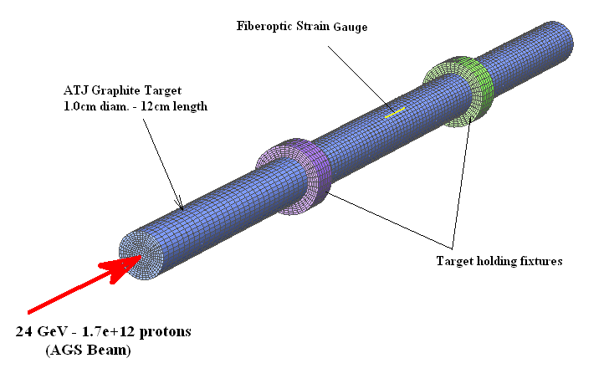
Figure 4: BNL solid target test set-up and instrumentation

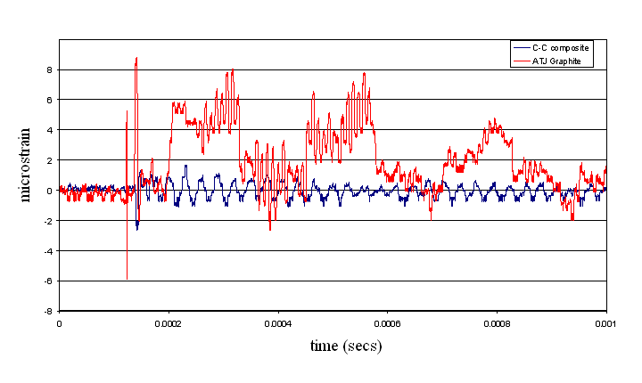
Figure 5: Response to intense beam comparison between graphite and carbon-composite targets
The primary collimator, or scraper, of the system is shown in Figure 6. The collimator high-Z jaw, under normal operating conditions, provides the necessary kick to the halo protons to diverge from the beam and be absorbed by the secondary collimators or absorbers. Under the accident scenario, however, the entire beam may drift and be intercepted by the collimator.
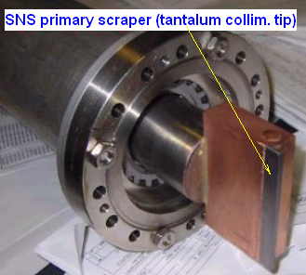

Figure 6: Spallation Neutron Source (SNS) collimator
The deposited energy density for such a scenario approach those of an actual target and thus thermal shock conditions must be considered. Results of the analysis are shown in Figure 7. Figure 8 is a testament to the serious conditions that can result from the accidental intercept of the full beam by materials unable to tolerate the high temperatures or stresses generated.

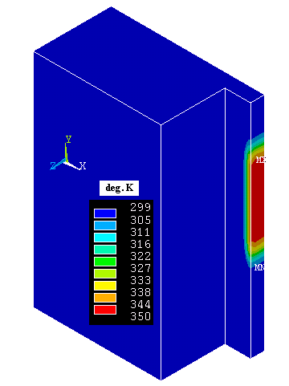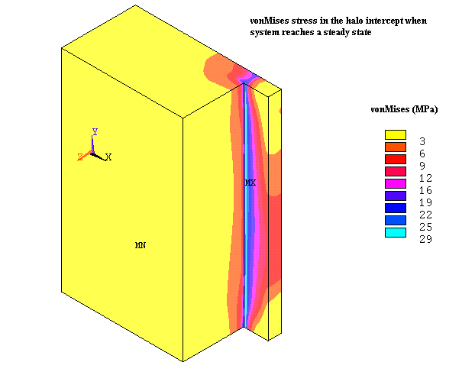
Figure 7: Estimated temperatures and critical stresses in the SNS primary collimator during a full beam intercept

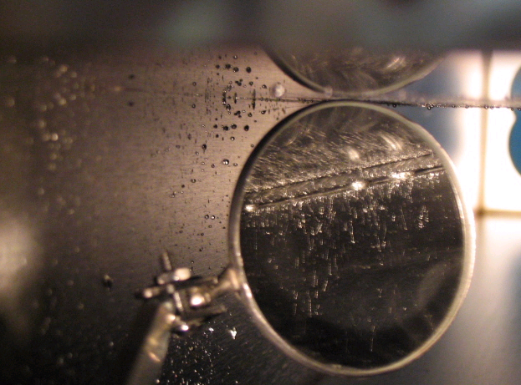

Figure 8: Collimator accident condition following beam miss steering at the FNAL Tevatron

Irradiation Damage Studies
The proton beam-intercepting element (either a production target or a collimator scraper) in addition to surviving the thermo-mechanical shock must maintain its structural integrity and hold onto key properties that control its functionality. Long exposure to irradiation is expected to alter the microstructure of the materials through the formation of defects and the generation and trapping of gases. Dramatic changes in the macroscopic material properties occur as a result of radiation exposure. In graphite, for example, thermal conductivity suffers seriously even with limited exposure. Loss of ductility with simultaneous increase in yield strength is typical with most materials exposed to ionizing radiation. The wealth of experience and data available to-date is from neutron irradiation in nuclear reactors, and there is still no direct way of correlating the effects of neutrons to those of protons. Proton irradiation studies using accelerator beams have been under way in an attempt to answer questions directly related to accelerator elements that are intercepting high-energy protons.

In order to keep the shock stresses under tolerable limits for target or collimator materials while maintaining the heat transfer path to the heat sink, certain properties in materials are more desirable (since they control peak stress values) and their stability with increasing irradiation from the beam becomes critical. To hold shock stresses at reasonable levels materials must exhibit low thermal expansion, low elastic modulus and high strength. To enable the removal of heat from beam-intercepting zones (such as target center or tip of collimator jaws) high thermal conductivity is desirable. Low thermal expansion properties in materials not dramatically affected by radiation exposure are of particular interest to collimating systems where positional stability of the element intercepting the halo protons (as in the cases of LHC or SNS) is paramount. Dedicated experimental studies have been conducted to assess the behavior of materials under anticipated levels of irradiation selected to intercept the 7 TeV protons of the LHC where tight positional stability requirements (~25μm) in reference to the beam must be met. Therefore, emphasis was placed on materials exhibiting low CTE such as carbon composites, graphite, and super invar.

To assess how these key properties are affected by high proton fluences, especially for new alloys and composites that have not been exposed even to neutron irradiation, a series of irradiation studies have been performed at BNL. Irradiation of materials has been conducted using the 200 MeV, ~90 μA Linac beam of the isotope production facility. Different peak fluences have been achieved during the different phases of the study with the maximum fluence reaching ~0.6x10²¹ protons/cm² during the irradiation of the two-dimensional carbon composite of the LHC collimator jaws. Post-irradiation analysis of the materials was performed at the BNL hot lab facilities.

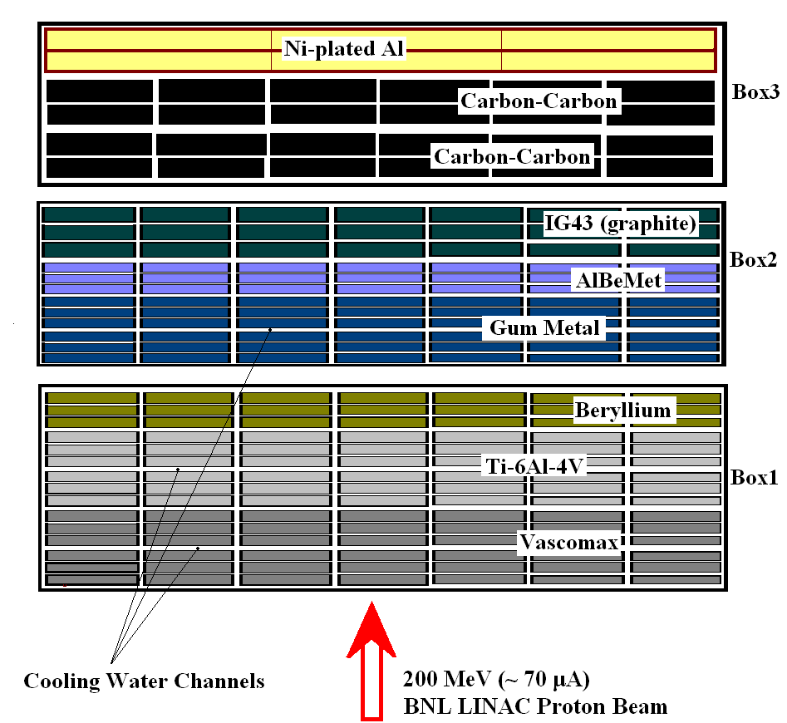
Figure 9: Material matrix arrangement during one of the proton irradiation exposure studies at BNL
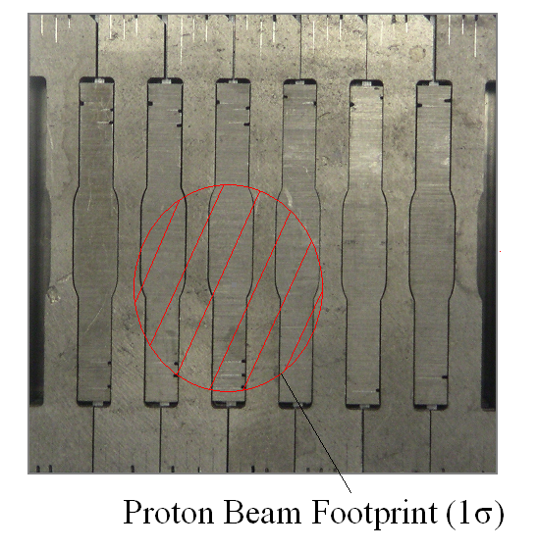
Figure 10: Matrix layer packing during irradiation.
The attractive, extremely low coefficient of thermal expansion (CTE) of the alloy super-invar was tested under irradiation early on in the BNL experimental study. Figure 11 depicts the CTE in the un-irradiated state (~1x10⁻⁶/ºK) and the effects of modest levels of irradiation on this key property (peak ~0.2 displacements-per-atom). As seen in Fig. 11 the effect of irradiation on the CTE of this promising alloy is quite dramatic. However, following indications of damage reversal achieved through thermal cycling observed in low-CTE carbon composites, the super invar alloy was subjected to thermal cycling to assess whether it also exhibits such tendency and if so identify the temperature threshold. Figure 12 depicts the experimental verification of its annealing while establishing the temperature threshold at T_{anneal} ≥ 600 ºC.

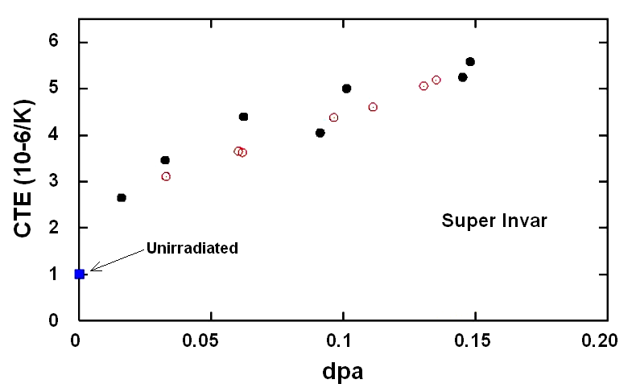
Figure 11: Irradiation effects on the thermal expansion coefficient of super Invar.

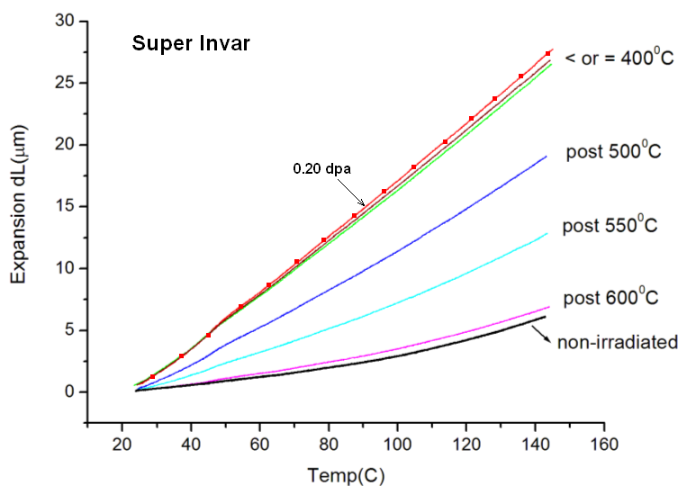
Figure 12: Damage reversal exhibited by the super-Invar alloy during thermal cycling.
In search of low-Z materials that can withstand beam-induced shock in high power accelerator targets, the 3D carbon-carbon composite was evaluated for irradiation damage and “annealing”. Discussed in the previous section and shown in Fig. 5 is the ability of this composite to minimize the dynamic effects of intense, fast proton pulses. Its ability stems from the particular fiber structure resulting in very low thermal expansion for the macro-material (the material actually exhibits negative CTE for up to 800ºC !). Figure 13 depicts the dramatic effect that irradiation has on the CTE property of this 3D composite but also the equally dramatic reversal of damage achieved by thermal cycling. Similar annealing behavior was observed in the two-dimensional carbon composite, Figure 14, selected to “clean” the 7 TeV LHC proton beam. Figures 13 and 14 show the similarity in the two materials along the fiber-reinforced planes. Figure 15 depicts both the effects of different levels of irradiation along the “weak” direction (normal to the fiber-reinforced planes) and the corrective action induced by thermal cycling. However, as shown in Figure 16, the 2D composite experiences serious structural degradation (especially along the non-reinforced direction) from high proton fluences. Follow-up experiments evaluating both the 3D and 2D carbon composites have been initiated to assess how common such serious radiation induced damage is on fiber-reinforced carbon structures.

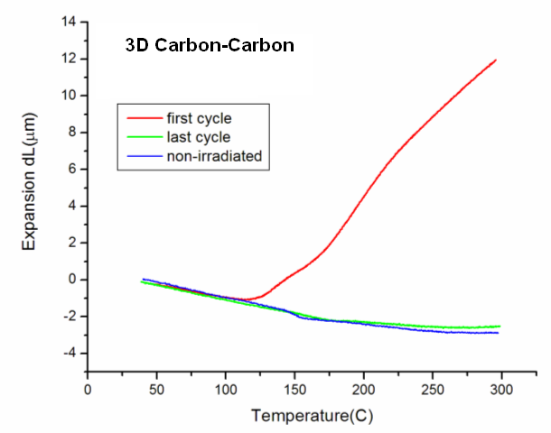
Figure 13: "Annealing" behavior exhibited by the 3D carbon-carbon composite
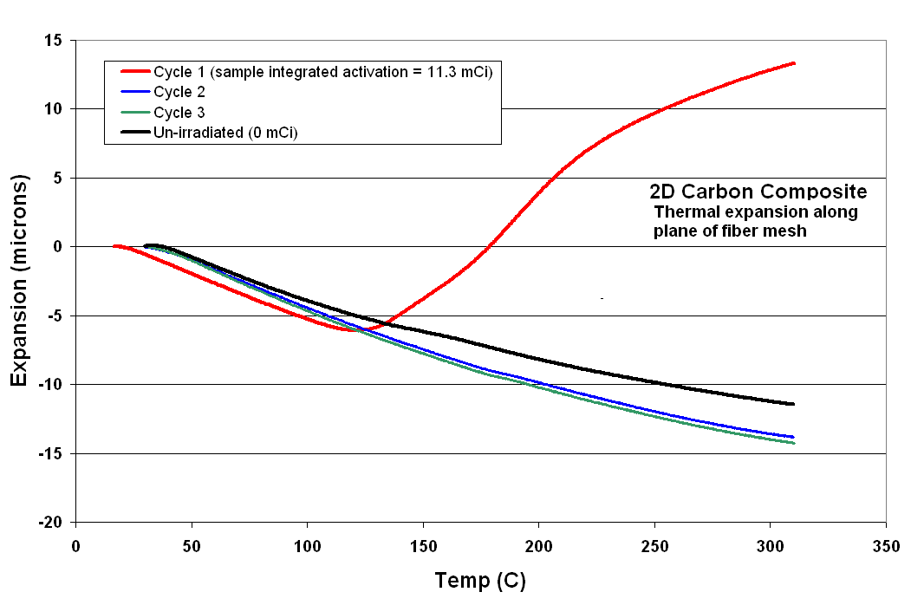
Figure 14: "Annealing" behavior of the 2D carbon-carbon composite (along plane of reinforcing fibers)
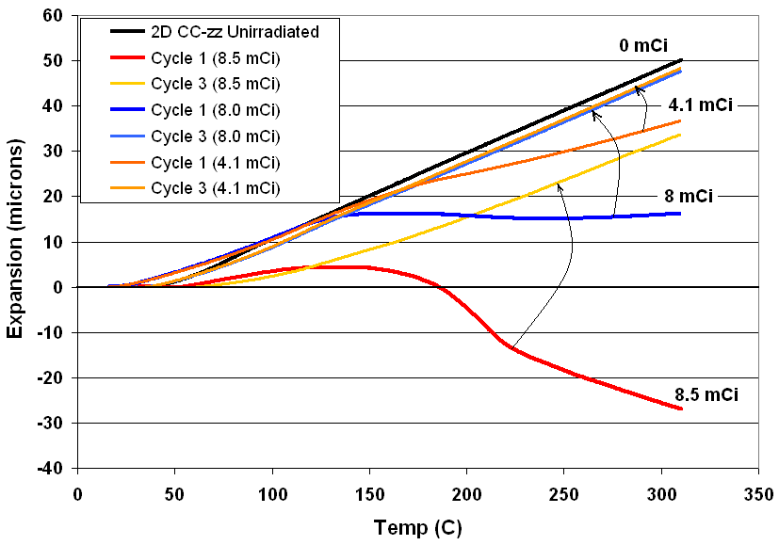
Figure 15: "Annealing" behavior of 2D carbon composite along the normal to fiber-reinforced planes while at different levels of irradiation exposure (expressed in mCi)
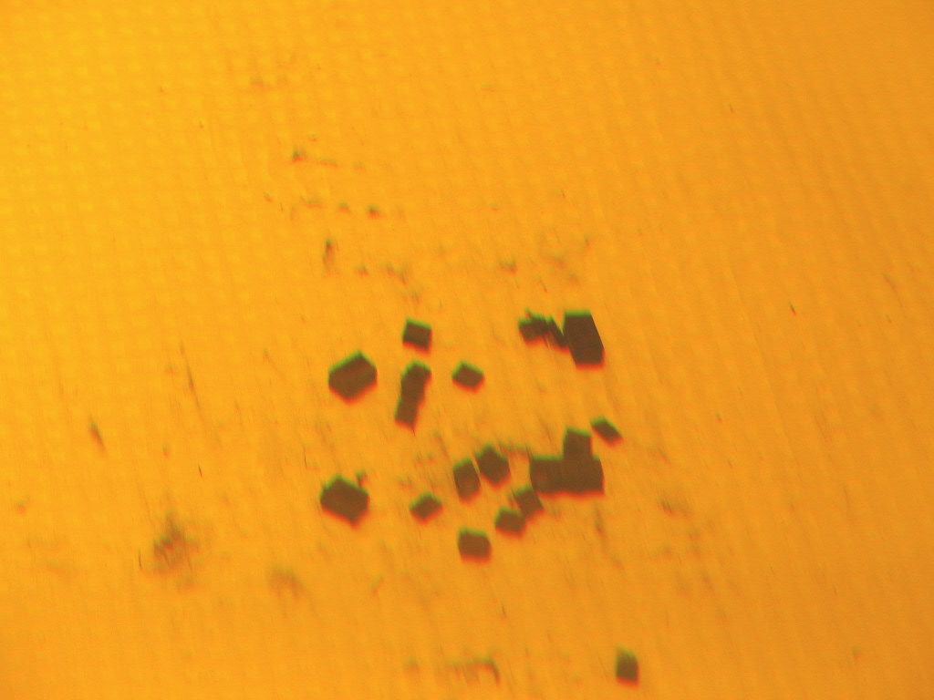
Figure 16: Effect of high proton fluence on the "weak" direction of the 2D fiber- reinforced carbon composite (fluence ~0.6x10²¹ protons/cm²)

Materials that favorably combine several of their physical and mechanical properties are of special interest to both high power targets and collimators. As indicated earlier, low CTE combined with low elastic modulus, high ductility, high strength and high thermal conductivity will be the ideal choice. The super alloy “gum metal” appears to possess such optimal property space as seen in Figure 17 especially very high ductility and strength as well as low invar-like CTE to ~400 ºC and low elastic modulus. Irradiation studies that lead to modest levels of irradiation damage (~0.26 dpa) have shown the dramatic loss of ductility in the annealed gum metal (Fig. 18).
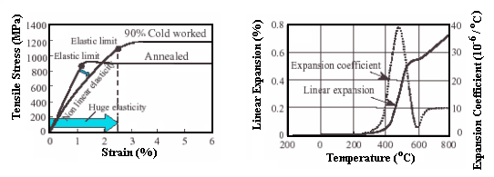
Figure 17: Mechanical and physical properties of the super alloy "gum metal" [Ref. 4]
Follow-up irradiation studies on the cold-worked gum have been conducted with the post-irradiation assessment pending. What is important to note, however, is the effect of thermal cycling, even in the non-irradiated cold-worked gum metal, on the thermal expansion behavior of the material as shown in Figure 19. It appears that thermal cycling (even a single cycle) removes the invar-like behavior in the gum metal induced by cold working.
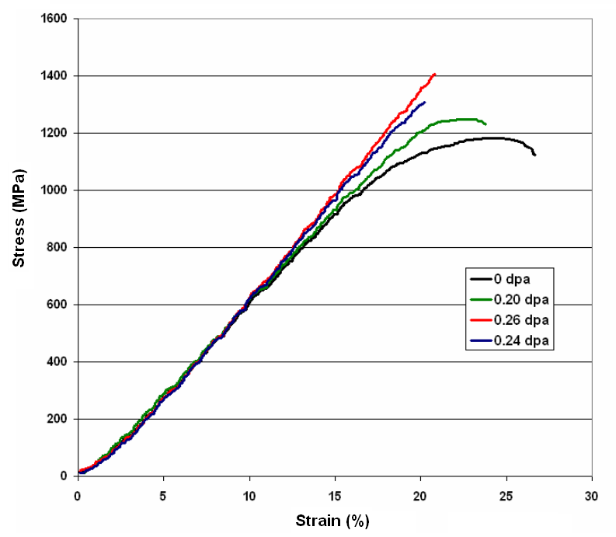
Figure 18: Irradiation effects on the stress-strain behavior of "gum metal"

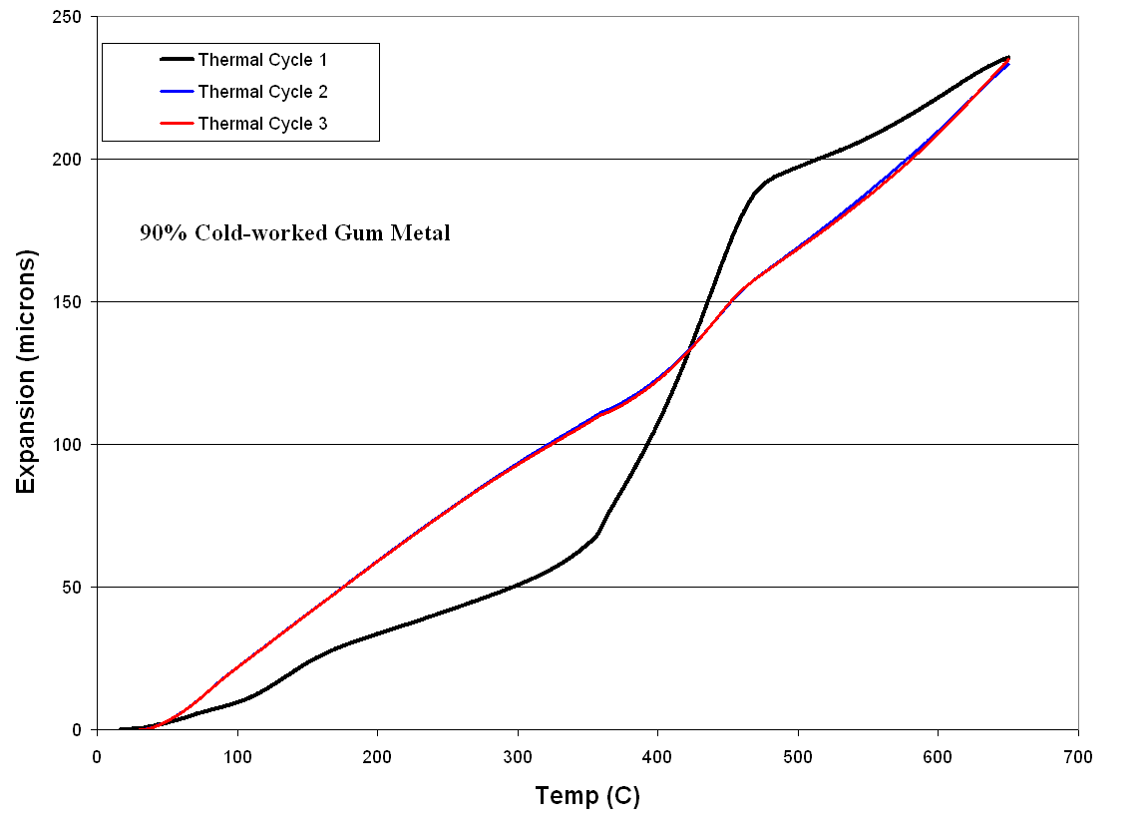
Figure 19: Annealing effects on the cold-worked "Gum metal" thermal expansion
To support the interest in mid-Z range materials as high power accelerator targets and even collimator jaws, the experimental studies explored beam induced damage in a number of such materials. Some post-irradiation results of this extensive search and subsequent irradiation study are shown in Figures 20 and 21. Figure 20 depicts the stress-strain behavior of the Vascomax material (iron-based alloy exhibiting very high strength) under different levels of irradiation while Figure 21 represents similar stress-strain results on the titanium alloy Ti-6Al-4V. As seen in Fig. 20, Vascomax retains most of its ductility while increases its strength with increasing irradiation. The titanium alloy has a similar behavior but suffers more ductility loss. Of interest is to compare the irradiation-induced embrittlement or ductility loss between the three mid-range Z materials (gum metal, Vascomax and titanium alloy).
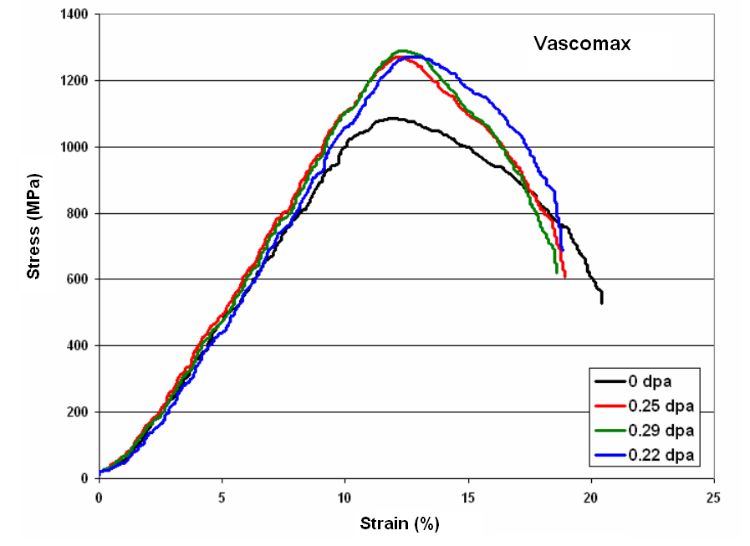
Figure 20: Irradiation effects on the stress-strain relation of Vascomax
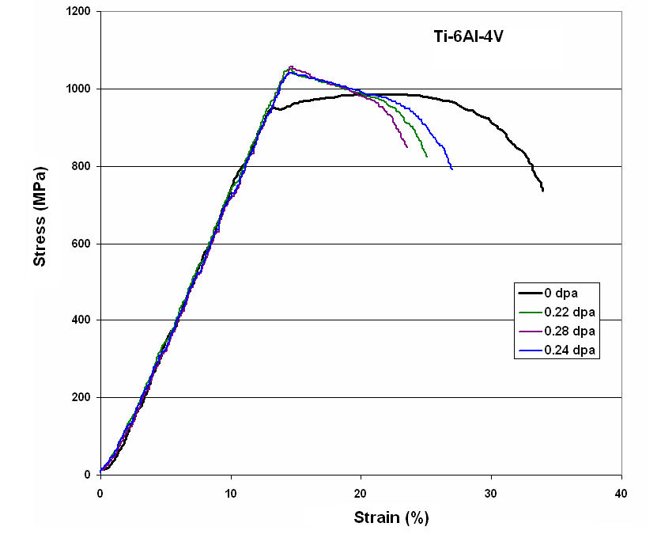
Figure 21: Irradiation effects on stress-strain relation of Ti-6Al-4V

SUMMARY
This paper discusses experimental results generated by experimental studies at BNL on a host of materials considered for high power accelerator targets and collimators. The experimental effort includes both beam-on-target and irradiation damage studies. Of particular interest have been fiber-reinforced carbon composites and several super-alloys with thermo-mechanical properties appropriate for withstanding shock and/or providing stability as in the case of critical collimation elements. Below is a preliminary assessment of results to-date:
- Carbon composites respond to intense proton pulses with much lower dynamic strain or stress than graphite
- Both 3D and 2D structured fiber-reinforced composites exhibit “annealing” of damage with thermal cycling. High fluences, however, appear to seriously degrade their structure. Follow-up studies to fully assess the behavior of these composites are in progress.
- Certain super-alloys (e.g. super-invar) exhibit annealing behavior, or damage reversal, through thermal cycling. New irradiation studies on irradiated and “annealed” super invar have been conducted and are pending analysis.
- Irradiation, even at modest levels, seems to have a dramatic effect on the super-alloy “Gum Metal” by removing its super-ductility completely. Thermal cycling seems to also remove the effect of cold-work manifesting itself in the form of low CTE (invar-like behavior).
In the most recent irradiation damage study where the integrated flux exceeds the flux achieved in previous material exposures by a factor of two, high Z materials such as tantalum and tungsten have been introduced into the irradiation matrix along with various graphite grades, carbon-composites, cold-worked gum, albemet, etc. Results of the upcoming post-irradiation analysis will be reported in the follow-up reports on these experiments.

References

[1] N. Simos, et al., “Target Material Irradiation Studies for High-Intensity Accelerator Beams,” Nucl. Phys. B (Proceedings Suppl.), 149, 259-261, 2005

[2] N. Simos, et al., “Solid Target Studies for Muon Colliders and Neutrino Beams,” Nucl. Phys. B (Proceedings Suppl.), 155, 288-290, 2006

[3] H.G. Kirk, et al., “Target Studies with BNL E951 at AGS,” Proceedings of the 2001 Particle Accelerator Conference, Chicago, IL, March 2001, p.1535.

[4] K. Nishino, “Super Multifunctional Alloy GUM Metal.” Toyota CRDL Inc., Technical News

[5] R. Assmann, “LHC Collimator Overview,” Private comm.

[6]

G.I. Kanel et al., “Shock-wave compression and tension of solids at elevated temperatures: superheated crystal states, pre-melting, and anomalous growth of yield strength,” Journal of Physics: Condensed Matter, 16, S1007-S1016, 2004

[7] V. E. Fortov and I. V. Lomonosov, “Thermodynamics of extreme states of matter,” Pure & Appl. Chem., Vol. 69, No. 4, pp.893-904, 1997

[8] B. King, N. Simos, N. Mokhov and R.V. Weggel, “Rotating Metal Band Target for Pion Production at Muon Colliders and Neutrino Factories”, Physical Review-Special Topics: Accelerators and Beams, 2002

 *Work supported by the U.S. Department of Energy. #simos@bnl.gov

