12th International Conference on Nuclear Engineering
Arlington, VA, April 25-29, 2004

ICONE12-49441

MATERIAL STUDIES FOR PULSED HIGH-INTENSITY PROTON BEAM TARGETS

Nicholas Simos¹, Harold Kirk¹, Hans Ludewig¹, Peter Thieberger¹, W-T Weng¹, Kirk McDonald² and K. Yoshimura³
¹Brookhaven National Laboratory, UPTON NY 11973, USA
²Princeton University, Princeton, NJ, USA
³KEK, Tsukuba, Japan
simos@bnl.gov

ABSTRACT

Intense beams for muon colliders and neutrino facilities require high-performance target stations of 1-4 MW proton beams. The physics requirements for such a system push the envelope of our current knowledge as to how materials behave under high-power beams for both short and long exposure. The success of an adopted scheme that generates, captures and guides secondary particles depends on the useful life expectancy of this critical system. To address the key technical challenges around the target of these initiatives, a set of experimental studies have either been initiated or being planned that include (a) the response and survivability of target materials intercepting intense, energetic protons, (b) the integrity of beam windows for target enclosures, (c) the effects of irradiation on the long-term integrity of candidate target and focusing element materials, and (d) the performance of the integrated system and the assessment of its useful life. This paper presents an overview of what has been achieved during the various phases of the experimental effort including a tentative plan to continue the effort by expanding the material matrix. The paper also attempts to interpret what the experimental results are revealing and seeks for ways to extrapolate to the required intensities and anticipated levels of irradiation and it discusses the feasibility of the proposed approaches to achieving such high-performance systems. Further it explores the connection of accelerator target systems with reactor systems in order to utilize experience data that the nuclear reactor sector has acquired over the years.

Keywords: Irradiation, beam targets, high-power proton driver

1.0 BACKGROUND

With increasing demand for high-power accelerators in support of initiatives for new physics opportunities such as the neutrino superbeam, the muon collider/neutrino factory, etc. where intense secondary beams of pions, muons and neutrinos are of great interest, the pool of materials that can be utilized and play the role of production targets is dramatically reduced. At power levels of 1 MW to potentially 4 MW the development of integrated target systems that can function under such demand is a serious challenge to the accelerator community. The challenge stems from the uncertainties associated with the long-term survival of the highly irradiated target material given that, at these power levels materials, and target configurations used in the past will not suffice. The ever greater deposited energy and induced thermo-mechanical loads are the reason for the limitations.
To overcome the challenges and meet the physics requirements, an intensive search has been under way for both “smart” target designs and target materials that exhibit favorable behavior over a certain range of key properties that define their resilience. Specifically, in an effort to overcome the issue of shock and potential shattering of the target, systems composed of either liquid metals or particle beds have been assessed. Experiments have been conducted recently [1] in an effort to address issues associated with liquid metal jets as potential target for the muon collider/neutrino factory initiative. It becomes clear in these endeavors that, when dealing with high-power systems, by solving the primary issue (such as shock-induced shattering) secondary issues tend to pop up. This implies that one has to walk a fine line between a choice of the target material and the target configuration.
In evaluating the various materials as possible candidates their physical and mechanical non-irradiated properties typically form the basis of evaluation. While many materials are well understood from their application to other areas, most of them are disqualified due to their inability to withstand the level of shock anticipated. A variety of new and “smart” materials have become available for use in special areas (other than accelerator targets) and some of them hold the promise of playing the role of high power targets while eliminating the primary failure mode. The advantage of these materials, as it applies to high power targets, stems primarily from the low thermal expansion they exhibit and secondly from the increased strength.
During the BNL E951 experiment, typical graphite (ATJ-grade) thermo-mechanical response to rapid proton heating was compared to the response of a Carbon-Carbon composite which is specially fabricated to eliminate thermal expansion and thus eliminate thermal stress. Figure 1 depicts recorded strains in the two types of targets intercepting 24 GeV proton pulses. The superiority of the new composite is clearly shown. However, the question of whether this superior response of the composite holds true when is irradiated is still unanswered. Irradiation studies are needed to confirm its resilience to such exposure. This is of course true with several other new materials that present similar properties. As it will be discussed in detail in the next section, one such material of interest is the Super-Invar alloy which exhibits low thermal expansion up to temperatures of ~150 ºC. A comprehensive experimental study was undertaken to assess whether the material maintains this advantage after it is irradiated.
Prompted by the need that different accelerator initiatives around the world have to identify candidate materials for higher power solid targets, this current effort is set out to evaluate some of the promising materials under irradiation environment. The goal of the study which is a continuation of the super-Invar irradiation effort, is to qualitatively assess how prone are these “new” material to experiencing degradation of their advantageous properties under irradiation. In this phase of the experimental assessment only qualitative evaluation can be achieved (due to low cumulative dpa that is feasible at this stage). Candidate materials that show promise will be included in a follow-up phase of irradiation to levels of dpa anticipated during the useful life of the target. The materials selected for the immediate irradiation studies as well as the tentative plan are discussed in a later section.
Several studies have been performed in recent years (in addition to the BNL E951) that addressed the properties of several materials that are either in use or planned to be used in accelerator components. These include the Accelerator Production of Tritium (APT) Material Handbook study and the Spallation Neutron Source studies in the US, Europe and Japan. While an extensive matrix of materials has been used (between the various studies), no information regarding irradiation effects on the new alloys/composites is available. It should be noted that the wealth of reactor-based material irradiation experience continues to provide the baseline for the new studies for long-term irradiation exposure extrapolation, understanding mechanisms of material property changes, etc.
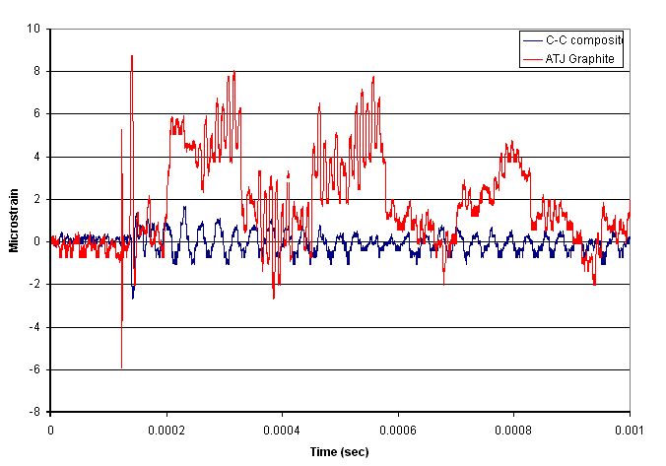
Figure 1: Graphite (ATJ) and Carbon-Carbon Composite Response to 24 GeV Protons

2.0 PHASE-I IRRADIATION STUDIES

In Phase-I of the BNL irradiation studies the super-Invar alloy was irradiated and subsequently evaluated for changes in its mechanical and primarily its thermal expansion properties. As mentioned earlier the super-Invar alloy is a candidate for a robust solid target used in conjunction with an intense pulsed proton beam because of the low coefficient of thermal expansion (CTE) it exhibits over a certain range of operating temperature. Invar is a metal alloy which predominantly consists of 62% Fe, 32% Ni and 5% Co. The CTE for Super-Invar at room temperature is ~0.6 × 10⁻⁶ ºK, but its variation after radiation damage from an intense proton beam is unknown.

2.1 Experimental Layout

The irradiated Super-Invar samples consisted of 28 3/16-in rods each 1.688in long. Half of the samples were necked down to a diameter of 0.08 in. The necked-down samples were used for post-irradiation mechanical tensile testing. In addition, 8 Inconel-718 rods were used as fillers in the target stack. While extensive irradiation data are available from the APT study for Inconel-718 the effects of irradiation on the CTE of the material has been assumed to be negligible. This study was expected to provide some proof of that. Figure 2 depicts the configuration of the samples within the target holder. In addition, 16 1-mm diameter nickel wires were placed between sample cylinders (front and back faces of the arrangement) and were used as horizontal and vertical proton beam profile monitors.
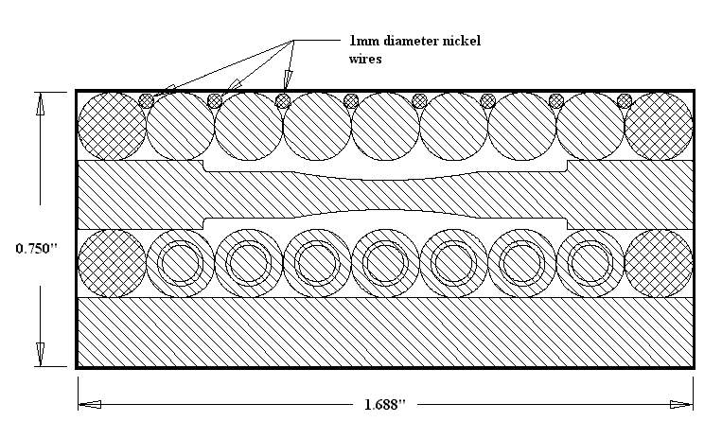
Figure 2: Target sample layout. Cross-hatched samples are Inconel. The proton beam enters from the top

The irradiation was done at the Brookhaven Linac Isotope Producer (BLIP) facility with a 200 MeV proton beam. The integrated beam current over a 2-week period was 24 mA-hrs that corresponds to a total of 5.4× 10²⁰ protons on target. The proton fluence at the target center was 1.3 × 10²⁰ protons/cm². The beam energy after attenuation in the water surrounding the target was ~190 MeV at our sample entrance. The samples were immersed in a water tank for target cooling purposes and cooling water was directed to flow through the sample arrangement. Based on an estimated flow rate through the samples of 2gpm and peak proton current of 108 µA during irradiation, the peak temperature within the interior of a sample rod was of the order of 200 ºC. No thermocouples were used to monitor the temperatures during irradiation.
Following irradiation at the BLIP facility, the target samples were removed and placed in a lead shielded enclosure for seven months to allow for the radioactivity to decline to more manageable levels. Subsequent measurements of the CTE and tensile properties were performed in the BNL hot cell facility equipped with remote handling capabilities.

2.2 Measurements

Activation Measurements

The irradiated samples were placed individually into an ATOMLAB-100 dose calibrator in order to measure the integrated activation levels. The entrance plane of samples (Fig. 2) consisted of straight cylindrical rods and wires positioned in a horizontal orientation, while the exit plane had a similar arrangement but with a vertical orientation. The activation levels of the front plane were used to extract information as to the vertical profile of the incident proton beam, while the exit plane was used for obtaining the horizontal profile of the proton beam (Fig. 3).
This measured beam profile, along with the total proton flux and incident energy, served as input into the MCNPX transport code [2] utilized to calculate the atomic displacements within each sample. Results of the activation measurements of each sample correlate well with the calculated values for the atomic displacements averaged over each rod.

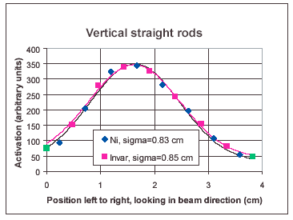
Figure 3: Measured specimen activity as a function of target position. The lines are Gaussian fits

Thermal Expansion Measurements

The evaluation of coefficient of thermal expansion and its changes from irradiation were performed using a L75 dilatometer purchased from LINSEIS, Gmbh. The dilatometer was specifically fabricated to allow ease of remote operation since the measurements were confined to a hot cell where remote manipulation of the equipment as well as the mechanical insertion of the samples was required. Measurement of non-irradiated samples demonstrated that the virgin material had the expected CTE of 0.6 × 10-6 /K at room temperature while the base line for the temperature range of 50 ºC to 150 ºC was an average CTE of 1.0 × 10⁻⁶/K. Figure 4 demonstrates that irradiation dramatically alters the thermal expansion properties of Super-Invar. Figure 5 plots the results of the entire set of super-Invar samples as a function of the dpa received.
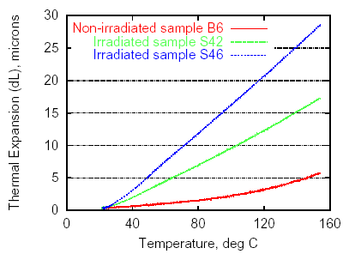
Figure 4: Measured thermal expansions for three different Super-Invar specimens
The average CTE values reported in this section correspond to the temperature interval between 50 ºC and 150 ºC and are averaged over the length of each sample.
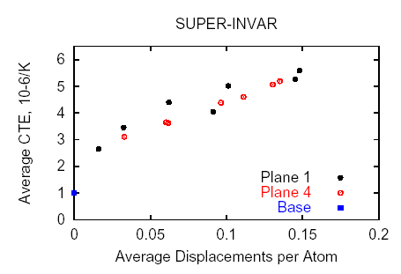
Figure 5: Measured average CTE as a function of calculated average dpa

Given the uncertainties in the operating temperatures inside the assembly box complementary measurements of un-irradiated super-Invar samples were made. Specifically, samples were heat treated to various temperatures up to 400 ºC before tested. Results indicate that most of the observed effect is attributed to radiation damage, but some contribution from heating during irradiation and from possible effects of thermo-mechanical shock caused by the pulsed beam can not be excluded. It should be further noted that the presence of Fe in the composition of super-Invar led to evident surface corrosion.
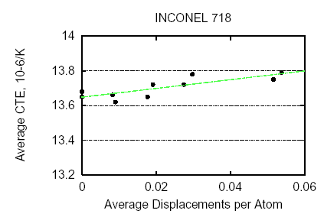
Figure 6: Measured average CTE of Inconel-718 samples as a function of dpa

The average CTE of the eight irradiated Inconel-718 samples as well as of two additional non-irradiated ones was also measured. As seen in Figure 2 the Inconel specimens are used as spacers located at the far ends of the assembly leading to significantly smaller activation levels (~0.05 dpa max.) than those received by the super-Invar specimens. Even these small activation levels, however, provide valuable information on how, if at all, irradiation affects CTE. As seen in Figure 5 the most dramatic changes in CTE occur between 0 and 0.05 dpa for super-Invar. The APT materials evaluation study [4] pertinent to irradiation effects on Inconel-718, and based solely on theoretical physics arguments that the CTE depends on the shape of the potential well associated with lattice cohesion and not affected by defects introduced by irradiation or by changes in the alloy microstructure, concluded that the CTE for Inconel-718 will be un-affected by irradiation. Figure 6 provides a qualitative confirmation of that where it is seen that the changes in CTE, based on actual measurements, are very small compared to the changes seen in super-Invar.

Tensile Measurements

The effect of different levels of irradiation on the mechanical properties of Super-Invar was assessed by performing tensile tests on specimens that have been specially designed for that purpose. The irradiation levels reached during the exposure to the beam vary from a fraction of a dpa to about 0.25 dpa. While the irradiation levels may appear small, the changes in material properties, as seen from previous irradiation experiments on different materials (other than Invar), occur within that regime of dpa values. Figure 7 depicts the irradiation-induced changes on the yield strength of Inconel-718 [4]. It is evident that the bulk of the change (hardening) occurs at dpa levels up to 0.2.

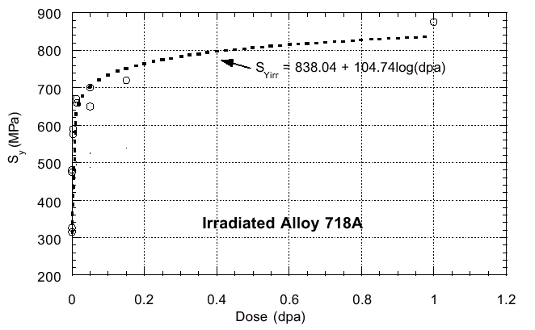
Figure 7: Yield vs. dpa level for Inconel-718 alloy [4]

Of interest were the effects of irradiation level on material hardening, loss of ductility, and elastic modules. During the experiment the load-displacement curves of virgin as well as irradiated specimens from the same block of material were obtained. Particular care was taken to maintain the same parameters of tensile test in order to avoid scattering of the data. As a result very similar load-displacement curves were achieved for the non-irradiated specimens. This provided an excellent reference for the critical properties (such as the yield strength, the ultimate strength and the modulus of elasticity) that had to be evaluated as a result of the irradiation. In addition to irradiation, temperature effects were also evaluated given that super-Invar exhibits a characteristic threshold temperature beyond which its thermal expansion coefficient increases.
The results revealed the following:
- The elasticity modulus, as expected, experienced no effect as a result of irradiation
- Irradiation-induced hardening is observed. Specifically, the material becomes stronger but brittle. Approximately 15% increase in tensile strength was observed. Figures 7 and 8 depict the changes in the yield strength. As seen, the material lost its post-yield strength (no ultimate strength) and fractured at smaller displacement (strain) levels.
- Heat treatment appears to have a profound effect on the material properties (lower yield point, more ductile). Treatment up to a temperature leads to material strengthening. Crossing the temperature thresh-hold (still unknown) super-Invar becomes more ductile, weaker and its elasticity modulus is reduced (Figure 9).

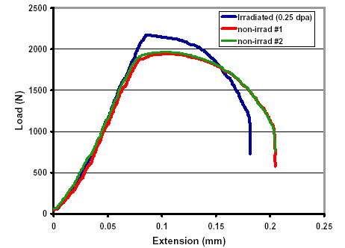
Figure 7: Load-displacement curves for irradiated and non-irradiated invar specimens

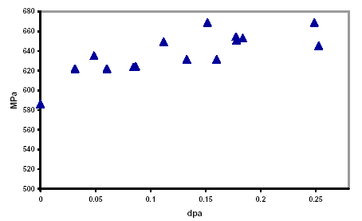
Figure 8: Yield vs. atomic displacement for irradiated and non-irradiated invar specimens

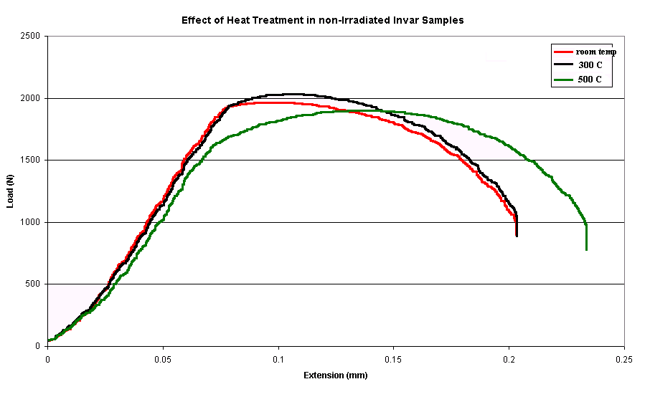
Figure 9: Effects of heat treatment on the stress-strain relationship of super-Invar

3.0 PHASE-II TARGET MATERIAL STUDY

During Phase-I of the material irradiation study attention was primarily focused on Super-Invar and in a lesser degree on Inconel-718. Relevant information to the overall study was also obtained from E951 where several materials (either in the form of proton windows or targets) were subjected to 24 GeV proton pulses and had their dynamic response measured and analyzed. These materials included Al-3000, Inconel-718, Havar and Ti alloy (6Al-6V) as windows and graphite (ATJ grade) and Carbon-Carbon composite as low-Z targets. It was indicated earlier that the Carbon-Carbon composite appears to minimize the thermal shock as compared to classical graphite. Super-Invar held the same promise based on its low CTE over a specific range of operating temperature. As seen in the previous section, however, even small levels of irradiation have a profound effect on the advantage that the non-irradiated material appeared to have.

A number of new “smart” alloys and composites other than Carbon-Carbon composite and super-Invar have been developed in recent years for a wide range of applications. These materials exhibit either high strength or, as in the case of Invar, low CTE. Such a situation appears to be beneficial to the accelerator community since it optimizes the two material properties that matter the most. For example, Figure 10 depicts the characterization of the “Gum Metal” alloy (Ti based alloy) which seems to have significant advantages over other alloys. However, these alloys/composites were not developed with accelerator applications (especially targets) in mind where radiation damage is a key factor. Their properties are, nevertheless, intriguing enough to consider them for high-power target applications, provided that the radiation damage issues are addressed. Phase-II of the study plans to do exactly that. Given that the interest of the accelerator community in these materials is at either low-Z or high-Z the selected matrix for irradiation studies include materials of both ranges.
The material matrix for Phase-II consists of the following:

- Carbon-Carbon composite. This low-Z composite gives the indication that it can minimize the thermal shock and survive high intensity pulses. Because of its promise it is the baseline target material for the BNL neutrino superbeam initiative. The way its key properties (such as CTE or strength) degrade with radiation is unknown.
- Titanium Ti-6Al-4V alloy. The evaluation of the fracture toughness changes due to irradiation is of interest regarding this alloy that combines good tensile strength and relatively low CTE.
- Toyota “Gum Metal”. This alloy with the ultra-low elastic modulus, high strength , super-elastic like nature and near-zero linear expansion coefficient for the temperature range -200 ºC to +250 ºC to be assessed for irradiation effects on these properties.
- VASCOMAX. This very high strength alloy that can serve as high-Z target to be evaluated for effects of irradiation on CTE, fracture toughness and ductility loss.
- AlBeMet. A low-Z composite that combines good properties of Be and Al. Effects of irradiation on CTE and mechanical properties need to be assessed.

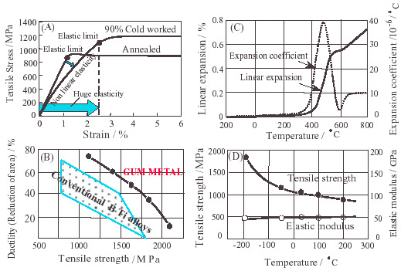

Figure 10: “Gum Metal” material characterization in its un-irradiated state (Ref. 6)

The procedure described in section 2.0 will be followed in Phase-II of the study with the exception that the specimens will be strips rather than round bars (straight or necked-down). Provisions for fracture toughness testing will be made with notched samples on some of the selected materials (Vascomax and the two titanium alloys).

4.0 SUMMARY

The results of the recent material studies indicate that selecting a target material based on it’s seemingly attractive properties that appear to be the solution to the daunting task of surviving the high intensity pulses of high-power accelerators (such as coefficient of thermal expansion, fracture toughness, strength, etc.) should be preceded by a consideration of the effects that radiation damage can impart on this property. Super-Invar for example, whose non-irradiated properties held such promise, can only be considered a serious target candidate for an intense proton beam only if one can anneal the atomic displacements followed by the appropriate heat treatment to restore its favorable expansion coefficient.
As many new materials are developed by optimizing key properties that are of value to the accelerator community (and possibly to the reactor community) the need for assessment of radiation damage potential is paramount.
This material study focuses on some of the new materials and hopes to screen them as possible target candidates. Upon completion of the study those materials that maintain their properties under modest levels of irradiation (that this study can achieve) will undergo further irradiation to levels that are equivalent to those expected during their life expectancy as accelerator targets.

AKNOWLEDGEMENTS

The support of the US DOE is greatly appreciated.

REFFERENCES
- H.G. Kirk, TARGET STUDIES WITH BNL E951 AT THE AGS, Proceedings of the 2001 Particle Accelerator Conference, Chicago, Il., March 2001, p.1535.

- MCNPX Users Manual-Version 2.1.5, L.S. Waters, ed., Los Alamos National Laboratory, Los Alamos, NM. TPO-E83-GUG- X-00001. (1999)

- M. Kawai, K. Kikuchi, editors, “Proceedings of 3rd Workshop on Material Science and Technology for Spallation Neutron Source”, KEK Proc. 2003-6, 2002

- APT Materials Handbook, TPO-P00-MDD-X-00001, 20001

- J. Gittus, “Creep, Viscoelasticity and Creep Fracture in Solids,” John Wiley & Sons, 1975

- K. Nishino, “Super Multifunctional Alloy “GUM METAL”.Toyota CRDL., INC. Technical News

