Solid Target Studies for Muon Colliders and Neutrino Beams

N. Simos,¹ H.G. Kirk,¹ H. Ludewig,¹ P. Thieberger,¹ W-T Weng,¹ P.T. Trung,¹ L. Mausner,¹ J. O’Conor,¹
K.T. McDonald,² J.C. Sheppard,³ K. Yoshimura,⁴ and Y. Hayato⁴

¹Brookhaven National Laboratory, Upton, NY 11973, USA
²Princeton University, Princeton, NJ 08544, USA
³Stanford Linear Accelerator, Menlo Park, CA 94025, USA
⁴KEK, Tsukuba, Japan

This paper presents preliminary results from an ongoing post-irradiation analysis of materials that have been irradiated at the Brookhaven National Laboratory (BNL) Isotope facility. The effort is part of an experimental study that focuses on how prone to irradiation damage these materials are and thus what is their potential in playing the role of high-power targets in the neutrino-superbeam and the muon-collider initiatives.

1. BACKGROUND

To address the issue of target viability and performance in the ever increasing demand for high- power accelerators, a systematic effort has been under way at BNL consisting of exposure of targets to high-intensity beams [1], as well as material irradiation studies [2]. These irradiation studies focus on “smart” materials, new alloys and composites that appear to have physical and mechanical properties favorable for target survival from beam-induced shock. Since target survivability also depends on the ability of the material that it is made of to resist damage caused by the bombarding energetic particles, that information is crucial in assessing how long will a target last after it succeeds to absorb the thermal shock induced by a pulse. Relevant damage information for several materials considered for high-power targets is available [3] from reactor studies and almost entirely from neutron doses. It is, however, unclear whether there is a difference between proton and neutron irradiation of materials. Irradiation-damage data for the “new” and “smart” alloys and composites are far more scarce or non-existent.
In ref. [2] the different phases of the BNL material irradiation studies were presented in detail. Specifically, in the first phase inconel-718 and super-invar were irradiated at the isotope facility receiving approximately 0.25 dpa for the super- invar. During the first post-irradiation analysis it appeared that even a small amount of irradiation was enough to dramatically alter its extremely low thermal expansion coefficient that it enjoyed in the non-irradiated state.
In the second phase of the material irradiation study, the search for new alloys, composites and “smart” materials continued and a new and expanded matrix was established for irradiation studies. It includes a 3D weaved carbon-carbon composite considered as the target candidate for the neutrino superbeam, and the IG-43 graphite considered for the target in the T2K neutrino beam experiment. The material assembly also includes Vascomax, Ti-6Al-4V alloy, beryllium, AlBeMet and the “smart” alloy gum metal [4] that exhibits non-elasticity, low modulus and thermal expansion as well as magnificent strength in the post-yield state (Figure 5). Lastly, specimens of nickel-plated aluminum, the same material used in the magnetic horn of the NuMI experiment was included to study the effects of irradiation on the special plating.
This paper presents preliminary results of the post-irradiation study that followed the irradiation of the assemblage of materials at the BNL isotope facility. From the wealth of results generated only a few that are especially intriguing are presented here for the lack of space. Complete results will be published in another report to follow.

2. MATERIAL IRRADIATION STUDY

Shown in Figure 1 is the schematic of the actual assembly of the irradiated materials. The specimens were irradiated with the 200-MeV beam of the BNL isotope facility that was degraded to about 104 MeV at the back of the last irradiation box. The current associated with beam was estimated to be 70 μA. From radiography analysis of special nickel foils it was estimated that the beam spot had σ_{x} = 8.1 mm and σ_{y} = 8.4 mm. The total proton flux incident on the targets was ~3.7x 10²⁰.
An analysis based on damage cross sections for the materials involved using the MCNPX Monte Carlo code [5] revealed that most of the damage, expressed in Displacements-per-Atom (dpa), was from the incident protons. The contribution of neutrons to the damage was minimal. The heavier materials, such as Vascomax, Ti-6Al-4V and “gum metal”, experienced irradiation damage of the order of 0.27 dpa (protons and neutrons combined). The carbon-carbon (CC) composite and graphite received irradiation damage of 0.012 dpa. While the damage value for graphite and CC composite appear small, it has been shown that even at this level of irradiation, key properties of graphite change dramatically. Further, mechanical properties for metallic materials, such as those in this study, experience the largest change at irradiation levels below 0.2 dpa.

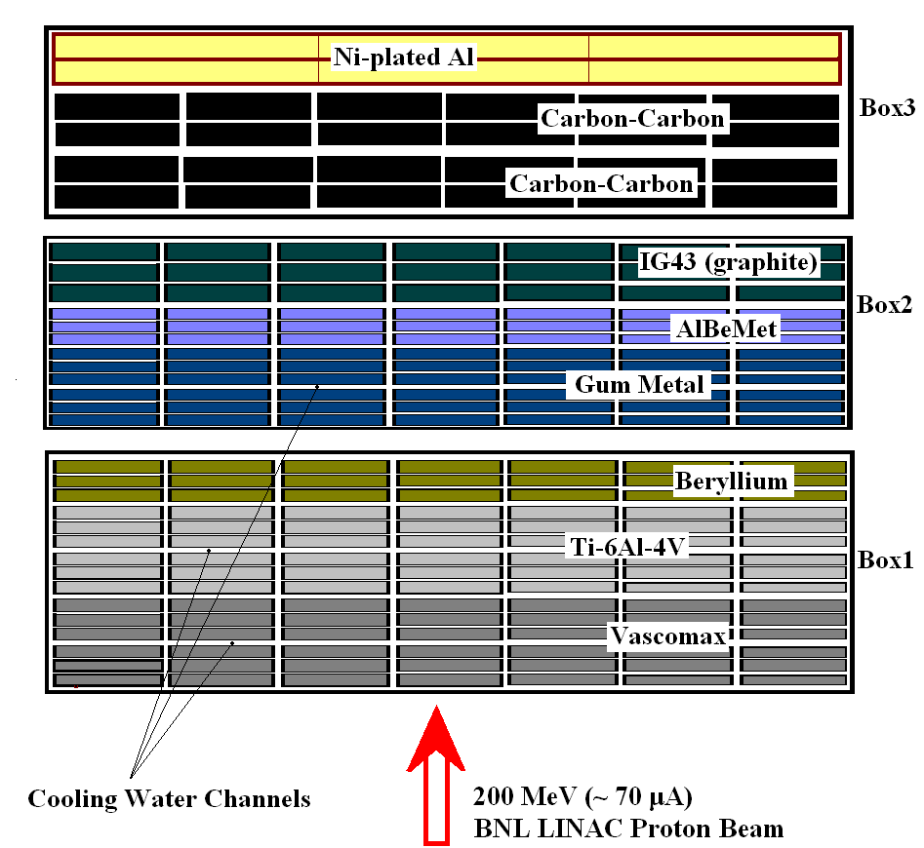

Figure 1: Specimen layout in the irradiation boxes used the BNL Phase II irradiation.

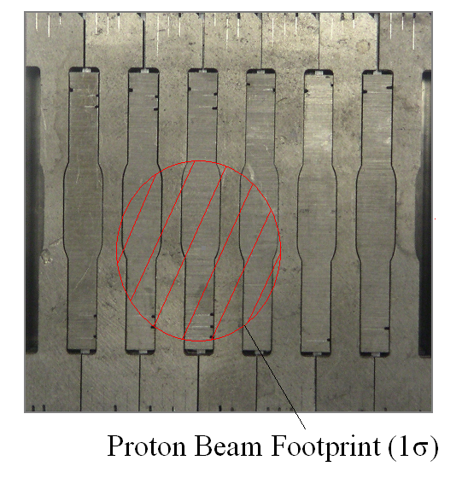
Figure 2: Specimen arrangement in one of the layers in the irradiation assembly.

3. POST IRRADIATION ANALYSIS

The post-irradiation analysis in the BNL hot cell facilities, consisting of thermal expansion measurements using a sensitive dilatometer and tensile testing using a remotely operated mechanical testing machine, revealed the following regarding material response to irradiation: The CC composite shown in Figure 3 in its non-irradiated state exhibits negative thermal expansion. Irradiation dramatically changes that (as shown by the red trace). However, with repeated thermal cycles, the damage is annealed and slowly the material gets back to its original state.
This interesting “annealing” behavior prompted the re-examination of the super-invar that had been studied during phase-I and abandoned because of the dramatic effects of irradiation on its thermal- expansion coefficient. Subsequent thermal cycling revealed that super-invar also experiences annealing while reclaiming of its original thermal-expansion properties. As seen in Fig. 4, complete recovery occurs when the thermal cycling crosses the “threshold” value of 600º C.
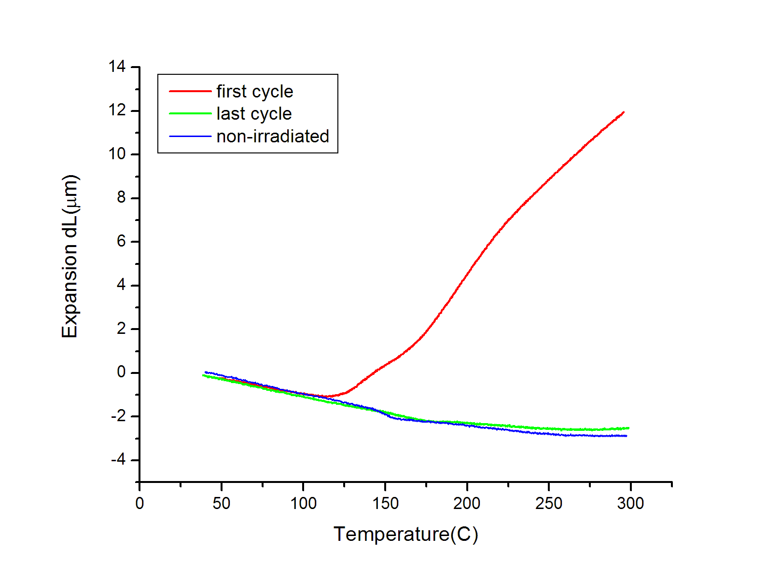
Figure 3: Thermal expansion behavior/annealing of irradiated carbon-carbon composite.

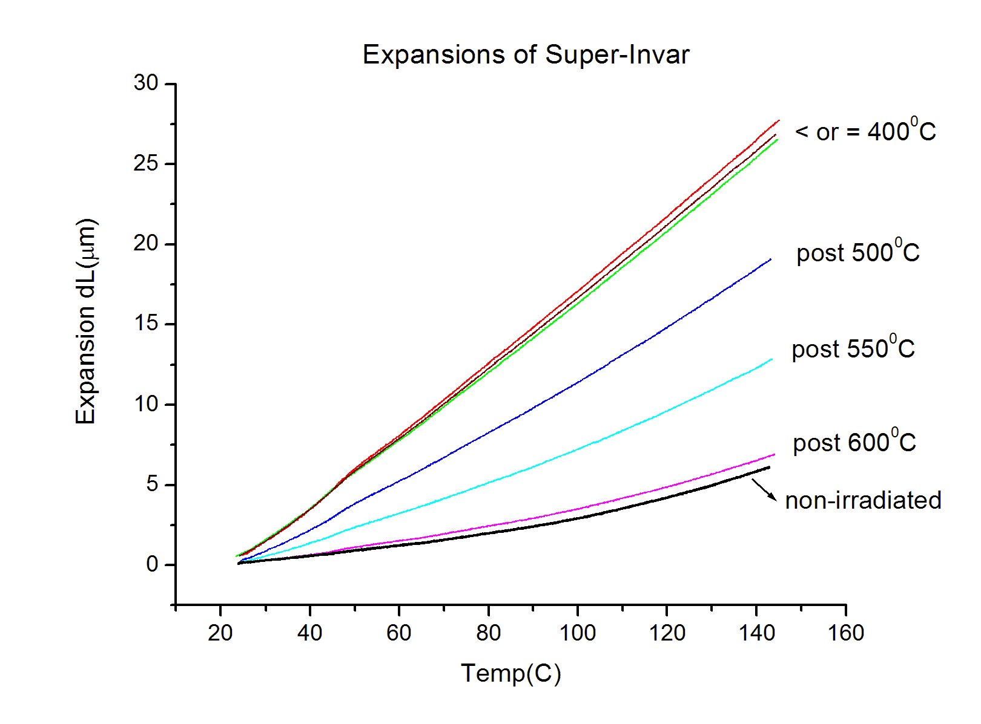
Figure 4: Thermal expansion and annealing threshold of irradiated super-invar.

Figure 5 depicts the superb properties of “gum metal”, especially those of the 90% cold-worked material with its very high ductility.
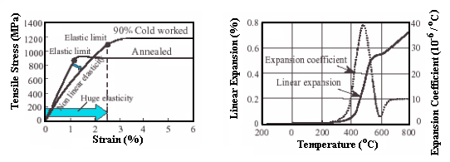
Figure 5: “Gum metal” material characterization in its non-irradiated state.

Figure 6 shows that the ductility of “gum metal” disappears after 0.24 dpa of irradiation damage and it becomes totally brittle. Such loss of “cold-working” in other materials has been observed in neutron irradiation studies and is an issue that must be attended to in the next phase of the study.

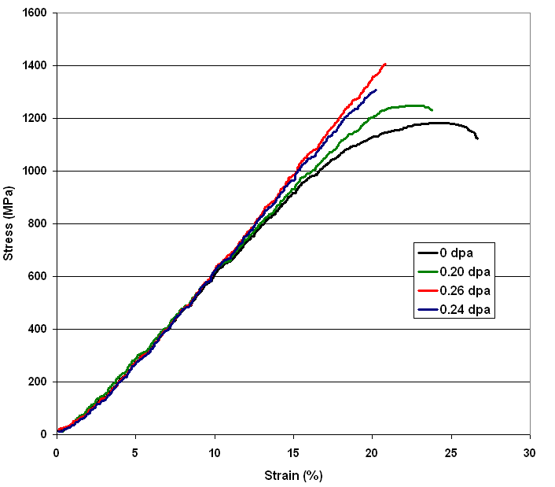
Figure 6: Irradiation effects on stress-strain relation of “gum metal”.

As seen in Fig. 7, irradiation actually reduces the thermal expansion coefficient of AlBeMet. It is the only material in the study that such a behavior was observed. In Fig. 8 the stress-strain behavior of Vascomax is depicted. Interestingly, Vascomax gets stronger with irradiation but retains its ductility. This is not true, however, with the Ti-6Al-4V alloy that experiences significant ductility loss (Fig. 9).

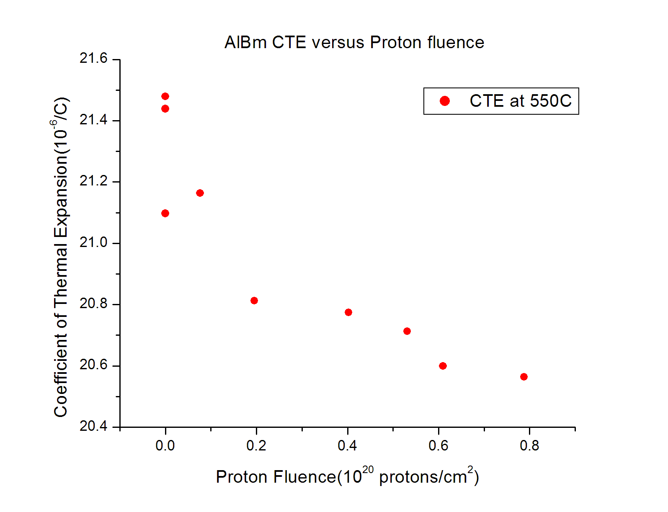
Figure 7: Irradiation effects on thermal expansion coefficient of AlBeMet.

4. CONCLUDING REMARKS

The irradiation and post-irradiation analysis of an array of materials ranging from low-Z to high-Z provided several interesting preliminary results of importance in the search for high-power target materials. Specifically, the observation and identification of “annealing” and radiation-damage correction in some materials is a very important finding with significant consequences. The loss of cold-work, observed in some materials even under modest levels of irradiation exposure, is quite troubling and needs further study. Positive surprises are the low rate of ductility loss of Vascomax and the apparent “reduction” of thermal expansion coefficient of AlBeMet.

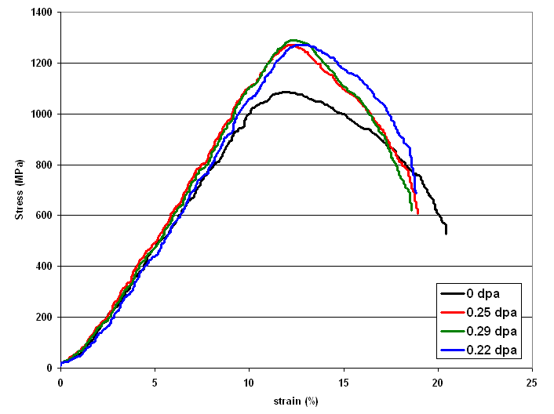
Figure 8: Vascomax stress-strain behavior.

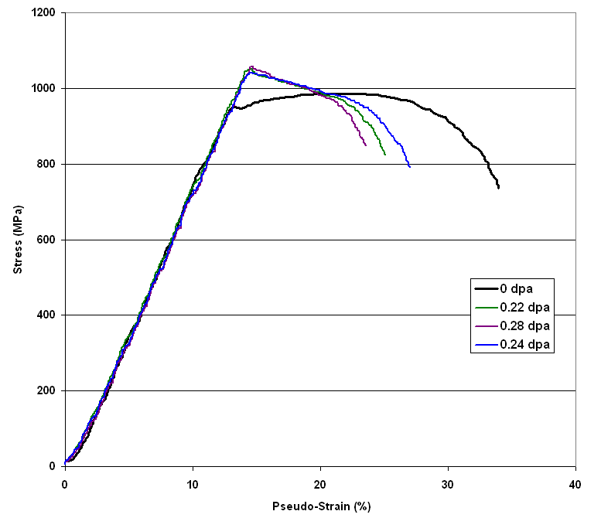
Figure 9: Ti-6Al-4V stress-strain behavior.

ACKNOWLEDGEMENT
This work was performed under the auspices of the US DOE

REFFERENCES
- N. Simos, et al., “Target Material Irradiation Studies for High-Intensity Accelerator Beams,” NuFact04 Proceedings (2004).
- H.G. Kirk, et al., “Target Studies with BNL E951 at the AGS,” Proc. PAC 2001 (Chicago, IL, March 2001), p.1535.
- APT Materials Handbook, TPO-P00-MDD-X-00001 (2001).
- K. Nishino, ‘Super Multifunctional Alloy “GUM METAL”,’ Toyota CRDL, INC. Technical News.
- MCNPX Users Manual-V2.1.5, L.S. Waters, ed., LANL TPO-E83-GUG- X-00001 (1999).

