Bob Weggel Particle Beam Lasers, Inc. March 9, 2015

Magnet “15to2T120cm”: Winding-pack X-sections, field profile & parameters

Figure 1 shows the coil cross sections and field magnitude, direction & streamlines of a magnet with solenoids of 120-cm I.R. to z = 10 meters; Fig. 2 plots the on-axis field profile. Table I lists selected parameters, identical to those of the superconducting coils of magnet “20to2T120cm4pDL”. In the table, dimensions are in centimeters, and current densities are in A/mm2. Downstream of superconducting coil #2 is a huge axial gap of 238 cm that will be very convenient for facilitating assembly and disassembly, which must be robotic, because of activation by radiation during operation.

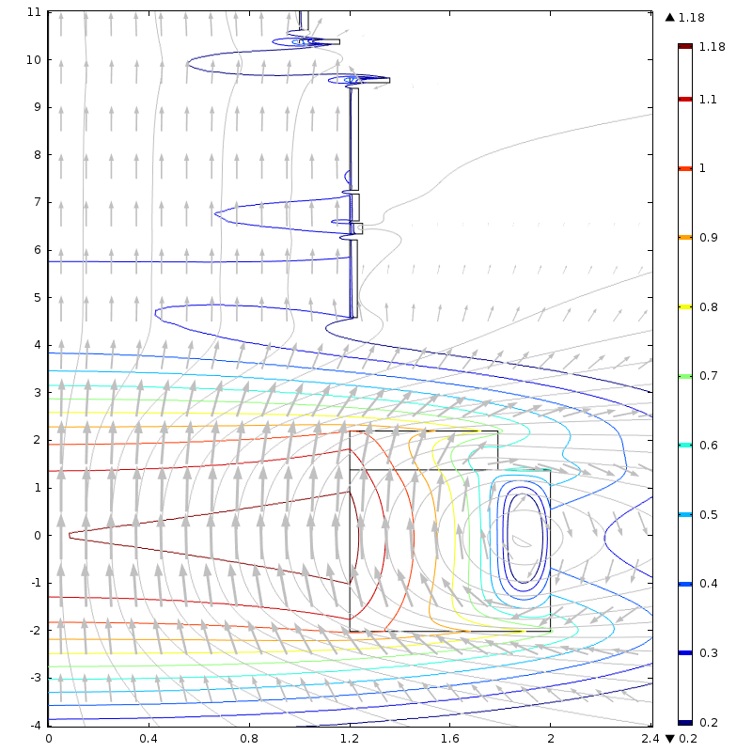

Fig. 1: Target Magnet “15to2T5m120cm,” whose on-axis field B(z) tapers from 15 T at z = 0 to 2 T at z ≈ 5 m: winding-pack cross sections, field direction (arrows), streamlines (grey), & field magnitude log10|B| (contours). Consecutive contours, in teslas, are [100.2 = 1.6 (navy), 2, 2.5, 3.2, 4, 5, 6.3, 8, 10, 12.6, 15 (maroon)].

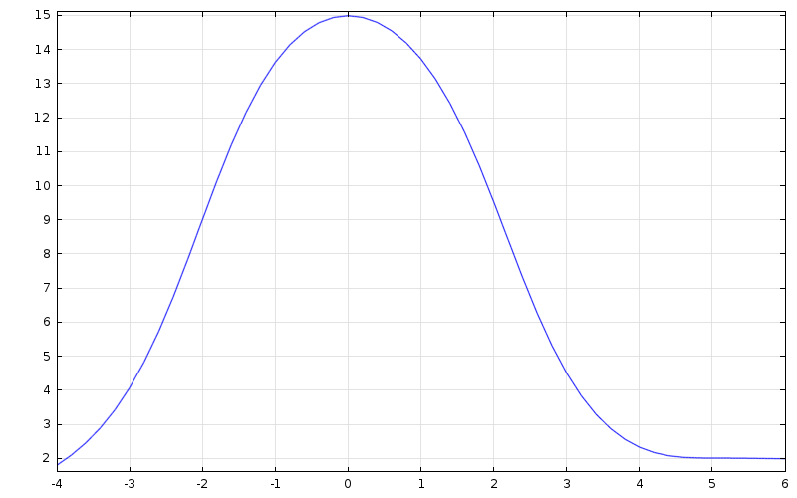

Fig. 2. On-axis field profile of Target Magnet “15to2T5m120cm”. B ≈ 2 T at z = 4.6 m; B ≈ 2.4 T at z = 4 m.

Table I: Parameters of Target Magnet “20to2T5m120cm”

|  |  |  |  |  |  |  |  |  |  |  |
| --- | --- | --- | --- | --- | --- | --- | --- | --- | --- | --- |
| Cur. density | 1.910 | 2.110 | 4.358 | 4.325 | 4.364 | 4.333 | 4.288 | 4.288 | 4.288 | 4.288 |
| Inner radius | 120.0 | 120.0 | 120.0 | 120.0 | 120.0 | 120.0 | 120.0 | 100.0 | 100.0 | 100.0 |
| Radial depth | 78.00 | 59.07 | 3.01 | 5.10 | 3.76 | 3.50 | 15.98 | 15.98 | 3.50 | 15.98 |
| Outer radius | 200.0 | 179.1 | 123.0 | 125.1 | 123.8 | 123.5 | 136.0 | 116.0 | 103.5 | 116.0 |
| Upstr. end | -201.7 | 137.8 | 458.1 | 634.0 | 661.5 | 725.8 | 952.0 | 1033 | 1063 | 1455 |
| Coil length | 339.5 | 82.0 | 163.3 | 22.2 | 56.6 | 214.4 | 15.0 | 15.0 | 377.0 | 15.0 |
| Down. end | 137.8 | 219.8 | 621.4 | 656.3 | 717.9 | 940.2 | 967.0 | 1048 | 1440 | 1470 |
| Axial gap | 0.0 | 238.3 | 12.6 | 5.2 | 7.9 | 11.8 | 66.0 | 15.0 | 15.0 | 60.0 |

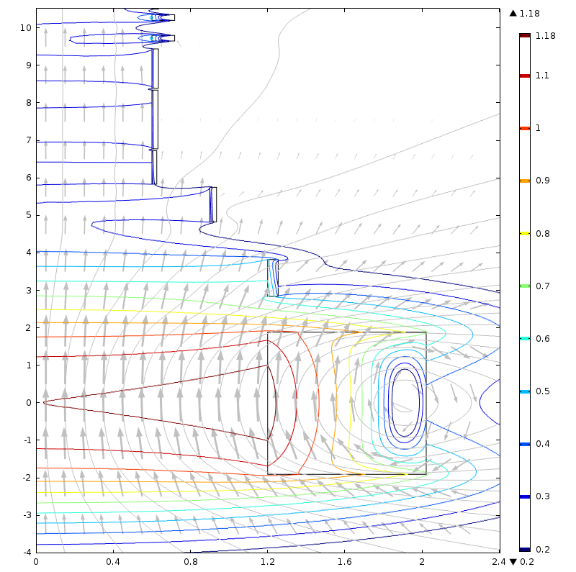

Fig. 3: Target Magnet “15to2T5m’2+5,” whose on-axis field B(z) tapers from 15 T at z = 0 to 2 T at z ≈ 5 m: winding-pack cross sections, field direction (arrows), streamlines (grey), & field magnitude log10|B| (contours): [100.2 = 1.6 (navy), 2, 2.5, 3.2, 4, 5, 6.3, 8, 10, 12.6, 15 (maroon)]. Dimensions are identical to those of SC coils of magnet “20to2T5m’2+5”.

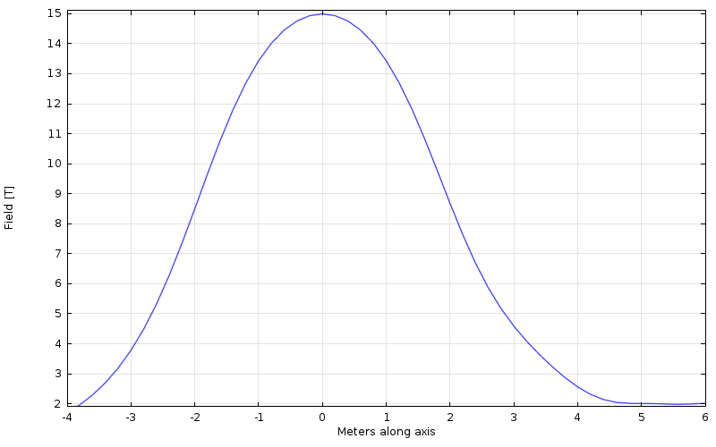

Fig. 4. On-axis field profile of Target Magnet “15to2T5m’2+5”. B ≈ 2 T at z = 4.7 m; B ≈ 2.6 T at z = 4 m.

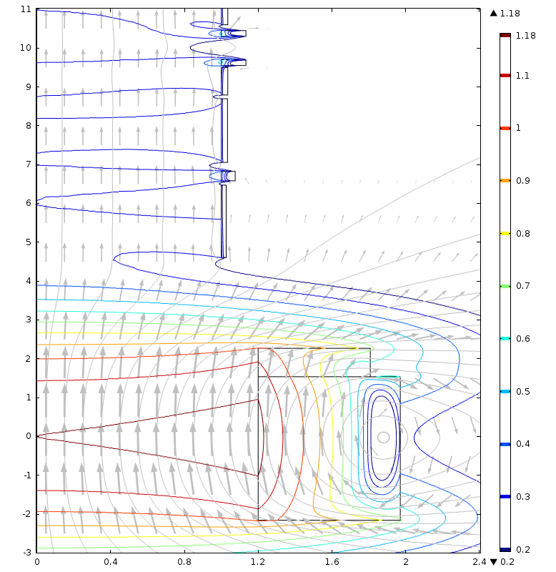

Fig. 5: Target Magnet “15to2T5m100cm,” whose on-axis field B(z) tapers from 15 T at z = 0 to 2 T at z ≈ 5 m: winding-pack cross sections, field direction (arrows), streamlines (grey), & field magnitude log10|B| (contours): [100.2 = 1.6 (navy), 2, 2.5, 3.2, 4, 5, 6.3, 8, 10, 12.6, 15 (maroon)].