A Three-Stage Cryogenic Pulse Magnet Program for BNL Targetry Experiment

Robert J. Weggel; BNL, bldg. 901A; Upton, NY 11973-5000
(April 12, 2002)
631-344-2428 (fax = 3248); weggel@bnl.gov

General Description of Magnet System

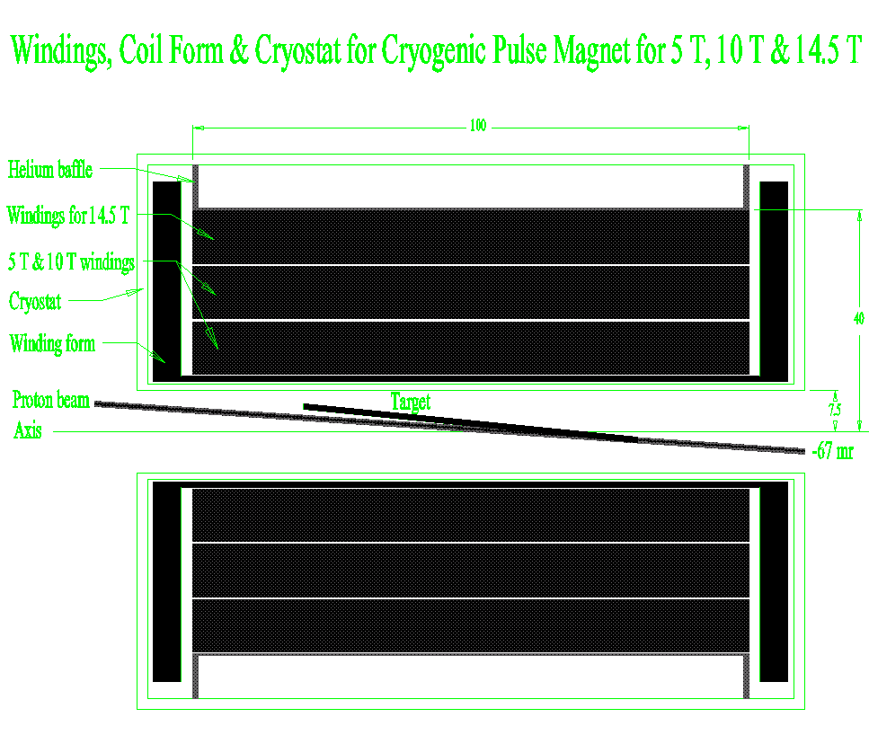

Fig. 1. Cross section of Targetry Experiment magnet system: cryostat, magnet windings, target (mercury jet), and proton beam. The bore is 15 cm. The winding pack is of 100 cm length, 20 cm I.D., and 80 cm O.D. Channels for coolant separate the three subcoils, each of ~10 cm radial depth.

This report documents the conceptual design of a cryogenic pulse magnet to generate up to 14.5 teslas in a room temperature bore of 15 cm. The winding I.D., O.D. and length are 20 cm, 80 cm and 100 cm, respectively; the conductor is 3.6 metric tons (1,800 turns) of high-purity copper. Cooling of the magnet prior to each pulse is by helium gas or liquid nitrogen forced through axial channels in the magnet; recooling of the helium gas is by either liquid nitrogen or liquid hydrogen in a heat exchanger inherited from the SSC. To hasten cooldown of the magnet, it includes coolant channels not only at its inner and outer radius, but also at two intermediate radii.

At the outer of these radii (30 cm) is an additional current lead, to allow operation with the outermost coil omitted from the electrical circuit. The remaining magnet, of 60 cm O.D. and 1,200 turns, is appropriate for liquid-nitrogen operation; the full magnet has too high a resistance to reach full current unless cooled to less than ~34 K. The option to energize just the 1,200-turn magnet enables a staged approach to the full-field mode of operation. One can postpone fabrication of the outermost coil until needed by the last of the three stages that we propose.
Three Proposed Stages: 5 T, 10 T & 14.5 T

Fig. 2. Field vs. time for cryogenic pulsed magnet for BNL Targetry Experiment upon completion of each of three stages culminating in 14.5-tesla operation. Stage 1: 1,200 turns, 0.54 MVA; Stage 2: 1,200 turns, 2.16 MVA; Stage 3: 1,800 turns, 2.16 MVA.

Figure 2 graphs the field versus time for the three proposed modes of operation. Stage 1 employs the 1,200-turn magnet cooled to 87 K or less by liquid nitrogen at barely above atmospheric pressure (77-78 K). The power supply is one of many at BNL that is rated at 3.6 kiloamperes and 150 volts (540 kVA). At this voltage, the magnet takes about seven seconds to reach its full field of 5 T, which one holds for up to a second. Discharge at full negative voltage, –150 V, takes an additional three seconds.

Stage 2 employs the same 1,200-turn magnet, but energized by four BNL power supplies in series/parallel: 7.2 kA x 300 V = 2.16 MVA. The pulse is about 10% shorter than for Stage 1. Simultaneously doubling both the current and the voltage calls for a magnet of the same resistance at peak current as Stage 1. However, because of the fourfold increase in peak power, the magnet heats up nearly four times as much during each pulse; therefore, it must start from a lower temperature — no more than 75 K. To reach this temperature, one can employ evaporative cooling at reduced pressure to subcool the nitrogen to within a few degrees of its 64 K freezing point. BNL has roughing pumps ample to accomplish this. Cryogenic investments will be in hardware and engineering associated with the SSC heat exchanger and cryogen delivery systems. Investments in the power supply will be hardware and software to ensure that its four 0.54 MVA modules share the load equally.

Stage 3 employs the same 2.16 MVA power supply as Stage 2, but now energizing all 1,800 turns. In order for the same 300 volts to suffice to drive full current through the much greater length of conductor, one must reduce its electrical resistivity by cooling it to ~30 K with helium gas whose temperature may be as low as 22 K. The heat sink is liquid hydrogen trucked to BNL from an industrial liquefaction plant. With 1½ times as many turns as Stage 2, Stage 3 generates 14.5 T instead of 10 T. The pulse is much longer than for the previous cases: ~15 seconds to full field, a flat top of about a second, and eight seconds to return to zero, when driven down at –300 V.

Table I tabulates parameters of Stages 1, 2 and 3. The last two rows give the temperature rise and cumulative heating for a typical pulse, in which, after a one second flat top, the power supply (“two-quadrant,” or “bipolar”) discharges the coil with negative voltage of the same magnitude used to charge the magnet.

Table I: Pulse Magnet Systems for E951 Targetry Experiment
 | Units | Case 1 | Case 2 | Case 3
Peak on-axis field | T | 5.0 | 10.0 | 14.5
No. of 0.54 MVA power supplies | - - | 1 | 4 | 4
Mode of ganging supplies | - - | None | 2 x 2 | 2 x 2
Initial temperature | K | 84 | 74 | 30
Number of turns utilized | - - | 1200 | 1200 | 1800
Charge time | sec | 7.2 | 6.2 | 15.2
Temperature rise at end of pulse | K | 6 | 21 | 48
Cumulative heating at end of pulse | MJ | 2.4 | 7.9 | 13.5

The remainder of this report supports the choice of magnet parameters of Table I. Each choice is to some extent subjective, involving judgment calls on the relative importance of costs and benefits. Of interest is the rate of change of each cost and benefit with a change in each magnet parameter. The following nine sections look at perturbations from a base-case design for each of the three stages of operation, examining the effects of just one or two parameters at a time.

How Long Should the Magnet Be?

An easy parameter to fix is that of magnet length, because the Targetry Experiment has a requirement for field homogeneity, which depends very strongly on magnet length and much less strongly on anything else. The field homogeneity is to limit the magnetohydrodynamic forces on the mercury jet target traversing the field; the field should be uniform to 10% over a length of 60 cm. Figure 3 reveals that the magnet should be about 100 cm long.

The “ideal field” in figure 3 is that which would retain quite well most of the pions captured in the 60 cm long target region, while transitioning to its much lower value in downstream components of a neutrino factory or muon collider. The field ramps downward by a factor of sixteen over a length of three meters from the end of the target region, while the magnet bore increases by a factor of four. This field profile would allow one to test downstream components, such a radio-frequency cavity, in the intense shower of particles emanating from the target. Unfortunately, given the present budgetary climate, the Targetry Experiment cannot afford to build these downstream components, nor the more elaborate, expensive, and power-consumptive magnet in which to test them. Therefore, it is irrelevant that beyond the target region neither of the above field profiles matches very well the ideal field.
Fig. 3. On-axis field profile of magnets of 20 cm I.D., 80 cm O.D., and either 80 cm or 100 cm length. The longer magnet achieves the desired profile very well over the target, from –30 cm to +30 cm; the shorter magnet does not.

How Much Does Electrical Conductivity Improve at Low Temperature?

The motivation to cryogenically cool any magnet, pulsed or not, is to improve the electrical conductivity of its conductor. Figure 4 shows that the resistivity of high-purity copper declines greatly from room temperature down to 30 K. The incentive to operate at cryogenic temperatures is great indeed. Cooling to 80 K (with liquid nitrogen at atmospheric pressure) improves the electrical conductivity by a factor of nearly seven. Cooling to 66 K (with liquid nitrogen subcooled to nearly its freezing point of 64 K) gives a ratio of about ten. Cooling to 30 K (with liquid hydrogen as the heat sink, for example) can achieve a ratio of about 30.

Fig. 4. Electrical resistivity ρ, heat capacity c_{p}, and ratio ρ/c_{p} between room temperature and 30 K, for copper with a residual resistivity of 0.05 μΩ cm below ~20 K.

There is very little motivation to cool the conductor still further; one has entered a regime of diminishing returns. Figure 5 illustrates two of the reasons for this. One reason is that electrical resistivity improves rather little. This is true even for copper that is exceedingly pure, unless it is so completely annealed as to be too weak for a very high field magnet. The other reason is that, if the copper is uncooled, with only its heat capacity to limit its temperature rise, it will heat up very rapidly, because its heat capacity plummets, approximately as T³, below ~30 K. The heating rate, proportional to ρ/c_{p}, is three times worse at 20 K than at 30 K.

Fig. 5. Low-temperature electrical resistivity ρ, heat capacity c_{p}, and ratio ρ/c_{p} for copper with a residual resistivity of 0.05 μΩ cm below 20 K.

How Beneficial is Cryogenic Operation?

Fig. 6. Field vs. initial temperature of cryogenic pulse magnets of 100 cm length, 20 cm I.D. and either 60 cm or 80 cm O.D.

With the maximum magnet power, 2.16 MVA, deliverable at the targetry site, a Stage-3 targetry magnet could generate only about 4 T if operated at room temperature. Figure 6 shows that even precooling to the magnet to 80 K fails to deliver sufficient field intensity to duplicate the 14-15 T desirable for a neutrino factory of muon collider. To achieve this field, one needs to precool the targetry magnet to about 30 K.

The field-versus-temperature predictions of figure 6 (and all the other relevant figures in this report) acknowledge that electrical resistivity depends not only on temperature, as shown in figure 5, but also on magnetic field. This magnetoresistance can significantly degrade electrical conductivity at very low temperatures.

How Detrimental is Magnetoresistance?

Fig. 7. Electrical resistivity vs. temperature from 20 K to 100 K and magnetic fields from zero to 20 T.

Magnetoresistance can be severe at low temperatures and high fields. It becomes ever more significant at low temperature. Figure 7 graphs, as a function of temperature and magnetic field, the electrical resistivity of copper with a residual resistivity of 0.05 μΩ cm. Note that at 20 K the magnetoresistance at 20 T nearly triples the resistivity at zero field. Even at fields that are more modest and temperatures that are less frigid, magnetoresistance is non-negligible. At 10 T and 100 K, the effect is about 13%.

What Does a Typical Pulse Look Like?

Figure 9 graphs the time dependence of some of the more important parameters of the highest field (Stage 3) pulse magnet for the Targetry Experiment. Note that the resistance increases by a factor of about 3½ during the pulse. The slight decline in resistance during the last several seconds of the pulse is because the magnetoresistance is decreasing faster with the decreasing field than the zero-field resistance is increasing from the still-increasing temperature.

Note also that the peak resistive voltage of the magnet, when pulsed from this temperature, is about 240 V, i.e., about 80% of the full voltage available from the power supply. To obtain the flat top to the field requires the power supply voltage instantly to drop to 240 V from 300 V, because the inductive back voltage abruptly has dropped to zero. Then, for the duration of the flat top (shown here as one second), the voltage must increase several percent to track the increase in resistance as the windings heat up. Full negative voltage drives the current to zero.

Fig.9. Current, magnet resistance and power supply voltage of Stage-3 pulsed magnet for Targetry Experiment.

How Should One Discharge the Magnet?

Fig.10. Peak temperature rise and cumulative heating in cryogenic pulsed magnets of 20 cm I.D., 80 cm O.D. and 100 cm length. Left-hand curves: peak temperature rise; right-hand curves: cumulative heating.

Figure 10 graphs, as a function of time, the temperature rise and cumulative heating at the end of each field pulse of the Stage 3 magnet when discharged in any of four ways. One way is that of a typical pulse, in which one drives the current down with reverse voltage of the same magnitude used to charge the coil. Driving the current down, from a flat top of one second, limits the peak temperature rise to 48 K and the heating to 13 MJ. Another way is with the current coasting down, dissipating in the magnet all of the magnetic energy that it stored. This would occur if the power supply tripped out at the end of the flat top, and therefore did not deliver the reverse voltage expected from it. The windings must absorb all, instead of just a part of, the magnetic energy stored in the coil. The additional 6 MJ leads to a total temperature rise of nearly 60 K. This is still a very comfortable value from the standpoint of thermal stresses, but the magnet will take longer to recool.

The other two modes of discharge employ an external resistor. A 100 mΩ resistor, implying a peak discharge voltage of –720 V, gives an energy dissipation and temperature rise roughly equivalent to that when discharged through the power supply at a constant voltage of –300. With a 1 Ω resistor (–7.2 kV peak discharge voltage), the energy dissipation and temperature rise are about 9 MJ and 38 K, respectively. At such a high discharge voltage, the external resistor absorbs nearly all the magnetic energy stored in the magnet.

How Big in Diameter Should the Magnet Be?

Figure 11 reveals that to generate the very most field with a fixed power supply calls for a targetry magnet with an outer diameter of about one meter, irrespective of the power level or initial temperature. Note, however, that the maximum of each curve is very broad. Well before one has reached a diameter as large as a meter, the increase in field becomes too gradual to justify the rapid increase in conductor mass and cost. Already at an outer diameter of 80 cm, the conductor mass has risen to 3.6 metric tons. Increasing the outer diameter to one meter would require 60\% more conductor, for less than a 3% increase in field.

Fig. 11. Central field vs. outer diameter of cryogenic pulse magnets of 20 cm inner diameter and 100 cm length.

An additional reason for limiting the outer diameter of the targetry magnet is to limit the heat that one must remove after each pulse. Figure 12 shows that the cumulative heating increases rapidly with diameter. For example, doubling the diameter approximately triples the cumulative heating, tripling the recool time in any system that is limited by the mass flow of coolant. This consideration, like the one concerning conductor mass and cost, favors magnets no larger than 80 cm in diameter.

Fig. 12. Cumulative heating vs. outer diameter of cryogenic pulsed magnet of 20 cm inner diameter and 100 cm length.

How Warm Does the Conductor Get?

Figure 13 plots temperature contours for the Stage-3 magnet pulsed to full field (with a flat top of ½ sec.) from a uniform initial temperature of 30 K. The resulting temperature is highest, 76 K, at the inner radius of the magnet midplane (r = 10 cm, z = 0), where magnetoresistance adds most to the resistivity, and therefore the heating rate. Near the kernel, where the field and magnetoresistance are zero, the maximum temperature is only 62 K.

Fig. 13. Temperature at end of a pulse of the Stage-3 magnet energized to 7,200 A, 14.5 T (with a half-second flat top) from an initial uniform temperature of 30 K.

For comparison, figure 14 plots temperature contours for the Stage-3 magnet pulsed to full field (again with a flat top of ½ sec.) from an initial temperature with the same average as before, 30 K, but with a distribution suggestive of that in a magnet pulsed to full field and then recooled too briefly for temperatures to equilibrate. The peak temperature, coincidentally, is the same, 76 K, as when energized from a uniform temperature, but occurs at a different radius, ~14 cm, where the initial temperature was high. At r = 10 cm the peak temperature is less than 75 K, despite the magnetoresistance being greatest there, because the initial temperature was only 22 K.

Fig. 14. Temperature distribution in Stage-3 magnet if energized from an illustrative non-uniform temperature: 34 K at radii of 15 cm, 25 cm and 35 cm, falling parabolically to 22 K at radii of 10 cm, 20 cm, 30 cm and 40 cm.

How Do the Magnetic Field and Heating Depend on Initial Temperature?
Fig. 15. Field and cumulative heating in Stage-3 magnets of 100 cm length, 20 cm I.D., 80 cm O.D. and 1,800 turns, pulsed from an initial temperature of 20 K to 50 K.

If one pulses a cryogenic magnet from too high a temperature, it will fail to reach its design current and, hence, its design field. Figure 15 shows that for the Stage-3 magnet, the critical temperature is 35 K. A magnet pulsed from 40 K, for example, can generate only 14 T, instead of 14.5 T. Pulsing the magnet from any temperature lower than 35 K will not increase its field, because one runs out of current. However, one now has spare voltage with which to shape the pulse. For example, a magnet pulsed from 33.7 K not only can reach full field, but also can hold it for the desired one second. A further benefit is the reduction in dissipation, thereby improving the rep rate of the magnet. Pulsing from 25 K instead of 30 K decreases by 10% the heat that one must remove. Relative to a magnet pulsed from 33.7 K, the improvement is 23%.

Fig. 16. Central field and cumulative heating of the Stage-2 magnet of 100 cm length, 20 cm I.D., 60 cm O.D. and 1,200 turns, pulsed from an initial temperature of 60 K to 90 K. Comparative magnet is of same dimensions but has 5% more turns.

Figure 16 plots data similar to that of figure 15, but now for the Stage-2 magnet, whose intended coolant is subcooled nitrogen. 75.5 K is the maximum temperature at which the magnet will generate full field with a flat top of one second. Cooled to 80 K (as with nitrogen that is not subcooled) limits the field to 9.6 T instead of 10 T. Cooled to 66 K, the minimum likely with subcooled nitrogen, reduces the cumulative dissipation to 5.6 MJ, an improvement of 37% relative to 75.5 K operation. The comparison magnet, with 5% more turns, will generate 5% more field at any temperature below 69 K, but at the price of significantly more heating. For example, at 66 K its cumulative heating is 7.4 MJ, one third more than for the magnet with 1,200 turns.

Figure 17 presents data as in the previous two graphs, but now for variants on the Stage-1 magnet, whose intended coolant is liquid nitrogen at atmospheric pressure. A magnet with 1,200 turns generates full field, complete with a flat top of one second, at all temperatures below 87.4 K. This temperature is so far above that of liquid nitrogen that cooldown should be rapid, if governed by heat transfer to the coolant. However, if cooldown is limited by mass flow through the coolant channels, then operation from a lower temperature may be superior. Pulsed from 80 K, the magnet dissipates 3\% less heat—only 1.94 instead of 3.08 MJ. One may even wish to subcool the nitrogen. Cooled to 66 K, the magnet dissipates only 1.13 MJ, 42\% less than at 80 K. The two comparison magnets, with 5% and 10% more turns, respectively, generate correspondingly more field, but with substantially narrower temperature ranges of operation and higher dissipations at any given temperature. These considerations, plus the convenience of making a single magnet suffice for both Stages 1 and 2, make the 1,200 turn magnet the compelling choice.

Fig. 17. Central field and cumulative heating for Stage-1 magnet and comparative magnets with 5% and 10% more turns, each pulsed from an initial temperature of 65 K to 90 K.

