Cross Section of Coils & Vessel Containing Magnet-Shielding Material

Bob Weggel 6/1—6/6/2011

The inner radius of the bore tube should flare in proportion to the inverse square root of the magnetic field. A field ratio of 20/1.5 implies a radius ratio of 3.65; if the radius is 7.5 cm when B = 20 T, then the radius should be 27.4 cm when B = 1.5 T. The bore tube plotted in Fig. 1 flares from 8 cm at z = zero to 28 cm at z = 15 m, to provide a radial clearance of 0.5 cm at z = zero and 0.6 cm at z = 15 m.



Fig. 2: Bore tube whose I.R. flares elliptically from r1,0 = 8 cm at z = zero to r1,15 = 28 cm at 15 m, and whose O.R. flares from r2,0 = 10 cm at zero to r2,15 = 30 cm at 15 m. At z = 2.95 m the I.R. = 17.87 cm, and the O.R. = 19.59 cm.

Vessel (bore tube, flanges & cylindrical shell) are of steel; specific gravity γ = 7.85; E = 200 GPa.

Shielding, of γ = 10 (61% WC of γ = 15.8 + 39% H20), exerts pressure proportional to depth.

Thickness of annular disks =5 cm; thickness of cylindrical shells = 2 cm.

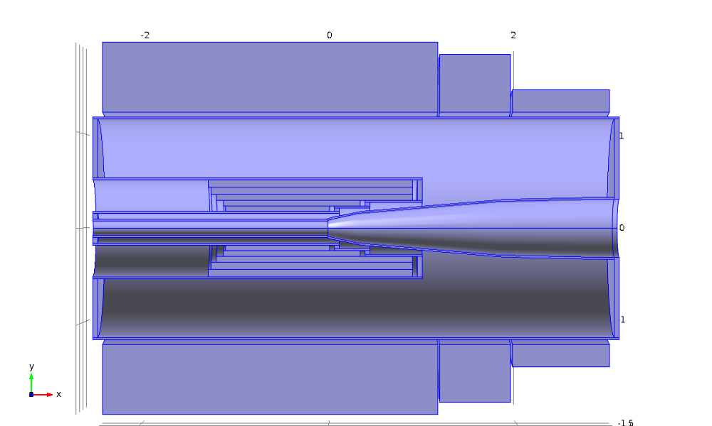

Fig. 2: Cross section of resistive magnet, upstream three coils of superconducting magnet, and vessel of design “Lay2e7at11MW.xlsx”. Cylindrical shells are 2-cm thick; annular disks are 5-cm thick. Bore tube is of constant inner radius of 8 cm from z = **−**2.42 m to zero, flaring elliptically thereafter to 17.87 cm at z = 2.95 m.