Stresses and Deformations in Outer & Inner Shielding Vessels of IDS120
Bob Weggel, M.O.R.E., LLC
December 5, 2011

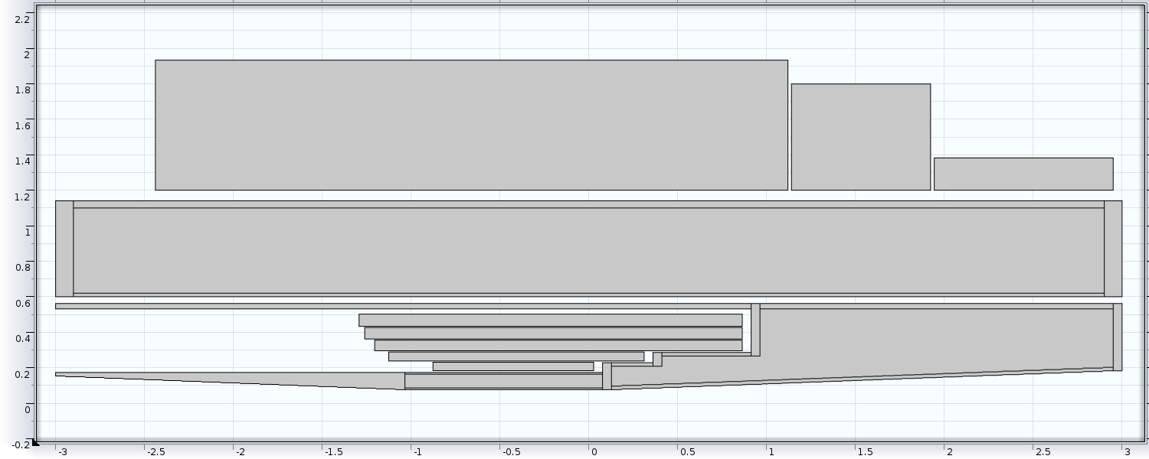
Fig. 1: Cross section of resistive coils, superconducting coils, shielding vessels and shielding. Vessels start at −3 meters (upstream) and end at +3 meters (downstream). Outer vessel: r_{max} = 1.14 m; r_{min} = 0.60 m; inner vessel: r_{max} ≈ 0.56 m; r_{min} = 0.076 m. Thickness of vessel walls: outer walls = 4 cm; inner walls = 2 cm. Water pressure = (100 − y) kPa. Density of water-buoyed shielding = 9 g/cm³.

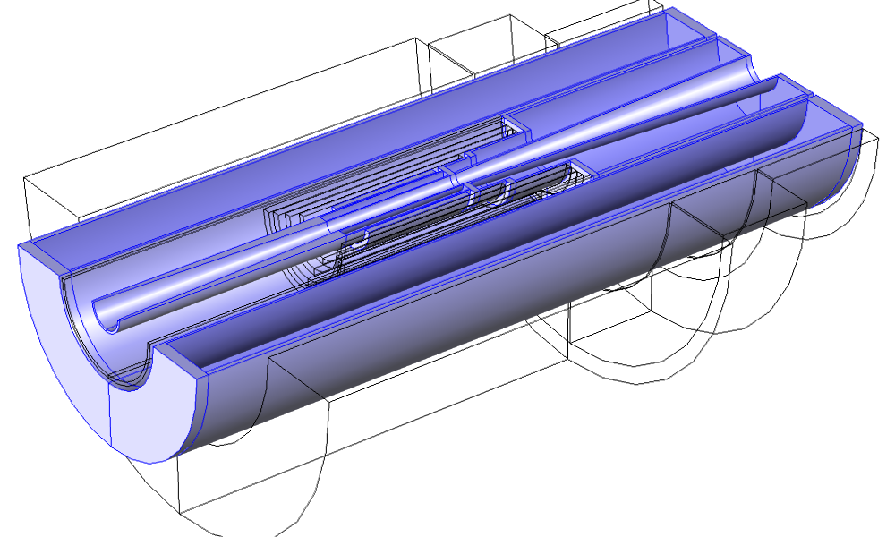
Fig. 2: Isometric view of coils & shielding vessels of Fig. 1. Shading of coils & shielding omitted for clarity.

Fig. 3: Sag of outer shielding vessel of Fig. 1, as modeled by beam consisting of two coaxial tubes. Outer tube: r_{max} = 114 cm; t_{wall} = 4 cm; inner tube: r_{min}. = 60 cm; t_{wall} = 2 cm. Young’s modulus of tubes = 200 GPa; tube density = 7.85 g/cm³; density of shielding+water in annulus = 10 g/cm³; support condition: cantilevered from upstream end; loading condition: total load (= weight of tubes, water and shielding) distributed uniformly over entire length.

Fig. 4: Sag of inner shielding vessel of Fig. 1, as modeled by beam consisting of two coaxial tubes. Outer tube: r_{max} = 58 cm; t_{wall} = 4 cm; inner tube: r_{min}. = 16 cm; t_{wall} = 2 cm. Young’s modulus of tubes = 200 GPa; tube density = 7.85g/cm³; density of shielding+water in annulus = 10 g/cm³; support condition: cantilevered from upstream end; loading condition: total load (= weight of tubes, water and shielding) applied at z = (L+3)/2.

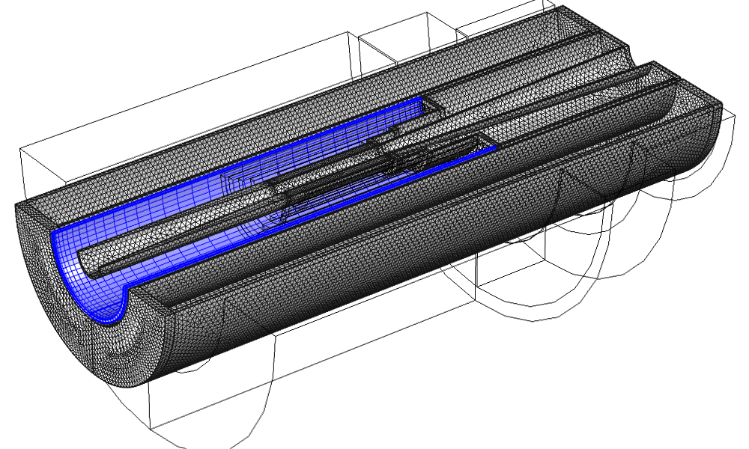
Fig. 5: Meshing of shielding vessels of Fig. 1, with mapped mesh (blue) to improve accuracy where stresses change most rapidly.

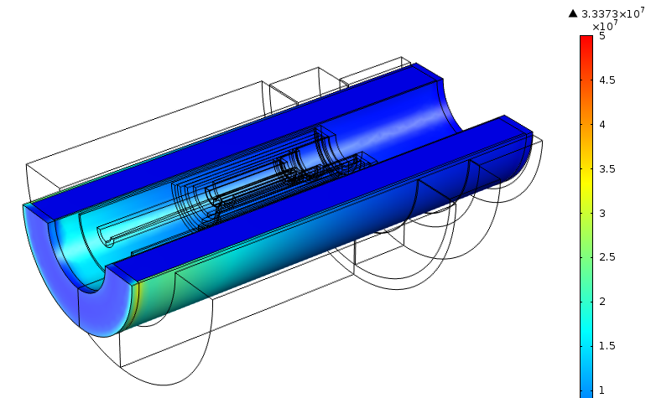
Fig. 6: Von Mises stress σ_{vM} in outer shielding vessel of Fig. 1 (overall length = 6 meters); maximum σ_{vM} = 33 MPa.

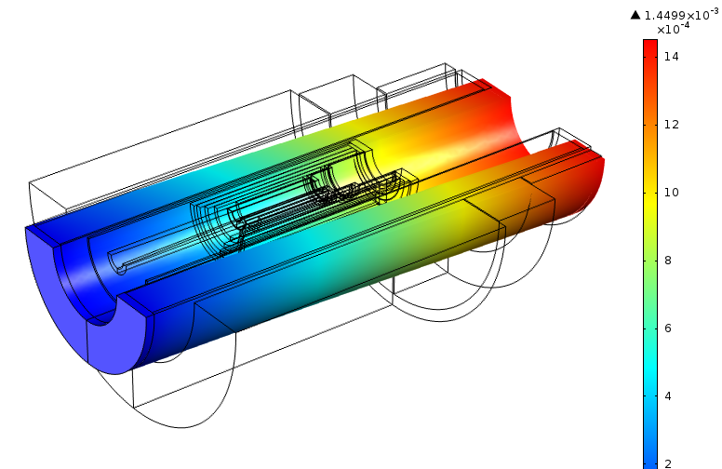
Fig. 7: Deformation δ in outer shielding vessel of Fig. 1 (overall length = 6 m); δ_{max} = 1.45 mm.

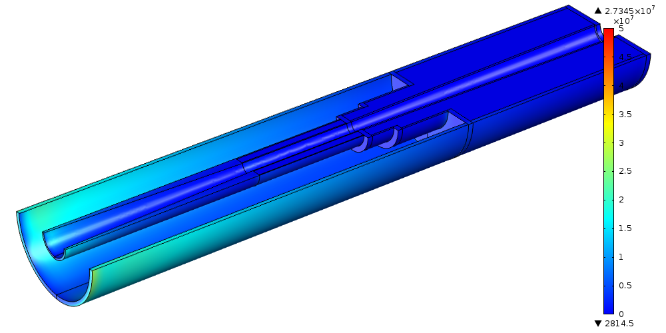Fig. 8: Von Mises stress in inner shielding vessel of Fig. 1 (overall length = 6 meters); maximum σ_{vM} = 27 MPa.

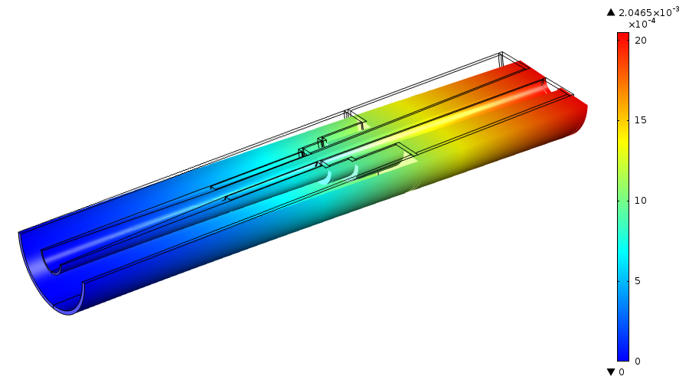
Fig. 9: Deformation δ in inner shielding vessel of Fig. 1 (overall length = 6 m); δ_{max} = 2.05 mm.

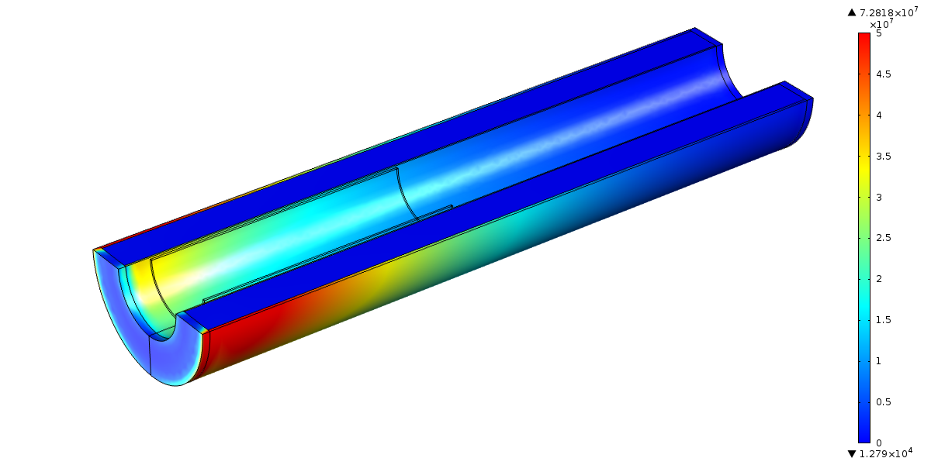
Fig. 10: Von Mises stress σ_{vM} in outer shielding vessel such as in Fig. 1, but 3 meters longer (i.e., overall length = 9 meters, ~0.4 m longer than in Magnet IDS120h); maximum σ_{vM} = 73 MPa.

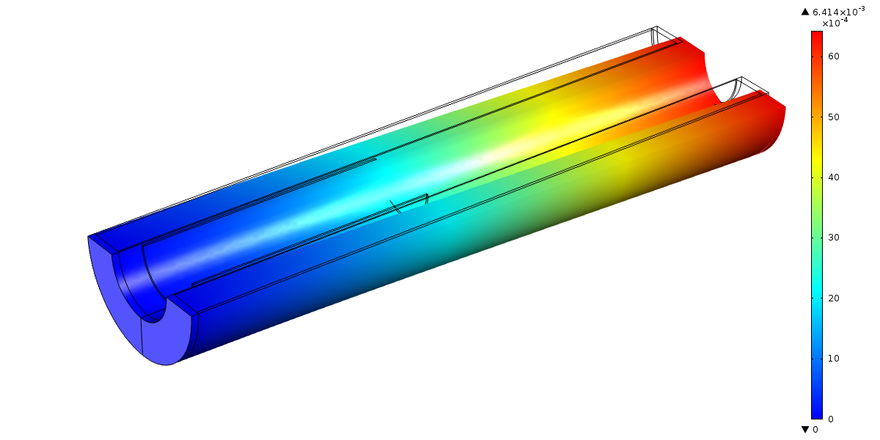
Fig. 11: Deformation δ in outer shielding vessel such as in Fig. 1, but 3 meters longer (i.e., overall length = 9 meters, ~0.4 m longer than in Magnet IDS120h); δ_{max} = 6.4 mm.

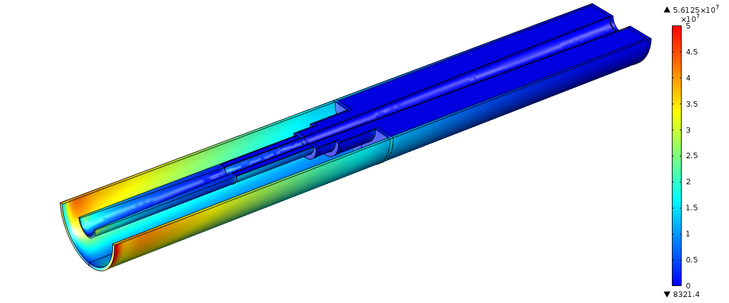
Fig. 12: Von Mises stress in inner shielding vessel such as in Fig. 1, but 2 meters longer (i.e., overall length = 8 m, ~0.6 m shorter than in Magnet IDS120h); maximum σ_{vM} = 56 MPa.

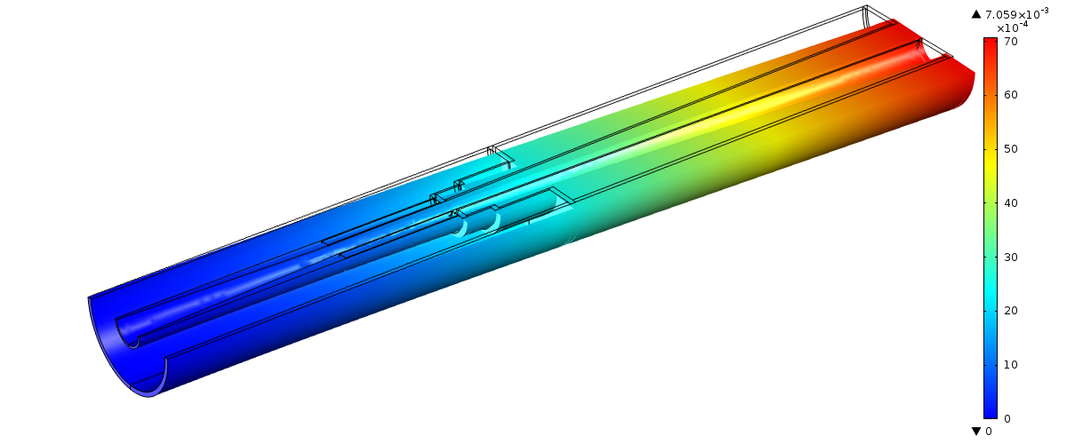

Fig. 13: Deformation δ in inner shielding vessel such as in Fig. 1, but 2 meters longer (i.e., overall length = 8 m, ~0.6 m shorter than in Magnet IDS120h); δ_{max} = 7.08 mm.

