Target Magnet “20to2T5m100cm” & Chicane from 5 m to ~14 m

Bob Weggel Magnet Optimization Research Engineering (M.O.R.E.), LLC 2/16/2014

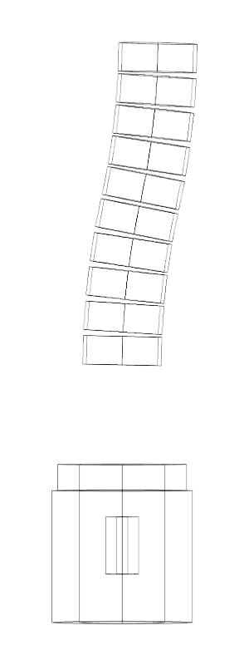 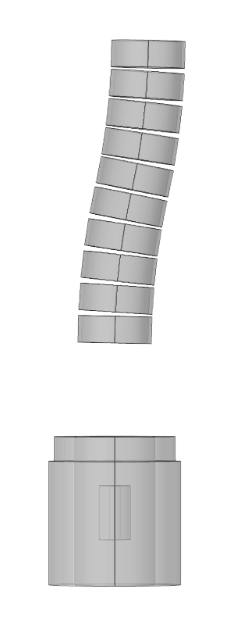 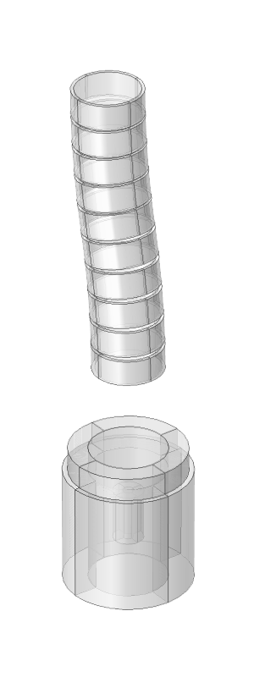

Fig. 1a-c. Views of Target Magnet “20to2T5m100cm” with 10-coil chicane. Left: y-z plane wireframe; Center: y-z plane transparency; Right: Isometric. Target-Magnet dimensions as in “20to2T5m100cm.xlsx” of 2/12/2014. Chicane dimensions: vertical (y) offset = 100 cm; toroidal half-angle θ = 12.5°; major radius = 50 cm / [1 – cos(θ)] = 21.09 m; minor radius = 100 cm; coil build = 10 cm; coil length = 80 cm; overall length ∆z = 2 R sin(θ) = 9.131 m.

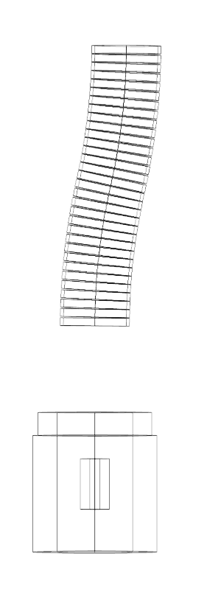 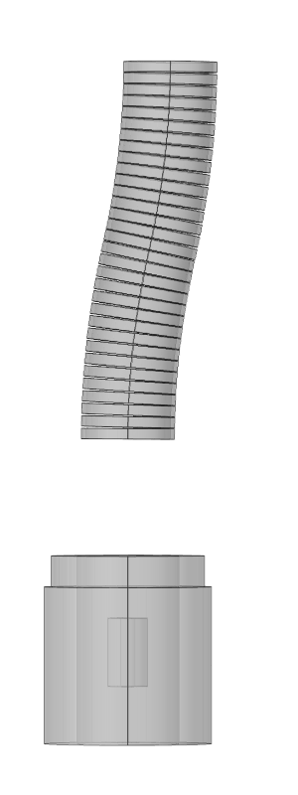 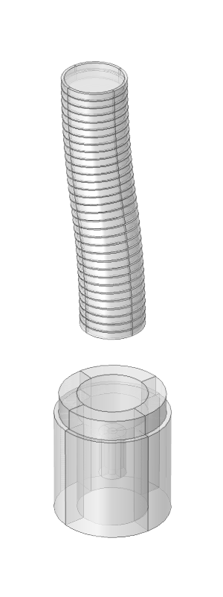

Fig. 2a-c. Views of Target Magnet “20to2T5m100cm” with 32-coil chicane. Left: y-z plane wireframe; Center: y-z plane transparency; Right: Isometric. Target-Magnet dimensions as in Fig. 1. Chicane dimensions: vertical (y) offset = 100 cm; toroidal half-angle θ = 12.8°; major radius = 50 cm / [1 – cos(θ)] = 20.12 m; minor radius = 100 cm; coil build = 10 cm; coil length = 25 cm; overall length ∆z = 2 R sin(θ) = 8.915 m.

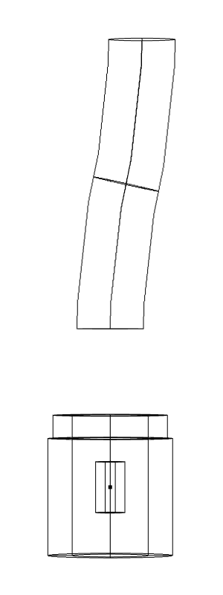 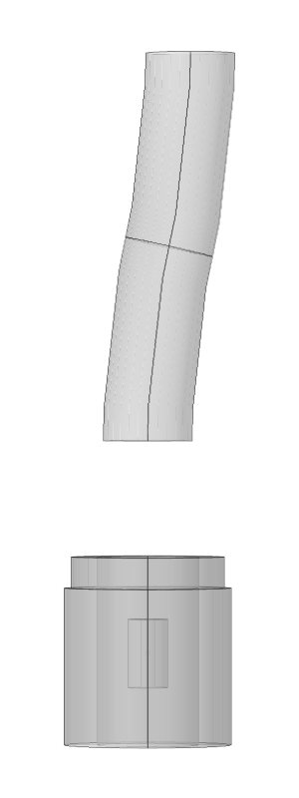 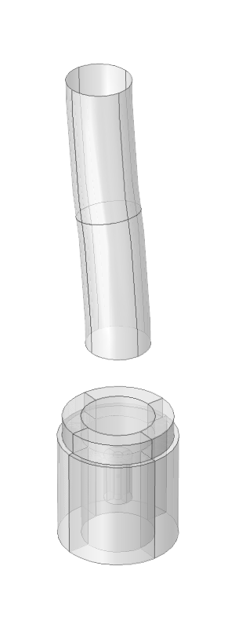

Fig. 3a-c. Views of Target Magnet “20to2T5m100cm” with toroidal current-sheet chicane. Left: y-z plane wireframe; Center: y-z plane transparency; Right: Isometric. Target-Magnet dimensions as in Figs. 1 & 2. Chicane dimensions: vertical (y) offset = 100 cm; toroidal half-angle θ = 12.5°; major radius = 50 cm / [1 – cos(θ)] = 21.09 m; minor radius = 100 cm; overall length ∆z = 2 R sin(θ) = 9.131 m.

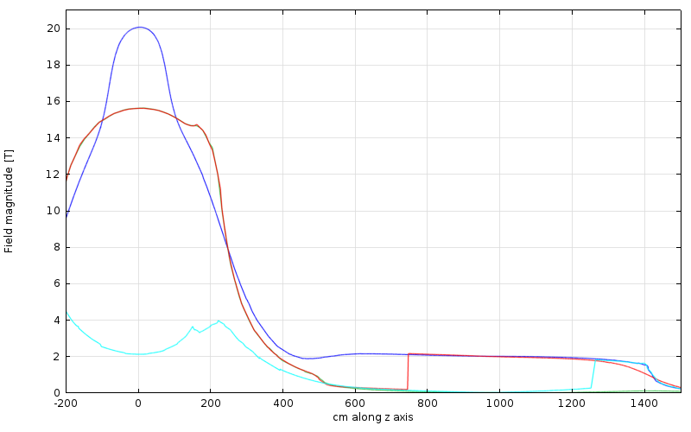Fig. 4. Field magnitude of Fig. 3 magnet in [y, z] plane at y = 0 (blue), y = 1.2 m (red), y = 2 m (cyan) and y =−1.2 m (green). Toroidal current-sheet begins to enclose y = 1.2 m at z ≈ 740 cm and y = 2 m at z ≈ 1260 cm.

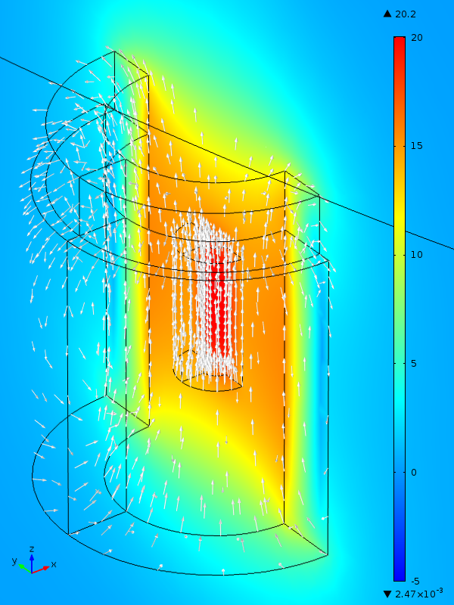 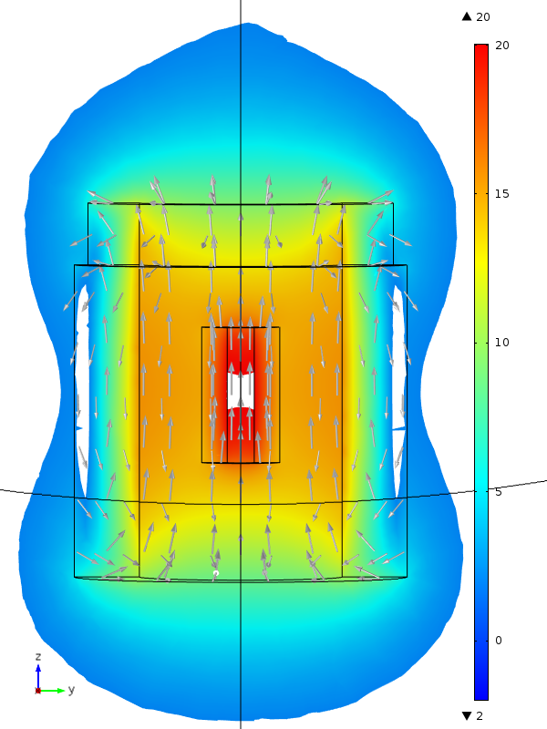

Fig. 5a&b. Field magnitude (color) and direction (arrows) in target region of Fig. 3. Left: Isometric view. Right: y-z plane; in central white area, B > 20 T.; in outer areas, B < 2 T.

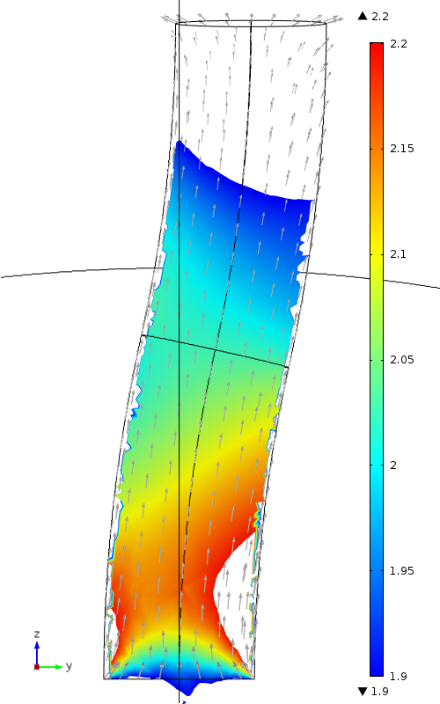

Fig. 6. Field magnitude (color) and direction (arrows) in chicane region of Fig. 3. In white regions either B > 2.2 T or B < 1.9 T. In each half of the chicane the field is slightly higher on the side that is closer to its toroidal axis.