Conductor X-Sections & Field Profile of Target15to1.5T5m1+3+3

Robert J. Weggel; Magnet Optimization Research Engineering (M.O.R.E.), LLC; 12/16/2013

The magnet described below consists of a main coil, notched on its inner surface to improve field homogeneity, plus two sets of triplets, each ~5 m long, between z ~ 4 m and 14 m. The Excel spreadsheet used to design the system embodies the following goals and constraints:

1) Main-solenoid I.R. = 120 cm; current density = 18 A/mm2, as typical for SC#1 (~60% steel);

2) Current density of solenoids #2-#7 = 45 A/mm2 (~10% steel); I.R. = 60 cm for coils #5-#7;

2) B(z), is 15 T at z = −0.5 m, 1.5 T at 5 m, & 14.7 T (∆B = 0.3 T = 2% of 15 T) at 0 & −1 m;

3) Field derivative B' ≡ dB/dz = 0 at z = −0.5 m & z = L = 5 m;

4) Goal function strongly penalizes ampere-meters of conductor usage;

5) Penalized gently is I.R. < 120 cm for solenoid #2 and O.R. > 100 cm for #3 & #4;

6) Penalized is a weighted sum of the squares of ∆B ≡ B−1.5T, B' & B" ≡ d2B/dz2 (5<z<12 m).



Fig. 1. On-axis field profile, |B(z)| (blue);10 log10(|B|) (black); first derivative, dB/dz (turquoise); and second derivative d2B/dz2 (green). B(−50 cm) = 15 T; B(500 cm) = 1.5 T. B(-100 cm) = B(0) = 14.7 T.

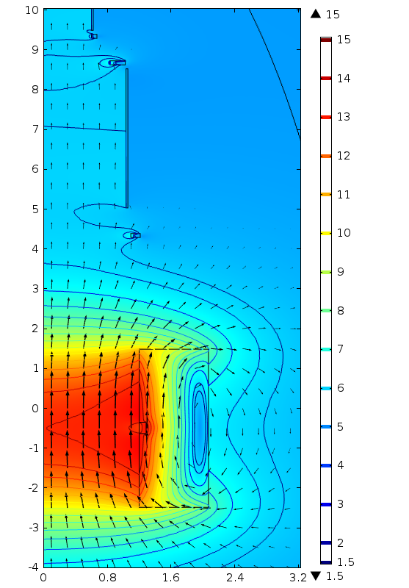

Fig. 2. Conductor cross sections and field direction (arrows) and magnitude (color & contours). Inner radius of successive coils is [1.20, 1.10, 1.03, 0.83, 0.60] m. Gap between coil #1 & 2 is 2.80 m; between triplets #1 & #2 is 0.56 m = 1/3 of sum of outer radii of flanking coils. Peak ambient field is 16.0 T.