A Three-Stage Cryogenic Pulse Magnet Program for BNL Targetry Experiment

Robert J. Weggel; BNL, bldg. 901A; Upton, NY 11973-5000
631-344-2428 (fax = 3248); weggel@bnl.gov

The following twelve transparencies, presented on February 9, 2002 to the Muon Collaboration Technology Board, document the conceptual design of a cryogenic pulsed magnet to generate, in a 15 cm bore, up to 14.5 T, uniform to 10% over a length of 60 cm. This field strength requires four BNL power supplies, each rated at 540 kVA (3,600 A @ 150 V), connected in series/parallel, energizing a magnet of 80 cm outer diameter. For this power (4 x 0.54 = 2.16 MVA) to suffice, we reduce the resistance of the magnet by cooling it to about 30 K, using 15-atmosphere helium gas cooled by liquid hydrogen in a heat exchanger salvaged from the SSC program. A system that is cryogenically simpler is cooled instead to ~74 K by subcooled liquid nitrogen. The 2.16 MVA power supply has adequate voltage to deliver the same current at the higher temperature if one leaves unenergized the outer third of the windings of the magnet (i.e., a winding O.D. of 60 cm). With the number of turns reduced by 1/3, the field is 10 T instead of 14.5 T. For economy, the 60 cm O.D. magnet can generate 5 T with a single 0.54 MVA power supply. It heats up very little, and hence one can pulse it from 84 K instead of 74 K. These magnets we call, respectively, Cases #3, #2 and #1 of our three-stage approach to 14.5 T.

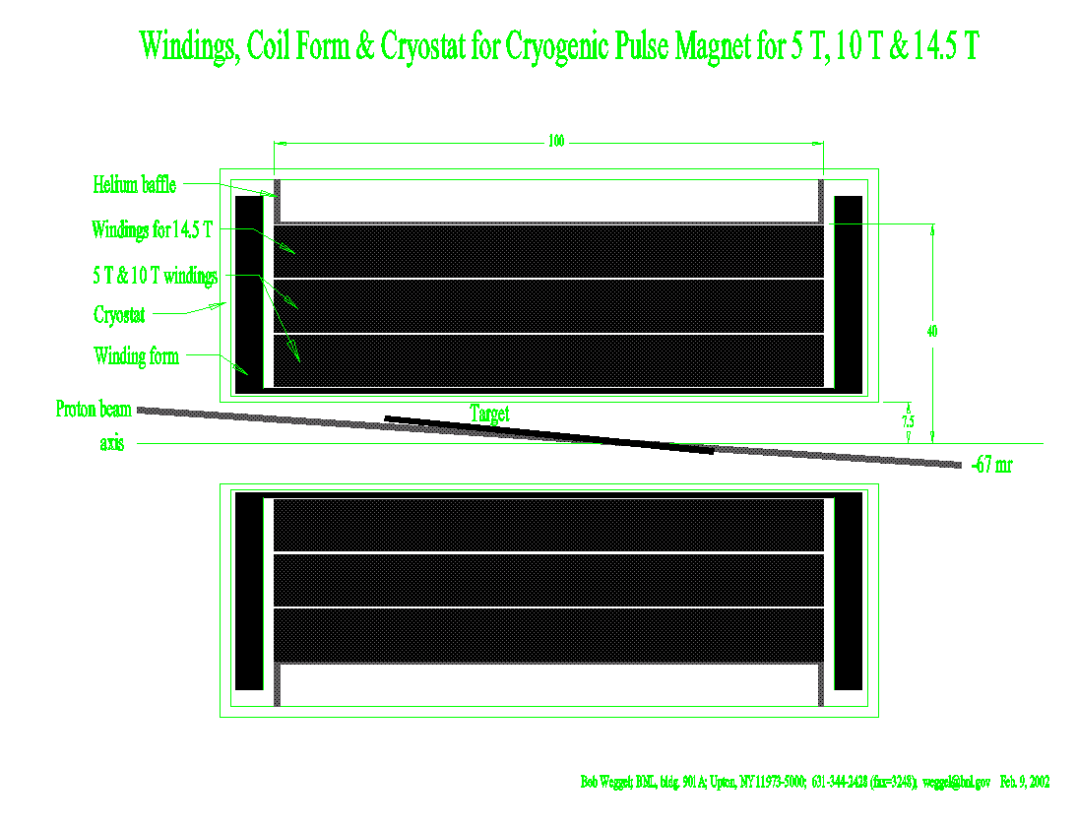
Fig. 1. Sketch of cross section of targetry system: winding pack, mercury jet and proton beam. The magnet has three shells, each 10 cm thick, separated by channels for helium gas coolant.
Transparency #2 tabulates parameters of Cases #1, #2 and #3. The last two rows give the temperature rise and cumulative heating for a typical pulse, in which, after a 1-s flat top, one drives the current down with reverse voltage of the same magnitude used to charge the magnet.

Pulse Magnet Systems for E951 Targetry Experiment

 | Units | Case#1 | Case #2 | Case #3
Peak on-axis field | T | 5.0 | 10.0 | 14.5
No. of 0.54 MVA power supplies | - - | 1 | 4 | 4
Mode of ganging supplies | - - | none | 2 x 2 | 2 x 2
Initial temperature | K | 84 | 74 | 30
Number of turns utilized | - - | 1200 | 1200 | 1800
Charge time | sec | 7.2 | 6.3 | 15.3
Temperature rise at end of pulse | K | 5.8 | 21.7 | 48.3
Cumulative heating at end of pulse | MJ | 2.7 | 9.1 | 15.2

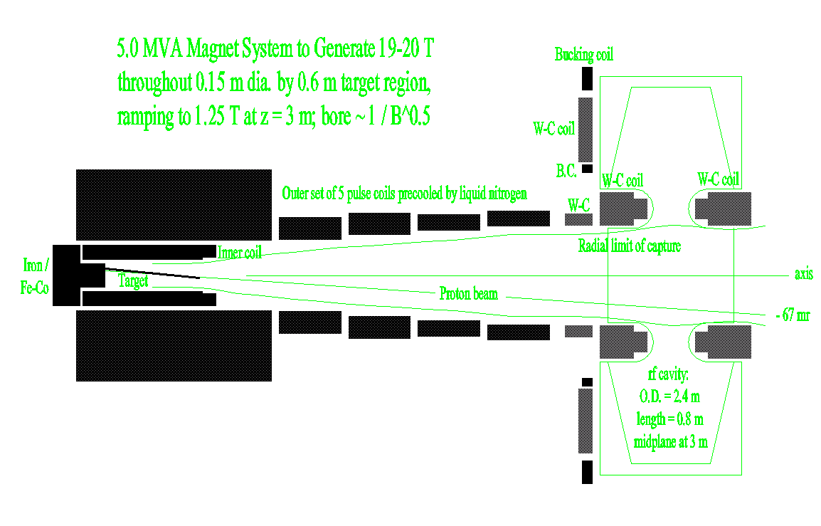
Figure 3. Cross section of superseded two-stage magnet to generate 20 T in a 15 cm bore. A new power supply of 5 MVA energizes the 14-metric-ton outer set of five coils to 16 kA, generating 10 T and storing 28 MJ from which to charge the inner coil. Introduction of a ¼ Ω resistor generates a voltage, initially 4 KV, which charges the inner coil in 1/3 s to 10 kA, 12.6 T. Meanwhile, resistive losses and inductive coupling have caused the current in the outer coil to decay to 12 kA, reducing its field contribution to 7.5 T. Abandoned as too costly.

Fig. 4. On-axis field profile of magnets of 100 cm length and outer diameter of either 60 cm or 80 cm. The profiles match the desired profile well over the target, from –30 cm to +30 cm. However, after another 30 cm, the field has fallen too much to retain many of the pions captured in the target region. One relinquishes pion retention for the sake of a more affordable system.

Fig. 5. Electrical resistivity ρ, heat capacity c_{p}, and ratio ρ/c_{p} between room temperature and 30 K, for copper of residual resistivity ratio RRR = 34.5 (ρ = 0.05 μΩ cm below ~20 K.) Note that cooling to 80 K (with liquid nitrogen at atmospheric pressure) improves electrical conductivity by a factor of nearly seven. Cooling to 66 K (with liquid nitrogen pumped to nearly its freezing point of 64 K) gives a ratio of nearly ten. Cooling to 30 K (with liquid hydrogen as the heat sink) achieves a ratio of about 30. However, all of these values neglect magnetoresistance, which can be substantial at low temperatures and high fields. The heating rate is proportional to ρ/c_{p}.

Fig. 6. Current, magnet resistance and power supply voltage of Case #3 pulse magnet for targetry experiment. Note that to obtain a flat top to the field requires some gymnastics from the power supply. When, 15.4 s into the pulse, the current tops out (at 7,200 A), the voltage must drop from 300 V to 230 V, because there no longer is any inductive back voltage. Then, for the duration of the flat top (shown here as one second), the voltage must increase several percent to track the increase in resistance as the windings heat up. Full negative voltage drives the current to zero.

Fig. 7. Electrical resistivity versus temperature from 20 K to 100 K and magnetic field from zero to 20 T. At 30 K the magnetoresistance at 14.5 T more than doubles the resistivity at zero field.

Fig. 8. Temperature at end of pulse of Case #3 magnet energized to 7,200 A, 14.5 T (with a half-second flat top) from an initial uniform temperature of 30 K. Where magnetoresistance is greatest (at r = 10 cm, z = 0, the inner radius of the magnet midplane) the turns reach 76 K, whereas they reach only ~62 K near the outer radius, where the magnetoresistance is least.

Fig. 9. Temperature T and cumulative heating Q at end of pulse in Case #3 magnet under two conditions of energization. One is that of a typical pulse, in which one drives the current down with reverse voltage of the same magnitude used to charge the coil. Driving the current down, from a flat top of one second, limits the peak temperature to 78 K and the heating to 15 MJ. In the other condition, the current coasts down, dissipating in the magnet all of the magnetic energy that it stored. The windings must absorb an additional 7 MJ, thereby reaching a temperature of nearly 90 K—still a safe value. The only penalty is a corresponding lengthening in recool time.

Fig. 10. Temperature distribution in Case #3 magnet if energized from an illustrative non-uniform temperature: 34 K at radii of 15 cm, 25 cm and 35 cm, falling parabolically to 22 K at radii of 10 cm, 20 cm, 30 cm and 40 cm. This distribution preserves, approximately, an average temperature of 30 K. The peak temperature is the same, ~76 K (again with a flat top of ½ sec.), as when energized from a uniform temperature, but occurs at a different radius, ~14 cm, where the initial temperature was high. At r = 10 cm the peak temperature is less than 75 K, despite the magnetoresistance being greatest there, because the initial temperature was only 22 K.

Fig. 11. Low-temperature electrical resistivity ρ, heat capacity c_{p}, and ratio ρ/c_{p} (in zero magnetic field) for copper of residual resistivity ratio RRR = 34.5 (ρ = 0.05 μΩ.cm below 20 K). Note that there is little motivation to cool the conductor below ~30 K: the electrical resistivity improves only about 10%. Furthermore, if the copper is uncooled, with only its heat capacity to limit its temperature rise, it will heat up very rapidly, because its heat capacity plummets, approximately as T³, below ~30 K. The heating rate, proportional to ρ/c_{p}, is three times worse at 20 K than at 30 K. Magnetoresistance further destroys the incentive to cool below 30 K.

Fig. 12. Graph that suggests how total operating power (for refrigerator as well as magnet) depends on conductor temperature and magnetic field (magnetoresistance). The graph applies for magnets in which the duty cycle exactly matches the Carnot efficiency—for example, a magnet with a duty cycle of 10% and whose refrigerator delivers only 10% of the refrigeration allowed by Carnot. At 77 K, the Carnot efficiency of typical small cryocoolers, according to the Spring 2002 issue of Superconductor & Cryoelectronics, is 4-10%; at 35 K, the range is from 2-5%. Note that magnetoresistance raises the optimum operating temperature from ~38 K at zero field to ~50 K at 20 T. For targetry magnets, with a duty cycle of only 1-2%, the optimum operating temperature is lower, because refrigerator power is a smaller fraction of the total power.

