LOI for a Study of a LANNDD of 100 kTon at DUSEL/Homestake

David B. Cline
Astrophysics Division
Department of Physics & Astronomy,
University of California, Los Angeles, CA 90095 USA
dcline@physics.ucla.edu

for
UCLA: David B. Cline, Franco Sergiampietri, Kevin Lee, Xiaofeng Yang, H. Wang
Princeton U: Kirk T. McDonald
Univ. of Hawaii: John Learned
UTD: Ervin J. Fenyves, Robert F. Burkhardt
and the Pisa and Granada Collaborations

Abstract
We propose to study the siting of a massive liquid Argon TPC (LANNDD) at DUSEL. This detector would greatly improve the reach of proton decay searches in the channel that is widely favored by many current models. It could also serve as a neutrino detector for use with a long-baseline accelerator neutrino beam. A related study in progress is LANNDD-5m to validate the use 5-m drift distance for massive LAr detectors. We propose to locate the 5m detector at some point at Homestake for tests.
1. Introduction
The major scientific issues of elementary particle physics may be partially solved with the CMS and Atlas detector operation at the LHC. Other problems such as the nature of dark energy and dark matter are under investigation around the world (see the proceedings of the 6th Symposium on the Sources and Detection of Dark Matter and Dark Energy in the Universe, Marina Del Rey, California, 2005).
Other equally fundamental questions involve the possibility of proton decay and CP violation in the neutrino sector. Until now these areas of science have been dominated by the use of water Cherenkov detectors such as Super K and IMB. However, with the successful development of the ICARUS liquid Argon TPC for the Gran Sasso Laboratory a new very powerful detector technique has entered the field.
In order to mount a new method to search for proton instability (mainly) a new very large underground laboratory is needed. It is possible that such a laboratory will be developed in the USA called DUSEL (Deep Underground Science and Engineering Laboratory) by the U.S. National Science Foundation. In this report we discuss the progress to develop a 100 kT liquid Argon detector called LANNDD. This detector is well matched to the size and scope of DUSEL and a possible super neutrino beam produced either by BNL or FNAL. A powerful R&D program for LANNDD is in progress that we will describe.
2. The Status of the ICARUS Liquid Argon Detector
The ICARUS LAR detector has made great progress recently.
(a) The T600 has now moved to the LNGS Hall B
(b) The CNGS neutrino beam will be sent to the LNGS mid-2006; ICARUS will detect several hundred events.
With about 2 kT years of detector and the R & D program discussed here the time is ripe to plan a larger ≈ 100 kT detector. LANNDD is a major candidate for this detector and it could be located in DUSEL.
3. The LANNDD Concept: Possible application of this technology in the USA
One option for a next generation nucleon decay search instrument is a fine-grained detector, which can resolve kaons as well as background from cosmic ray neutrinos that are below the threshold for water Cerenkov detectors such as Super-Kamiokande (SK). Such a detector can make progress beyond the few × 10³³ year limits from SK for SUSY favored modes because the reach improves linearly with the time and not as the square root of exposure as in SK. It will be possible to discover nucleon decay up to about ≈10³⁵ year lifetime/branching ratio with an instrument of ≈ 70 kT mass in liquid argon, as the one studied in the LANNDD project after a few years of exposure.
A second major goal for such an instrument, as demonstrated in a spectacular example of synergy in the last two generations of underground detectors, is the study of neutrino interactions and oscillations. Such a detector can make neutrino oscillation studies using the cosmic ray neutrinos alone (being able to resolve muon neutrino regeneration, detect τ's and tighten measurements of Δm² searches for other mixing than ν_{τ} → ν_{e}. But coupled with a neutrino factory, this detector, outfitted with a large magnet, offers the advantage of being able to discriminate the sign not only of muon events, but of electron events as well. Given the bubble-chamber-like ability to resolve reaction product trajectories, including energy/momentum measurement and excellent particle identification up to a few GeV, this instrument will permit the study of the neutrino MNS matrix in a manner that is without peer. The LANNDD detector is shown in Figure 3.
One may question whether such a marvelous instrument is affordable, by which we mean buildable at a cost comparable or less than the neutrino source cost. It is indicated, by simple scaling from existing experience with ICARUS, that such an instrument will cost out in the class of a large collider detector instrument and represents a straightforward extrapolation of existing technology.
As expected for such a large, isotropically sensitive, general-purpose detector, there are many ancillary physics goals that can be pursued. This device would allow exploration of subjects ranging from the temporal variation of the solar neutrino flux (above a threshold of perhaps 10 MeV), to searches for neutrinos from individual or the sum of all supernovae and other cataclysmic events (e.g. GRBs), to cosmic ray research (composition, where the WIPP depth is advantageous), dark matter searches (via annihilation neutrinos), searches for cosmic exotic particles (quark nuggets, glueballs, monopoles, free quarks), and point source neutrino astronomy. In all these instances, we can go beyond SK by virtue of lower energy threshold, better energy loss rate resolution, momentum, angle, sign and event topology resolution.
4. Sensitivity to Proton Decay, etc.
Much of the scientific studies that are being done with LANNDD follow the success of the ICARUS detector program. The main exception is for the use of the detector at a neutrino factory where it will be essential to measure the energy and charge of the m± products of the neutrino interaction. We will soon propose an R&D program to study the effects of the magnetic field possibilities for LANNDD.
4.1 Search for Proton Decay to 10³⁵ Years
The detection of would seem to be the key channel for any SUSY model. This channel is very clear in liquid argon due to the measurement of the range and detection of the decay products. We expect very small background events at 10³⁵ nucleon years for this mode (refer to ICARUS studies).
4.2 Solar Neutrinos and Supernova Neutrinos Studies
The major solar neutrino process detected in liquid argon is ν_{e} + ⁴⁰Ar → ⁴⁰Ar + e⁻, with Ar* de-excitation giving photons with subsequent Compton events. The same process is useful for supernova ν_{e} detection – the expected rate for the solar neutrinos is ≈ 123,000 per year. For a supernova in the center of the galaxy with full mixing there would be ~ 3000 events - no other detection would have these many clear ν_{e} events.
4.3 Atmospheric Neutrino Studies
By the time LANNDD is constructed it is not clear which atmospheric neutrino process will remain to be studied. However this detector will have excellent muon, hadron and electron identification as well as the sign of μ± charge. This would be unique in atmospheric neutrino studies. The rate of atmospheric neutrinos in LANNDD will be (50 kTon fiducial volume):
CC ν_{e} events: 4800/year
CC ν_{μ} events: 3900 ÷ 2800/year (depending on the neutrino mixing).
There would also be about 5000 NC ν events/year. We would expect about 25 detected ν_{τ} events / year that all would go upward in the detector.
4.4 Use of LANNDD in a VLBL Beam
Because of the large mass and nearly isotropic event response, LANNDD could observe neutrinos from any of the possible neutrino beam: BNL, FNAL. The LANNDD detector could be useful for the search for CP violation from any BNL or FNAL beam. This will depend on the value of the mixing angle θ₁₃ and the magnitude of the CP violation. Figure 4 shows the distance to all the Homestake site.
5. The proposed detector for DUSEL/Homestake
A study line is in progress to design a multi-tenth of kTon detector to be sited in an underground laboratory. The design for such a detector is strongly conditioned by the following constraints and guidelines:
- Detector efficiency and construction costs:
Large volume monolithic configuration: to maximize the fiducial-to-instrumented liquid argon volume ratio, to minimize the surface-to-volume ratio (minimum heat input, minimum cryostat wall out-gassing) and to minimize the number of wires and electronic channels.
Long electron drift (~ 5m): to minimize the number of drift regions and of the related wire chambers (drawbacks: use of 250-300 kV noiseless high voltages, argon purity at 10-50∙10⁻¹² p/p O₂ equivalent levels).
Ultra low-noise economic front-end electronics: also to partially compensate the drawbacks of the previous point.
Cryostat built with UHV standards (clean materials and assembly techniques) with design allowing vacuum before filling with liquid argon: to allow for the required argon purity
- Running costs:
Optimized thermal insulation: cryostat insulation based on lattice double walls with vacuum in-between, to minimize the liquid nitrogen consumption to compensate heat inputs. See Table 1 and Ref. 1.
- Underground site and safety:
Tectonic study and survey: to understand the realistic size of an underground hall suitable for hosting the detector and the yard for its construction/assembling.
Shaft for elevators (for pre-assembled large size detector details, liquid argon and liquid nitrogen supply dewars), ventilation and argon/nitrogen exhausts.
By the above listed criteria, a cryostat with the following main parameters has been studied for a 2 kTon active mass detector (Figures 1 and 2), conceived as preliminary scalable prototype for testing the above mentioned guidelines (approximate values for higher detector masses are given for comparison):
Table 1
Active LAr
mass [kTon] 2 4 10 100
diameter = height [m] 12.2 15.5 20.9 45
volume [10³∙m³] 1.43 2.9 7.2 71.6
Inner vessel
diameter = height [m] 13.0 16.5 22.3 48.0
outer surface [m²] 797 1′591 2′906 13′464
volume [10³∙m³] 1.7 3.5 8.7 86.9
Outer vessel
diameter [m] 15.0 19.0 26.0 55.5
height [m] 16.0 20.3 27.4 59.1
Total heat input [kW] 1.6 3.2 5.8 27.0
LN₂ consumption [m³/day] 1 2.1 3.7 17.3
Number of wires/el. channels 8320
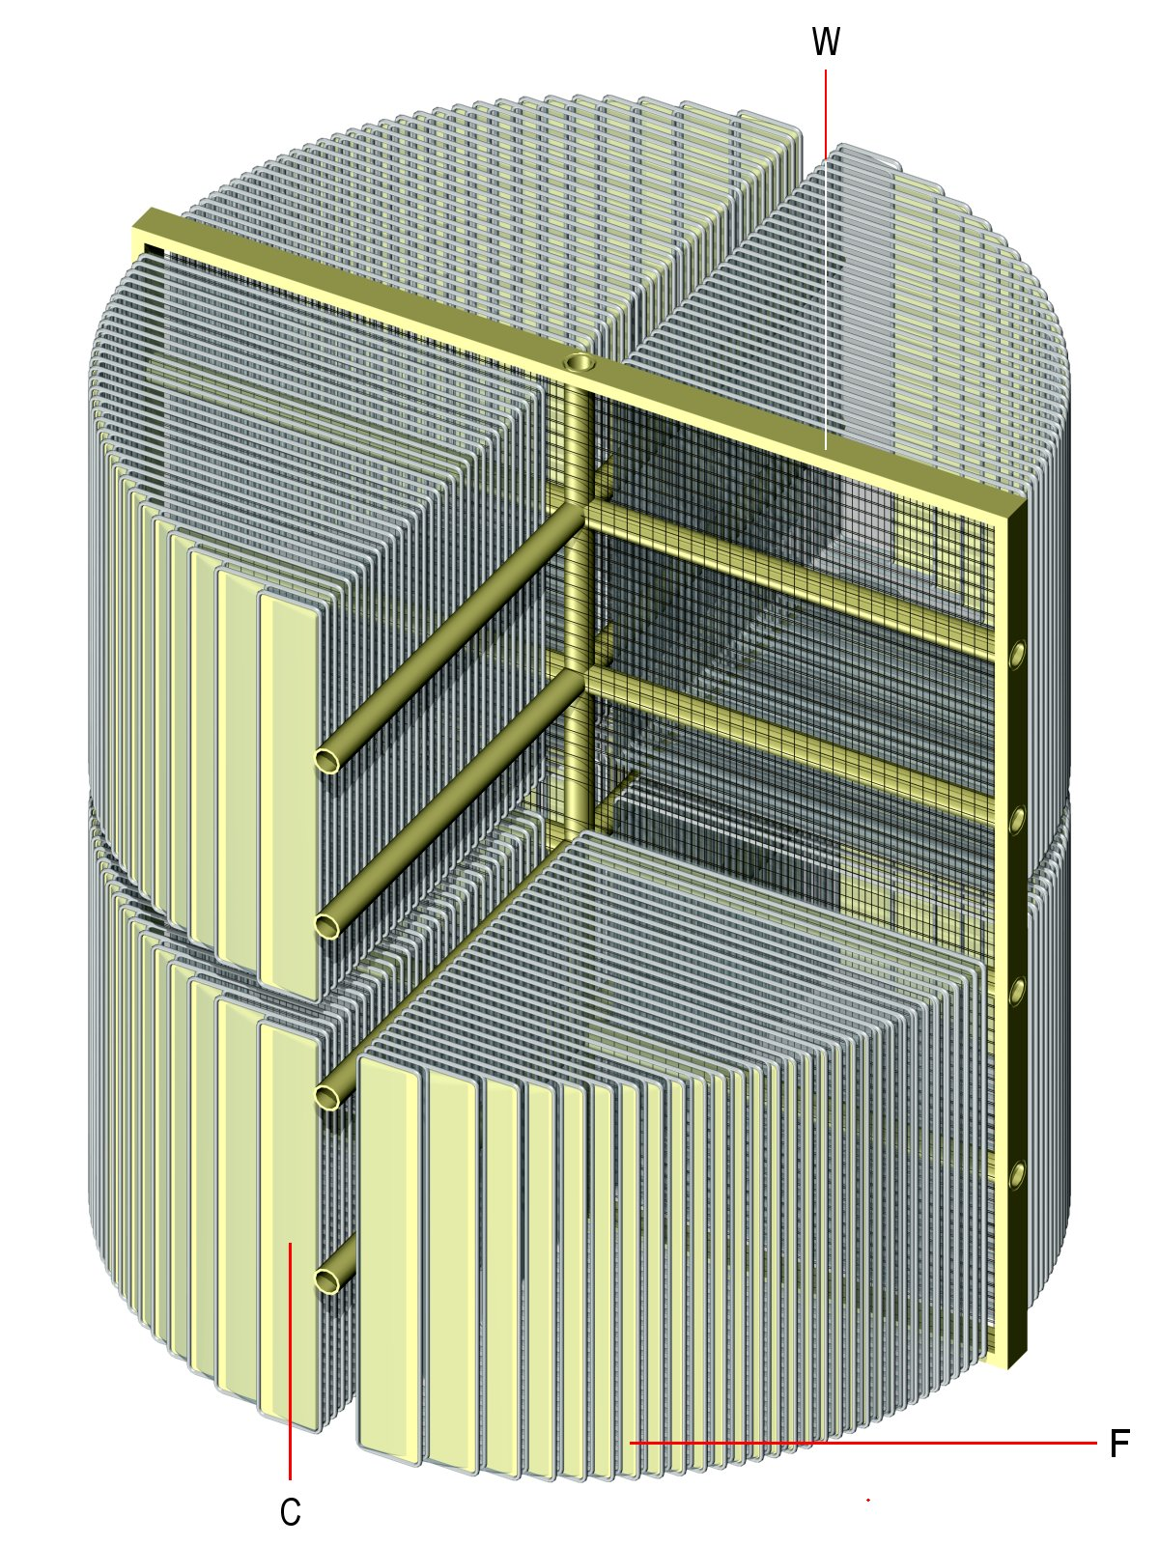 | 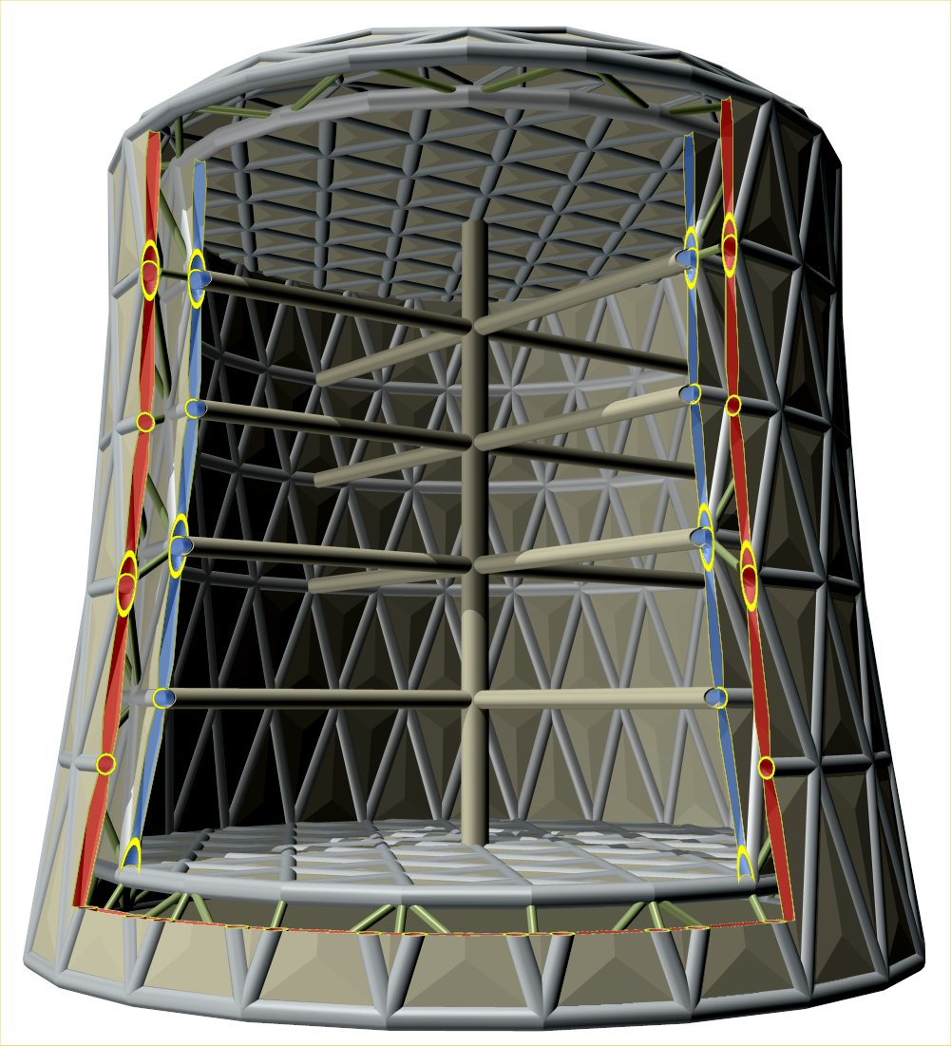
Figure 1 – The inside detector, with one of the top quarters not shown. W: wire chambers; F: field-shaping electrodes; C: cathodes. The inner reinforcing cross is also indicated. | Figure 2 – Cutaway view of the proposed cryostat design. The inner cross-structure is indicated for an eventual increase of the inner vessel rigidity.
The extremely low LN₂ consumption, due to the double-wall vacuum insulation, and the reduced number of channels, due to the monolithic detector geometry and to the long drift, largely compensate for the investments in the cryostat design and geometry and make the described example solution worthy of in-deep working out, in an engineering frame, for a realistic 2 kTon prototype. Essential requirements are a wise choice of materials and structure solutions aimed at achieving the UHP and UHV standards. Solutions coming from other application areas (LNG tanks) should be eventually revised according to these criteria. The geometry of this detector-cryostat complex is such to allow for its scaling up to greater volumes in an economically convenient way.
6. R&D effort: 5m Drift Experiment
6.1 Introduction
Aimed to the fields of neutrino physics and of nucleon decay, a preliminary study was started, in the year 2000, for identifying the main configuration criteria, the critical items and the related required tests for a 50-100 kTon detector, configured as liquid argon TPC, eventually fitted out with magnetic field. This study pointed out general thoughts, dictated by detection efficiency, mechanical stability, feasibility, underground operation, safety and costs, for the choice of:
- shape
- modularity
- detector parameters
- cryostat parameters
- magnet parameters
- site parameters.
The results, presented at NuFact'01, Tsukuba, describe a possible future detector named LANNDD (Liquid Argon Neutrino and Nucleon Decay Detector). A huge-scale detector, as the conceived one, requires a preliminary R&D activity for directly verifying all a series of design parameters, peculiar of its large scale, beyond the indications obtainable from extrapolation from much smaller size detectors or from Monte Carlo simulations. In particular, should be considered as first priority tests:
- long electron drift (4-8 m)
- track reconstruction in magnetic field (e.m. shower sign discrimination, muon momentum resolution)
- electron drift velocity at different (high) hydrostatic pressures.
The “LANNDD-5mD” experiment is proposed for the first of these tests.
6.2 Long Electron Drift in Liquid Argon
In order to decrease the complexity and the cost of a large scale detector it is important minimizing the number of electron collection wire planes. The purpose of the test is to experimentally verify the limits set on the maximum drift length by diffusion and attenuation of the drifting charge, by measuring the electron collection efficiency with a 5 m (or greater) drift path. For a long drift space the problems to be faced are:
- Use of high voltages for the drift in the range V_{d} ≈ 200 - 400 kV. Every detail of the high voltage system (power supply, residual ripple rejection filters, cables, feedthroughs and inner voltage degrader) should be carefully designed for a safe and smooth operation suitable for a low noise environment as the liquid argon TPC.
- Diffusion of electrons. Drifting electrons diffuse transversally and along the drift direction. The transverse diffusion can spoil, for a localized ionization, its reconstructed image definition by inducing signals in more than a single wire. The longitudinal diffusion increases the signal time duration, by proportionally decreasing its amplitude and then worsening the S/N ratio in the front-end preamplifier. This problem can be faced by a proper choice of the wire spacing and by optimizing the input stage of the read-out electronics.
- Electron attachment probability during the drift time. A particular care is used in providing an “ultra-clean” environment for the liquid argon and in optimizing the removal of electro-negative impurities from the argon itself by a forced, continuous circulation in liquid phase through getter cartridges.
- Low-noise electronics. This item plays a strategic role as a higher S/N ratio can compensate for realistically achievable argon purities and longitudinal diffusion effects and can allow the operation at not excessive high voltages.
6.3 Experimental Methods
We plan to measure attenuation and diffusion effects for ionized tracks along a 5-m long drift space. A first method is based on recording tracks induced by vertical cosmic ray, selected at different distance along the drift by a pair of scintillator counters in coincidence. After each trigger from the counters, data are acquired during a time window corresponding to the maximum drift time. The dependence on the counter position of the peak of the pulse height distribution in the collection wires will show the attenuation along the drift. The time duration of signals is related to the diffusion along the drift direction.
A second method is based on recording single long tracks, slightly slanting with respect to the drift direction, from a muon test beam (p_{μ} ≥ 10 GeV/c). Portions of the track originated at different distance from the collection wire plane are collected in different wires and the pulse height distribution along the wires gives immediately, in each single event, the exponential behavior due to the attenuation.
6.4 The Detector
The detector is configured as a time projection chamber with cylindrical drift volume (Figure 3). The drift volume, 5 m long, is bounded by a cathode, at one end, and by a wire chamber, at the opposite end. The electric field generated between cathode and wire chamber, is kept uniform by mean of a stack of uniformly spaced metallic rings (field shaping electrodes), biased at voltages linearly decreasing from the cathode voltage to the wire chamber voltage.
In a first configuration, the wire chamber is made by two wire planes. The first plane, with grounded horizontal wires, works as grid (Fisher type) for screening the second wire plane (collection plane) from the drift volume and then avoiding position dependent signals. The collection wires are vertically oriented and individually connected by signal lines to a low voltage multi-contact feedthrough and, from there, to the outer front-end electronics (charge sensitive preamplifiers, amplifiers, ADC's).

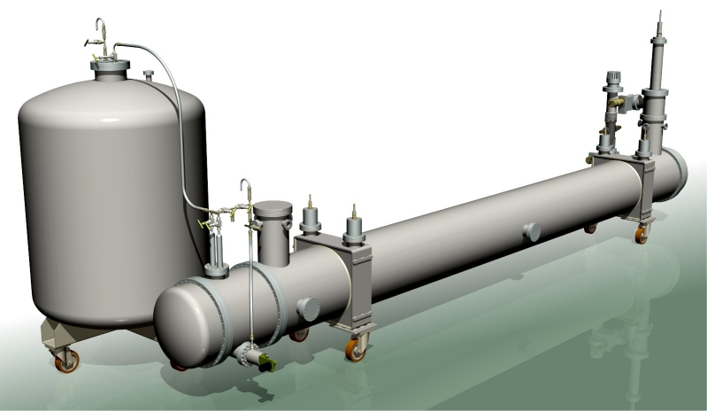
S
P
V
LANNDD-5mD
HV
Figure 3 – The LANNDD-5mD detector with the liquid argon storage tank (S), the integrated purification system (P), the high voltage feedthrough (HV) and the insulation vacuum pumping group (V).

We would plan to move this to Homestake for tests in 2008 or 2009.

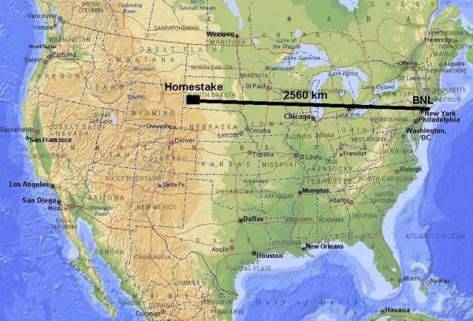
Figure 4 – DUSEL Homestake site.

D.B. Cline and F. Sergiampietri, “A Concept for a Scalable 2 kTon Liquid argon TPC Detector for Astroparticle Physics”, http://arxiv.org/abs/astro-ph/0509410
Unitary heat inputs lower than 1 W/m² are reachable with vacuum and super-insulation layers. We assumed 2 W/m² to take into account residual conduction heat inputs through signal cables, mechanical supports and spacers.
LANNDD-5MD. R&D PROPOSAL. By A. Bueno, C. Cerri, D.B. Cline, S. Navas, R. Pazzi, F. Sergiampietri, X. Yang, H. Wang (Pisa, UCLA, Granada), CERN-SPSC-2004-033, CERN-SPSC-I-230, Sep 2004

