Vibration of Wires in Liquid Argon Due to Fluid Flow

Kirk T McDonald (kirkmcd@princeton.edu)
Princeton University
(April 5, 2006)

This note follows up on calculations by Z. Tang on convective flow of liquid argon in a big tank.

I have made slight corrections to p. 6 of Tang's note:
http://www.hep.princeton.edu/~mcdonald/nufact/Tang/liquidArgonTank_convection.ppt
http://www.hep.princeton.edu/~mcdonald/nufact/Tang/liquidArgonTank_convection.pdf

Richard Schmitt has alerted us to possible issues of wire vibration induced by flow of liquid argon.

Bottom line: Not a serious issue by itself.

[I should next consider how the presence of electric forces on the wires may aggravate vibrations. Also, wire vibration induced by resonant ground motion remains potentially troublesome.]

Details are given below, based on a quick reading of useful lore in chap. 29 of
http://www.knovel.com/knovel2/Toc.jsp?BookID=625

1. From Tang we learn that for a large tank of a specified heat leak, the convective flow has a peak velocity of ~ 7 cm/s. This occurs near the bottom center of the tank, where the liquid is flowing downwards in a column that is a few m in diameter.

2. The steady drag force on a wire of diameter 0.15 mm due to liquid argon flow of 7 cm/s is less than 10% of the weight of the wire
=> Steady drag force not much of an issue.

3. The Reynolds number corresponding to the maximum velocity of 7 cm/s is about 56. This is just barely large enough to excite a so-called Karman vortex stream. See Fig. 29.7 of Blevins (Chap 29-1 of above link)

Since the spacing between our wires is more than 10 diameters, it appears that the effect of one wire's vortex stream on another is negligible (see "wake buffeting", p. 29.40 of above link). Hence, the remaining discussion concerns possible vibrations induced on a single wire.

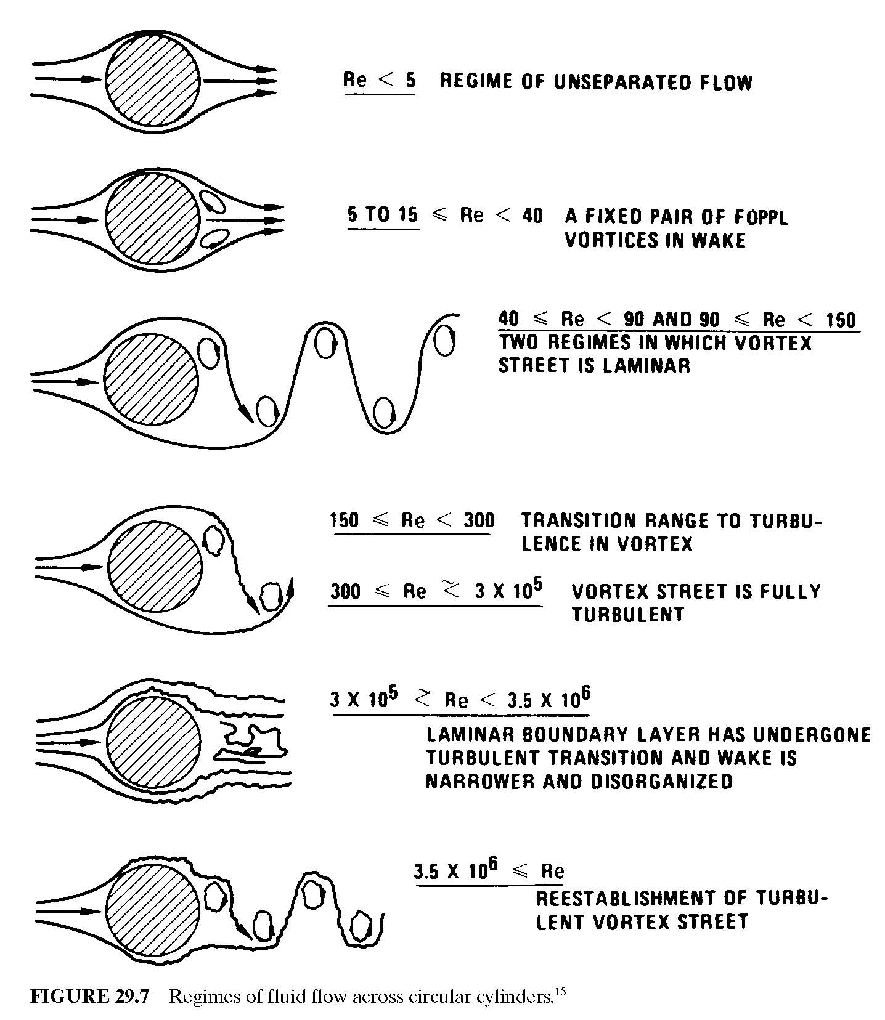

4. For moderate Reynolds number, the vortex stream is rather regular, which leads to a fairly sharply defined frequency f_{ex} of transverse excitations of a wire: (see eq. (29.12)):

f_{ex} = 0.2 U / D ~ 100 Hz, for U = 7 cm/s and D = 0.015 cm.

Figure 29.9 shows data indicating that the bandwidth of the excitation has a FWHM of about 20%.

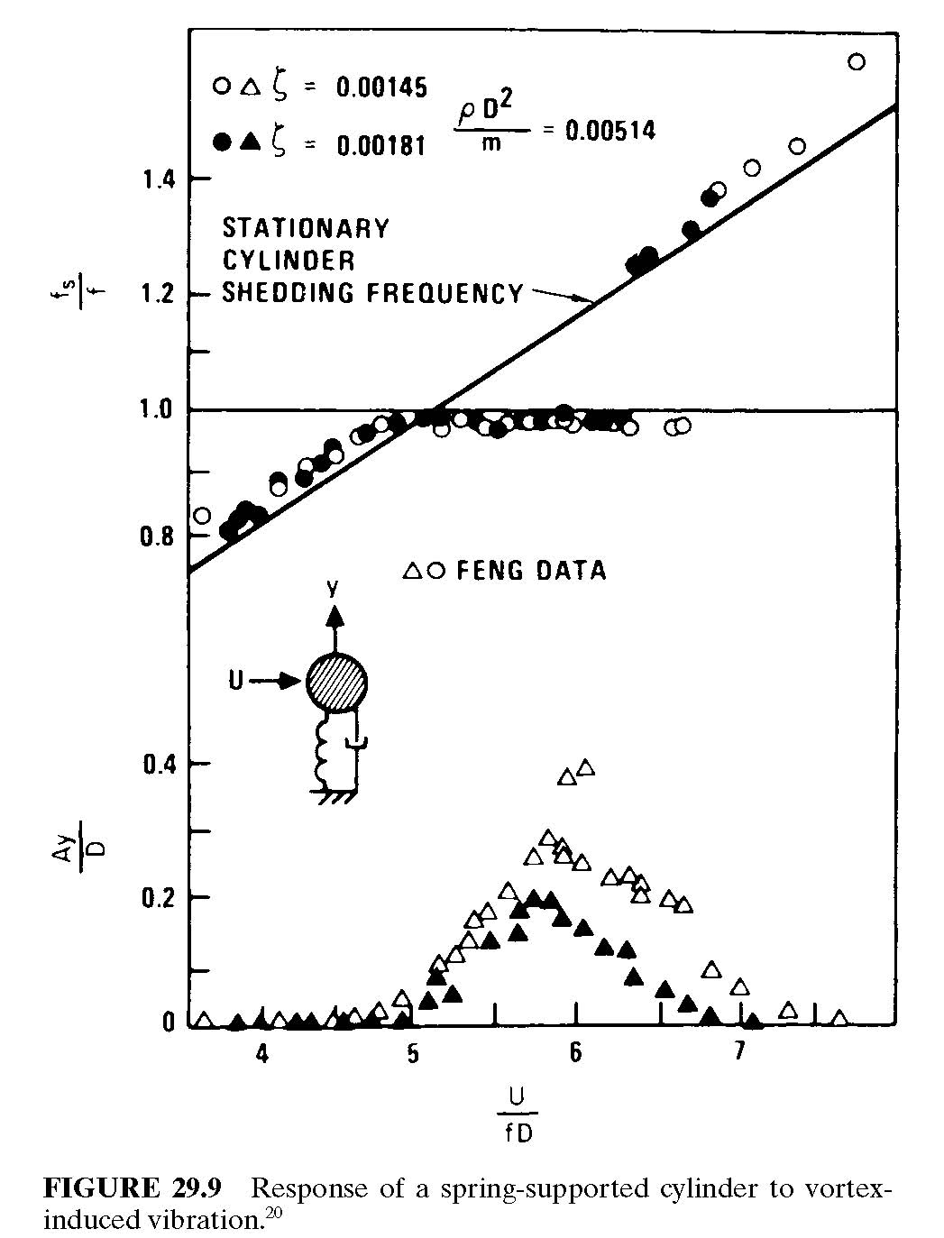

5. What are the resonant frequencies of our wires?

Hz for the parameters below.

n = integer

L = length, say 30 m = 3000 cm

T = tension, say 7 N = 7e5 dyne

g/cm³. (As noted on p. 29.3 of Blevins' article, the effect of a wire vibrating in a liquid is that the necessary motion of the liquid adds an effective mass to the wire equal to the mass of the displaced liquid.)

So, the peak fluid velocity of 7 cm/s would excite the 23rd harmonic. This is probably a negligible effect.

To excite the fundamental, according to the formula in item 4, the fluid velocity should be 7/46 = 0.15 cm/s.

There will be regions of the tank in which the velocity is this low. But in these regions, the Reynolds number of the flow is 56/23 = 2.4, in which case the flow is laminar, not turbulent, and there is no excitation of wire vibration.

So, I conclude that wire vibration due to fluid flow is negligible (unless aggravated by the electrostatic wire instability).

6. This is an academic footnote about what could happen IF the fundamental frequency of a wire matched the vortex excitation frequency of 100 Hz.

Fig. 29.10 plots the ratio of the oscillation amplitude to the wire diameter (γ = 1 for round wires) as a function of a dimensionless parameter , where ζ is a dimensionless damping parameter, which I believe is 1/Q.

I estimate ζ as, where K is related to the drag force: F_{drag} = - K U.

Then, ζ ~ 6e-5, and

Fig. 29.10 indicates that the amplitude of the oscillation would then be about 0.04 wire diameter = 6 μm.

I doubt that such a vibration would be noticeable to us.......
