Edward Weston: TOADSTOOL, 1931 B&W Print
malm@taconic.net
June 22, 2002

This is an exquisite photograph by Edward Weston, called "Toadstool, 1931." The size of the paper is 8" x 10", and the image is just slightly smaller than the trim size. The photo is an exquisite study of a toadstool, or mushroom, which was part of one of Weston's series.

The history of this photograph is that I purchased it at an estate sale in Millerton, New York. I was told that it had been among the items cleared out from the "Strand house" (a house on Simmons Street purchased by Paul & Hazel Strand where they stayed when conducting business with their publisher, Aperture). The photograph is of very, very good quality. The tonal range is excellent, as are shadow and highlight details. This is absolutely not a photomechanically generated print. It is printed on good quality fiber paper.

The print is not mounted, stamped or signed and so it is very difficult to determine whether it was printed from Weston's original 8 x 10 negative. Experts who have examined this print are unable to say one way or the other. The most likely explanation is that the print was produced from Weston's negtative for the express purpose of reproduction by Aperture when they published Weston's works---particularly the large monograph. The detail in this print is superior to the photographic detail in the big Aperture monograph (WESTON: HIS LIFE AND WORKS), and those of you familiar with this book know how magnificent the printed reproduction is. (Aperture was originally housed in Millerton, NY, and still has an office there.)

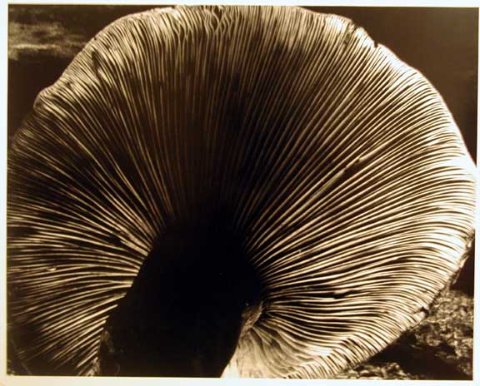

Edward Weston: Juniper Tree
malm@taconic.net
June 22, 2002

This photograph is part of a series of photographs Weston took at Lake Tanaya in the 1930's. The size of the paper is 8" x 10", and the image is just slightly smaller than the trim size.

I purchased it at an estate sale in Millerton, New York. I was told that it had been among the items cleared out from the "Strand house," a house on Simmons Street purchased by Paul & Hazel Strand where they stayed when conducting business with their publisher, Aperture. (Aperture was originally housed in Millerton, NY, and still has an office there.)

The print is not mounted, stamped or signed and so it is very difficult to determine whether it was printed from Weston's original 8 x 10 negative. Experts who have examined this print are unable to say one way or the other. The most likely explanation is that the print was produced from Weston's negative for the express purpose of reproduction by Aperture when they published Weston's works --- particularly the large monograph WESTON: HIS LIFE AND WORKS.

